MICROSOFT PUBLISHER 2003

Page
LESSON 1: GETTING STARTED 1
♦ Starting Microsoft Publisher 1
♦ The New Publication Task Pane 1
♦ Creating a Publication for Print 2
♦ Parts of the Publisher Screen 6
♦ Terminology 6
♦ Navigation 7
LESSON 2: PUBLISHER BASICS 10
♦ Saving Files 10
♦ Closing a Publication 11
♦ Opening Files 11
♦ Page Setup 13
♦ Adding and Deleting Pages 14
♦ Printing 16
LESSON 3: WORKING WITH TEXT 18
♦ Formatting Text 19
♦ Inserting Information from Another Source 21
♦ Connecting Frames 21
♦ Disconnecting Frames 22
♦ Text Box Properties 22
♦ Hyphenation 27
♦ Drop Caps 28
LESSON 4: NON-TEXT OBJECTS 31
♦ Drawing Objects 31
♦ Clip Art 32
♦ WordArt 35
LESSON 5: FORMATTING OBJECTS 38
♦ Arranging Objects 38
♦ Resizing Frames 39
♦ Rotating a Frame 40
♦ Formatting Objects 42
♦ Aligning Objects 49
♦ Grouping and Ungrouping Objects 50
LESSON 6: COMPLETING A PUBLICATION 52
♦ Design Gallery Objects 52
♦ Headers and Footers 53
♦ Design Checker 54
LESSON 7: GIVE IT A TRY! 56
LESSON 8: DELETING 58
NICE TO KNOW 60
♦ Mail Merge 60
♦ Information for the Printing Service 66
♦ Font Guidelines 66
♦ Proofreading Tips 67

This workbook may be reproduced in whole or in part by an employee of the Department of Health and Human Services. All other reproduction is prohibited unless written permission is obtained from the Training Institute.

Last Updated: September 27, 2006

GETTING STARTED

OBJECTIVES: Identify key Publisher terms.
Understand the Publisher Catalog.
Create a Publication by Wizard.
Identify parts of the Publisher Screen.
Navigate within a publication.

OVERVIEW

Desktop publishing is the process of using a personal computer to design flyers, newsletters, posters, brochures, business forms, calendars, and other documents. Desktop publishing programs have more powerful layout and design functions and offer more design choices than standard word processing programs.

Starting Microsoft Publisher

STEPS

- Click START, ALL PROGRAMS, MICROSOFT OFFICE PUBLISHER 2003.

The New Publication Task Pane

OVERVIEW

When you first open Publisher, the New Publication Task Pane appears. This is designed to assist you in creating a publication that begins with a basic style and guides you through several color and design choices; a publication with a style that can be repeated in many other types of publications; or a completely blank publication.
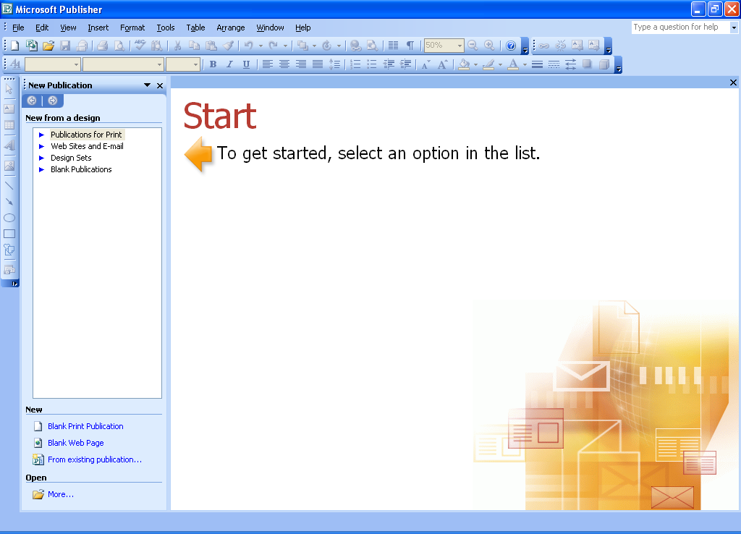
Publications for Print
Web Sites and E-mail
Design Sets
Bland Publications
Publications for Print – Preloaded styles of newsletters, brochures and other publishing products to help you design your publication.

Web Sites and E-Mails – Creates a publication that is optimized for display in a Web browser. For this reason, certain text formatting options and other features are not available in Web mode.

Design Sets – Groups various publications by a design theme; like business cards, catalogs, invoices, and letterhead.

Blank Publications – A blank publicaiton without frames.

Creating a Publication for Print

OVERVIEW

The following steps outline the options for creating a newsletter. When designing a different type of publication, the options may vary.

Steps

- Click PUBLICATIONS FOR PRINT.

- Click a publication type in the left pane.

- In the right preview pane, click a format. If necessary, use the scroll bar to see additional formats.

- The first time you choose a style, Publisher will ask if you wish to enter information about yourself and your organization to be used in this and future publications.

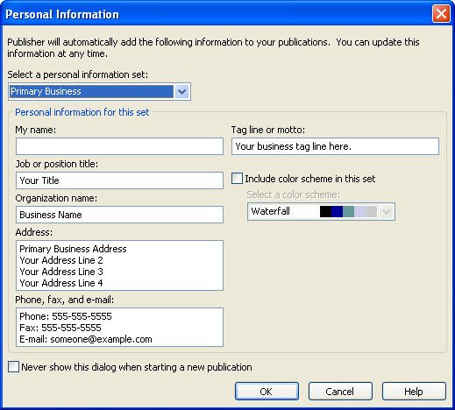

- Once completed, click OK.

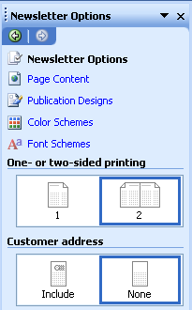

- On the Task Pane, click either one or two sided Printing.

- Choose to include or not include a customer address.

- On the Task Pane, click on PAge Content.

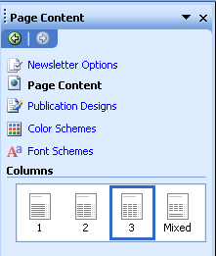

- Click the number of COLUMNS for each page of the publication.

- To change your design, click PUBLICATION DESIGNS and select a different style.

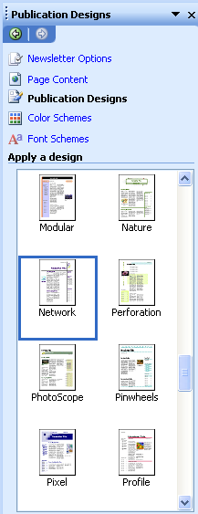

- Click COLOR SCHEMES and select the scheme to use throughout the publication.

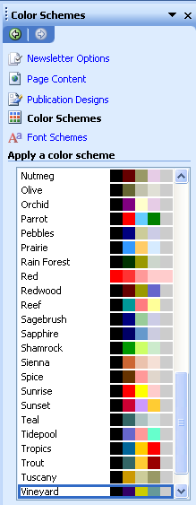

- Click FONT SCHEMES and select the scheme to use throughout the publication.

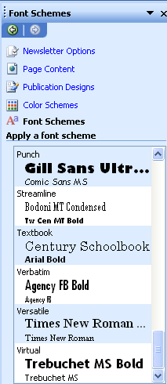

Parts of the Publisher Screen

OVERVIEW

Once you have opened a publication, a screen similar to the following appears.
Title Bar

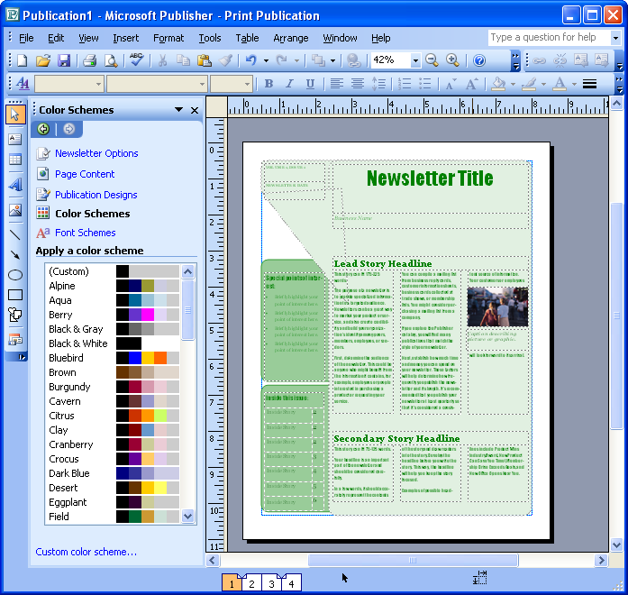
Menu Bar
Standard Toolbar
Objects Toolbar
Formatting Toolbar

Page Navigation Control

Terminology

OVERVIEW

The following terminology will assist you in utilizing Microsoft Publisher:

Title Bar: The blue bar at the top of the screen; it shows the program and publication name.

Menu Bar: A list of functions; click once on the menu name, then on the desired function (or press Alt plus the underlined letter). You may need to wait for the menu to expand or click the double-down arrows to find the function you want.

Toolbars: Rows of buttons representing shortcuts to common features. Click the tool you wish to use.

Task Pane: Panel on the left side of the window that allows you to change your publication’s design.

Layout Guide: A layout guide is a grid that helps you to align text, pictures, and other objects so that your publication will have a consistent look. These guides are set using the layout guides command on the Arrange menu. They are represented by blue and pink dotted lines.

Page Navig- Allows you to view different pages of your publication.
ation Control:

Object: An object is a picture, a line, a frame, text, or any item placed in the foreground or background of your publication. Many commonly used objects are accessible through the Objects Toolbar.

Frame: Frames assist the user in placement of picture and text objects.

Text Box: A text box is used to enter text in a publication.

Navigation
Helpful Hint:

A quick way to change the zoom to 100% is to click an object, and press the F9 key. To go back to the previous view, press F9 again.

Overview

Your publication will usually include multiple pages, which will require you to move between pages to work on them. In addition, you might want to “zoom out” to see the layout of an entire page, or “zoom in” on a particular object in order to work on it more easily.

steps

- To view a particular page of the publication, click the appropriate page number on the PAGE NAVIGATION CONTROL at the bottom of the Publisher screen.

- To zoom in on an object, click on the object, and click the ZOOM IN button on the Standard toolbar.

- To zoom out, click the ZOOM OUT button .

- To zoom to a particular size, click the ZOOM drop-down , and make the appropriate selection.

Lesson Example

You need to create a newsletter for your department. The Publications Wizard seems to be the best option since it formats the entire publication quickly and easily.

STEPS

- Click START, ALL PROGRAMS, MICROSOFT OFFICE PUBLISHER 2003.

- Click PUBLICATIONS FOR PRINT.

- Click NEWSLETTERS.

- Scroll down and click TILT NEWSLETTER.

- Make sure that 2 SIDED PRINTING is selected.

- Select NONE for the CUSTOMER ADDRESS.

- Click the PAGE CONTENT link click the drop down list by 2 COLUMNS. Select APPLY TO ALL PAGES.

- Click the PUBLICATION DESIGNS link and choose the WATERMARK design.

- Click the COLOR SCHEMES link and choose the SAPPHIRE COLOR SCHEME.

- Click the FONT SCHEMES link and choose ETCHED.

- Zoom in on the graphic on the right side of Page 1.

- Zoom out to view the entire page.

EXERCISE:

1) Identify the parts of the Publisher window.

2) On Your Own: Change the color scheme to Eggplant.

3) Zoom in on the text in the bottom left corner of Page 4.

4) Change the Publication Design to Vintage.

PUBLISHER BASICS

OBJECTIVES: Save, close, and open publications.
Edit page setup.
Add and delete pages.
Print a publication.

Saving Files

OVERVIEW

Saving a publication is very important. If the computer is turned off or the electricity fails, you will lose the file if it is not saved. By default, Microsoft Publisher will save your publication every 10 minutes.

STEPS
- Click the SAVE button on the toolbar or CTRL + S on your keyboard and type a filename. The program will automatically assign .pub as an extension.

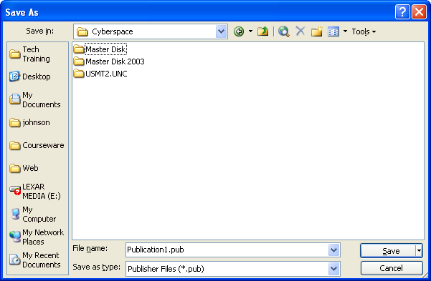

- Select an appropriate location for saving the file from the SAVE IN drop-down list.

- Click SAVE, or press ENTER on your keyboard.

- To resave a file after making changes, click the SAVE button. This will resave the new information over the old with the same name and file location.

- To save a separate copy of your publication, click FILE, SAVE AS. Type a new filename, and/or select a new file location. Click SAVE.

Closing a Publication

STEPS

  - Click FILE, CLOSE.

  - If you have not saved your most recent changes, you will be prompted to do so. Click YES or NO depending on your needs.

Opening Files

STEPS

- Click the OPEN button of the toolbar or press CTRL+O on the keyboard.

- If you are in the NEW PUBLICATION TASK PANE, click the MORE…link at the lower left corner of the window.

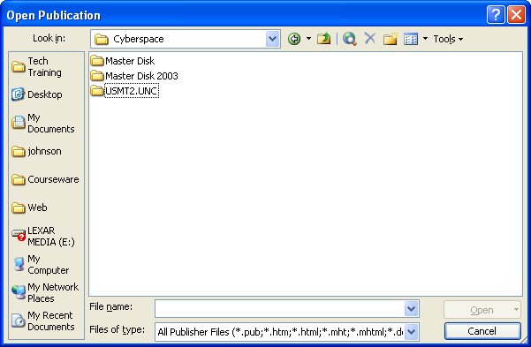

- Find the name of the file to open. If your filename is not visible, click the arrows of the Scroll Bar or click and drag the Scroll Box.

- Click the filename, then OPEN. Or, double-click the filename.

Lesson Example

You need to save and close the newsletter.

STEPS

- Click FILE, SAVE.

- Type My Newsletter for the FILENAME.

- If necessary, click MY DOCUMENTS in the left panel.

- Click SAVE.

- Click FILE, CLOSE.

EXERCISE:

1) Open the My Newsletter file.

2) View each of the pages of your newsletter.

3) Click FILE, SAVE AS and save the newsletter as New Newsletter in the My Documents folder.

4) On Your Own: Close New Newsletter and open My Newsletter.

Page Setup

Overview

There will be many times when you need to change the way your publication will be printed on a sheet of paper. You can change the paper size, add a fold, or change the orientation from portrait to landscape. You can even set up envelopes and labels in Page Setup.

Steps

- Click FILE, PAGE SETUP.

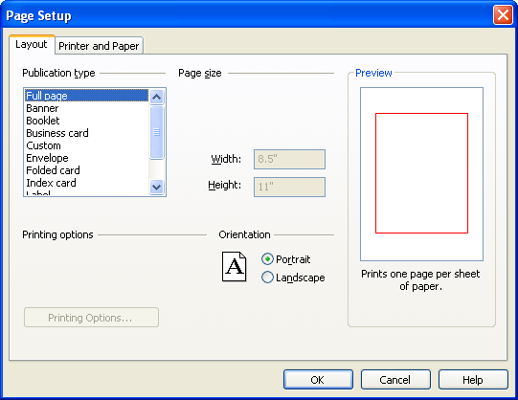

- On the LAYOUT tab, choose a publication type. According to the publication layout, you may have more selections to make in the PAGE SIZE section.

- Click the appropriate ORIENTATION radio button. Keep in mind the need for a special paper size or fold.

- Click OK.

- Click the YES button to allow Publisher to adjust the Wizard created design.

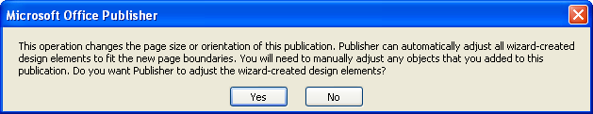
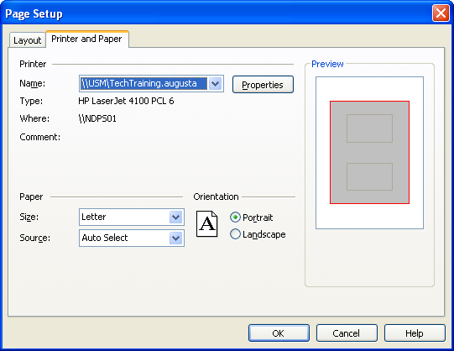

- Click the PRINTER AND PAPER tab to change the paper size and the printer.

- Click OK.

Adding and Deleting Pages

OVerview

At times, you may want to add or remove pages from your publication. The important thing to remember is how adding or deleting one page will effect the entire publication. Each side of a sheet of paper is considered one page; the front side is one page and the backside is another.

Steps

- To insert a new page, click INSERT, PAGE.

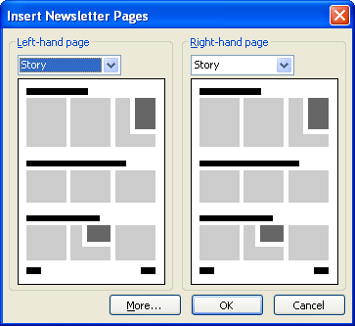

- Depending on the type of publication, you may have the option to choose what to place on the new page(s). Click the drop-down arrow under LEFT-HAND PAGE or RIGHT-HAND PAGE to see your choices.

- If necessary, click the MORE button to open the following dialog box:

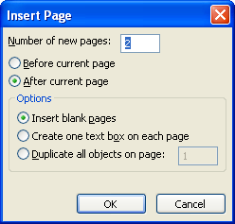

- Click the BEFORE CURRENT PAGE or AFTER CURRENT PAGE radio button to place your new page(s).

- You can have Publisher leave the new page blank, add a text box, or duplicate a page by clicking on the corresponding radio button in the OPTIONS section. Click OK.

- If an information message appears, click the appropriate response.

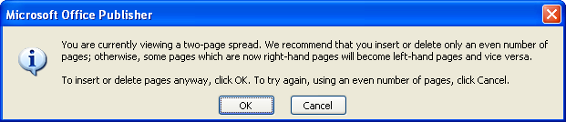

- To delete a page, click EDIT, DELETE PAGE. If there is an information message, click the appropriate response.

Printing

OVERVIEW

Your may choose to print in color or black and white, depending on your available printer(s). You can also print the whole publication or a single page.

STEPS

- To print one copy of your entire publication, click the PRINT button on the toolbar.

- To print more than one copy or specific pages of your publication, click FILE, PRINT.

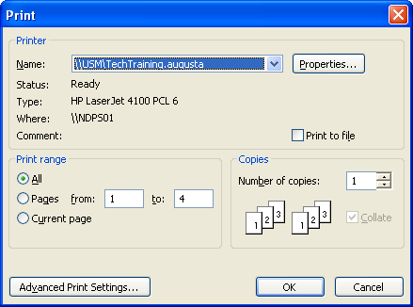

- If you are attached to more than one printer, choose the appropriate printer in the PRINTER section.

- The PRINT RANGE section allows you to print all the pages, a range of pages, or the current page.

- The COPIES section allows you to select the number of copies that will be printed.

- You may click ADVANCED PRINT SETTINGS to make selections such as printing crop marks or not printing pictures by clicking the corresponding options.

- When you have made all of your selections, click OK.

Lesson Example

Before printing your newsletter, you decide to check the page setup.

STEPS

- Delete the inside pages by viewing pages 2 and 3 and clicking EDIT, DELETE PAGE.

- Keep BOTH PAGES selected, and click OK.

- Save your changes.

EXERCISE:

1) Click on page 1.

2) Click Insert, page and click the More button.

3) Choose 1 page after the current page that duplicates the objects on page 2 and click OK two times.

4) On Your Own: Add one blank page after page 1.

5) Save your changes.

WORKING WITH TEXT

OBJECTIVES: Add text frames.
Format text.
Insert text from another source.
Connect and disconnect frames.
Use continued notices.
Adjust hyphenation.
Apply Drop Caps to paragraphs.

OVERVIEW

In Publisher, all items are enclosed in frames. Text can be added, edited, and deleted within text frames that are either created by the Wizard or added manually to the publication.

STEPS

- To overwrite placeholder text in an existing frame, click once in the text frame to select all of the text, and type over the existing text.

- To edit text in an existing frame, click in the text frame to get an insertion point. Edit as you would in Microsoft Word.
Helpful Hint:

Instead of clicking and dragging to insert a new object, just click once on the page where it should go. You may have to move and resize the object later.

- To add a new text frame to your publication, click the TEXT BOX button on the Objects toolbar.

- Place the mouse where the upper left corner of the frame will start.

- Hold down the left mouse button, and drag diagonally to where the lower right corner will be located and release the mouse button. A blinking cursor will be automatically positioned in the upper left corner of the frame.

- Type the text.

- To delete a text frame, click within the text frame, and click EDIT, DELETE OBJECT. Or, right-click on the object and click DELETE.

Formatting Text
Helpful Hint:

To select a font size that does not appear in the drop-down list, click the FONT SIZE tool, type the number of the desired font size, and press ENTER.

overview

You can format your text by following the same steps that you use with Microsoft Word.

STEPS

- To change the font, font size, and style, click in the text frame you wish to edit.

- Select the text to be modified and use the font controls on the toolbar to choose a FONT , FONT SIZE , BOLD , ITALIC , and/or UNDERLINE .

- To change the color, select the text to change, and click the FONT COLOR button .

- Choose a color from your scheme or select MORE COLORS for additional choices.

- Click OK.

Lesson Example
Helpful Hint:

If there is to much space between paragraphs, press Shift + Enter instead of just Enter.

You would like to add some information to your newsletter and format the text. Use the Zoom feature as needed throughout this example.

STEPS

- On page 1, click once in the NEWSLETTER TITLE text frame.

- Type News from (your Department).

- Click in the LEAD STORY HEADLINE text frame.

- Type Department Update.

- In the Newsletter Title text frame, change the word News to Hello.

- Select the title text, and click the ITALIC button.

- Click the FONT COLOR button, and select a different color from the SCHEME COLORS.

EXERCISE

1) In the text frame under the Department Update headline type the following:

(your Department) is proud to deliver to you this inaugural edition of Hello from (your Department). Look for this newsletter in your mailboxes every month. In it, we will provide you with information on upcoming events, recent accomplishments, and other exciting news. If you wish for an item to be included in the newsletter, please submit it to (your name).

Happy Reading!

2) Press CTRL + A to select all of the text and change all of the font in this frame to Georgia, 16 pt.

3) Add a small text frame in the white space above the Special Points of Interest.

4) In it type (your name), Editor-in-Chief.
Helpful Hint:

An easy way to select multiple objects is to lasso them by clicking and dragging around all of the objects.
5) Change the font to Garamond, 14 pt, in the color of your choice.

6) Delete the Volume 1, Issue 1, Newsletter Date, Special Points of Interest, and the Inside This Issue text frames.

7) On Your Own: On Page 3 and 4 of the newsletter, delete all of the objects above the Back Page Story Headline.

8) Save your changes.

Inserting Information from Another Source

OVERVIEW

There will be times when you want to bring information from another program into Microsoft Publisher. This information could include text from Microsoft Word or a chart or spreadsheet from Microsoft Excel, among other things.

STEPS
Did You Know?

If you do not have a frame, Publisher will create one for you when you click PASTE.
- Open the file containing the information to be used.
- Select the information, and click the COPY button .
- Open the publication, and click in the frame into which you want the information to be inserted. Click the PASTE button .

Connecting Frames

OVERVIEW

You may connect text frames together so that large amounts of text will automatically flow from one frame to another. This allows changes in related text to be formatted at once. The connected frames can span any number of pages.

STEPS
Helpful Hint:
If the CONNECT FRAMES toolbar is not showing, click VIEW, TOOLBARS, CONNECT TEXT BOXES.
- Insert a new text frame.

- Click to select the original text frame. The CONNECT TEXT BOXES toolbar becomes activated.

- On the Connect Text Boxes toolbar, click the CREATE TEXTBOX LINK button .
- The mouse pointer changes to a pitcher .

- Click the text frame to which you want to connect the initial frame.

Disconnecting Frames

OVERVIEW

Disconnecting two connected frames is like breaking a link in a chain. The text in the secondary link in the chain is placed in the overflow area of the initial frame. You must increase this frame to view all of the text or connect it with another frame.

STEPS

- Click the edge of the first frame in the chain, so it is selected, but there is no insertion point.

- On the Connect Text Boxes toolbar, click the BREAK FORWARD LINK button .

Text Box Properties

overview

You may set several properties for text boxes including margins and text wrapping. If two connected frames appear on different pages, you may also add Continued Notices to let the reader know that there is more information elsewhere.

steps

- Click the text box to be edited, and click FORMAT, TEXT BOX….

- To change the background color and border options, click the COLORS AND LINES tab.
Did You Know?

You can change the size of a text box by clicking and dragging the white handles that appear once you click the border of the text box.

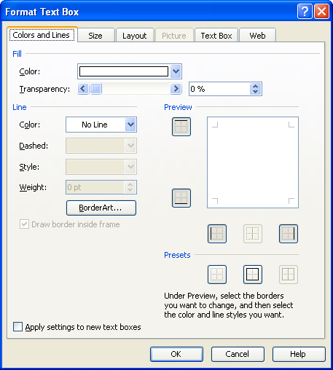
- Click the down arrows to select FILL COLOR, LINE COLOR, LINE STYLE, etc. Set the COLOR TRANSPARENCY by sliding the bar or click the up arrow.
- To adjust the size of the text box, click on the SIZE tab. You may adjust the size either by changing the inches in HEIGHT and WIDTH or by the SCALE options.
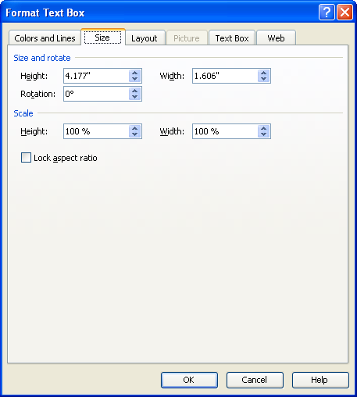

- To have text in a frame flow around other objects in the same space, click on the LAYOUT tab and click a WRAPPING STYLE.

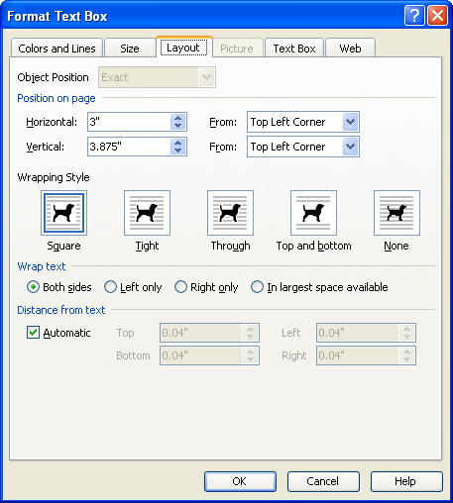
- To change margins within a text frame, click the TEXT BOX tab and increase or decrease the numbers next to each margin by clicking the up or down arrows.

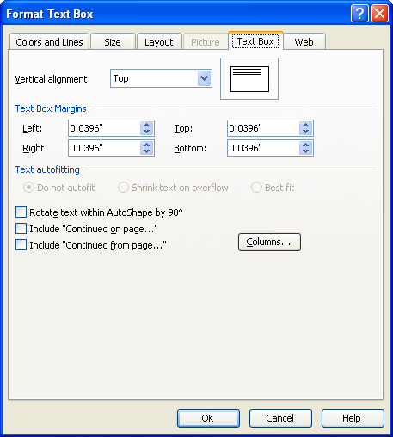

- To add notification that this information continues in another text box, click to select the INCLUDE “CONTINUED ON PAGE…” or INCLUDE “CONTINUED FROM PAGE…” check box.

- If the document you are working on is going to be displayed on the web, you can specify text to appear while the text box is loading. Click the WEB tab and type the text in the ALTERNATIVE TEXT box.
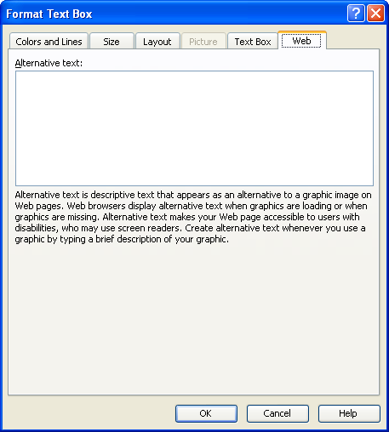
- When all text frame properties are set, click OK.

Lesson Example

The Commissioner has provided you with a Word document to use for his “message”. You need to copy the text into the newsletter and arrange it in the appropriate frames.

STEPS

- On Page 1 of the newsletter type Message from the Commissioner in the SECONDARY STORY HEADLINE text frame.

- Click START, ALL PROGRAMS, MICROSOFT OFFICE WORD 2003.

- Click FILE, OPEN and Navigate to the COMMISSIONER file (your instructor will provide the location) and click OPEN.

- Select all of the text in the document by clicking EDIT, SELECT ALL or press CTRL + A.

- Click the COPY button.

- Click the PUBLISHER button in the Taskbar to return to the newsletter.

- Click the text frame under MESSAGE FROM THE COMMISSIONER.
- Click the PASTE button.

- Click YES two times in the resulting dialog boxes.

- On Page 1, click the right-hand text frame of the Commissioner’s message.

- Click FORMAT, TEXT BOX…, and click the TEXT BOX tab.

- Place a check in the Include CONTINUED ON PAGE option and click OK.

- Click the BREAK FORWARD LINK button in the Connect Text Boxes toolbar to disconnect this frame from page 2.

EXERCISE:

1) Click the CREATE TEXT BOX LINK button and go to page 4.

2) Click in the text frame under Back Page Story Headline to Continue the Commissioner’s message.

3) If necessary, click in the left column.

4) Add a Continued From notice.

5) Change the headline to Message from the Commissioner.

6) On Your Own: Insert the text from the Word file Challenge.doc (your instructor will provide the location) into the text frame under Back Page Story Headline on Page 3.

7) Change the headline to Brain Teaser and save your changes.

Hyphenation

overview

Having hyphenation in a publication is acceptable, but having too much is distracting and makes the information difficult to read. Publisher automatically hyphenates your publication with no set limit on the number used. The steps below show you how to set a hyphenation zone to reduce the number of hyphens or to turn it off completely.

steps

- Click in the text frame to be affected.

- Click TOOLS, LANGUAGE, HYPHENATION.

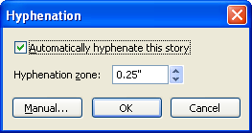
Helpful Hint:

To turn off hyphenation in the entire publication, go to TOOLS, OPTIONS, and EDIT. Remove the checkmark from the Hyphenation section. Click OK.

- Use the up and down arrows to increase or decrease the HYPHENATION ZONE (the area beyond which words will be hyphenated). Or, click to remove the checkmark in AUTOMATICALLY HYPHENATE THIS STORY.

- To go through each word that Publisher might hyphenate and indicate if you wish to or not, click the MANUAL button, and click the YES or NO button as desired.

- Click OK.

Drop Caps

overview

If you want to add an interesting element to your text frame, a Drop Cap turns the first letter in a paragraph into a graphic of the letter.

steps

- Click in the text frame to be affected. Be sure your insertion point is in the desired paragraph in that frame.

- Click FORMAT, DROP CAP.

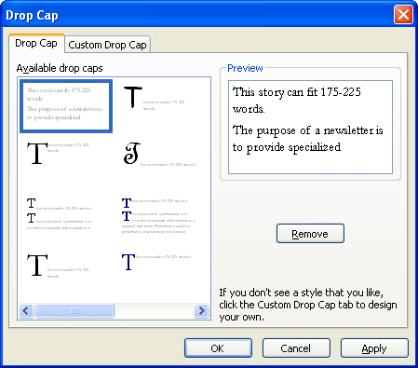

- Click to select an AVAILABLE DROP CAP, and click OK.

- To set a custom drop cap, click FORMAT, DROP CAP, CUSTOM DROP CAP.

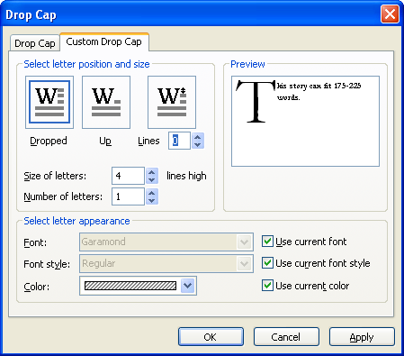

- Select the desired POSITION, SIZE, and APPEARANCE options. Click OK.

- To edit an existing drop cap, click FORMAT, CHANGE DROP CAP.

Lesson Example

You think that there is too much hyphenation in the Message from the Commissioner, and you’d like to try adding a Drop Cap to the first paragraph of this story.

STEPS

- On Page 1, click in the first paragraph of the Message from the Commissioner story.

- Click TOOLS, LANGUAGE, HYPENATION.

- Leave the checkmark in AUTOMATICALLY HYPHENATE THIS STORY, and change the HYPHENATION ZONE to 0.6”.

- Click OK.

- Click FORMAT, DROP CAP.

- Click the CUSTOM DROP CAP tab.

- Click the down arrow next to SIZE OF LETTERS to make them 3 lines high.

- Remove the checkmark from use current font style.

- Click the drop-down arrow next to FONT STYLE and select ITALIC.

- Remove the checkmark from use current color.

- Click the drop-down arrow next to COLOR and select a color from the palette of SCHEME COLORS. Click OK.

- Save your changes.

EXERCISE:

1) Click in the first paragraph of the Department Update story. Remove all hyphenation by removing the check from automatically hyphenate this story.

2) Add a Drop Cap to the first paragraph from the available drop caps.

3) On Your Own: Add Drop Caps to the rest of the publication.

4) Save your changes.

NON-TEXT OBJECTS

OBJECTIVES: Draw shapes.
Search for and insert Clip Art.
Insert and manipulate WordArt.

Drawing Objects

Overview

You may want to insert additional graphic objects into your publication. One way to do so is by drawing them with the help of the shape tools in the Objects toolbar.

STEPs

- To add a Line, Oval, or Rectangle, click once on the LINE TOOL , OVAL TOOL , or RECTANGLE TOOL in the Objects toolbar.

- Move to the location in your publication where you would like to place the shape, and click and drag.

- To make a straight line, perfect circle, or perfect square, press the SHIFT key while clicking and dragging the shape onto the page.

- To draw a Custom Shape, click the AUTO SHAPES button in the Objects toolbar.

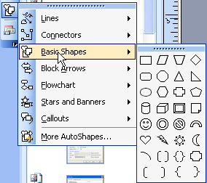

- Click the desired shape. Move your mouse to the location where you would like the shape in the publication, and click and drag.
- To format the border or background of a shape, see Formatting Object Borders and Formatting an Object’s Fill in LESSON 5: Formatting Objects.
Did You Know?

If your Clip Art picture loses its color, click FORMAT on the Menu Bar. Select PICTURE. Click the PICTURE tab. Click the RECOLOR BUTTON and click the ORIGINAL COLORS button. Click OK.

Clip Art

Overview

If you wish to change or insert additional graphics into your publication, Microsoft Publisher provides access to the Clip Art Gallery.

STEPs

- To change existing Clip Art, double-click the graphic.

- To insert new Clip Art, click the PICTURE FRAME button in the Objects toolbar and click CLIPART.

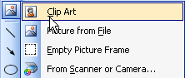
Did You Know?

After clicking the CLIP ART button, you may click and drag on the page to make a rectangle the size you would like the clip to be.

- The CLIP ART task pane will appear.
Did You Know?

All Clip Art and Pictures are now embedded in your publication. You no longer need to make sure that all images are saved in the save location.

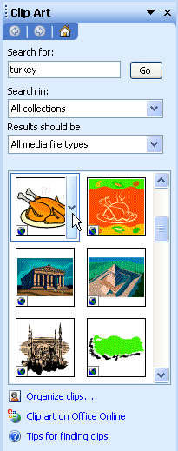
Search for:
Go

- Type a keyword or words in SEARCH FOR and click the GO button or press the ENTER key.

- Scroll through the selection of clips and click the picture you want to insert.
- To resize clip art, click to select the picture, then click and drag a resizing handle with the double-sided arrow mouse pointer .


Resizing Handle
Helpful Hint:

To resize clip art proportionately, choose a corner handle.

- To move clip art, click to select the picture, then click and drag from the middle of the picture when the mouse changes to a four-headed arrow . Release the mouse button at the new location.

Lesson Example

You would like to add decorative shapes around the title and change the graphic on the front page of the newsletter.

STEPS

  - On page 1, click AUTOSHAPES, STARS AND BANNERS, and click the 5-point STAR shape.

  - Press the SHIFT key and click and drag a small star on the left side of the title text frame.

  - Click the PICTURE FRAME button in the Objects toolbar and click CLIP ART.

  - Type announcement in SEARCH FOR and click the GO button or press the ENTER key.

  - Scroll through the selection of clips and click the picture you want to insert.

  - Resize the clip by clicking to select it, then click and drag a resizing handle with the double-sided arrow mouse pointer.

  - Move the clip to the blank area to the left of the Department Update by clicking and dragging from the middle of the picture when the mouse changes to a four-headed arrow. Release the mouse button at the new location.

EXERCISE:

1) Copy the 5-point star and paste it to the right of the title text frame.

2) Change the graphic on page 1 to another clip of your choice by double clicking it and selecting a new clip. Delete the caption frame.

3) On Your Own: Change the graphics on pages 3 and 4 to the clips of your choice.

4) Delete the remaining captions from the publication and save your changes.

WordArt

overview

Microsoft WordArt allows you to turn text into a picture in Publisher. You can be creative in formatting text into many shapes and styles.

STEPS
Did You Know?

If you select a word or phrase that is already typed before clicking the WORDART button, Word will assume that is the text you want in Word Art. It will allow you to edit this text, and it will not delete the original text from the document.

- Click once on WORDART button on the Objects toolbar.

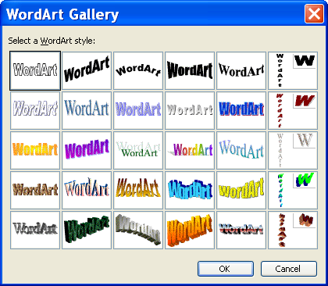

- Select a style. Click OK.

- Type in the word(s) you want to use. Click OK.

- When you select the WordArt object the toolbar will appear. Choose the options you want to use (style, size, position, etc.).

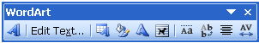

Button | Name | Description
 | Insert WordArt | Makes creative text
 | Edit Text | Edits your text
 | WordArt Gallery | Changes your WordArt style
 | Format WordArt | Changes the format, layout, size, etc. of your text
 | WordArt Shape | Changes the shape of your text
 | Text Wrapping | Adjusts the position of WordArt
 | Same Letter Heights | Makes lowercase and uppercase letters the same height
 | Vertical Text | Rotates text vertically
 | Alignment | Click to justify, left, right, or center text
 | Character Spacing | Adjusts the spacing of the text

- Click outside the object to return to your document.

- To edit the text or formatting, double click the object.

- To resize, click the WordArt, then click and drag on the resizing handles with the double-sided arrow mouse pointer.

- To move WordArt, click to select the picture and click the text wrapping button . Select TIGHT. Click and drag from the middle of the picture when the mouse changes to a four-headed arrow . Release the mouse button at the new location.

Lesson Example

You would like to add WordArt to your newsletter.

STEPS

- On page 4, click the WORDART button on the Objects toolbar and select a style.

- Click OK.

- Type (your department) Newsletter, and click OK.

- Click the Format WordArt button and change the color of your WordArt.

EXERCISE:

1) Change the WordArt text to read (your department) News by double-clicking on the object.

2) Change the shape by clicking on the WordArt shape button.

3) Move the WordArt to the top of the page.

4) On Your Own: Add WordArt at the top of Page 2 that reads What Do You Think?.

5) Format the WordArt shape, style, and colors to your liking.

6) Save your changes.

FORMATTING OBJECTS

OBJECTIVES: Move and resize objects.
Format object borders.
Apply fill effects.
Delete objects.

OVERVIEW

Frames of all kinds, whether they contain text, graphics, or other objects, can be moved, resized, rotated, and the borders and background formatted.

Arranging Objects

OVERVIEW

Certain objects will likely need to be moved as you develop a publication. If any objects end up overlapping, you may also need to alter the way they are layered.

STEPS
Did You Know?

That you can nudge an object by pressing your arrow keys on your keyboard.
- To move an object frame, move the mouse over the edge of the frame until it changes into a four-head arrow .

- Click and drag the frame to its new location.

- To change the layering of overlapping objects, click the object, then click the select arrow on the ORDer button .
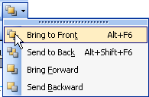

- Click on the appropriate position.

- To make text flow around a graphic object (Clip Art, WordArt, or another Text frame), click the text frame to select it, click FORMAT, TEXT BOX, and click the layout tab.

- Click on the appropriate Wrapping Style and click ok.

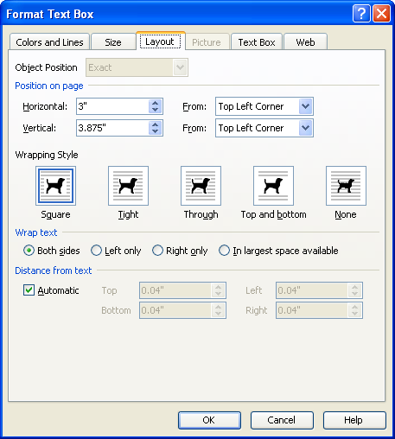
Wrapping Styles

Resizing Frames

OVERVIEW

You may need to make your object larger or smaller in order to place it in your publication.
Helpful Hint:

Holding the Shift Key down while you do a corner resize will keep the sides of the frame proportional.

STEPS

- Click once within the frame to be resized.

- Point to one of the resizing handles at each corner or side of the frame’s border. The mouse will change into a doubled-headed arrow .
- Click and drag to the size you want.

Rotating a Frame

OVERVIEW

Rotating a frame is a simple way to add some character to your publication. It places the object, be it graphics or text, at an angle on your page.

STEPS

- Select the frame to rotate.

- To use free rotate, place your mouse pointer over the green rotate button and click and drag until it is in the desired position.
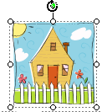
Rotate

- To flip or rotate the object by 90○, click the select arrow on the ROTATE button on the standard toolbar.

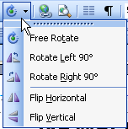
- To rotate left or right by 90○, click the rotate left 90○ or rotate right 90○ button.

- To flip horizontally or vertically, click the flip horizontal or flip vertical button.

Lesson Example

You would like the “What Do You Think?” WordArt to run up and down the left side of Page 2 rather than across the top.

STEPS

- On page 2, click the WordArt to select its frame.

- Click the FREE ROTATE select button and choose ROTATE LEFT 90 .

- Move the WordArt until it is along the left edge of page 2.

- Move your mouse pointer to the middle of the bottom border until it becomes a RESIZE pointer, and click and drag down until the frame is the entire length of the page.

EXERCISE:

1) On Page 3 of the newsletter, move the headline to the top of the page. Move the text frames holding the story below beneath the headline.

2) Enlarge the clip art frame in the bottom right corner.

3) Horizontally flip this clip art.

4) On Your Own: On Page 4 of the newsletter, adjust the WordArt frame .

5) Save your changes.

Formatting Objects
STEPS

- To change the color, click on the arrow to the right of the Fill Color button and then More Fill Colors.
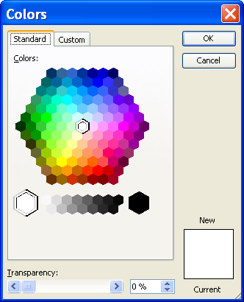
- Click the STANDARD tab to select from the color palette.
- In the Standard color palette, click the color you want, and then click OK.
- To change the fill effects, click on the arrow to the right of the Fill Color button and then Fill effects.
- To apply a gradient effect, click on the GRADIENT tab.
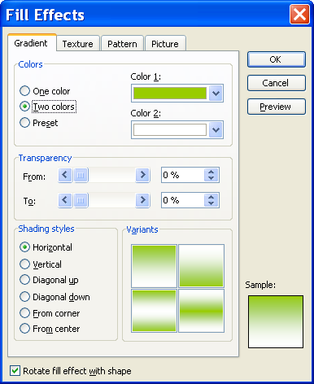
Gradient
- Choose ONE COLOR, TWO COLORS, or PRESET.

- Make your color choices by clicking on the COLOR 1, COLOR 2, or PRESET COLORS drop-down boxes.

- You may set a TRANSPARENCY level by either sliding the bar or changing the % up and down arrows.

- In the SHADING STYLES section, choose a style.

- To apply a texture effect, click the TEXTURE tab.

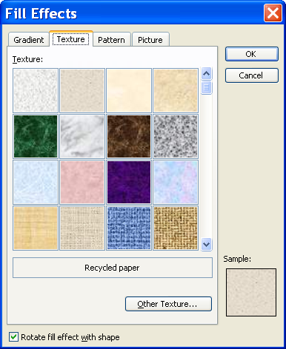
Texture
- Select the texture of your choice.
- To apply a pattern to a background, click the Pattern tab.
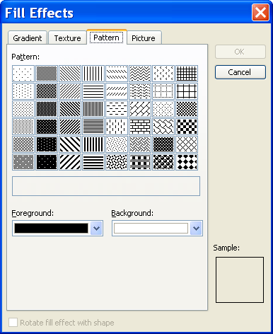
Pattern
- Select the Foreground and Background colors and the Pattern desired
- To add a picture to an item, click the Picture tab.
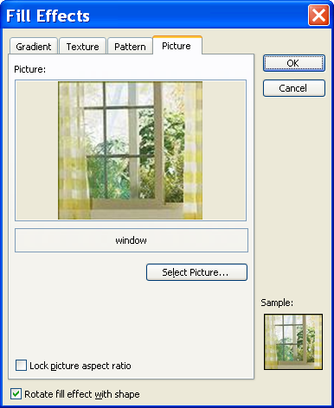
Picture
- Click Select Picture, and browse to find the picture.
- After selecting the picture file, click Insert and click OK.
- To change the line color, click the arrow to the right of the LINE COLOR button and then MORE LINE COLORS.
- Click the STANDARD tab to select from the color palette.
- In the STANDARD color palette, click the color you want, and then click OK.
- To change the color of text, select the text.
- Click the arrow to the right of the FONT COLOR button .
- Click on the color of your choice.
- To change a line, click the LINE STYLE , DASH STYLE , or ARROW STYLE button .
- To add artwork to a border, click the LINE STYLE button , then MORE LINES.
Helpful Hint:

You cannot add BorderArt to drawn objects.

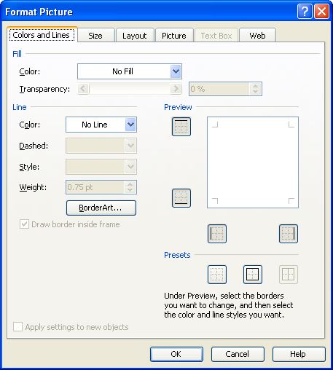
Helpful Hint:

To create Border Art from a Clip Art graphic, click on CREATE CUSTOM, and then CHOOSE PICTURE. Choose the desired clip from the gallery and click INSERT CLIP ART.

- Click the BORDERART button .

- Scroll through the AVAILABLE BORDERS, and click to select one. Click OK.

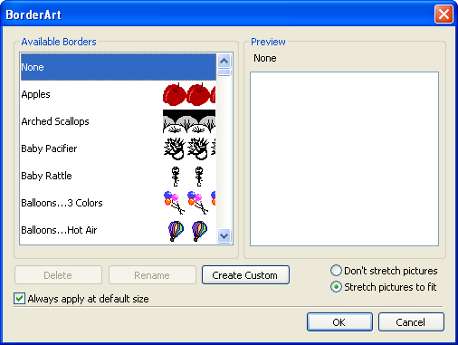
- To add a shadow, click the SHADOW STYLE button .
- Click on the style of your choice.
- To add a 3-D style, click the 3-D STYLE button and click on the style of your choice.

Lesson Example

Now that you have the WordArt frame exactly where you want it on Page 4, you want to format its border and fill.

STEPS

- On page 4, click to select the WordArt frame.

- Click the LINE/BORDER STYLE button, and then click MORE LINES.

- In the LINE section, click the drop-down arrow for COLOR and click one of the SCHEME COLORS, then click 2 PT for the thickness. Click OK.

EXERCISE

1) On Page 2, click in the center of the page to select the empty text frame.

2) Click the LINE/BORDER STYLE button, and then click MORE LINES.

3) Click the Border Art button and select a border. Click OK two times.

4) On Your Own: On Page 1, change the fills of the stars around the title to the same color as the title text.

5) Change their black borders to the same color.

6) Save your changes.

Aligning Objects

overview

It can be difficult to move objects so they line up perfectly with one another or with the page itself. Publisher provides you with a tool to make this simpler.

STEPS

- Click the object to align. If aligning several objects, hold the SHIFT or CTRL key and click each additional object.

- On the Menu bar, click ARRANGE, ALIGN OR DISTRIBUTE and the appropriate alignment.

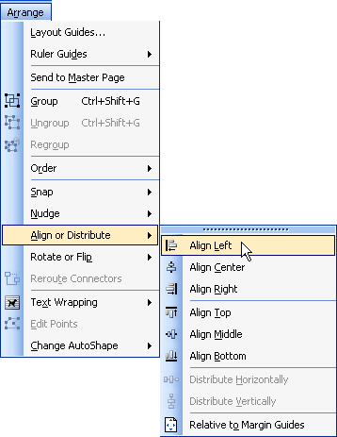

- To line up objects vertically, click either ALIGN LEFT, ALIGN CENTER or ALIGN RIGHT.

- To line up objects horizontally, click either align top, align middle, or align bottom.

Grouping and Ungrouping Objects

OVERVIEW
Helpful Hint:

Another way to select more than one object is to click and drag to encompass the objects.

Once your objects are arranged correctly in your publication, you may want to group several of them as one object. As a single object, you are able to move the entire group and keep the spacing consistent, or resize all objects within the group to the same degree.

STEPS

- Move the mouse to the first object you wish to group and click.

- Hold down the CTRL or SHIFT key, and click on all other objects to be included.

- Click the GROUP OBJECTS button . You may move and resize as usual.

- To ungroup objects, click on the group you wish to separate.

- Click the UNGROUP OBJECTS button .

Lesson Example

You want your graphic to line up with your text, and you want to be sure headlines stay with their corresponding stories and graphics.

STEPS

- On Page 1, click to select the star on the left.

- Hold down the shift or the CTRL key and click the newsletter title and the star on the right.

- Click ARRANGE, ALIGN OR DISTRIBUTE, ALIGN MIDDLE.

- Click the GROUP OBJECTS button.
- Move your mouse pointer to any edge and move this group as close to the center as possible.

EXERCISE:

1) Align the graphic near the Message from the Commissioner story with the story’s headline.

2) Group the Department Update headline, story text frames, and graphic.

3) On Your Own: On Page 3, group the headline and two story text frames.

4) Align the graphic and the group above on their center.

5) Move the group to the left margin of the page.

6) Save your changes.

COMPLETING A PUBLICATION

OBJECTIVES: Add a reply form.
Use the Design Checker.
Perform a Mail Merge.

Design Gallery Objects

OVerview

If you would like readers of your publication to respond in some way, you may add a Reply Form to your publication. In the Design Gallery, Publisher has reply forms pre-formatted and ready to insert.

steps

- Click INSERT, DESIGN GALLERY OBJECT.

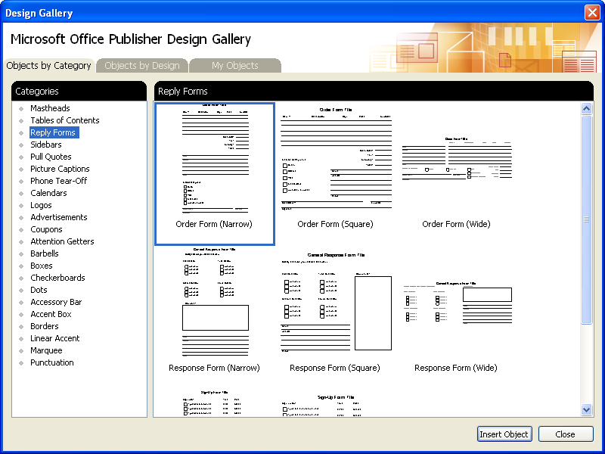

- On the OBJECTS BY CATEGORY tab, click once on REPLY FORMS.

- Click the style of reply form to insert.

- Click on the INSERT OBJECT button .

- Once the object has been inserted, it can be formatted like any of the other objects placed in your publication.

Headers and Footers

OVERVIEW

A header is text such as the title of the publication, a page number, etc. that appears at the top of each page of the publication. A footer is similar to a header except it appears at the bottom of the page.
Helpful Hint:

To edit an existing header or footer, double click the header or footer sections at the top or bottom of the page.

STEPS

- Click VIEW, HEADER AND FOOTER. This will take you into your header. Type the text to be added to the header (change the font and alignment if necessary).

- To create a footer, click the SHOW HEADER/FOOTER button on the Header/Footer toolbar. Type your footer.

- To add a page number to the header or footer, click the INSERT PAGE NUMBER button on the Header and Footer toolbar.

- Click CLOSE on the Header and Footer toolbar to close the header and/or footer.

Design Checker

overview

Sometimes when you resize text frames, add a continued notice, or copy information into text frames, text may seem to disappear. Publisher will let you know that there is missing text with the Text in Overflow icon . A quick and easy way to check and see if there is any text in overflow, as well as other design issues, is to use the Design Checker.
Helpful Hint:

Clicking DESIGN CHECKER OPTIONS allows you to set what problems the Design Checker will look for.

STEPS

- Click TOOLS, DESIGN CHECKER.

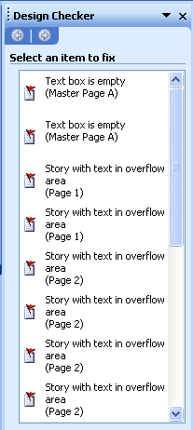

- Place your mouse over the problem and click the drop-down arrow.

- To see the problem, click go to this item.

- To fix the problem, click fix:.

- To view Microsoft Help for the problem, click EXPLAIN.

- To bypass the problem, click NEVER RUN THIS CHECK AGAIN.

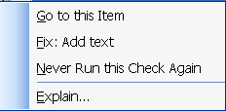

Lesson Example

You want to add a reply form to your newsletter.

STEPS

- On Page 2, click INSERT, DESIGN GALLERY OBJECT.

- On the OBJECTS BY CATEGORY tab, click REPLY FORMS.

- Select RESPONSE FORM (NARROW), and click the INSERT OBJECT button.
- Move and resize the form appropriately.

- Click Tools, Design Checker and make corrections as you see fit.
- For Text in Overflow problems, either resize the text or resize the text box as you see fit.

EXERCISE:

1) Click VIEW, HEADER AND FOOTER.

2) Click the SHOW HEADER/FOOTER button to go to the footer.

3) Click the insert page number button to insert a page number

4) Center the page number and click the Close button.

5) On Your Own: Move the clipart on Page 3 to the top of the page.

6) Add a Phone Tear-Off form from the Design Gallery to the bottom of the page.

7) Elongate this form left to right.

8) On the first tear-off, type your name and phone number. Click anywhere outside of the tear-off section.

9) Save your changes.

GIVE IT A TRY!

OBJECTIVE: Practice the Publisher lessons learned in class.

EXERCISE:

Refer to Lesson 1 for assistance

1) Create a flyer for your company using the Publications For Print and the Radial design.

2) Keep the placeholder for the graphic.
3) Do not add a customer address.
4) Add no tear-offs.
5) Choose any color scheme and font scheme that you like.
Refer to Lesson 2 for assistance

6) Save the publication as My Flyer in the C:\My Documents folder.
7) Insert a new page after the first page that duplicates all objects on the first page.
8) Print the first page of the publication.
9) Delete the second page of the publication.
10) Save your changes.
Refer to Lesson 3 for assistance
11) Replace the text in the Product/Service Information text frame with (your Department) Information.
12) Change the text in this frame to the font, size, and color of your choice.

13) Delete the text frame containing the “Your business tag line here”.
14) Reduce the size of the picture and make the text frame larger.
15) Insert the text from the Challenge Word file into the text frame near the picture.
16) Change this font as you like, increasing the text frame as necessary.
17) Turn off the hyphenation in this text frame.
18) Apply a drop cap to the first paragraph in this text frame.
19) Save your changes.
Refer to Lesson 4 for assistance
20) Draw a 4 pt horizontal line above the (your department) Information text that spans the entire text frame.
21) Copy this line and paste it below this text.
22) Change the width of the lower line to 2 pt.
23) Replace the picture with one of your choosing
24) Add WordArt in the blank area along the lower right side of the flyer that says Attention!.
25) Have the WordArt read from top to bottom, and change its color to something that complements the color scheme.
Refer to Lesson 5 for assistance
26) Delete the Logo on the left side of the page.
27) Group the separate frames in the bottom right corner together and move them to the upper right corner of the flyer.
28) Run the Design Checker on your flyer, making the appropriate changes along the way.
29) Save your changes.

DELETING

OBJECTIVE: Maintain organized file directories.

STEPS

1. If necessary, close the open publication.

2. Click FILE, OPEN.

3. Click once on the name of the file to be deleted. Or, use the CTRL or SHIFT keys to select multiple files.

- Press the DELETE key on your keyboard.

- Click YES to confirm the deletion.

6. Click the CANCEL button to close the dialog box.

Lesson Example

The newsletter has gone to the printer and a revision was made there. You want to delete the version without the change.

STEPS

1. Close all open publications.

2. Click FILE, OPEN.

3. Click once on MY NEWSLETTER.

4. Press the DELETE key on your keyboard.

5. Click YES to confirm the deletion.

6. Click the CANCEL button to close the dialog box.

EXERCISE:

1) Delete My Flyer and New Newsletter from C:\My Documents.

2) Close the Open dialog box.

3) On Your Own: Close Microsoft Publisher

4) Shut down your computer.

NICE TO KNOW

Mail Merge

overview

A mail merge can be done in Publisher to generate labels, certificates, or any other item that will go to numerous people or places. You may begin with an existing list of names and addresses or create one right in Publisher.

- Click tools, mail and catalog merge, mail and catalog merge wizard.
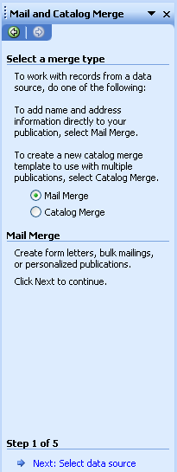
- With Mail Merge selected click the next: select data source link at the bottom of the Task Pane.
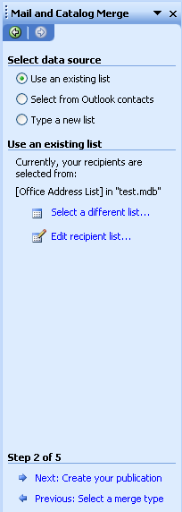
- If you have already created a data source, select USE AN EXISTING LIST. Click the BROWSE link, and locate your data source.
- If you are creating a data source, select TYPE A NEW LIST and click the CREATE link.
- The New Address List window appears.
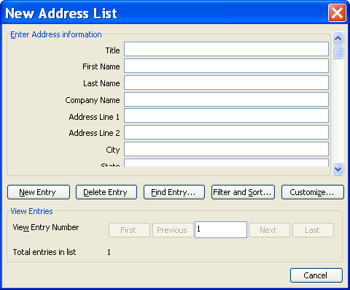

- Enter the first person in the New Address List window.
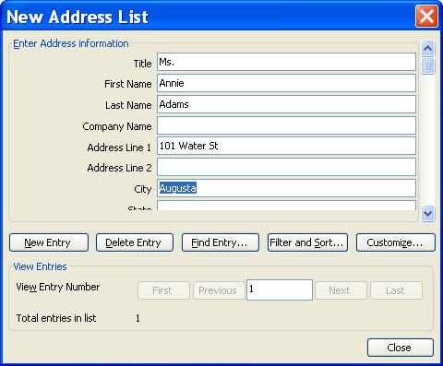
- To enter another person, click the NEW ENTRY button .
- When your list is complete, click the CLOSE button .
- You will be directed to save the address list.
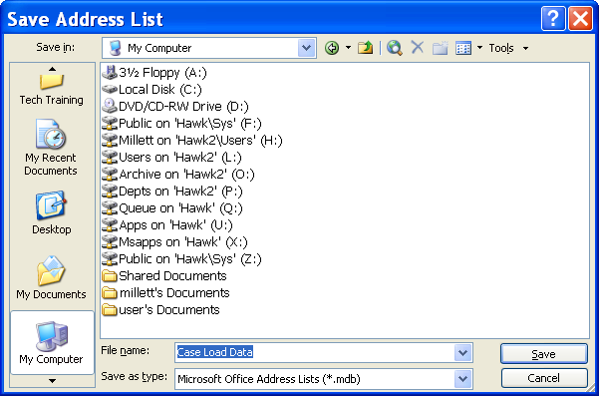
Save in
File Name
Save
- Select the drive to SAVE IN, enter a FILE NAME, and click SAVE.
- The Mail Merge Recipients window appears.
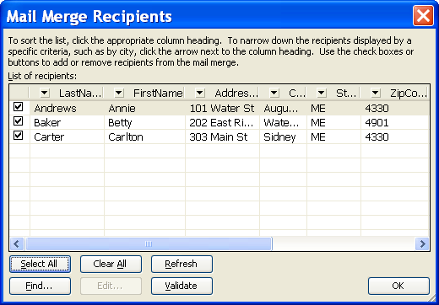
- Click OK.
- Click the next: create your publication link at the bottom of the task pane.
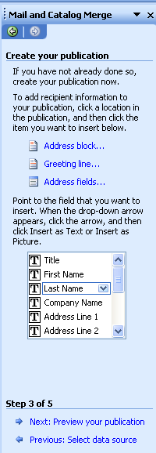
Address Block
Fields
- To insert a person’s name and address, click the ADDRESS BLOCK link.
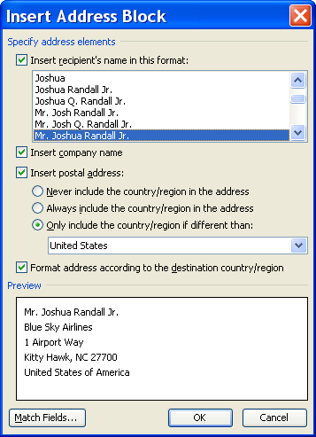
- Select the appropriate choices from the INSERT ADDRESS BLOCK window and click OK.
- To insert other recipient information, click on the individual field.
- Type any spaces, punctuation, and returns necessary to lay out your fields correctly. For example, type a comma and a space between the field codes for city and state.

- To preview your publication, click the Next: preview your publication link at the bottom of the task pane.
Helpful Hint:

If you need to edit your data source, click the Previous: link to return to Step 2 and then click the edit recipient link, then click the Edit button.
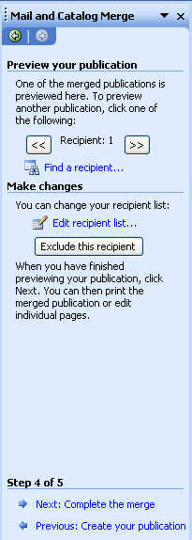
Helpful Hint:

To exclude a recipient, click the Exclude this recipient button.

- To complete the merge, click the Next: complete the merge link at the bottom of the task pane.

- To print the publication, click PRINT.
- To merge to a new document, click CREATE NEW PUBLICATION.
- To add the merged pages at the end of a different publication, click add to existing publication
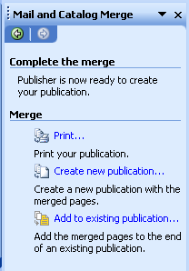

Information for the Printing Service
  - Is there going to be color involved in the publication?
  - How many colors?
  - How many pages?
  - How many copies are needed?
  - What type of paper will the publication be printed on?
  - What is the weight?
  - What is the color?
  - What is the finish?
  - When will the publication arrive at the printer?
  - When is the publication needed?
  - What type of software is being used?
  - Is your software compatible?

Font Guidelines
  - Serif fonts (those with “feet”, i.e. Times New Roman) are good for body text.

  - Sans serif fonts (without “feet”, i.e. Arial) are better for headlines, headings, subheadings, and captions.

  - Limit the number of different typefaces used in a single publication to no more than three or four.

  - Color: Keep the psychological impact of colors in mind when planning your publication. For example, red and yellow are strong colors that attract attention; blue is rarely used in association with food. Research shows that people prefer white, gray, or beige as page backgrounds.

  - Use one family of font throughout your publication except for headings to make the publication cohesive. You can change the size, weight, bold, and italics to change the look.

  - Headlines should be between 18 and 36 point.

  - Set headlines in upper and lower case, not all caps. All caps slow the reading speed down. Title case is easier to read, because the eye identifies words by their upper outline; readers must comprehend them letter-by-letter instead of at a glance. Headlines with a beginning capital for each word signal people to read each word separately, not the whole line as one message.

Proofreading Tips
  - Use the spell checker and grammar checker as a first screening, but do not depend on them.

  - Read it out loud and also silently.

  - Read it backwards to focus on the spelling of words.

  - Have others read it.

  - Read it slowly.

  - Use a screen (a blank sheet of paper to cover the material not yet proofed).

  - Point with your finger to read one word at a time.

  - Do not proof for every type of mistake at once—do one proof for spelling, another for missing/additional spaces, consistency of word usage, font sizes, etc.

  - Keep a list of your most common errors (or of the writers you are proofing) and proof for those on separate "trips."

  - Read down columns in a table, even if you are supposed to read across the table to use the information. Columns may be easier to deal with than rows.

  - First, proof the body of the text. Then go back and proof the headings.

  - Double-check fonts that are unusual (italic, bold, or otherwise different).

  - Carefully read type in very tiny font.

  - Be careful that your eyes don't skip from one error to the next obvious error, missing subtle errors in between.

  - Double-check proper names.

  - Double-check little words: "or," "of," "it," and "is" are often interchanged.

  - Double check boilerplate text, like the company letterhead. Just because it is frequently used does not mean it has been carefully checked.

  - Closely review page numbers and other header/footer material for accuracy and correct order.

