Introduction to PowerPoint 2003

Table of Contents
Page
LESSON 1: INTRODUCTION TO POWERPOINT 1
♦ What is PowerPoint? 1
♦ Planning Process 1
♦ Starting PowerPoint 2
♦ Parts of the PowerPoint Window 4
♦ Terminology 4
♦ Slide Views 6
LESSON 2: DEVELOPING A PRESENTATION 9
♦ Creating a New Presentation 9
♦ Adding Slides to a Presentation 12
♦ Saving a Presentation 14
♦ Copying a Presentation 16
♦ Closing a Presentation 16
♦ Opening a Presentation 17
LESSON 3: FORMATTING a PRESENTATION 19
♦ Applying Design Templates 19
♦ Changing the Color Scheme 21
♦ Slide Master 25
♦ Formatting Text on an Individual Slide 29
LESSON 4: SLIDE MANAGEMENT 32
♦ Changing Slide Layouts 32
♦ Changing Slide Sequence 35
♦ Adding Notes 39
♦ Deleting Slides 40
LESSON 5: ADDING OBJECTS 41
♦ Clip Art 41
♦ Drawing Toolbar 46
LESSON 6: TRANSITIONS AND EFFECTS 54
♦ Running a Presentation 54
♦ Transitions 56
♦ Animation Schemes 57
LESSON 7: PRINTING 60
♦ Printing 60
LESSON 8: GIVE IT A TRY! 62
LESSON 9: DELETING FILES 64
NICE TO KNOW 65
♦ PowerPoint Help Features 65
♦ The AutoContent Wizard 66

This workbook may be reproduced in whole or in part by an employee of the Department of Health and Human Services. All other reproduction is prohibited unless written permission is obtained from the Training Institute.

INTRODUCTION TO POWERPOINT

OBJECTIVES: Discuss the use of PowerPoint as a presentation tool.
Identify the parts of the Microsoft PowerPoint window.
Recognize basic PowerPoint terminology.
Create a presentation using the AutoContent Wizard.

What is PowerPoint?

Overview

PowerPoint is a presentation tool that allows you to create a multimedia presentation of material that you want to communicate to others. Typically, PowerPoint presentations are projected onto a screen where the audience is able to view the information. One screen of the presentation is called a slide and a collection of slides is called a presentation.

Planning Process

OVERVIEW

Taking the time to plan your presentation helps you save time as you make decisions regarding the content and layout of your presentation.

STEPS

- Identify the purpose of the presentation.
- Anticipate the needs of your audience.
- Determine how the presentation will be viewed.
- Begin creating the presentation.

Starting PowerPoint

OVERVIEW

When you open PowerPoint, it displays a new, bland presentation, but you also have the option to open an existing presentation.

Blank presentation: You can choose to begin with a blank presentation that contains no text or design. You make all the decisions regarding the format and content.

Open an existing presentation: You can open a previously saved presentation to make changes or run the slide show.

STEPS

- Click START, PROGRAMS, MICROSOFT POWERPOINT. A new presentation opens.
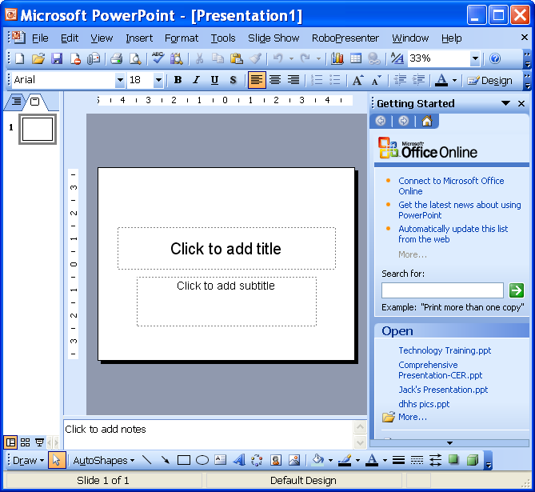
File names
More
- To open an existing presentation, click the name of the presentation or click the MORE… hyperlink .

Lesson Example

You want to open a presentation to become familiar with PowerPoint.

STEPS

- Open PowerPoint by clicking START, PROGRAMS, MICROSOFT POWERPOINT.
- Click the MORE… hyperlink.
- In the Open dialog box, navigate to Anatomy of a PowerPoint Presentation. (Your trainer will provide you with the location.)
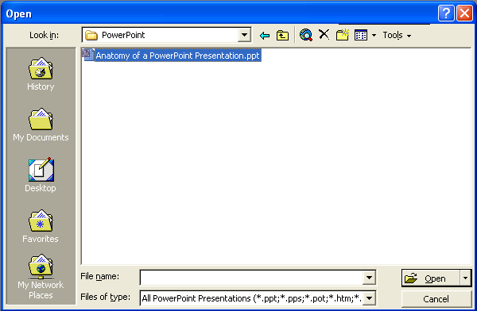
- Click OPEN.

Parts of the PowerPoint Window

OVERVIEW
Maximize/Restore

The PowerPoint window typically shows the following:
Close
Minimize
Title Bar

Menu Bar
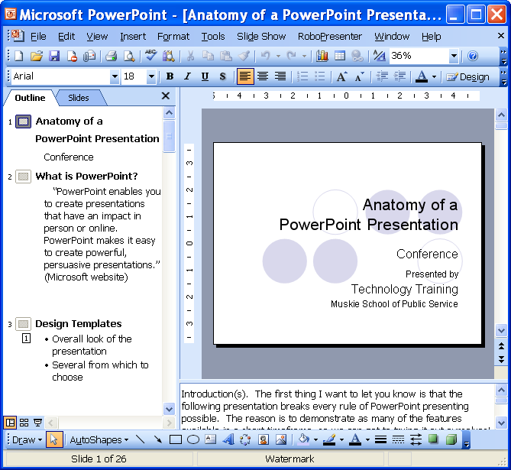
Slide Area
Notes Area
Standard toolbar
Formatting toolbar
Outline View
Slide View
Slide view buttons
Drawing toolbar
Status Bar

Terminology
Title Bar – The bar at the top of the screen; it shows the program name and file name.

Minimize, Maximize/Restore, and Close Buttons – Allows you to manipulate the program and document windows. Minimize collapses the window into the taskbar, Restore shrinks the window slightly, Maximize makes it as large as your screen, and Close exits the document or program.

Menu Bar – A list of options; click once on the menu name, then click on the desired function . When you open a menu, it defaults to list the most common options. If you wait for a few seconds or click on the double-down arrow button, the full menu appears.

Toolbars – Rows of icons representing shortcuts to common features. Click the tool you wish to use.

Standard toolbar – Usually the top toolbar. Use it to open, save, and print a file.

Formatting toolbar – Typically the second toolbar. Use it to change font style, bold, underline, and center text, etc.

Drawing toolbar – Normally appears at the bottom of the window. Use it to include shapes, lines, WordArt, fill color, etc. in a file.

ToolTips – A box that appears with the name of the tool when the mouse pointer pauses on an icon.

Outline Area – Shows only the text that appears on the slides.

Slide Area – Shows what each individual slide in the presentation will look like when viewed.

Notes Area – Allows you to type in speaker notes that go along with a particular slide in a presentation.

Slide View Buttons – Allow you to toggle between different views of your presentation.

Rulers – Allow you to adjust the indents, margins and layout of the slide.

Status Bar – Located at the bottom of the program window. It shows the number of slides in the current presentation.

Scrollbars – Appear in panes, and allow you to see different areas of the pane.

Slide Views

OVERVIEW

PowerPoint creates presentations using “slides”. Slides are the pages that are viewed during the presentation. There are five ways slides can be viewed while working on your presentation. Shortcuts to each view are located in the lower left corner of the screen.

Outline/Normal View: Displays three panes: the outline pane, the slide pane, and the notes pane. These panes let you work on all aspects of your presentation in one place.

Normal view
Outline view

Slides View: Displays the slide pane prominently to see how text and graphics looks on each slide.

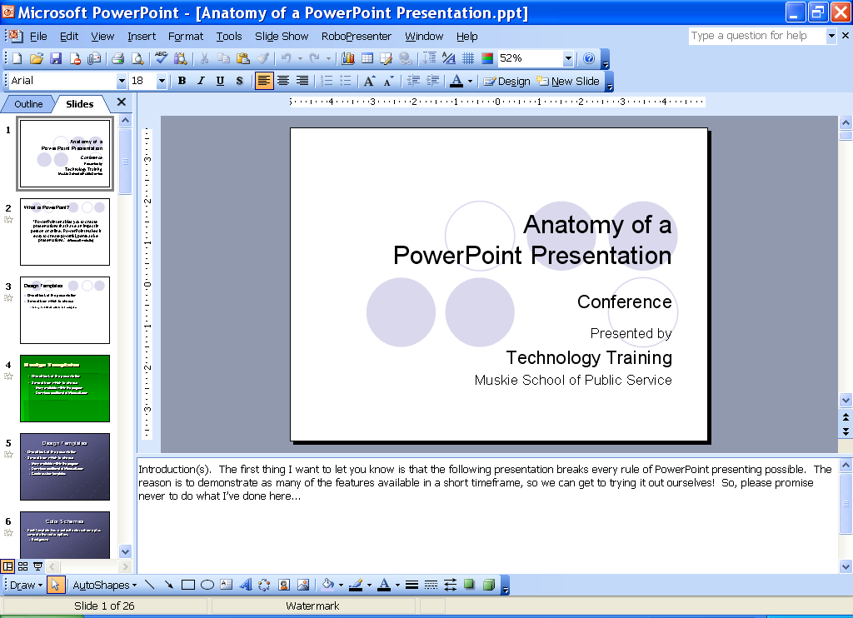
Slides view

Slide Sorter View : Displays miniature versions of the slides in your presentation on the screen at the same time. This is helpful in organizing the order of your slides.

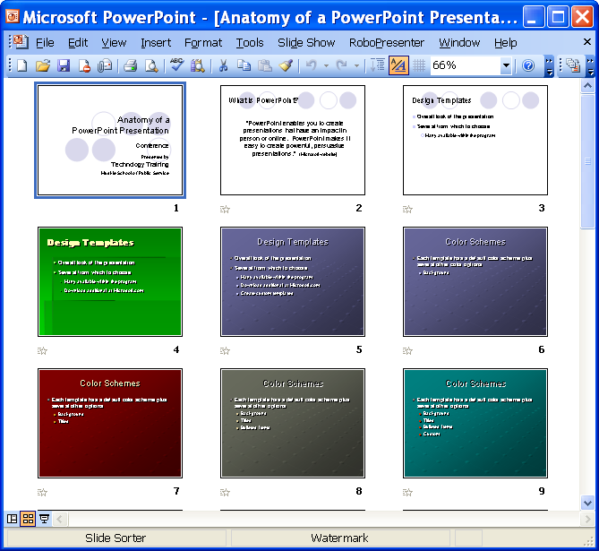
Slide Show View : Runs the presentation from the slide that you are currently viewing. It fills up your entire screen so your audience isn’t distracted by menus, toolbars, outlines, and notes.

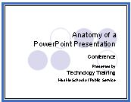

Lesson Example

Now that you have a presentation open, you are ready to become more comfortable navigating in PowerPoint. Slide show view is discussed in a later section.

STEPS

- Click the SLIDE SORTER VIEW button. How many slides are there? ___________
- Look at the presentation in NORMAL view.
EXERCISE:

1) Read the note on the first slide.

2) On Your Own: Toggle between Slides and Outline views.

DEVELOPING A PRESENTATION

OBJECTIVES: Create a blank presentation.
Save, close, and open a presentation.

Creating a New Presentation

OVERVIEW

There are three ways to create a new presentation:

- Blank Presentation
- Design Template
- AutoContent Wizard

The blank presentation option in PowerPoint allows you to create a presentation from a clean slate. It provides you with blank slides, so you can establish the outline, flow, and design of your presentation as well as the formatting.

The design template option allows you to create a presentation in a short amount of time. The formatting decisions have already been made, but may be changed as desired. You may also apply one of PowerPoint’s many design templates to a blank presentation.

The AutoContent Wizard option helps you create a specific type of presentation. For example, an employee orientation or company meeting presentation. Placeholder text is included as a guide.

STEPS
- Click FILE, NEW or click the NEW button .
- To create a blank presentation, select the BLANK PRESENTATION hyperlink.
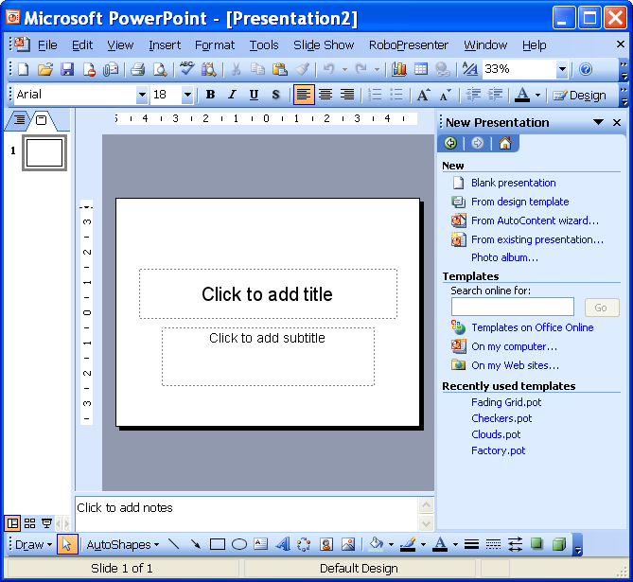
Blank presentation
Helpful Hint:

It is best to always choose an AutoLayout because it can save time if you want to make a global change (for a font, for instance). When all slides have been created using an AutoLayout, certain changes adjust on all slides accordingly.
- Click the slide layout of your choice from the TEXT LAYOUT section. These layouts determine where the text boxes, Clip Art frames, charts, tables, etc. appear on the slide.
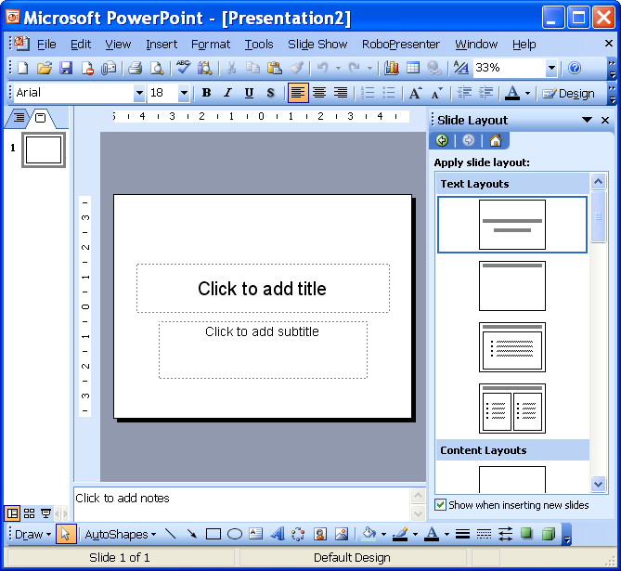
Text Layouts
- To add information to a text box, click in the box and type.
- To insert a graphic object in a placeholder, double click as directed and make the necessary selections.
- To create a presentation from a design template, click the FROM DESIGN TEMPLATE hyperlink.
From design template
- Select the design template of your choice.
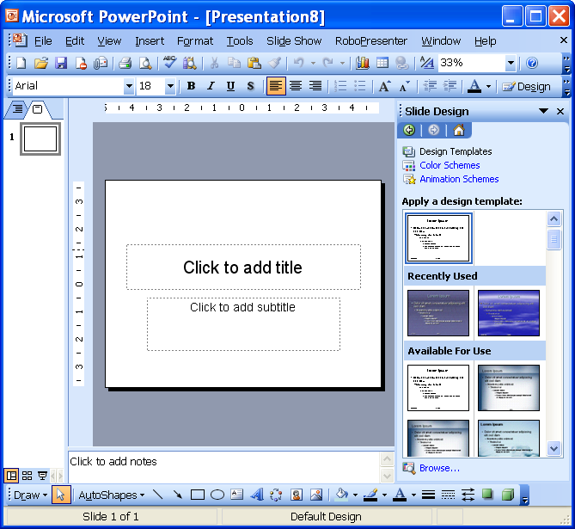
- To create a presentation using the AutoContent wizard, click the From AutoContent wizard hyperlink.
From AutoContent wizard…
- Use the wizard to go through the five steps to complete the presentation.

Adding Slides to a Presentation

overview

Most presentations require more than one slide, so you have to add additional slides.

STEPS

- Click the slide preceding the location of the new slide.
- Click the NEW SLIDE button on the Formatting toolbar.
- Select a layout in the APPLY SLIDE LAYOUT section.
Apply slide layout
Placeholder
Did You Know?
More than seven consecutive words forces many of the audience members to re-read, because it is too much to process the first time through.
- On the slide, click in the placeholders as directed to add information.
- To add items to a bulleted list, select the appropriate slide layout. Click in the placeholder and type in bulleted information. Press the Enter key after each entry except the last one.
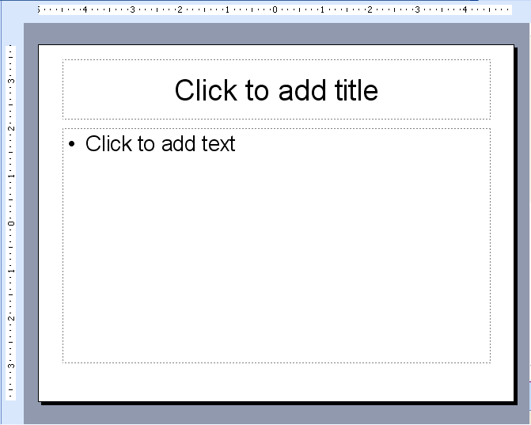
Placeholder
Helpful Hint:

When you are using a bulleted list slide, if you accidentally press Enter at the end, press the backspace key at the end and the empty bullet disappears.

Saving a Presentation

OVERVIEW

It is important to remember that when working with any type of file it is essential to save often. It is a good habit to save after multiple changes. If the computer is turned off or the electricity fails, any unsaved changes are lost.

STEPS

- Click the SAVE button on the Standard toolbar.
Save in
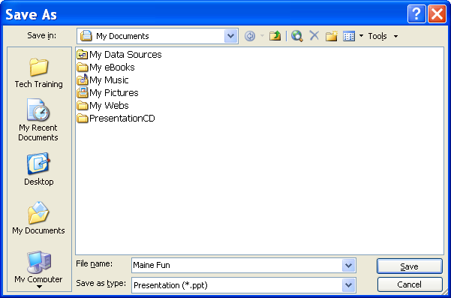
File name
Save
Did You Know?
You can save your file to automatically run when opened (a presentation shortcut) by changing the Save As
Type to PowerPoint Show. The file extension is .pps.
- Place the file in the appropriate drive and folder by using the drop-down beside SAVE IN.
- In the FILE NAME box, type a name.
- Click SAVE or press ENTER on your keyboard.

Lesson Example

You have been asked to give a presentation on Maine Fun.

STEPS

- Click the NEW button. The Title Slide automatically appears.
- Click in the title area of the slide, and type Maine Fun.
- Click in the Subtitle area and type Presented by (your name).
- Click the NEW SLIDE button and select the Title and Text Slide
- Click in the title area and type Seasons of Fun.
- Click in the Bullet area and type in the four seasons (Winter, Spring, Summer, Fall).
- Click the SAVE button.
- Name the presentation Maine Fun and save in C:\My Documents.
- Click SAVE.
EXERCISE:

1) Click the NEW SLIDE BUTTON and add a Title and Text Slide.

2) Type Winter Fun as the title and add a list of things you do for fun in the winter.

3) On Your Own: Add a Title and Text Slide at the end of the presentation with the title of Spring Fun. Include a list of things you do for fun.

4) Save the presentation.

Copying a Presentation

OVERVIEW

There are times when you want to adapt a presentation you have already created for a new presentation, but want to keep your original copy. The Save As function allows you to make a copy of the file by changing the name and/or the location.
Helpful Hint:

The F12 key is the keyboard shortcut for Save As.

STEPS

- Click FILE, SAVE AS.
- Type a new filename and/or change the location.
- Click SAVE.

Closing a Presentation

overview

When you are done working on a presentation, you can close it without having to exit PowerPoint.

STEPS

- Click the CLOSE button located at the top right-hand corner of the presentation window, beneath the program close button, or click FILE, CLOSE.
- You may be prompted to save your presentation. Click YES if appropriate.

Opening a Presentation

overview
Did You Know?

By default, the last four files opened in PowerPoint appear at the bottom of the File menu. You may simply click the name of the file to open it.
If you want to open up a presentation in PowerPoint, you can do so without having to exit and reopen the application.

STEPS

- Click the OPEN button located on the Standard toolbar, or click the FILE menu and OPEN.
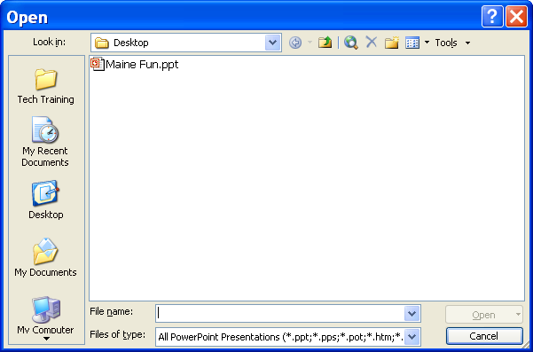
- Locate the file and click on the file name.
- Click OPEN.

Lesson Example

Your supervisor would like to see a copy of your presentation before you get too far into it. You decide to save a copy to the network drive where it can be reviewed.

STEPS

  - Click FILE, SAVE AS.

  - Change the SAVE IN location by clicking on the drop-down arrow to the location provided by your instructor.

  - In the FILE NAME field, type (Your Name) Maine Fun.

  - Click SAVE.

EXERCISE:

  - Close all open presentations without saving them.

  - Open the (Your Name) Maine Fun presentation.

3) Click on the last slide of the presentation.

4) On Your Own: Add a Title and Text slide at the end of the presentation with the title of Summer Fun. Include a list of things you do for fun.

5) Save the presentation.

FORMATTING a PRESENTATION

OBJECTIVES: Apply templates.
Change slide color schemes.
Utilize the Slide Master.
Format text.

Applying Design Templates

OVERVIEW

PowerPoint has several pre-defined backgrounds and styles already created for use. Microsoft refers to these as Templates.

STEPS

- Click the SLIDE DESIGN button on the formatting toolbar.
- Select a DESIGN TEMPLATE from the list.
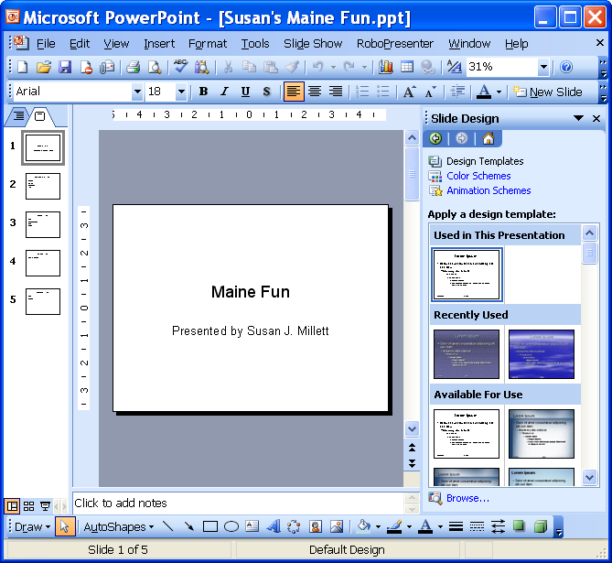
Design Templates

Lesson Example

It is now time to add a template to the slides.

STEPS

- Apply a template by clicking the DESIGN button.
- Select the fireworks design.
- Save the presentation.
EXERCISE:

- Select the template of your choice for the presentation.
- On Your Own: Change the template to Axis.

- Save the presentation.

Changing the Color Scheme
Color schemes are sets of eight coordinated colors you can use in your presentation. Each design template comes with a set of color schemes. You might change the color scheme because you like a Design Template, but wish it could be another color. Another reason would be because you might want to highlight portions of your presentation or a single slide.

STEPS

- Click the SLIDE DESIGN button on the formatting toolbar..

- Click COLOR SCHEMES hyperlink.

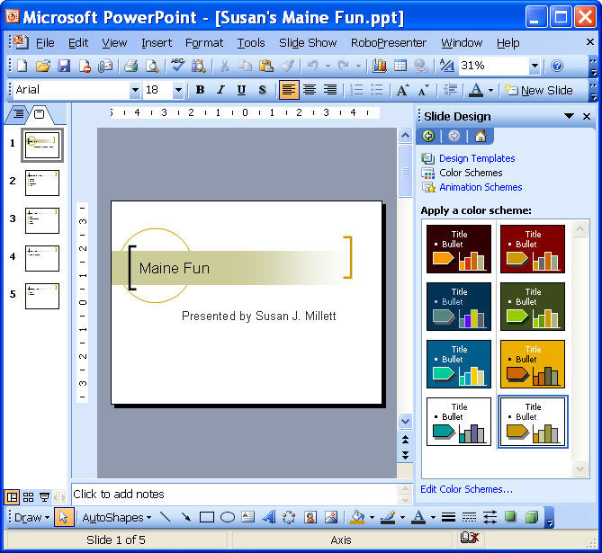
Color Schemes
Helpful Hint:

Depending on which Design Template you select, there are different color schemes available.

- Select a COLOR SCHEME.
- To apply the new color to only the current slide, right click on the COLOR SCHEME, and click APPLY TO SELECTED SLIDES.
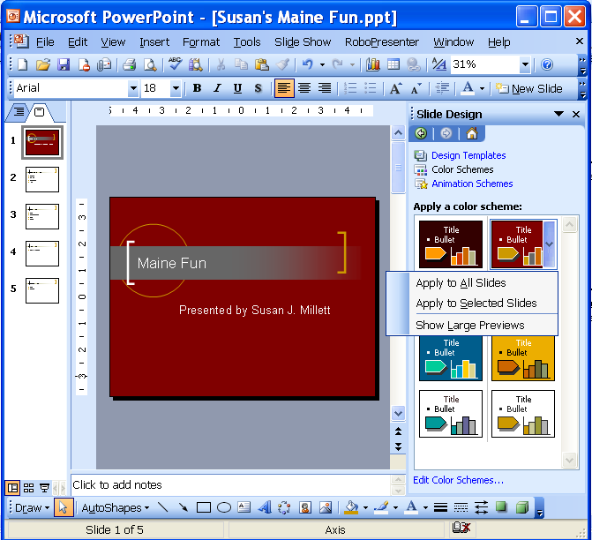
Apply to Selected Slides
Apply to All Slides
Edit Color Schemes
- To apply it to all slides in the presentation, right click on the COLOR SCHEME, and click APPLY TO ALL SLIDES.
- To create a custom scheme, click the EDIT COLOR SCHEMES hyperlink.
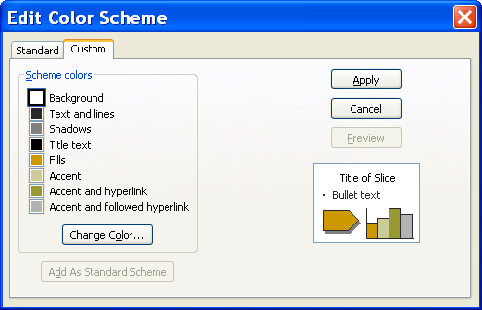
Change Color
- Under EDIT COLOR SCHEME, click the color of the feature you want to change, and then click the CHANGE COLOR button.
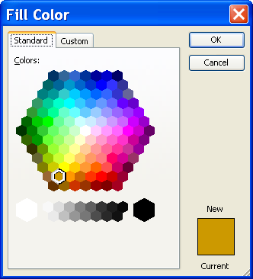
Standard
- Click the STANDARD tab to select from the color palette.
- Choose the color you want, and then click OK.
- To save your color scheme with the presentation, click the ADD AS STANDARD SCHEME button .
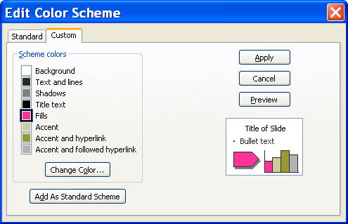
Add As Standard Scheme
Apply
- Click the APPLY button .
- Lesson Example

You really like the design template that you picked out, but you want to change some of the colors. You also want to make the Seasons of Fun slide stand out, so you want it to have a different background color.

STEPS

- Click the SLIDE DESIGN button.

- Select the COLOR SCHEMES hyperlink.
- Click the EDIT COLOR SCHEMES hyperlink.
- Click the CUSTOM tab.
- Under SCHEME COLORS, click the color of the background.
- Click the CHANGE COLOR button.
- In the STANDARD color palette, click the color you want and then click OK.

EXERCISE:

1) Change the color of Text and Lines.

2) Change the color of the Shadows.

3) On Your Own: Make other color changes as you desire and click apply.

4) Save your changes.

Slide Master

OVERVIEW

When you want to make a global change to your presentation, use the Slide Master. The Slide Master controls text and bullet characteristics such as size, and color. It also contains placeholders for footers: date, time, slide number, etc. Additionally, you may add an object that appearS on all slides, for example, your organization’s logo.

STEPS

- Click the VIEW menu, point to MASTER, and then click SLIDE MASTER.
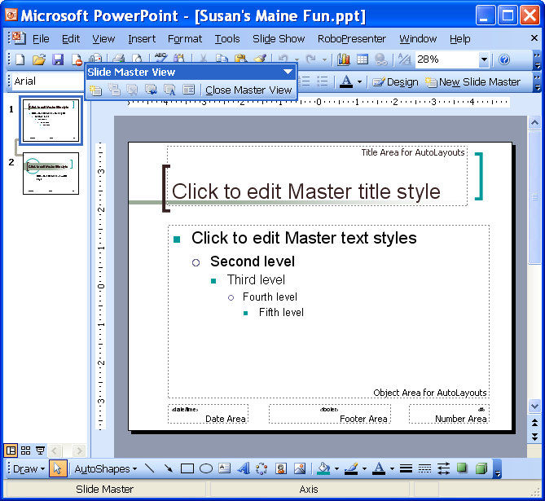
1st slide
- Click the 1ST slide.

Font

Bold

Underline
Align
Left
Align
Right

Bullets
Decrease Font Size
Increase Indent
Slide Design
Font
Size
Italic
Shadow
Center
Numbering
Increase Font Size
Decrease Indent
Font
Color
Insert New Slide Master

- To change the font style, select the text and click the drop down arrow beside FONT .
- To change the font size, select the text and click the drop down arrow beside FONT SIZE .
- To add enhancements such as Bold, Italics, Underline, and Shadow, select the text to change, then click on the appropriate button.
- To change a bullet, select the text, click FORMAT, BULLETS AND NUMBERING, and click a bullet style. For additional options, see below.
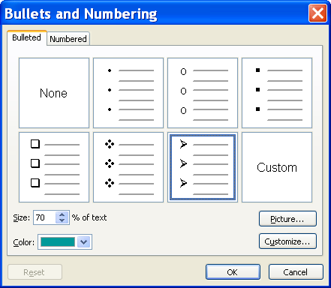
Picture
Customize
Color
  - To select a picture as a bullet, click PICTURE. Select a bullett and click OK.
  - To choose from other symbols for your bullet, click CUSTOMIZE. Locate a symbol among the different styles, and click OK.
  - To change the color of the bullet, select a color from the COLOR drop-down box.
- Once all selections are made, click OK.
- To change bullet levels (i.e. topics with sub-topics), click the line that is changing and click the INCREASE INDENT button (to increase the indent and decrease the font size) or click the DECREASE INDENT button (to decrease the indent and increase the font size) on the Formatting toolbar. You may also press TAB to increase the indent or SHIFT + TAB to decrease the indent.
- To add a graphic to all slides, click Insert, Picture, and either Clip Art or From File (for a logo or stored picture file).
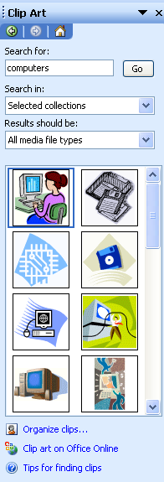
Search for
Go
- If you choose Clip Art, type your subject in the SEARCH FOR box.
- Select a picture.
- If necessary, click in the center of the picture and drag to move the graphic to the desired location.
- To move an item in the footer area, click on the text box and drag it to a different location.
- When finished, click the CLOSE MASTER VIEW button on the slide master toolbar.

Lesson Example

You are concerned about the size of the font on the slides. You decide to make some formatting changes in the Master Slide.

STEPS

- Click VIEW, MASTER, SLIDE MASTER.
- Click the 1ST slide.
- Select the title text and change the font size to 48.
- Click the BOLD button.
- Click the UNDERLINE button.
- Select CLICK TO EDIT MASTER TEXT STYLES to edit the bullets.
- Click FORMAT, BULLETS AND NUMBERING.
- Click the CUSTOMIZE button.
- Change the FONT to Webdings.
- Select a bullet and click OK.
- Change the bullet color by selecting a color from the COLOR drop-down box.
- Click OK.

EXERCISE:

1) Change the SECOND LEVEL bullet.

2) Format the SECOND LEVEL font to a style of your choice.

3) On Your Own: Make any formatting changes needed.

4) Click CLOSE MASTER VIEW on the Slide Master toolbar.

5) Save the presentation.

Formatting Text on an Individual Slide
Helpful Hint:

It is best to make individual changes after global changes are completed in the Master Slide.

OVERVIEW

The success of a presentation depends on the clarity of each slide. You want to be sure that people watching the presentation find it visually appealing and easy to read. It may be helpful to adjust the font style, size, and other attributes.

STEPS

- To change the font style, select the text, click the drop down arrow beside FONT , and make a selection.
- To change the font size, select the text, click the drop down arrow beside FONT SIZE , and make a selection
- To add enhancements such as Bold, Italics, Underline, and Shadow select the text to change, then click on the appropriate button.
- To change a bullet, select the text, click FORMAT, BULLETS AND NUMBERING, and click a bullet style.
Picture
Customize
Color
  - To select a picture as a bullet, click PICTURE. Select a bullett and click OK.
  - To choose from other symbols for your bullet, click CUSTOMIZE. Locate a symbol among the different styles and click OK.
  - To change the color of the bullet, select a color from the COLOR drop-down box.
- Once all selections are made, click OK.
  - To select a picture as a bullet, click PICTURE, click on a picture, and click the INSERT PICTURE button.
  - To choose from other characters for your bullet, click CHARACTER, locate the character among the different styles, and click OK.
  - To change the color of the bullet, select a color from the COLOR drop-down box.
- Once all selections are made, click OK.
- To change bullet levels (i.e. topics with sub-topics), click with the line that is changing and click the INCREASE INDENT button (to increase the indent and decrease the font size) or click the DECREASE button (to decrease the indent and increase the font size) on the Formatting toolbar. You may also press TAB to demote or SHIFT + TAB to promote.

- Lesson Example

There are some individual slides that you need to make changes to.

STEPS

- Click the Spring Fun slide.
- Select the title and change the size to 52.
- Change the Font Style by clicking the drop down arrow beside FONT, and select Times New Roman.
- Below one of your items, list two items that are needed in order for you to complete your activity (ex. a hat, skis, etc.).
- Demote these two new items a level by selecting them and clicking the INCREASE INDENT button.
EXERCISE:

  - Add a new bulleted slide after Summer Fun titled Fall Fun.
  - Add several bullets of fun activities.
  - Enlarge the title and bulleted list to 52 and 28 respectively.
  - Save the presentation.
  - On Your Own: Make each of the bullets on this slide a different character and color.

  - Use the Bold, Italics, and Shadow enhancements on the text.

  - Save the presentation.

SLIDE MANAGEMENT

OBJECTIVES: Identify and use slide layouts.
Change the slide order.
Delete slides.
Add speaker notes.

Changing Slide Layouts

OVERVIEW

Microsoft PowerPoint makes it easy for you to change slide layouts. For example, if you have set up a slide as a title slide, and decide you would like to have a bulleted list, you can change the layout and PowerPoint adjusts your slide accordingly.

STEPS

- In any view, click on the slide you would like to change.
- Click FORMAT, SLIDE LAYOUT. The slide layout pane appears.
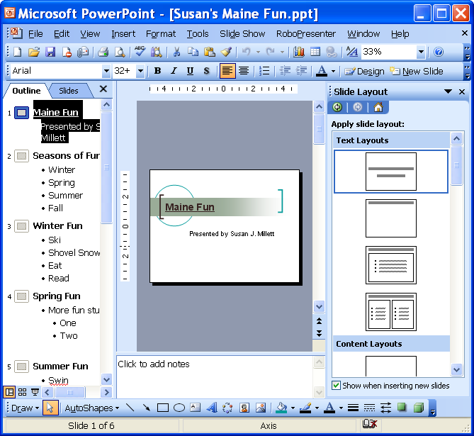
Slide Layout
- Select a new SLIDE LAYOUT.
There are four types of layouts to choose from: Text Layouts, Content Layouts, Text and Content Layouts, and Other Layouts. The available layouts are:
Symbol | Slide Description
 | Text Layouts
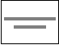 | Title Slide – shows a title and subtitle.
 | Title only – shows only a title on a slide.
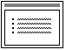 | Title and Text – shows a title with a bulleted list.
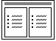 | Title and 2 Column Text – like a title and text slide, but lists bullet points in two columns. Best used for longer lists of shorter items.
 | Content Layouts
 | Blank – no text or objects appear on the slide unless manually added. It is not recommended, except for a final slide.
 | Content – allows you to select the following objects to insert: Table, Chart, Clip Art, Picture, Diagram or Organizational Chart, or Media Clip.
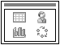 | Title and Content – shows the title and your choice of content.
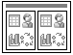 | Title and 2 Content – shows the title and two different contents.
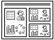 | Title, Content, and 2 Content – shows the title, one large content and two smaller contents.
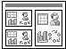 | Title, 2 Content, and Content – shows the title, two small content and one large content.
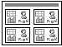 | Title and 4 Content – shows the title and four small contents.
 | Text and Content Layouts
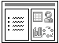 | Title, Text and Content – allows you to have a bulleted list with a content.
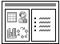 | Title, Content and Text – allows you to have a bulleted list with a content, but content is on the left.
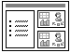 | Title, Text and 2 Content – allows you to have a bulleted list with two contents.
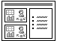 | Title, 2 Content and Text – allows you to have a bulleted list with two contents, but the contents are on the left.
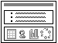 | Title and Text over Content – places the bulleted list on top of the content rather than side by side.
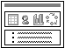 | Title and Content over Text – as above with the content over the bulleted list.
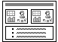 | Title and 2 Content over Text – as above with two contents.
 | Other Layouts
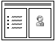 | Title, Text and Clip Art – allows you to have a bulleted list with a piece of Clip Art to the right.
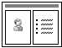 | Title, Clip Art and Text – as above with the Clip Art on the left.
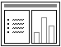 | Title, Text and Chart – allows you to have a bulleted list with a chart to the right.
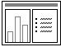 | Title, Chart and Text – as above with the chart to the left.
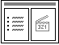 | Title, Text and Media Clip – allows you to have a bulleted list with a media clip to the right.
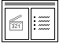 | Title, Media Clip and Text – as above with the media clip on the left.
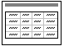 | Title and Table – allows you to insert a table.
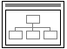 | Title and Diagram or Organizational Chart – allows you to insert a diagram or an organizational chart.
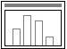 | Title and Chart – allows you to insert a chart.

Changing Slide Sequence

OVERVIEW

You do not have to be concerned with the order in which you originally enter your slides. You can quickly and easily rearrange your presentation.

STEPS

- In the Outline or Slides pane, click and drag the slide icon to a new location. When a line appears in the desired location for the slide, release the mouse button.
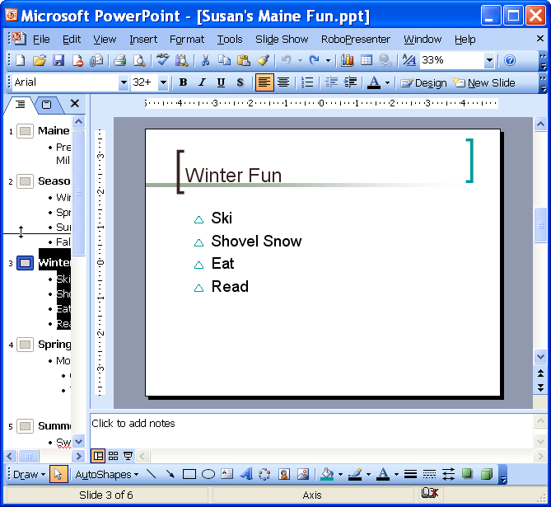
- In Slide Sorter view , click and drag the slide. When a line appears in the desired location for the slide, release the mouse button.
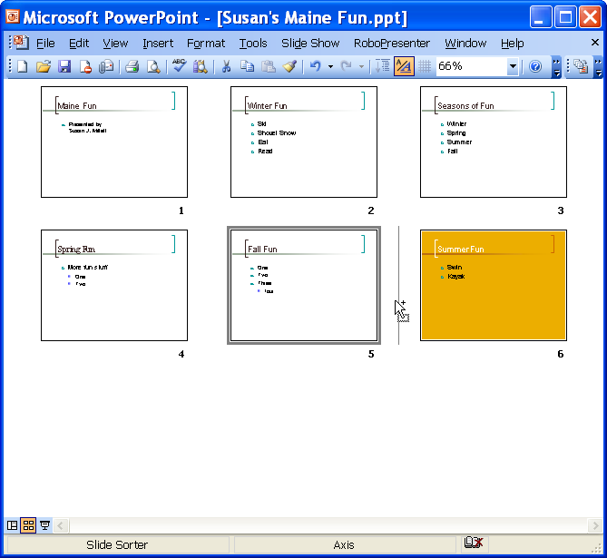

Lesson Example

After thinking about your content, you realize that you do a lot more activities in the spring, so you want to change the layout to a 2-Column Text slide. You also decide to change the slide sequence.

STEPS

- Click the Spring Fun slide.
- Click FORMAT, SLIDE LAYOUT.
- Select TITLE AND 2 COLUMN TEXT.
- Add some more spring activities to the second column.
- Click the SLIDE SORTER VIEW button .
- Move the Spring Fun slide before the Title slide by clicking and dragging.
- Save the presentation.
EXERCISE

- Click the NORMAL VIEW button.

- Add a new slide with the layout of Title Only before the Spring Fun slide.

- Type My Favorite Season as the Title.

- Move the My Favorite Season slide to the end of the presentation.

- Change the Slide Layout to Title and Text.

- Type your favorite season as the first bullet.

- As sub-bullets, type four reasons why this is your favorite season.

- Save the presentation.

- On your own: Move the Title slide to the beginning of the presentation.

- Insert a new slide with the layout of Blank.

- Change the Slide Layout to Title and 2 Column Text.

- Title the slide Enjoying the Seasons With Me and format it to fit on one line.

- Type two lists of people.

- Save your presentation.

Adding Notes

OVERVIEW

PowerPoint allows you to type speaker notes specific to each slide that can be printed and used by the presenter during the presentation.

STEPS

- In NORMAL View , go to the slide where notes will be added.
- Click where it reads Click to Add Notes, below the slide.
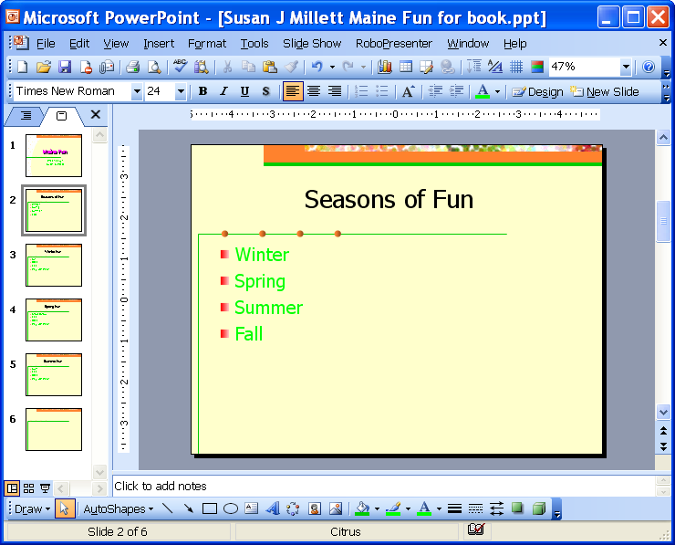
Click to add notes
- Type your notes.

Deleting Slides

Overview

You may find that you no longer need a particular slide in your presentation. You have the ability to delete individual slides.

Steps

- In Normal, Outline, or Slide Sorter view, select the slide you want to delete.

- Press Delete on the keyboard.

Lesson Example

You would like to include speaker notes with your presentation to help you practice.

STEPS

  - Click the Seasons of Fun slide.
  - Click where it reads Click to Add Notes and enter Share stories about some of the fun activities.
  - Click the Enjoying the Seasons With Me slide and press the DELETE key.
  - Undo the deletion.
  - Save the presentation.
EXERCISE:

- On the My Favorite Season slide, add the speaker note, Explain each reason in more detail.
- Save the presentation.
- On Your Own: Add a speaker note to any slide.

- Save the presentation.

ADDING OBJECTS

OBJECTIVES: Add Clip Art.
Utilize the tools on the Drawing Toolbar.

Clip Art

OVERVIEW

Clip Art graphics and pictures add interest to a presentation, but make sure that they do not override your content. You may add Clip Art through the layout of a new slide or by adding Clip Art to an existing slide.

STEPS

- Click the NEW SLIDE button on the Formatting toolbar. You will pick a new slide layout. Click the TITLE, TEXT AND CONTENT or the TITLE, CONTENT AND TEXT LAYOUT.
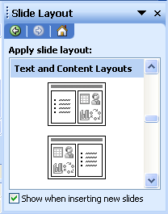
Title, Text and Content

Title, Content and Text
- Click INSERT CLIP ART on the slide.
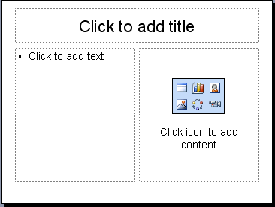
Insert Clip Art
- Type the name of clip you are looking for in SEARCH TEXT and click GO.
Go
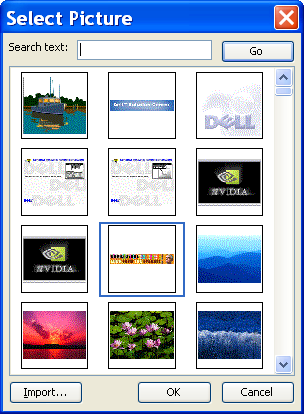
Search Text
OK
- Click the picture of your choice, and click OK.
- To add Clip Art to any slide not containing a Clip Art placeholder, click the INSERT CLIP ART button in the Drawing toolbar.
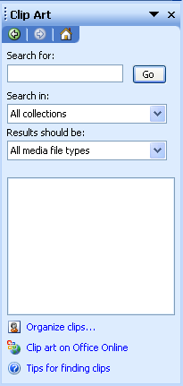
- Type the name of the clip you are looking for in SEARCH FOR and click GO.
- To resize Clip Art, click on the graphic.
- Point to any resizing handle (your mouse pointer will change to a double headed arrow).
Helpful Hint:

Use the corner handles to resize Clip Art in order to keep it in proportion.
- Click and drag until it is the desired size.

Resizing handle
Free rotate handle
- To move Clip Art, click on the graphic.
- Click and drag from the middle of the picture when the mouse changes to a four-headed arrow .
- Release the mouse button when at the new location.

Lesson Example

You want to add pictures to a new slide and slides already created.

STEPS

  - Create a slide after the Fall Fun slide containing Clip Art by clicking the NEW SLIDE button and selecting the TITLE, TEXT AND CONTENT layout.
  - Click in the title and type Favorite Places to Visit in Maine.
  - In the bulleted list, type a few places you enjoy visiting in Maine.
  - Click the INSERT CLIP ART object, and type SEASONS.
  - Click the GO button.
  - Click on a picture of your choice and click the OK button.
  - Resize the picture by clicking and dragging a corner handle.
  - Click on the Seasons of Fun slide.
  - Insert Clip Art by clicking the INSERT CLIP ART button on the Drawing toolbar.
  - Insert a picture of your choice, and then close the Clip Art Window.
  - Resize the Clip Art by clicking and dragging a corner handle.
  - Move the Clip Art by placing the mouse in the middle of the picture and clicking and dragging to the new location.
  - Save the presentation.
EXERCISE:

- Using the INSERT CLIP ART button, add Clip Art of your choice to the title slide.
- Resize and move the Clip Art as necessary.
- On Your Own: Add Clip Art to the My Favorite Season slide by changing the slide layout.

- Resize and move if necessary.

- Save the presentation.

Drawing Toolbar

OVERVIEW

The Drawing Toolbar allows you to actually create and format drawings within Microsoft PowerPoint presentations.

Button | Description
 | Click to select an option to adjust drawing objects
 | Select drawing objects
 | Click to select a shape
 | Line Tool
 | Arrow
 | Rectangle
 | Oval
 | Text Box
 | Insert WordArt
 | Insert Diagram or Organizational Chart
 | Insert Clip Art
 | Insert Picture
 | Fill Color
 | Line Color
 | Font Color
 | Line Style
 | Dash Style
 | Arrow Style
 | Shadow
 | 3-D

HELPFUL DRAWING TIPS

- To view the Drawing toolbar, right click any toolbar and click DRAWING.

- To create a drawing object, click the tool to select it and then click and drag to place the object within the document.

- To keep the drawing tool on, double-click the tool. Click and drag to place the drawing object on the slide, then click and drag again to place the shape in another location.

- To turn off the drawing tool, double-click the tool again or press the ESC key on your keyboard.

- To draw an AutoShape, click the AUTOSHAPES button in the Drawing toolbar, point to the category and then click the AutoShape.

- Point to the location on the slide where you would like to place the shape, then click and drag to draw the shape.

- To draw a perfect square, circle, or straight line, hold down the SHIFT key when drawing the object.

- To resize an object, click the object to select it, then click and drag one of the resizing handles with your double-sided arrow mouse pointer .

- To move an object, click and drag when the mouse is in the shape of a four-headed arrow.

- To change the layering of objects, click the object, then click DRAW, ORDER. Click the appropriate option. .
Places object in the top position
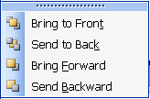
Places object in the bottom position
Move object forward one level
Move object back one level

- To group multiple shapes together, click on the first shape.

- Hold down the SHIFT key and click on the other shapes.

- Click the DRAW button.

- Click GROUP.

- To delete an object, click the object, then press the DELETE key. To delete several, hold down the SHIFT key as you click on several objects, then press the DELETE key.

- To change the color, click on the arrow to the right of the Fill Color button and then More Fill Colors.
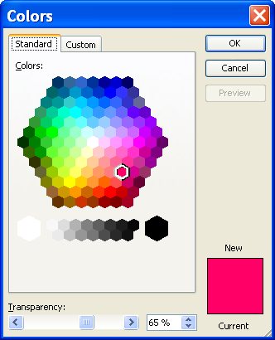
- Click the STANDARD tab to select from the color palette.
- In the STANDARD color palette, click the color you want, and then click OK.
- To change the fill effects, click on the arrow to the right of the Fill Color button and then Fill effects.
- To apply a gradient effect, click on the GRADIENT tab.
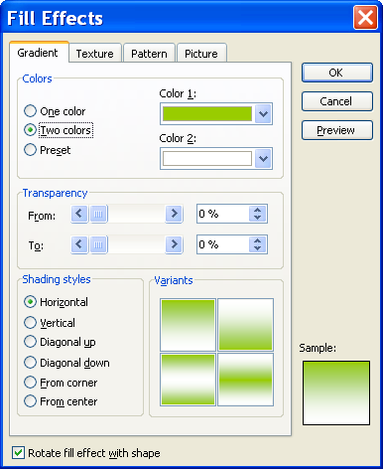
Gradient
- Choose ONE COLOR, TWO COLORS, OR PRESET.

- Make your color choices by clicking on the COLOR 1, COLOR 2, or PRESET COLORS drop-down boxes.

- You may set a TRANSPARENCY level by either sliding the bar or clicking the % up and down arrows.

- In the SHADING STYLES section, choose a style.

- To apply a texture effect, click the TEXTURE tab.

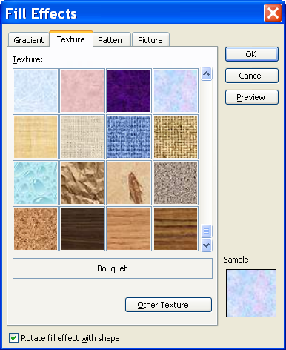
Texture
- Select the texture of your choice.
- To apply a pattern to a background, click the Pattern tab.
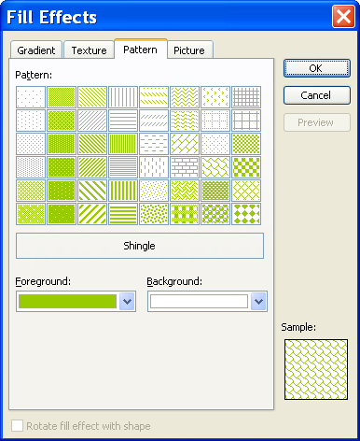
Pattern
- Select the Foreground and Background colors and the Pattern desired.
- To add a picture to an item, click the Picture tab.
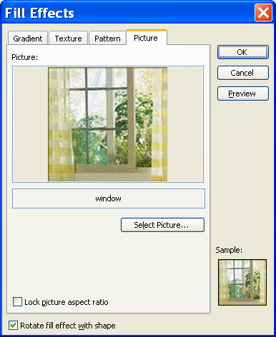
Picture
- Click Select Picture, and browse to find the picture.
- After selecting the picture file, click Insert and click OK.
- To change the line color, click the arrow to the right of the LINE COLOR button and then MORE LINE COLORS.
- Click the STANDARD tab to select from the color palette.
- In the STANDARD color palette, click the color you want, and then click OK.
- To change the color of text, select the text.
- Click the arrow to the right of the FONT COLOR button.
- Click on the color of your choice.
- To change a LINE STYLE , DASH STYLE , or ARROW STYLE , click the appropriate button.
- Click on the style of your choice.
- To add a shadow, click the SHADOW STYLE button.
- Click on the style of your choice.
- To add a 3-D style, click the 3-D STYLE button.
- Click on the style of your choice.

Lesson Example

After adding the Clip Art, you decide you would like to add some additional shapes.

STEPS

- Click the Summer Fun slide.
- Add the sun AutoShape by clicking AUTOSHAPES, BASIC SHAPES, and clicking the SUN shape.
- Click and drag the sun to the upper right hand corner.
- Move and resize as appropriate.
- Change the color by clicking on the arrow to the right of the Fill Color button and then More Fill Colors.
- Select a bright shade of yellow and then click Ok.
- Save the presentation.

EXERCISE:

- On the Winter Fun slide, create a snowman by using the Oval AutoShapes (Hint: double click on the tool to draw 3 ovals).
- Change the fill color of each.
- Move the ovals so that they are stacked like a snowman.
- Change the order of the ovals so that the lowest oval is in the front, the middle oval is in the middle, and the top oval is in the back.
- On Your Own: Select the three ovals and align them by the center (Hint: Draw, Align and Distribute).

- Select all of the ovals and apply a 3-D style.

- Group the Ovals

- Save the presentation.

TRANSITIONS AND EFFECTS

OBJECTIVES: Demonstrate running the presentation.
Add and change transitions and effects.

Running a Presentation
Did You Know?

If you press the F5 key, the presentation always starts from the first slide.

OVERVIEW

Usually, the purpose for creating a PowerPoint presentation is to run the presentation for an audience, which means to progress from the first to the last slide. You should always preview your presentation before running it in front of an audience to see how it will appear on screen.

STEPS

- Move to the first slide.
- Click the SLIDE SHOW button .
- While running the presentation, the following functions are available to navigate and use presentation effects:
Function | Actions
Display the next slide or animation | Left click, Right arrow, Down arrow, Enter, Spacebar, Page Down, N
Display the previous slide or animation | Left arrow, Up arrow, Backspace, Page Up, P
Display the first slide | Home
Display the last slide | End
Stop the slide show and return to the PowerPoint window | Escape
Display the slide show shortcut menu, which you can use to advance to the next or previous slide, etc. | Right mouse button
Blacken/unblacken the screen | B
Whiten/unwhiten the screen | W
Show/Hide the arrow pointer | A

- Lesson Example

You would like to practice running your presentation.

STEPS

- Click on the first slide of the Maine Fun presentation.

- Click on the Slide Show button.

- Use the spacebar to navigate through the entire presentation.

- Exit the slide show.

EXERCISE:

  - Run the presentation, this time using various navigation keys to go backward and forward.

  - Exit the presentation.

  - On Your Own: Click on the last slide in the presentation.

  - Run the presentation using the Slide Show button.

  - What slide did the presentation start on?

  - End the slide show.

Transitions

OVERVIEW

During an onscreen presentation you can choose how each slide appears on the screen. PowerPoint includes many transitions, for example: one slide can fade out while the next slide fades in, a slide may appear from the top of the screen, or the contents of one slide can dissolve into the next slide.

STEPS

- In SLIDE SORTER VIEW or NORMAL VIEW, select the slide where you want to apply a transition .
Did You Know?

In Normal View, you can click SLIDE SHOW, SLIDE TRANSITION to get to the SLIDE TRANSITION window.
- On the SLIDE SORTER toolbar, click the SLIDE TRANSITION button .
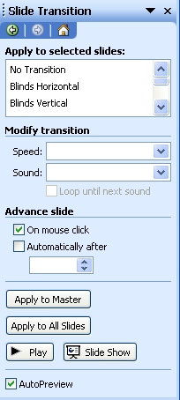
Transitions
Speed and Sound
Advance Slide
Apply to All Slides
- Select a transition from the list.
- To modify the speed of the transition, select either slow, medium or fast.
- To add sound effects, click the SOUND list and choose one (you must have sound activated on your PC in order to hear them).
- To have the slide transition automatically (for use as a kiosk, etc.), click in the box in front of AUTOMATICALLY AFTER and change the minutes and seconds in the box below.
- You may create transitions of individual slides, or you may APPLY TO ALL SLIDES.

Animation Schemes

OVERVIEW

After choosing the transition from slide to slide, you can also decide how each object and text on the slide appears. For example, you may want the text to Fly from the Bottom or Swivel as it appears on the slide.

STEPS

  - In SLIDE SORTER VIEW or NORMAL VIEW, select the slide where you want to apply an animation.
  - On the formatting toolbar, click the SLIDE DESIGN button . Choose the ANIMATION SCHEMES hyperlink.
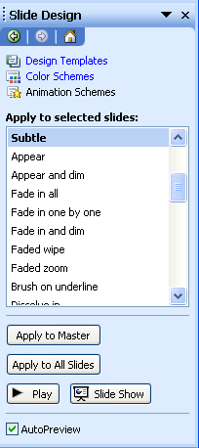
Animation Schemes
Apply to All Slides
  - You can create transitions of individual slides, or you can APPLY TO ALL.

Lesson Example

It is now time to jazz up the slide show by adding transitions and animations.

STEPS

  - Click the SLIDE SORTER VIEW button .
  - Select every slide by clicking EDIT, SELECT ALL or pressing CTRL+A on your keyboard.
  - On the formatting toolbar, click the SLIDE TRANSITION button.
  - Choose an animation from the list and click APPLY TO ALL SLIDES.
  - On the SLIDE SORTER toolbar, click the SLIDE DESIGN button.
  - Click an animation from the list.
  - Run the slide show from the first slide.
  - Save the presentation.
EXERCISE:

- You want the My Favorite Season slide to stand out, so you are going to add a different transition and effect to this slide.
- Select the My Favorite Season slide.
- Change the transition.
- Change the effect.
- Save the changes.
- On Your Own: Run the slide show.

- Make any changes to transitions and effects.

- Save the presentation.

PRINTING

OBJECTIVE: Print the presentation.

Printing
Helpful Hint:

Avoid using the Include Animations choice when printing. It prints a different page for each change on each slide of the entire presentation.

OVERVIEW

With PowerPoint, there are many printing options. You can print all the slides of the presentation or choose individual slides to print. You can also print the outline, handouts, and notes pages.

STEPS

- To print the entire presentation with each slide on one page, click the PRINT button on the Standard toolbar.
- To make other printing choices, click FILE, PRINT.
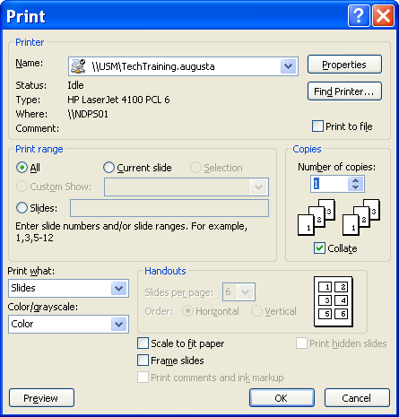
Current slide
Number of copies
- To print the slide your insertion point is on, click CURRENT SLIDE.
- To print multiple copies, click the arrows to specify the number of pages in NUMBER OF COPIES.
- To print a range of slides, click the slide radio button then type the slide numbers that you want to print (i.e. 2-4 or 3, 5,8).
- PowerPoint can print your presentation several ways as listed under Print What.
Type | Description
Slides | Prints one slide at a time on a page.
Handouts | Allows you to print from two to nine slides per page.
Notes Pages | Prints one slide per page with any notes for that slide appearing below it.
Outline View | Prints just the text found on each slide in an outline.  Helpful Hint:  When you print Handouts that are three-to-a-page, PowerPoint prints lines next to each slide on the page to be used by audience members to write notes.

- Once all options have been selected, click OK.

Lesson Example

You would like to print handouts for the presentation.

STEPS

  - Click FILE on the Menu bar and then PRINT.
  - Click the down arrow below PRINT WHAT and select HANDOUTS.
  - Select 3 for the number of SLIDES PER PAGE.
  - Click OK.
EXERCISE:

- Print the notes page of Slide 1.
- On Your Own: Print slides 2-4.

GIVE IT A TRY!

OBJECTIVE: Practice the lessons learned in class.

EXERCISE:

Refer to Lessons 1- 2 for assistance

      - Create a new, blank presentation that begins with a title slide. The title is My Hobbies, the subtitle will be Presented by (Your Name).
      - Save the presentation as My Hobbies in the My Documents folder.
      - Add a bulleted list slide to list your hobbies.
      - Add a bulleted list slide for each of your hobbies explaining why you like them.
      - Add a title slide at the end of the presentation that reads The End and Thank You.
      - Save the presentation.
Refer to Lesson 3 for assistance
      - Apply a design template of your choice.
      - Change the color scheme of your presentation.
      - Update the Slide Master to affect all slides by changing the bullet types and font for the text.
      - Format the text of the title slide to your liking.
      - Save the presentation.
Refer to Lesson 4 for assistance
12) Change the layout of your first bulleted list slide to Text and Clipart.
13) Change the order of the slide sequence.
14) Add a speaker note to any slide.
15) Save the presentation.
Refer to Lesson 5 for assistance
16) Add Clip Art to your first list slide and to one other slide.
17) Add an AutoShape to a slide.
Refer to Lesson 6 for assistance
18) Add transitions and effects to each slide.
19) Add custom animation to your piece of Clip Art or your AutoShape.
20) Customize the order of the appearance of objects on that slide.
21) Save the presentation.
22) Run the presentation.
Refer to Lesson 7 for assistance
23) Print handouts for your presentation.

24) Close the presentation.

DELETING FILES

OBJECTIVE: Maintain organized file directories.

STEPS

    - Close all open presentations but remain in PowerPoint.

    - Click FILE, OPEN.

    - Click once on the name of the file to be deleted or use the CTRL or SHIFT keys to select multiple files.

    - Press the DELETE key on your keyboard.

    - Click YES to confirm the deletion.

    - Click the CANCEL button to close the open window.

Lesson Example

You gave the Maine Fun presentation and it is now time to delete the file.

STEPS

- Close all open presentations but remain in PowerPoint.

- Click FILE, OPEN.

- Click once to select Maine Fun.

- Press the DELETE key on your keyboard.

- Click YES to confirm the deletion.

- Click the CANCEL button to close the open window.

EXERCISE:

1) Delete all other presentations.

2) Close the Open dialog box and shut down your computer.

NICE TO KNOW

PowerPoint Help Features

OVERVIEW

Microsoft PowerPoint contains several different types of help to assist you when you have difficulty with the program. The Office Assistant is an interactive help device that comes in the form of a cartoon character. It allows you to type a question or phrase related to your problem, and it searches for help topics based on your entry. In addition to the Office Assistant, PowerPoint provides help in a more standard form, where you search through lists of topics for one related to your issue. However, this requires that you are very familiar with PowerPoint terminology.
Helpful Hint:

The ANSWER WIZARD tab works in the same manner as the Office Assistant.

STEPS

- Click the OFFICE ASSISTANT icon .
- Type your question.
- Either press ENTER or click SEARCH.
- Click on one of the options available to receive additional information on that topic.

- To look for other topics, click the SHOW button .

- To utilize the CONTENTS tab, click the tab, then double-click a topic area. Double-click a specific topic to view the information.

- To utilize the INDEX tab, click the tab, then type in the first several letters of the topic you want. When it appears below, double-click the topic to view the information. In the secondary list of topics, click the appropriate one to open it.

- To close the Help window, click the CLOSE button in the upper right corner of the Help window.

The AutoContent Wizard

OVERVIEW

The AutoContent Wizard helps you to plan the content of your presentation. It creates slides based on presentation types. Each slide gives guidelines for adding your information.

STEPS

- Click FILE, NEW on the Menu bar and. The NEW PRESENTATION TASK PANE appears.
- Choose the FROM AUTOCONTET WIZARD hyperlink.
- In the AUTOCONTENT WIZARD window, click the NEXT button.
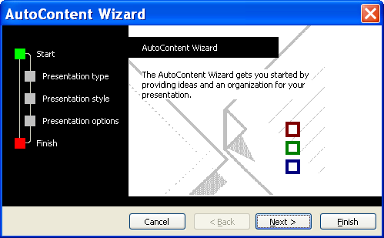
- Select the button for the type of presentation (example: All, General, Corporate, etc.) then click the appropriate content area.
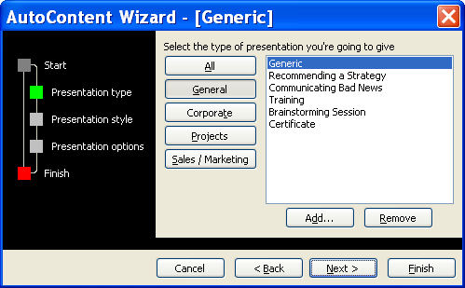
- Click NEXT.
- Select the method to use for presenting.
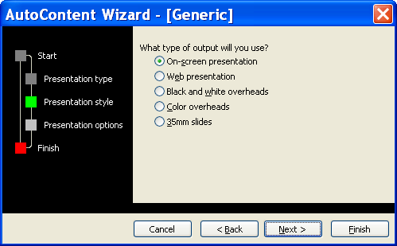
- Click NEXT.
- Type a PRESENTATION TITLE and any items to display in the FOOTER. If you do not want the date and slide number to display on the slide, remove the checkmarks.
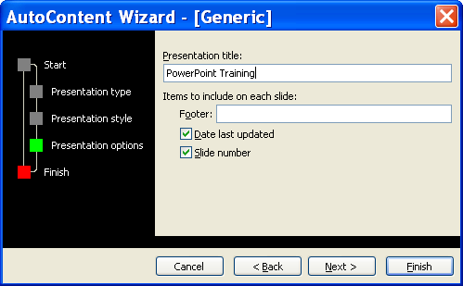
- Click NEXT.
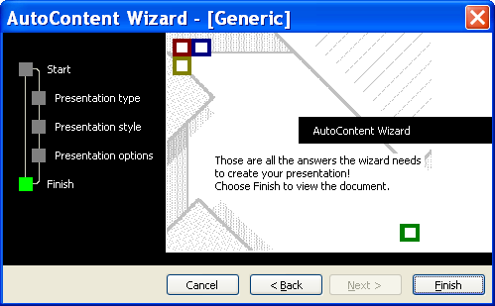
- Click FINISH.

