ADVANCED EXCEL 2003

Table of Contents
Page

LESSON 1: MANAGING LARGER WORKBOOKS 1
♦ Copying Worksheets 1
♦ Viewing Multiple Worksheets 2
♦ Grouping Worksheets 3
♦ Freezing and Unfreezing Rows and/or Columns 3
♦ Hiding and Unhiding Cells 4
♦ Formatting 8
♦ Linking Worksheet Cells 11
♦ Worksheet Protection 12
LESSON 2: EXCEL FUNCTIONS 16
♦ IF, COUNTIF, and SUMIF 16
LESSON 3: EXCEL FEATURES 23
♦ Data Validation 23
♦ Conditional Formatting 26
♦ Sorting 29
♦ AutoFilter 32
♦ Subtotals 35
♦ Summary Reports 36
LESSON 4: EMBEDDING AND LINKING 38
LESSON 5: GIVE IT A TRY! 42
LESSON 6: DELETING FILES 45
NICE TO KNOW 47
♦ Simple Macros 47

This workbook may be reproduced in whole or in part by an employee of the Department of Health and Human Services. All other reproduction is prohibited unless written permission is obtained from the Training Institute.

MANAGING LARGER WORKBOOKS

OBJECTIVE: Manage larger workbooks by copying, viewing, grouping, and linking cells and worksheets.

Copying Worksheets

Overview
Helpful Hint:

To remove the flashing lines from the copy function, press the ESC key.
You may copy an entire worksheet of a workbook. This is helpful if you have worksheets or workbooks that require the same information or are written in the same format.

STEPS

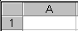
- Select the worksheet to be copied by clicking on the sheet tab (at the bottom of the worksheet), then press CTRL+A to highlight the entire sheet, or click the select all button between Column A and Row 1.

- Click the COPY button .

Did You Know?

You can also copy a worksheet by right clicking your mouse while on the sheet name (tab) and selecting copy.

- Click on the sheet where you want to copy the information.

- Click in cell A1 (or wherever you want the top left cell for the pasted data to begin).

- Click on the PASTE button or press Enter on your keyboard.

Viewing Multiple Worksheets

Overview

You can view more than one sheet of a workbook at one time. This is helpful if you have linked worksheets or workbooks and you want to see how the changes in one worksheet affect another sheet.

STEPS

1. Click WINDOW on the menu bar.

2. Select NEW WINDOW. (You may need to expand the menu by using the at the bottom of the menu to see the rest of the options.)

3. Click WINDOW on the menu bar.

- Select ARRANGE.

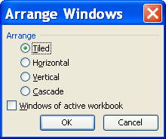

5. Select your choice (Tiled, Horizontal, Vertical, or Cascade). Click on the check box in front of WINDOWS OF THE ACTIVE WORKBOOK. Click OK.

6. To return the window to full screen, close either window and maximize the other window.

Grouping Worksheets
OVERVIEW

When preparing budgets or proposals it may be necessary to create several spreadsheets that have similar information but are different in some of the details. For example, you may be responsible for several departments that have some common information. Grouping worksheets in Excel allows you to enter the same information on several sheets at a time.

Did You Know?

You can also update cell formatting when grouping worksheets.

STEPS

- Click on the first worksheet (example – Sheet1).

- Press the SHIFT key and click on the last sheet in the series (example – Sheet3).
Helpful Hint:

To choose non-adjacent sheets, hold CTRL and click each sheet separately.

- Type in the data (headings, titles, formulas, etc.) that are shared for each sheet. Make sure to double-check your formulas to ensure they are still accurate.

- To turn off grouping, right click an individual sheet and select UNGROUP SHEETS or click on a different worksheet tab.

Freezing and Unfreezing Rows and/or Columns

OVERVIEW

One problem when working in a large spreadsheet is that rows and columns that contain descriptive headings scroll off the screen when viewing data. This makes it difficult to remember what information is being displayed. Excel solves this dilemma by allowing you to freeze selected columns and/or rows so they cannot be scrolled. When you are finished viewing the data you can then unfreeze the columns and/or rows.

STEPS

- To freeze a row(s), in Column A, activate the cell below the row(s) you want to freeze.

- To freeze a column(s), in Row 1, activate the cell to the right of the column(s) you want to freeze.

- To freeze columns and rows, activate the cell below the row(s) and to the right of the column(s) you want to freeze.

- Go to the WINDOW menu and select FREEZE PANES.

- To unfreeze, go to the WINDOW menu and click UNFREEZE PANES.

Hiding and Unhiding Cells

OVERVIEW

When you want to look at specific columns or rows of data that are located far apart from one another, you can "hide" the columns or rows in-between them.

STEPS

- To hide columns or rows, select the columns or rows you want to hide.
- Right click and select HIDE or click Format, Colum or Format, Row, Hide.
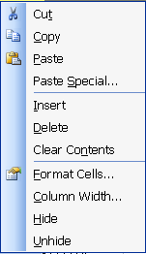
Hide
Unhide

- To unhide columns or rows, select the column or row to the left of the hidden cells and click and drag to the right of the hidden cells.
- Right click and select UNHIDE.

Lesson Example

You know you need to order supplies again in a month, so you want to copy your current order to another worksheet as a starting point for next time.

STEPS

- Open the Office Supplies workbook and save it in C/My Documents.

- Copy Sheet1 of the workbook to Sheet2, by selecting all the worksheet cells and then selecting copy. Go to Sheet2, click in cell A1, and click Paste.

- Replace the quantities on Sheet2 as follows:
Paper Clips – 6
Staples – 4
Stapler – 2
1" Binder Clips – 4
Dry Erase Markers – 2
Legal Pads – 8
Ballpoint Pens – 6
Flip Chart Paper – 2
File Folders – 2
Copier Paper – 4
Diskettes – 6

Did You Know?

You can select a Tab Color for your worksheets by right clicking the sheet and selecting TAB COLOR.
- Rename Sheet1 January and Sheet2 February by double clicking on the sheet name and typing the new name.

- Click on the January tab, hold down Shift and click on the February tab to group the sheets, Type in the following data in row 13 in the appropriate columns:

GSL 354515D Three-Ring Binders 3.78 each in stock

- Ungroup the worksheets by right clicking on either sheet and selecting UNGROUP SHEETS.

- In January, you order 12 of this item; in February you order 8.

- Create a new window by going to the WINDOW menu and clicking on NEW WINDOW. Then go to WINDOW and then ARRANGE, and select Horizontal and OK to view both windows.

- When finished viewing both windows, close the second window and maximize the first.

- Hide the Unit column by selecting Column E.

- Right click and select HIDE. View the data.

- Unhide the column by clicking and dragging across Columns D and F.

- Right click and select UNHIDE.

- Save your changes. Close the Office Supplies workbook.

EXERCISE:

1) Open the Employee List workbook and save it in C/My Documents.

2) Freeze the FirstName and LastName rows and the column headings by clicking cell C2.

3) Select WINDOW, FREEZE PANES.

- Scroll down and scroll across and observe the results.

- Save and close the file.

6) Open the Sales workbook and save it in C/My Documents.

7) Copy Sheet1 to Sheet2.

8) Rename Sheet1 January-June and Sheet2 July-December.

9) Change the data on July–December as follows:

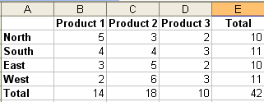

10) View both sheets on the screen and arrange vertically.

11) Return to one window, save the changes, and close the file.

12) On Your Own: Open the Agent workbook and save it to C/My Documents.

13) Copy the Collections worksheet to Sheet3.

14) Rename the Collections sheet 1st Quarter Collections and Sheet3 to 2nd Quarter Collections.

15) Group those two sheets together, and type in a motivating comment for the agents in cell A23. Ungroup the sheets.

16) On the Employees sheet, compare Susan's information to Emily's information by hiding rows 5, 6, and 7. View the data and unhide the rows.

17) Save your changes and close the file.

Formatting

Overview

If you enter a value in a cell and you don't like the way the data appears, you can adjust the cell's format. A cell's format determines how labels and values appear in it. When you change the formatting, you do not alter the cell's data.

STEPS

    - Select the cell(s) you want to format.
    - Click FORMAT, CELLS. Or right click when you are in the cell and select FORMAT CELLS.
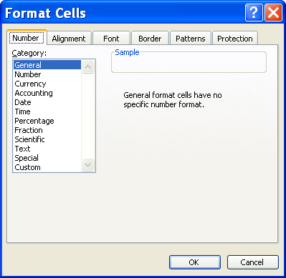

    - To change a number format, click the number tab and select a category.
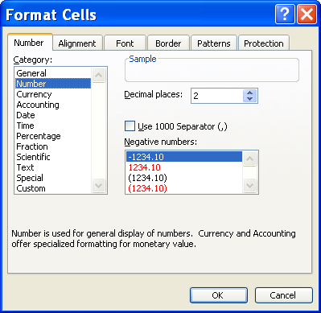

    - Make the necessary changes and click OK.
    - There are four choices in the SPECIAL category that are used for making lists and database values.
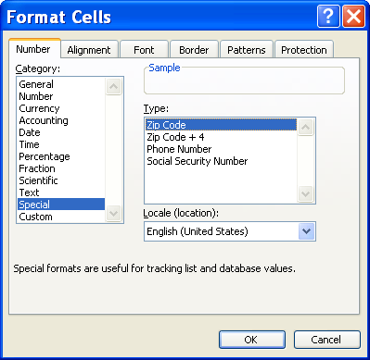

    - Zip Code allows you to have a leading 0 in the cell. Zip Code + 4 automatically places the – in the cell after you have typed the number. Phone Number automatically puts the ( ), a space, and the – in the cell after you have typed the number. Social Security Number automatically puts in the – after you have typed in the number.
    - To change a cell(s) alignment, select the ALIGNMENT tab.
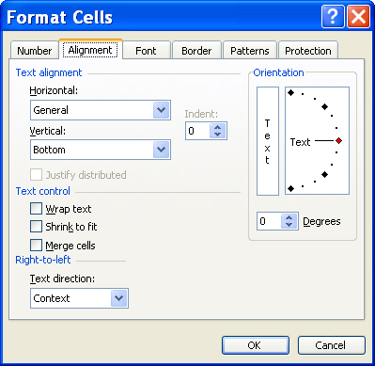
    - You may change the ALIGNMENT, the ORIENTATION, the TEXT CONTROL, and the TEXT DIRECTION.
    - You may also change a cell(s) FONT, BORDER, PATTERNS, and PROTECTION by clicking the appropriate tab.

Lesson Example

You would like to format the Employee List workbook.

STEPS

- Open the Employee List workbook, select Column O. Click and drag the column width to 19 (138 pixels).
- Right click the column heading and select FORMAT CELLS.
- Select the ALIGNMENT tab and put a check mark at WRAP TEXT. Click OK.
- Select Column F. Right click and select FORMAT CELLS.
- Click the NUMBER tab and select SPECIAL as the category.
- Choose ZIP CODE and click OK.
- Save and close the file.
EXERCISE:

  - Open the Office Supplies workbook, select Column G. Right click and select FORMAT CELLS.

  - Choose CURRENCY as the category, select 2 DECIMAL PLACES and add the SYMBOL $. Click OK.

  - Save and close the file.

  - On Your Own: In the Agent file go to the Employees worksheet and format the Zip column to show the leading zero.

  - Format the Base Pay column for currency with a $.

  - Save and close the file.

Linking Worksheet Cells

Overview
Helpful Hint:

If you are linking to another workbook, the source document (where the original information is stored) must be saved before the destination (dependent) document to preserve the links.

You may “link” a cell to another cell (on the same worksheet or another worksheet) so that information is updated in both cells when a change is made to the original (for example, to create a summary report).

STEPS

1. Select the cell(s) to put in the summary document.

- Click copy .

3. Click in the cell of the summary document where the new data is to be added (the top left corner if it’s a range of data).

- Click the EDIT menu, and then click PASTE SPECIAL.


Paste Link

- Click PASTE LINK.

Worksheet Protection

OVERVIEW

Did You Know?

You can type an = sign in the destination worksheet, then navigate to and click on the cell to link and press Enter to establish the link. This works for one cell, then you can use the AutoFill feature to fill in other nearby cells.

If you go to the trouble of creating a template that may be used by several people repeatedly, you would not want anyone to have the ability to change the fixed information or formulas within the spreadsheet. Excel allows you to identify the cells that users are permitted to modify (add, remove, or change data), and lock the remaining cells so they may not be modified. This procedure works within both Excel templates and workbook files.

STEPS

1. Select the cells you wish to allow the user to modify. Holding the CTRL key while clicking allows you to select multiple cells anywhere on the spreadsheet.

2. With your mouse pointer on any of the selected cells, click with the right mouse button.

3. In the resulting menu, select FORMAT CELLS.

4. Click the PROTECTION tab, and click to remove the check mark from LOCKED. Click OK.

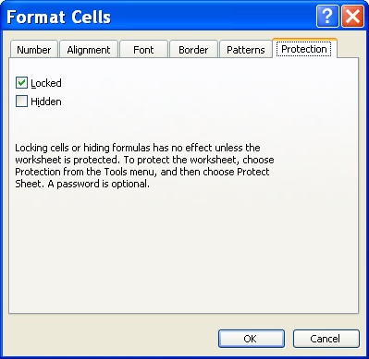
Locked
Helpful Hint:

You must unlock cells before protecting the sheet, because you cannot unlock cells after a sheet is protected.

5. Click TOOLS in the Menu Bar, point to PROTECTION, then click PROTECT SHEET.

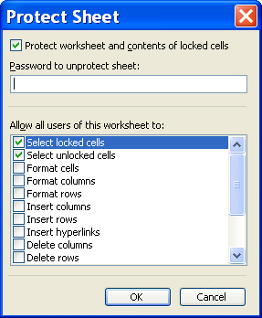

6. If desired, apply a password. Click the appropriate selections in ALLOW ALL USERS OF THIS WORKSHEET TO. Click OK.

Lesson Example

You want to keep a running total of product sales throughout the year. You also want to protect several cells.

STEPS

    - Open the Sales workbook and copy cells A1:A6 of the January-June sheet. Paste this into cell A1 in Sheet 3.
    - Rename Sheet3 Summary.
    - In cells B1:D1, type new column headings that read First Half, Second Half, and Totals.
    - Select cells E2:E6 from January-June and click copy.
    - On the Summary sheet, click in cell B2. Go to the Edit menu, click Paste Special and then Paste Link.
    - Repeat Steps 4 and 5 for the July-December totals and the Second Half column on the Summary sheet.
    - Select cells D2:D6 on the Summary sheet and click on AutoSum to insert the totals.
    - Arrange the windows horizontally, and change cell B2 on the January-June sheet to 100, press ENTER, and note that the numbers in your summary change as well. Undo the change and return to one window.
    - Return to the Summary sheet and save your changes.
    - On the January-June sheet, select cells B2:D5. Click FORMAT on the Menu Bar and select CELLS.
    - Click the PROTECTION tab and uncheck LOCKED. Click OK.
    - Click TOOLS in the Menu Bar and select PROTECTION, PROTECT SHEET.
    - Allow the users of the worksheet to select UNLOCKED CELLS. Click OK.
    - Repeat steps 10 through 13 on the July-December sheet.
    - Return to the Summary sheet. Click TOOLS in the Menu Bar. Select PROTECTION and click PROTECT SHEET. Take both of the check marks off. Click OK.
    - Try to make any change on the Summary sheet. Return to January-June and July-December sheets and test your protection.
    - Save the file.

EXERCISE:

1) In the Office Supplies workbook, copy cells B1:E13 from the February worksheet to Sheet3. Rename Sheet3 Total.

2) In cells E1:G1, add the headings January, February, and Total respectively.

3) Copy cells F2:F13 from the January worksheet and paste the link to its corresponding column in the Total worksheet.

4) On Your Own: Repeat Step 3 for February.

5) Select cells G2:G13 in the Total worksheet and insert an AutoSum.

6) Protect the Total sheet.

  - Save the file.

EXCEL FUNCTIONS

OBJECTIVE: Properly identify and utilize the IF, COUNTIF, and SUMIF functions.

IF, COUNTIF, and SUMIF
OVERVIEW

A function is a pre-defined formula that is automatically calculated when you supply it with numbers. It can simplify creating formulas. Excel 2003 has over 200 hundred functions that are defined by category (for example, statistical, financial, date and mathematical). The following are three of the most commonly utilized functions:

=IF(logical_test,value_if_true,value_if_false) – Checks a condition that must be either true or false. If the condition is true, the function returns one value; if the condition is false, the function returns another value. The IF function has three arguments: the condition you want to check, the value to return if the condition is true, and the value to return if the condition is false.

=COUNTIF(range,criteria) – Counts the number of times a specified value occurs in a range. The two arguments in CountIf are the range to be checked and the value (criteria) to look for.

=SUMIF(range,criteria,sum_range) – Checks for a value within a range and then sums all the corresponding values in another range. SUMIF has three arguments: the range to be checked, the value to check for within the range (the criteria), and the range containing the values to be summed.

Steps

- Select the cell where you want the answer to the function to go.

- Click the drop down list on the AutoSum button . The following window appears.

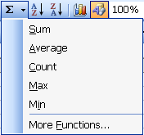
Helpful Hint:

Think IF, THEN, ELSE

- If the function you need is not listed, click MORE FUNCTIONS.

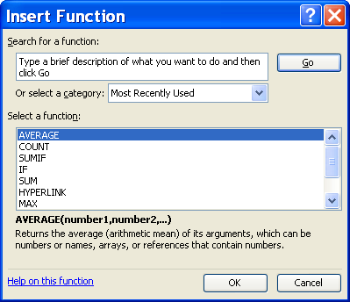

Did You Know?

You can refer to a cell reference for criteria, the Value_
IF_TRUE or the VALUE_IF_
FALSE if a string of characters is not possible or efficient.

- To choose the appropriate function, SEARCH FOR A FUNCTION, SELECT A CATEGORY. Click the GO button. Then SELECT A FUNCTION from the available list. A description of the function appears at the bottom of the window. Click Ok.

- For the IF function, the following window will appear:

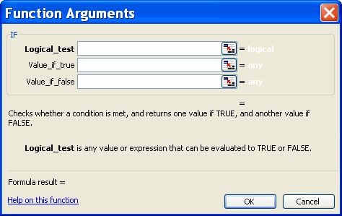

- In the Logical_Test field, enter what you are testing (for example, A1>0).
- In the Value_If_True field, enter what you want Excel to do if the value meets the criteria (for example, if A1 is greater than 0, return a value of “In Stock”).
Helpful Hint:

When using functions, if you can’t remember the cell reference and you can’t see the cells, press the Collapse button . Click the cell you want to refer to and then click the Expand button .

- In the Value_If_False field, type in what you want Excel to do if the value does not meet the criteria (for example, if A1 is not greater than 0, return a value of “Backordered”).
- Click the OK button when finished. Excel updates the formula bar to read =IF(A1>0,“In Stock”,“Backordered”).

- For the CountIf function, the following window appears:

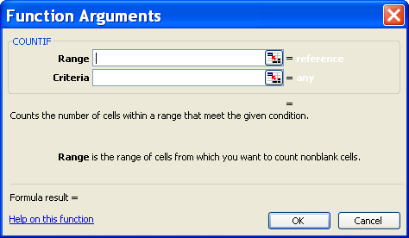

- In the range field, enter where you want Excel to look for a specific value (for example, B2:B9).
- In the criteria field, enter the specific value that you want Excel to find (for example, “Backordered”).
- Click the OK button when finished. Excel updates the formula bar to read =countIF(B2:B9,“Backordered”).

- For the SumIf function, the following window appears:

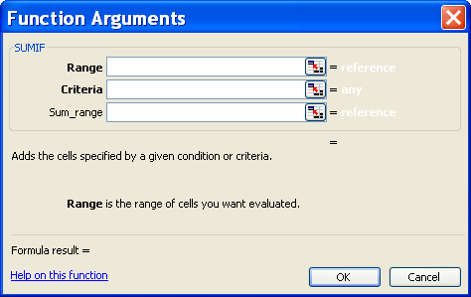

- In the range field, enter where you want Excel to look for a specific value (for example, B2:B9).
- In the criteria field, enter the specific value that you want Excel to find (for example, “In Stock”).
- In the Sum_Range field, enter the range where you want Excel to get the data to total for the fields with the given criteria (for example, C2:C9).
- Click the OK button when finished. Excel updates the formula bar to read =sumIF(B2:B9,“In Stock”,C2:C9).

Lesson Example

Your office supplies vendor offers a 10% discount on all orders $300 and over. You are also wondering how many items you ordered with a Category Code of LEK. Finally, you would like a total for only the items that are in stock so that you can request a check.

STEPS

- In the Office Supplies workbook, group the January and February sheets. Use the IF function to determine the discount you would receive for the monthly orders.

- Click in cell E16. Press the AUTOSUM drop down list and select MORE FUNCTIONS.

- Click the drop down list in SELECT A CATEGORY and select LOGICAL.

- Select the IF function and click OK.

- In the Logical_Test field, enter G14>=300.

- In the Value_If_True field, type G14*.1.

- In the Value_If_False field, type None.

- Click the OK button when finished. Notice the syntax for the function in the formula bar.

- Using the COUNTIF function, find the number of items ordered with a category code of LEK.

- Click in cell E17. Press the AUTOSUM drop down list and select MORE FUNCTIONS.

- Select the countIF function from the STATISTICAL category and click OK.

- In the range field, select cells A2:A13.

- In the criteria field, type “LEK”.

- Click the OK button when finished. Notice the syntax for the function in the formula bar.

- Use SUMIF to calculate the total for in stock items only.

- Click in cell E18. Press the AUTOSUM drop down list and select MORE FUNCTIONS.

- Select the sumIF from the MATH & TRIG category and click OK.

- In the range field, select cells H2:H13.

- In the criteria field, click cell H2.

- In the Sum_Range field, select cells G2:G13.

- Click the OK button when finished. Notice the syntax for the function in the formula bar.

- View both worksheets then ungroup the sheets.

- Save the workbook.

EXERCISE:

You are assigned to track how many times an agent collects money, their total amount collected, and assign a sliding scale bonus based on that amount. In the 1st Quarter Collections worksheet, if the total amount collected is under $10,000, the agent receives 10% of the funds collected; if it is greater than or equal to $10,000, the agent receives 15%.

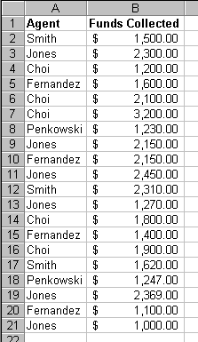
1. What would the formula look like to determine how many times Choi has collected funds? To count the number of collections per agent, use the COUNTIF worksheet function. (Hint: use the A26 cell reference instead of “Choi” in the function)
Helpful Hint:

You have the ability to “nest” other functions inside an IF function for more complex calculations. To do this, use the drop-down menu on the left side of the formula box while inside the original IF statement.

2. What would the formula look like to determine the total amount of funds Choi has collected? To calculate the total amount collected, use the SUMIF worksheet function. (Hint: use the A26 cell reference instead of “Choi” in the function)

3. What would the formula look like to determine the bonus that Choi should receive? To determine which one of two values to use, based on a condition that is either true or false, use the IF worksheet function.

4. On Your Own: In the 1st Quarter Collections sheet, insert the calculations for Choi into cells B26:D26, either by using the function wizard or typing it in yourself.

- Copy these formulas for all agents. Keep in mind that the range for funds collected would be absolute (Hint: use $ around the cell reference to make it absolute).

- If we had entered “Choi” instead of A26 in the original formula, what would have happened when we copied it?

________________________________________________

- Save your changes.

EXCEL FEATURES

OBJECTIVES: Use data validation tools to help ensure data is input correctly.
Utilize conditional formatting to bring attention to priority items.
Distinguish between the sorting and filtering features.
Add subtotals to worksheets and view summary information.

Data Validation

Overview

By using the Data Validation feature in Excel, you can limit cell entries to acceptable data.

STEPS
- Select the cells where you want to apply data validation.
- On the DATA menu, click VALIDATION, and then click the SETTINGS tab.
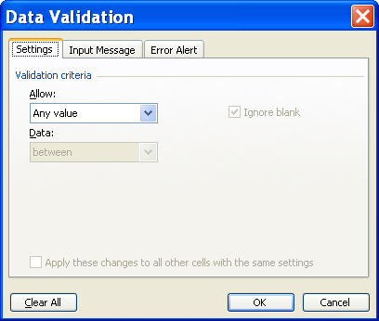
- In the ALLOW box, click the type of data.
To specify only numbers, click WHOLE NUMBER or DECIMAL.
To specify only dates or times, click DATE or TIME.
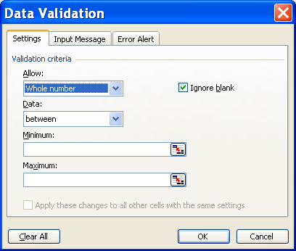
- Click the comparison you want in the DATA box, and then specify the upper, lower or both limits for the data, depending on the operator you select (you can enter values, cell references, or formulas for the limits).
- To allow the cell that you are restricting to be blank (or you set limits that use a cell reference or formula that depends on cells that are initially blank), make sure IGNORE BLANK is selected.
- To display a message to prompt for correct entries, specify the title and wording of the message you want on the Input Message tab.
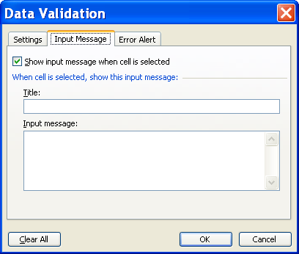
- To display a message and/or prevent incorrect entries when they are entered, go to the Error Alert tab and choose the Style of the alert, and type in a title and message.
To prevent certain data from being entered in a cell, choose the Stop style.
To give a warning message regarding the input, choose the Warning style.
To give information regarding the input, choose the Information style.
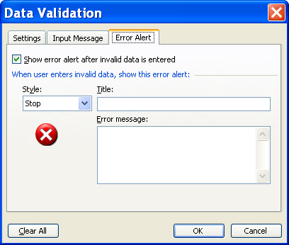
- Click Ok.
- To stop displaying messages, select the cells and go to Data menu, and then Validation and remove the checkmark from the Show input message when cell is selected check box on the Input Message tab, and remove the checkmark from the Show error alert after invalid data is entered check box on the Error Alert tab.
- When entering data into a cell that does not meet specified criteria if a Stop error alert style has been used, you may either press Retry and type in a new item or press Cancel to return to the original item.
- When entering data into a cell that does not meet specified criteria if a Warning error alert style has been used, you may press Yes to keep the item entered, press No to edit the item, or press Cancel to return to the original item.
- When entering data into a cell that does not meet specified criteria if an information error alert style has been used, you may press Ok to keep the new item or Cancel to return to the original item.

Conditional Formatting

Did You Know?

To remove all conditional formats as well as all other cell formats from selected cells, point to CLEAR on the EDIT menu, and then click FORMATS.

OVERVIEW

If a cell contains formula results or other cell values that you want to monitor, you can identify the cells by applying conditional formats. For example, you can apply green shading (highlighting) to the cell if the sales exceed forecast and red shading if sales fall short.

STEPS

- Select the cells where you want to apply conditional formatting.

- On the FORMAT menu, click CONDITIONAL FORMATTING.

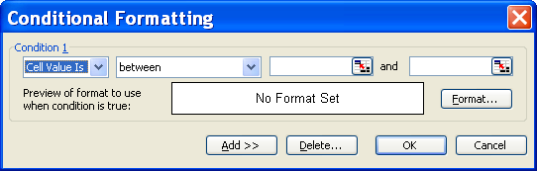

- To use values in the selected cells as the formatting criteria, click the comparison box (Between) select the comparison phrase, and then type a value in the next box. You can enter a constant value or a formula.

Did You Know?

You are not able to change fonts or font sizes in conditional formatting.

- To use a formula as the formatting criteria (to evaluate data or a condition other than the values in selected cells), choose FORMULA IS in the box on the left, and then enter the formula in the box on the right. The formula must start it with an equal sign (=) and must evaluate to a logical value of TRUE or FALSE.

- Click FORMAT.
- Select the font style, font color, underlining, borders, shading, or patterns you want to apply. Excel applies the selected formats only if the cell value meets the condition or if the formula returns a value of TRUE.
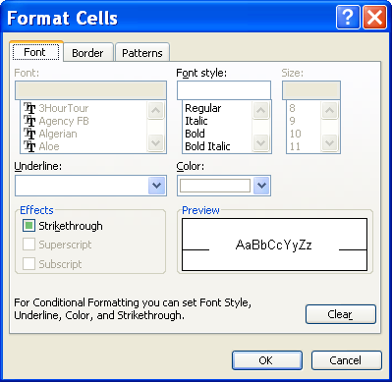

Did You Know?

If more than one specified condition is true, Excel applies only the formats of the first true condition.
- To add another condition, click ADD, and then repeat Steps 3 through 5. You can specify up to three conditions. If none of the specified conditions are true, the cells keep their existing formats.
Helpful Hint:

Another way to copy formats to other cells is to select the cells that have the conditional formats you want to copy and click the Format Painter button . Then select the cells where you want to apply conditional formatting.
- To copy the conditional formats, select the cells you want to format and include at least one cell in the selection that has the conditional formats you want to copy. On the FORMAT menu, click CONDITIONAL FORMATTING, and then click OK.

Lesson Example

A policy within your office requires that you obtain a supervisor's signature for the purchase of any single item $100 or greater. In addition, you like to keep track of items on backorder.

STEPS

  - In the Office Supplies workbook on the January worksheet, add data validation to the Price cells, by highlighting cells D2:D13, choosing DATA from the menu bar, and then VALIDATION.

  - Allow DECIMAL figures, select LESS THAN OR EQUAL TO under Data, and type 100 under Maximum.

  - Go to the Input Message tab and type the title Item Price. Use the message Enter the price of a single item here.

  - Next, go to the Error Alert tab and change the Style to Warning. Include a title of Expensive Item! and a message that states that You need a supervisor’s signature prior to ordering this item. Click Ok.

  - In cell D2, change the price of a box of paper clips to $101.00. Press Cancel to return to the previous value.

  - Apply conditional formatting to the status column by selecting cells H2:H13. Go to the Format menu and then Conditional Formatting.

  - Change the comparison box to Equal To and type Back Order in the next field.

  - Click the Format button and make the Font Style Bold On the Pattern tab, change the Cell Shading to Red. Click OK and Ok. View the worksheet and save your changes.

EXERCISE:

1) On the January-June sheet of the Sales workbook, click TOOLS, PROTECTION, UNPROTECT SHEET.

2) Use data validation to ensure that no sales figure exceeds 20 (i.e. less than or equal to 20) because that would mean there is an error.

3) Enter an Input Message stating that the entry is in millions and should not exceed 20.

4) Add an Error Alert in the Stop style that indicates the entry is too large. Try to enter an invalid figure.

5) Apply conditional formatting to the sales data, where any region's sale of a single product over $5 million will have a dark blue background with white lettering.

6) On Your Own: In the Agent workbook on the Employees tab, set validation on the Regional Manager's salary to go no higher than $40,000. Use input messages and error alert messages as appropriate. Attempt to change it to $50,000. Return to the original figure.

7) Format all Paternity Agent titles to be bright blue, bold, and italic.

Sorting

Overview

Excel uses specific sort orders to arrange data according to the value, not the format, of the data.
In an ascending sort, Excel uses the following order:
  - Numbers are sorted from the smallest negative number to the largest positive number.
  - When you sort alphanumeric text, Excel sorts left to right, character by character. For example, if a cell contains the text "A100," Excel places the cell after a cell that contains the entry "A1" and before a cell that contains the entry "A11."
Helpful Hint:

If you select an entire column and then attempt to sort it, it only sorts that column and not the corresponding columns.

  - Text and text that includes numbers are sorted in the following order:
0 1 2 3 4 5 6 7 8 9 (space) ! " # $ % & ( ) * , . / : ; ? @ [ \ ] ^ _ ` { | } ~ + < = > A B C D E F G H I J K L M N O P Q R S T U V W X Y Z
- Apostrophes (') and hyphens (-) are ignored, with one exception: If two words are the same except for a hyphen, the word with the hyphen is sorted last.
- In logical values, FALSE is placed before TRUE.
- Blanks are always placed last.
(In a descending sort, this sort order is reversed except for blank cells, which are always placed last.)

STEPS

- To sort ascending by one column, click a cell in the column you would like to sort by. Click SORT ASCENDING .
- To sort descending by one column, click a cell in the column you would like to sort by. Click SORT DESCENDING .
- To sort by multiple columns, click on any cell in the list you wish to sort.
- From the DATA menu, choose SORT.
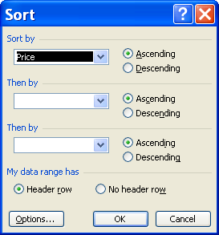
- In the SORT BY and THEN BY boxes, click the columns you want to sort.
- Select any other sort options you want by using the Options button.
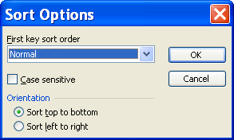
- To sort columns based on row contents, under ORIENTATION, click SORT LEFT TO RIGHT, and then click OK.

- To make the sort case sensitive, click in the box next to Case Sensitive.

Lesson Example

You want to sort your list of office supplies.

STEPS

1. On the January worksheet, sort the list by Price in ascending order by clicking in a cell in the Price column and clicking on Sort Ascending.

2. Sort by Price in descending order by clicking in a cell in the Price column and clicking on Sort Descending.

- Sort the list by Category Code, then by Total by going to the DATA menu and selecting SORT.

- In the SORT BY box, select Category Code. In the THEN BY box, select Total. Click Ok.

5. Save your changes.

EXERCISE:

1) On the Employees sheet of your Agent workbook, sort the list by Zip Code.

2) Sort the list by Gender, then by Base Pay.

3) On Your Own: Sort the list by Base Pay in descending order.

  - Save your changes.

AutoFilter
OVERVIEW

Filtering is a quick and easy way to find and work with a subset of data in a list. A filtered list displays only the rows that meet the criteria you specify for a column. Unlike sorting, filtering does not rearrange a list. Filtering temporarily hides rows you do not want displayed. When Excel filters rows, you can edit, format, chart, and print your list subset without rearranging or moving it.

STEPS
- Click on any cell in the list.
- From the DATA menu, choose FILTER, AUTOFILTER.
- Click the arrow appearing to the right of the column by which you wish to filter.
Helpful Hint:

When you have made a selection using AutoFilter, the arrow for that column turns blue. Your row numbers are also blue when AutoFilter is activated.

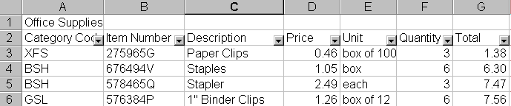

4. The following drop-down menu will appear:
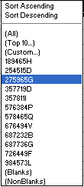
5. To view rows with one specific entry, select the entry from the list.
6. To view the "top" of the list, select TOP 10 and enter your criteria.
  - To view the entire list, select ALL.
  - To create a custom filter, click CUSTOM.
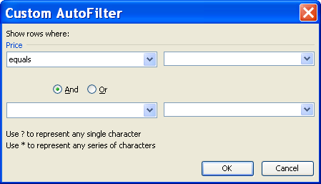

  - Fill in the appropriate choices and click OK.
  - To turn off AutoFilter, return to the DATA menu and select FILTER, AUTOFILTER.

Lesson Example

Sorting the list didn't give you exactly what you wanted to see. You think a filter might work better.

STEPS

    - Filter your January Office Supplies list to only see the items with a Category Code of LEK by going to the DATA menu and selecting FILTER, AUTOFILTER.

    - Click the arrow appearing to the right of the Category Code column and choose LEK from the drop-down list.

    - Return to the entire list by clicking the arrow appearing to the right of the Category Code column and choosing All from the drop-down list.

    - Filter the list to show only items that are in stock by clicking the arrow appearing to the right of the Status column and choosing In Stock from the drop-down list.

    - Turn the filter off by going to DATA, FILTER. Take the check mark off AUTOFILTER.
EXERCISE:

1) On the Employees sheet of your Agent workbook, filter the list to show only females.

2) Return to the entire list.

3) Create a CUSTOM FILTER to show you agents who live in Maine and make less than $25,000.

4) In the State column, select ME. In the Base Pay column, select Custom.

5) Choose is less than in Base Pay and select $25,000 from the drop down list. Click OK.

6) On Your Own: Return to your entire list.

7) Create a CUSTOM AUTOFILTER to find out which employees were hired after 01/01/1996.

8) Remove the filter and save the file.

Subtotals
OVERVIEW
Excel can automatically summarize data by calculating subtotal and grand total values in a list. To use automatic subtotals, your list must contain labeled columns and the list must be sorted by the columns for which you want subtotals. When you insert automatic subtotals, Excel outlines the list by grouping detail rows with each associated subtotal row, and grouping subtotal rows with the grand total row.
Helpful Hint:

If you are planning to use the subtotal feature, do not manually add totals to your existing data because Excel treats these as line items.
STEPS
- Sort the list by the column for which you want to calculate subtotals.
- Click a cell in the list.
- On the DATA menu, click SUBTOTALS.
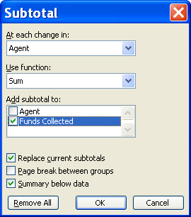
- In the AT EACH CHANGE IN box, click the column that contains the groups for which you want subtotals. This should be the same column by which you sorted your list in Step 1.
- In the USE FUNCTION box, click the function you want to use to calculate the subtotals.
- In the ADD SUBTOTAL TO box, select the check boxes for the columns that contain the values for which you want subtotals.
- Click OK.

Summary Reports
OVERVIEW
When you add automatic subtotals to a list, the list is outlined so that you can see its structure. You can create a summary report by clicking the outline symbols to hide the details and show only the subtotals.
STEPS
- Use the outline and buttons to expand or collapse the list as you like.
Detail level buttons

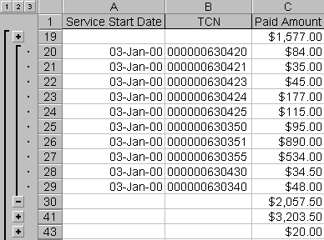.
Expand button
Collapse button
- To view just the grand total(s) for the list, click on .
- To view only the group subtotals and grand total(s), click on .
- To view all the details in the list along with the subtotals and grand total(s), click on .
- To create a chart of summarized data, keep the list collapsed as you like and use the Chart Wizard to develop a chart. As you show or hide details of your list, the chart also shows or hides this data.
- To remove subtotals, go to Data, Subtotals and then Remove All.

Lesson Example

You need to pay only for the items in stock. Subtotaling the list enables you to see what you owe currently and what you need to pay later. In addition, your supervisor wants to know how much you are spending by category.

STEPS

  - In the January worksheet of your Office Supplies workbook, sort by Status.
  - Delete the information in rows 14:18.

- On the DATA menu, click SUBTOTALS.

- In the AT EACH CHANGE IN box, click STATUS.

- In the USE FUNCTION box, click sum.

- In the ADD SUBTOTAL TO box, select the check boxes for the Quantity and Total fields. Click OK.

- View the summary information by clicking on the in the summary bar.

- Remove the subtotals and summary information by going to Data, Subtotals and then Remove All.

- Save your changes.

EXERCISE:

1) On the Employees sheet of your Agent workbook, sort the list by Title.

2) Create a subtotal that: AT EACH CHANGE in Title you will USE FUNCTION Average and ADD THE SUBTOTAL TO Base Pay.

  - On Your Own: Subtotal 1st Quarter Collections by Agent. What other way can this same function be done? (Hint: it was a previous exercise)

  - Remove the Subtotal and save your changes.

EMBEDDING AND LINKING

objective: Embed and link Excel files to Word documents.

overview

One of the most important features of Windows is the ability to transfer and share data between applications. This feature is known as Object Linking and Embedding (OLE). All Microsoft Office Applications allow you to use this feature (a worksheet, chart, picture, etc. can be either embedded in or linked to another application).

Some terminology that is helpful in understanding this process includes:

OBJECT a piece of information (chart, spreadsheet, picture, etc.)

SOURCE FILE the file (chart, spreadsheet, picture) in which the object is created.

DESTINATION FILE the document that is to receive the object.

LINKING a reference to the original object is added to the destination file. Any editing of the source document is reflected in the destination file the next time it is opened.

EMBEDDING a copy of the object is added to the destination file. Changes made in either file do not affect the other.

STEPS

1. If you haven't already done so, create your source and destination files.

2. Open your source file.

3. Select the portion of the file to be used, and click the COPY button in the Standard toolbar.

4. Open your destination file.

5. Position your insertion point where you want the object.

6. To embed the object, click the PASTE button in the Standard toolbar.

- To link the object, click EDIT, then PASTE SPECIAL.

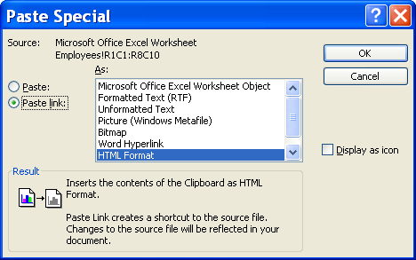
Helpful Hint:

If you move a source file, update the link in the destination file by going to Edit, Links and then Change Source.

- Click the PASTE LINK radio button, and select the source's file format from the AS list. Click OK. The more frequently used formats are:

- Microsoft Excel Worksheet Object – object remains an Excel worksheet
- Formatted Text (RTF) – object converts to a Word table
- Unformatted Text – object changes to plain text (not in a table)
- Picture – object becomes a picture (cannot edit)

- To edit the spreadsheet while it is embedded in Word, update it as you would a Word table. Calculated cells no longer function.

- To edit the spreadsheet while it is linked to Word, either edit it directly in the Word file or double click it to go to Excel and edit (it depends on Paste As type – see Step 8 above).

- To delete the spreadsheet embedded in Word, click in a cell in the table and click on Table, Delete, and then Table.

- To delete the spreadsheet linked to Word, if it is a picture or Excel formatted object, click on it and press Delete; if it is a table format, see Step 11, and if it is unformatted text, select the text and press Delete.

Lesson Example

You need to submit a report on office supply expenditures.

STEPS

- Select cells A1:H13 on the January sheet of the Office Supplies workbook. Click on Copy .

- Create a new Microsoft Word document by going to Start, Programs, Microsoft Word.

- Type Office Supplies – January at the top of the page.

- Change the page orientation to landscape by going to File, Page Setup. Click the Landscape button and click Ok. Position your insertion point below the title.

- Embed the January office supply order below the title by clicking Paste .

- Save your new Word document as Office Supplies.

EXERCISE:

1) Create a new Microsoft Word document.

2) Type Agent Collections on the first line of the new document.

    - Press Enter several times.

    - In the Agent workbook, on the 1st Quarter sheet, select cells A1:B21. Copy the selection.

    - In the word document, click EDIT, PASTE SPECIAL. Paste the link as Microsoft Office Excel Worksheet Object and click OK.

    - Double-click the object in the Word document and change Smith’s first collection amount to $15,000. Go back to the Word document to view the change.

    - Save the Word file as Agent.

    - On Your Own: Create another new Word document.

    - Type Product Sales 2000 at the top.

    - Press Enter several times, and embed the Summary sheet from the Sales workbook.

    - Close the document without saving.

GIVE IT A TRY!

OBJECTIVE: Practice advanced features of Excel learned in class.

EXERCISE:

Refer to Lesson 1 for assistance

  - Create the following worksheet on Sheet 1 of a new workbook:

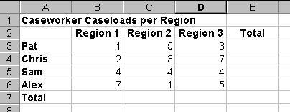

  - Save the file as Caseworker.

  - Copy the information to Sheet 2. Rename Sheet 1 2006 and Sheet 2 2007.

  - View both worksheets on your screen at the same time.

  - Return to normal view.

  - Group the worksheets together and add the AutoSum function to cells B7:D7 and E3:E7. Ungroup the sheets.

  - Place the cursor in cell B3 and freeze the panes.

  - Rename Sheet 3 Total and create the following:

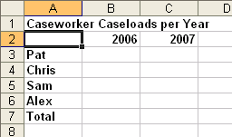

  - Paste the links from the 2006 and 2007 worksheets in the appropriate columns. Make a change on the 2006 worksheet and view the change on the Total worksheet.

Refer to Lesson 2 for assistance

  - Create the following section of the Total worksheet starting at cell A9:

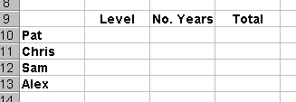

  - Use the IF function in cell B10 that assigns a category based on caseloads. Caseloads less than thirteen for year 2006 are considered “Light” and caseloads of thirteen or more are considered “Adequate”.

  - Use the COUNTIF function in cell C10 to determine the number of years a caseload was considered “Light” (Hint: Range=B3:C3 and Criteria=<13). Answers can be zero.

  - Use the SUMIF function in cell D10 to calculate the number of cases Pat had if they rated “Light” (Hint: Range=B3:C3, Criteria<=12, and Sum Range=B3:C3). Answers can be zero.

  - Copy the formulas for the other caseworkers.

Refer to Lesson 3 for assistance

  - Use data validation on the 2006 worksheet that does not allow any caseworker to have more than ten clients in any one region. Use input messages and warning styles as appropriate.

  - On the same sheet, use conditional formatting on the totals to bring attention to any caseworker who has less than 15 cases (so that you may possibly shift cases to be more efficient

  - Sort the list by caseworker name.

  - Use the AutoFilter to show only Alex’s regions. Show all caseworkers.

  - Add subtotals that show Sum amounts for each caseworker in each region.

  - Show the high level summary for each caseworker. Remove the subtotals.

Refer to Lesson 4 for assistance

  - Embed the 2006 worksheet to a blank Word document. Close the document and do not save the changes.

  - Link the Total worksheet to a new blank Word document. Change a figure in the Total worksheet and note the change in the Word document. Close the document and do not save the changes.

DELETING FILES

objective: Delete files and maintain organized file directories.

OVERVIEW

You can delete files through the Windows Explorer or you can delete files directly from a program. The following shows the steps to delete from a program.

STEPS

1. Close any open files. Click FILE on the menu bar, click OPEN, or the OPEN button .

2. Click on the file to delete, press the DELETE KEY on the keyboard, then click YES.

3. To choose several files, hold down the CTRL KEY (on the keyboard) and click on each file to delete, press DELETE, then YES.

4. To choose a block of files, click on the first file, hold down the SHIFT key, click on the last file, press DELETE, then YES.

- Lesson Example

You want to delete your exercise files.

STEPS

- Close any open files in both Excel and Word.
- In Word, click the OPEN button.

- Click on the Agent file, hold down the CTRL key and click on the Office Supplies file. Press the DELETE key on the keyboard, then click YES.

- Exit Word.

EXERCISE:

- In Excel, click the Open button. Select the Agent file and delete it.

- On Your Own: Delete the Offices Supplies and Sales files.

- Exit Excel and shut down the computer.

NICE TO KNOW

OBJECTIVES: Create and run basic macros.
Effectively design spreadsheets.

Simple Macros
OVERVIEW

A macro is a function that allows you to record a series of commands you use frequently and then allows you to perform them with one mouse click (or keyboard stroke) instead of numerous steps.

STEPS

1. Click TOOLS, MACRO. You may need to expand the menu to see this option.

2. Click RECORD NEW MACRO.

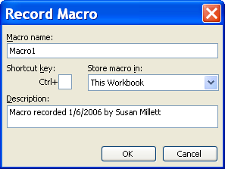

3. Type a name for the macro under Macro Name (macro names cannot contain spaces).

4. To assign to a keyboard command, type a letter (either capital or small) beside CTRL+ in the Shortcut Key section on the Record Macro window.

- Note where you want the macro stored, and type in a description of the macro under Description. Click OK. The Stop Recording toolbar appears.
Helpful Hint:
Avoid clicking on the ‘X’ in the macro recording toolbar because you won’t be able to get the toolbar back for any new macros.
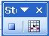

6. Perform the mouse or keystrokes you want to record. Click STOP RECORDING when finished.

7. To use the macro, click TOOLS, MACRO, and double click the macro you want to use (or click the macro name once, then click Run).

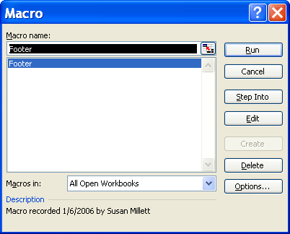

- To use the keyboard command, position the cursor in the cell where you want to use the macro, then press the shortcut key combination.

9. To delete a macro, click TOOLS, MACRO, MACROS, click the macro name, click DELETE, and YES.
Helpful Hint:

Macros store over any current keyboard commands. For example, if you were to use CTRL+B for your macro keyboard command, CTRL+B no longer creates bold text.

Did You Know?

You cannot use Undo after running a macro.

Did You Know?

A macro shortcut key must be a letter.

