INTRODUCTION TO ACCESS 2003

Table of Contents
Page
LESSON 1: ACCESS BASICS 1
♦ What is Access? 1
♦ Opening Access 1
♦ Opening an Existing Database 2
♦ Parts of the Access Window 3
♦ Terminology 4
♦ Closing a Database and Exiting Access 5
♦ Creating a New Database 6
LESSON 2: CREATING TABLES 9
♦ Introducing Tables 9
♦ Creating a Table in Design View 10
♦ Field Names 11
♦ Data Types 11
♦ Description 12
♦ Entering Field Information 12
♦ Creating a Primary Key 13
♦ Saving and Closing a Table 14
♦ Moving Fields 16
♦ Removing a Field 17
LESSON 3: FIELD PROPERTIES 19
♦ Field Size 19
♦ Default Values 21
♦ Input Masks 22
♦ Date Formatting 25
♦ Lookup Fields 27
♦ Data Entry in a Table 30
LESSON 4: CREATING FORMS 33
♦ Creating an AutoForm 33
♦ Data Entry Using a Form 35
♦ Record Navigation 35
♦ Creating a Form Using the Wizard 39
LESSON 5: EDITING DATA IN A FORM 43
♦ Find 43
♦ Editing Records 44
♦ Filtering 45
♦ Deleting Records 46
LESSON 6: BASIC QUERIES 48
♦ Creating a Query with the Wizard 48
♦ Creating a Query by Design 51
LESSON 7: BASIC REPORTS 57
♦ The Report Wizard 57
♦ Label Reports 63
LESSON 8: GIVE IT A TRY! 68
LESSON 9: DELETING 71
♦ Deleting Databases 71
NICE TO KNOW 72
♦ Access Help Features 72
♦ Mouse Pointers 73
♦ Toolbar Buttons 74
♦ Keyboard Shortcuts 75

This workbook may be reproduced in whole or in part by an employee of the Department of Health and Human Services. All other reproduction is prohibited unless written permission is obtained from the Training Institute.

ACCESS BASICS

OBJECTIVES: Create a database in Access.
Recognize the parts of the Access window.
Recognize the objects used in Access.

What is Access?

OVERVIEW
Microsoft Access is a relational database application. A database is a collection of data that may be organized to make it easier to find information according to a particular topic or purpose. Examples of a database would be a telephone book, an address book, a group of personnel files, a client base for a company, or even just a list of your own friends and relatives.

A relational database is also a collection of data. It is organized into individual tables, each with their own purpose. These tables include connecting data that allows them to “relate” to one another. Therefore, the user is able to combine data from many tables to analyze the data and gain useful information.

Opening Access

OVERVIEW
When you open Access, the Task Pane gives you the option of creating a new database or open an existing database. The last several databases you have used will be listed, so you may open them directly. If the database does not appear on the list, you are able to open a browser, which allows you to open any database file.

STEPS
1. Click START, PROGRAMS, MICROSOFT ACCESS.

Opening an Existing Database
OVERVIEW

When you have created a database or one has been provided for you to use, the opening dialog box in Access gives you the option to open that database.

STEPS

- To open a recently used database, click the name of the database in the Task Pane.

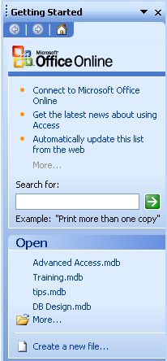

- To open a database not on the list, click MORE... or click the OPEN button in the toolbar.

- Click the drop-down arrow next to LOOK IN, and click the drive that contains the database you wish to open.

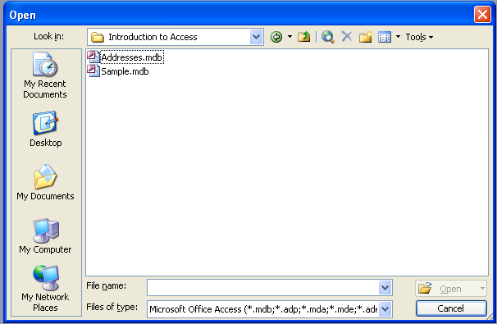
- Click the database name, and then click OPEN.

- You may get a Security Warning. Click OPEN.

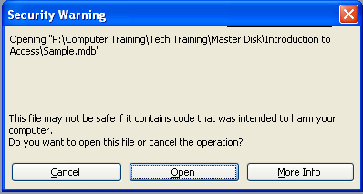

Parts of the Access Window

OVERVIEW
The Access window typically shows the following:

Title Bar
Database Title
Object Toolbar
Objects Bar
Status Bar
Database Window
Maximize/Restore
Minimize
Close
Database Toolbar
Task Pane

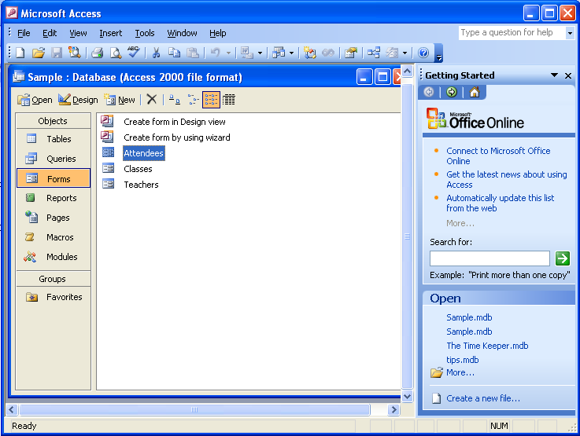
Menu Bar

Terminology
Title Bar - the blue bar at the top of the screen; that shows the program name.
Helpful Hint:

If you point to a toolbar icon for a moment, Access will display the tool name. This feature is called a ToolTip.

Minimize, Restore Down/Maximize, and Close Buttons - allow you to manipulate the program and workbook windows. Minimize collapses the window into the taskbar, Restore down shrinks the window slightly, Maximize makes it as large as your screen, and Close will exit the workbook or program.

Menu Bar - a list of functions. Click once on the menu name, then on the desired function (or use the ALT key and the underlined letter). When you open a menu, it will list the most common options. However, several other functions may not be visible. If you wait for a few seconds, the full menu appears or you can click on the double-down arrow button.

Toolbars - rows of icons representing shortcuts to common features. Click the tool you wish to use.

Database toolbar - the top toolbar, which contains buttons related to the overall database.

Object toolbar - the toolbar within the database window, which contains buttons related to the active object.

Database Window - the portion of the screen dedicated to the active database. It contains all of the objects that comprise the database. Access only allows one database to be open at a time (unless you open Microsoft Access twice).

Database Title - the blue bar at the top of the database window showing the database name.

Objects Bar - vertical panel on the left of the database window that displays the names of the various objects available in a database.

Tables - the only essential element of a database. Tables store data.

Field - a single element of a table. A field is an individual piece of data. Field names become the column headings of tables.

Record - a single row of fields that represent the data for one entity, such as a person or organization.

Queries - answer questions you may have about the data in your tables.

Forms - provide you with a user-friendly format for entering and editing your data.

Reports - nicely formatted, printable versions of complete or partial tables and queries.

Pages - allow users to create Web versions of Access databases

Macros - perform a series of actions automatically, such as opening a form directly to a new record or printing and closing a report.

Modules - a collection of Visual Basic for Application statements stored together as a unit.

Status Bar – an informational section at the very bottom of the program window.

Scrollbars - appear on the right and bottom of the window, and allow you to see different areas of the worksheet.

Task Pane - helps you get your work done, bringing the tools you need right up close to your work.

Closing a Database and Exiting Access
OVERVIEW

Unlike many Microsoft applications, Access does not allow you to open more than one database at a time. Therefore, it is best to close one database before opening another. In addition, you need to know how to exit Access when finished for the day.

STEPS

- To close an open database and remain in Access, click the CLOSE button in the upper right corner of the database window (inside window).

- To exit Access and close the open database at the same time, click the CLOSE button in the upper right corner of the Access window (outer window).

Lesson Example
You would like to open an existing database.

STEPS

- Click START, PROGRAMS, MICROSOFT ACCESS.
- Locate the SAMPLE database (your instructor will tell you where the file is located) and click OPEN. (You may have to click OPEN twice, depending on security messages.)
EXERCISE:

1) Identify the different parts of the Access window.

2) Close the Sample database, but remain in Access.

3) On Your Own: Open the database named Addresses.

4) Close the database, and exit Access.

Creating a New Database
OVERVIEW

The two methods for beginning a brand new database are to start from scratch, or use an Access Wizard that provides you with several different databases that you may modify to meet your needs. This lesson will cover how to create a new blank database from scratch.

STEPS

- Click START, PROGRAMS, MICROSOFT ACCESS.
- Click CREATE A NEW FILE … on the Task Pane.

- In the Task Pane, Click BLANK DATABASE…

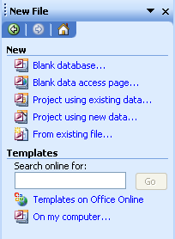

- In the FILE NEW DATABASE Window, type a filename for the database. An extension of .mdb will automatically be added in the SAVE AS TYPE drop-down menu.

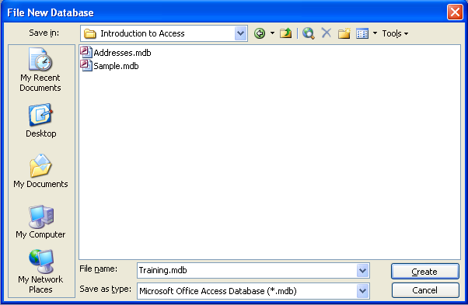

- Click CREATE.

Lesson Example
You would like to create a new database.

STEPS

- Click START, PROGRAMS, MICROSOFT ACCESS.
- Click the CREATE A NEW FILE hyperlink, then click BLANK DATABASE.
- Type Test for a filename, click MY DOCUMENTS in the left panel to indicate where to save it, and click CREATE.

EXERCISE:

1) Close the Test database, and create a new database named Access in the My Documents folder.

2) Close Access (and the Access database with it).

3) On Your Own: Create a new database named Training, and save it in the My Documents folder.

CREATING TABLES

OBJECTIVES: Create a table in Access.
Identify parts of a field.
Determine field properties.

Introducing Tables
OVERVIEW

There are three ways to create tables:

- Create table in design view - Design view requires you to create a table from scratch. This involves creating your own field names and data types.

- Create table by using wizard - The wizard uses sample tables to guide you through creating a table. A table is created based on the fields that you choose.

- Create table by entering data - Enter data directly into a blank datasheet. When the new datasheet is saved, Microsoft Access will analyze your data and automatically assign the appropriate data type and format for each field.

Tables include fields and records. Columns in tables are called Fields, and Rows are called Records. A Datasheet is the collection of fields and records.

FIELD - contains a piece of information about a person or product.

RECORD - a group of fields that contain all of the information about a particular topic.
Fields
Records

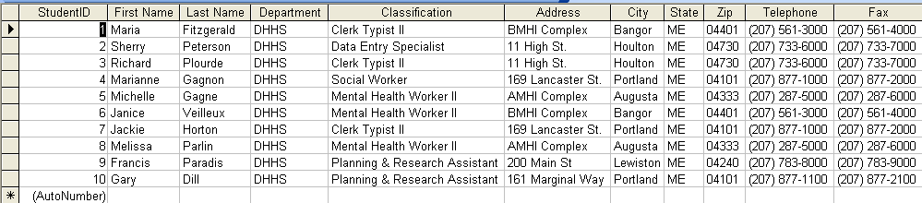

Creating a Table in Design View
OVERVIEW

The Table Design View window requires you to identify the field name and data type. You may also add a description and adjust several different field properties.

- Click the TABLES object in the Database Window.
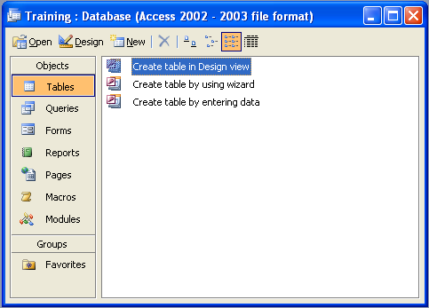

- Double-click CREATE TABLE IN DESIGN VIEW. The following window will appear:

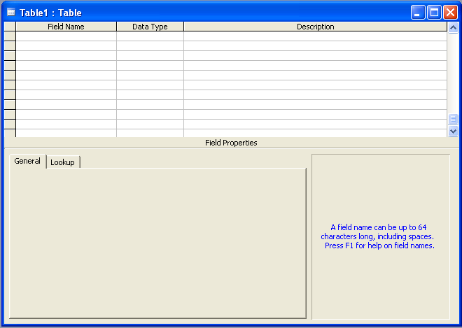

Field Names
OVERVIEW

When naming a field, the most important thing to remember is consistency. You will want to make sure the way you name a field is the same as others in your office. It is also important to use the same method for naming fields throughout your database. For example, LastName, FirstName or Last Name, First Name. It is also important to know that you cannot have two fields with the same name in one table, but you can use up to 64 characters and spaces for each field name.

Data Types
OVERVIEW

Access needs to know the type of information that will be contained in each field. The following options are available:

Text: use for all data that does not fit into another data type. Can hold 255 characters.

Memo: for longer text such as notes and descriptions. Can hold 65, 536 characters.

Number: when you want to be able to do mathematical calculations with the field.

Date/Time - use for dates and times.

Currency: use for money.

AutoNumber: use to have records numbered in the order they are entered.

Yes/No: use whenever you want “yes/no” or “true/false” choices.

OLE Object: Object Linking and Embedding - use to add pictures or charts.

Hyperlink: text or combination of text and numbers stored as text and used as a hyperlink address.

Lookup Wizard: uses a Wizard to help you create a drop-down list.

Description
OVERVIEW

If you want, you may add your own description for a field. You may use up to 255 characters. This description is helpful if others will be entering data. The description will be displayed on the status bar at the bottom of your screen when you work on this field in a form or in a datasheet.

Entering Field Information

STEPS
Did You Know?

You may simply type the first letter of the desired Data Type to call it up from the list.

- In the FIELD NAME section, type the name of the field. Press the TAB key.
- Click the drop down arrow and select a DATA TYPE. Press the TAB key.
- Type a description if desired. Press the TAB key to move to the next field.

Lesson Example
It is time to create a table of students in your Training database including appropriate fields.

STEPS

- Click the TABLES object in the Database Window.
- Double-click CREATE TABLE IN DESIGN VIEW.
- Type the field name of FirstName and press TAB.
- Verify the DATA TYPE is TEXT and press TAB.
- Type Please capitalize the first initial in the DESCRIPTION and press TAB.

EXERCISE:

1) Add a field named LastName with a data type of Text and the description Please capitalize the first letter.

2) On Your Own: Add the following fields:

Field Name Data Type Description
Address Text
Telephone Text Include Area Code
Birthdate Date/Time
E-mailAddress Text

Creating a Primary Key
OVERVIEW
Helpful Hint:

Allowing Access to add a Primary key adds an ID field to your table that automatically numbers records in the order in which they are typed.
A Primary Key identifies each record as unique. A Primary Key field cannot be null (empty) or a duplication. If your table has a field that will fit this description, it is best to use that field as the primary key. For example, if the table you are creating will track a unique Student ID, that should be used as your primary key field. However, if no field will be unique for every record, Access can actually create a field expressly for this purpose using a data type called AutoNumber.

STEPS – Creating a Manual Primary Key

- In Design View of your table, type the name of the field you will use as the primary key. Press the TAB key.

- Select an appropriate data type for the field, and press the TAB key.
Did You Know?

If you already have a field that meets Primary Key standards, simply click on the field, then click the PRIMARY KEY button on the toolbar.
- Type a description if desired.

- On the toolbar, click the PRIMARY KEY button . A small key will appear to the left of the field name.

STEPS – Creating an Automatic Primary Key

1. Create a table without a primary key field, and click the SAVE button in the toolbar.

2. Type the name of the table and click OK.
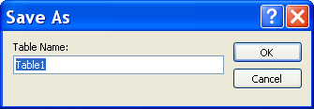
3. At the following dialog box, click YES. Access will add a field to your table with an AutoNumber data type that will require no data entry on your part.
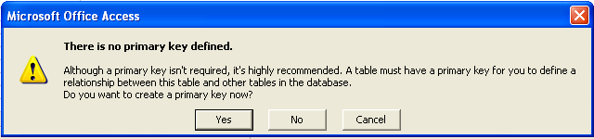

Saving and Closing a Table

STEPS

- Click the SAVE button .
- Type the name of the table and click OK.
Did You Know?

Once you have created other database objects based on a table, renaming that table will destroy the connection between the table and the other object(s).
- If prompted about the primary key, click YES to have a primary key automatically added or click NO to not have a primary key.
- To close a table, click the CLOSE button in the upper right hand corner of the Table window.

- To rename a table, right-click on the table name in the Database window, and click RENAME. Type the new name, and press the ENTER key.

- To delete a table, click once on the table name in the Database window, and press the DELETE key on your keyboard. Click OK to confirm the deletion.

Lesson Example
You want to add a Primary Key, save, and close the table.

STEPS

- Add the field StudentID with a DATA TYPE of AUTONUMBER.
- With your insertion point anywhere within the StudentID field, click the PRIMARY KEY button.
- Click the SAVE button, and type the name Students. Click OK.
- Click the CLOSE button in the upper right hand corner of the Students table.
EXERCISE:

1) Create a new table in Design View.

2) Add a FirstName and a LastName field with the data type as Text.

3) Save the table using the name Instructors. Allow Access to create a Primary Key for you.

4) Close the Instructors table.

5) On Your Own: Create a table, and add a field of ClassID with a data type of AutoNumber and a field named ClassName with a Text data type.

6) Make the ClassID field your Primary Key.

7) Save the table as Classes, and close the table.

Moving Fields

OVERVIEW

On occasion, you may decide you would like to add a field to your table. You may do this at the bottom of the field list at any time. However, if you would like to change the order of the fields, you will need to move whatever field(s) to a new location in the field list.

STEPS

- In Design View of the table, click once in the row selector of the field (the small gray box to the left of the field name). The field will be selected.
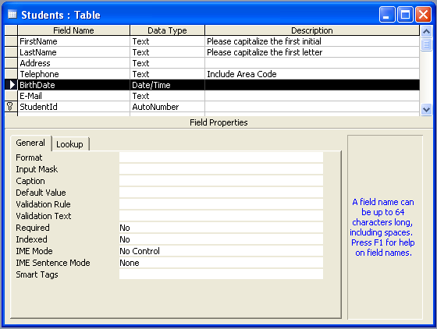
- With your mouse in the same spot (to the left of the field name), click and drag the field to the new location. A line will show where the field will be inserted.
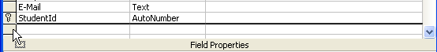
- Release the mouse button.

Removing a Field
OVERVIEW

You may decide that a field is not necessary for your table. You may delete entire fields from your table. Keep in mind that any data entered into that field in your table will be deleted as well.

STEPS

- In Design View of the table, click the row selector of the field to be deleted.

- Press the DELETE key on your keyboard.

- Click OK to confirm the deletion.

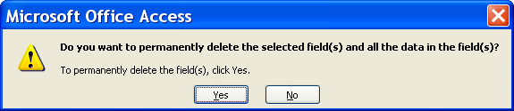

Lesson Example
You would like to add, remove, and relocate fields in your Students table.

STEPS

- Click the Students table once in the Database window, and click DESIGN button.
- Click in the next available Field Name area, and type City for the Field Name and choose Text for the Data Type.
- Click the row selector to the left of the City Field Name, then click and drag the field between the Address and Telephone fields.
- Click the row selector to the left of the E-mailAddress field, and press DELETE on your keyboard.

EXERCISE:

1) Move the StudentID field so it appears first on the list.

2) Add fields for State and ZipCode, both with Text data types.

3) Move the new fields after the City field.

4) On Your Own: Add fields for Department and Title with Text data types.

5) Move the new fields after the LastName field.

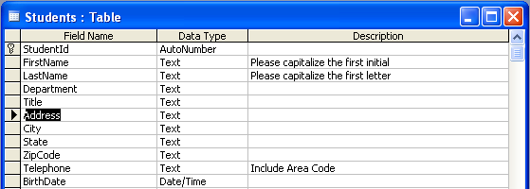

6) Save your changes.

FIELD PROPERTIES

OBJECTIVES: Set appropriate field properties.
Use the Lookup Wizard data type.
Perform data entry in a table.

OVERVIEW
There are several field properties that can be changed to meet the needs of your database. In changing these properties, the database can make data entry easier, enforce a specific format, and eliminate unneeded space.

Field Size

OVERVIEW
Text fields are limited to 255 characters and spaces of entry, and memo fields to 65,536. However, it is possible to limit these fields to a particular number of characters and spaces of entry. For example, in a text field that collects State data, you may be limited to entering only the two-character abbreviation. Like other field properties, it may not be apparent that the field size is limited until you attempt to type more than allowed.

STEPS

- In Table Design view, click in the field to modify.
- Press F6 to move to the FIELD PROPERTIES section or click in the FIELD PROPERTIES section.
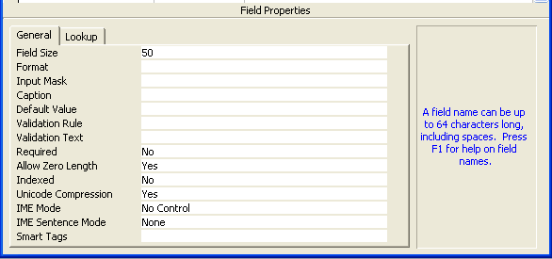
- Type the field size.
- Press F6 to return to the field or click in the FIELD section.

Lesson Example
It is a good idea to adjust field sizes.

STEPS

- In Design View of the Students Table, click in the FirstName field and press F6.
- Type 25 for the FIELD SIZE.
- Press F6.

EXERCISE:

1) Change the field size of the LastName field to 30.

2) On Your Own: Adjust the State field size to 2.

3) Save your changes.

Default Values

OVERVIEW
If a field will often contain the same data, a default value eliminates the need to enter that data repeatedly. However, it will allow you to enter alternate data whenever necessary. Fields with default values are very evident - they already have data in them.

STEPS

- In Table Design view, click in the field where you want the default value to be placed.
- Press F6 to move to the FIELD PROPERTIES section or click in the FIELD PROPERTIES section.
- Arrow down to DEFAULT VALUE. You may also click directly into Default Value with your mouse.
- Type the text to automatically appear in the field.
- Press F6 to return to the field or click in the FIELD section.

Input Masks

OVERVIEW
An Input Mask may be applied to certain types of fields so you do not have to type certain characters while entering data. For instance, when typing a telephone number, you can simply type the digits rather than having to remember parentheses around the area code and a dash in the middle of the number.

STEPS

- In Table Design view, click in a field.
- Press F6 to move to the FIELD PROPERTIES section or click in the FIELD PROPERTIES section.
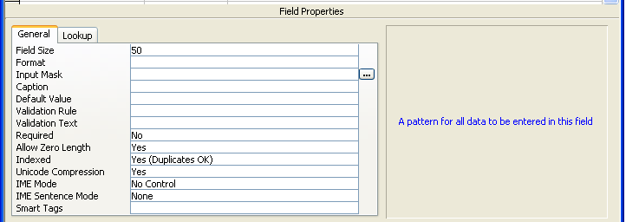
- Arrow down to INPUT MASK or click to the right of the label.
- Click the BUILD button that appears to the right of the box.
- You may be prompted to save any changes to the table at this point. Click YES.
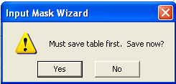
- When the Input Mask Wizard appears, click the type of INPUT MASK. Click NEXT.
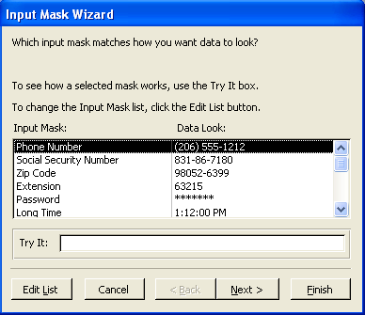
- The next screen is for making any changes to the Input Mask and to select a Placeholder character. The number 9 in the Input Mask code stands for an optional entry, while the number 0 means that an entry is required. In this example, that means that if you put any entry in the field you may skip the area code, but not the seven digits of the actual phone number. Click NEXT.
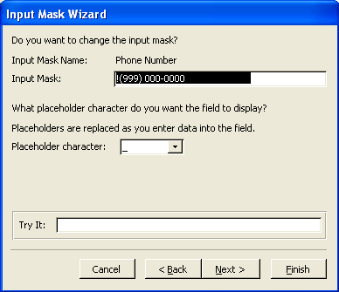
- Always click the option to save your data with the symbols. This option will make the entry look the way you want. Click NEXT.
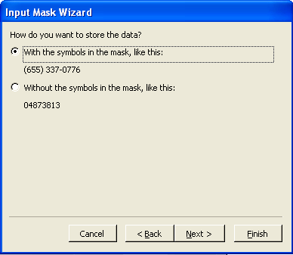
- Click FINISH.

- Access will enter the code for the Input Mask for you. This code will include the pattern for the input mask, followed by a 0 to denote that you chose to store the values with the symbols, and finally the placeholder character you selected. Press F6 to return to the field.

Date Formatting
OVERVIEW

You may format a Date/Time data type using one of several different types of date or time styles. For example, there is a format for a short date: 8/1/2001; or a long date: Saturday, August 11, 2001.

STEPS

- In Table Design view, click in the Date/Time field to be formatted.
- Press F6 to move to the FIELD PROPERTIES box. Or, click in the FORMAT line in the FIELD PROPERTIES area.
- Click the down arrow in the FORMAT box.
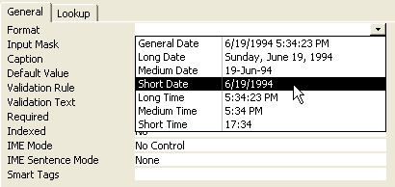
- Select the desired format.
- To have the date automatically format when doing data entry, add an Input Mask.
- Press F6 to return to the field.

Lesson Example

You would like an input mask for the Telephone field, so you don’t have to type the parentheses or dash.

STEPS

- In Design View of the Students table, click in the Telephone field.
- Press the F6 key, and arrow down to the INPUT MASK line.
- Click the BUILD button .
- If you get a prompt to save the table, click YES.
- Select PHONE NUMBER, and click NEXT.
- No changes are needed, click NEXT.
- Select the WITH THE SYMBOLS IN THE MASK option and click NEXT.
- Click FINISH.

EXERCISE:

- Add a default value of ME to the State field.
- Format the Birthdate field to the Short Date format.
- On Your Own: Add an Input Mask to the Birthdate field.
- Save your changes.

Lookup Fields

OVERVIEW
Helpful Hint:

If you have a list of data in a table that you wish to use as Lookup values for another table, use the LOOKUP VALUES IN TABLE option to save time.
A lookup field displays a drop-down list of possible choices. In most databases, you may not enter something in a lookup field that is not on the list.

STEPS

- In Table Design view, click in a field and TAB to the DATA TYPE.
- Select LOOKUP WIZARD.
- Once the Wizard starts, click I WILL TYPE IN THE VALUES THAT I WANT. Click NEXT.
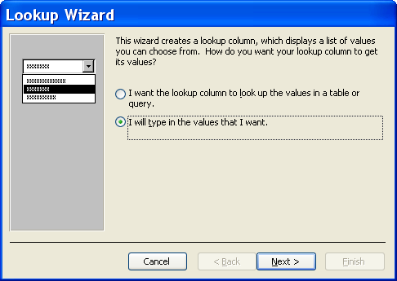
- Type the number of columns to be in the list and press the TAB key to enter the values that you wish to appear on the list. Press TAB after you type each value.
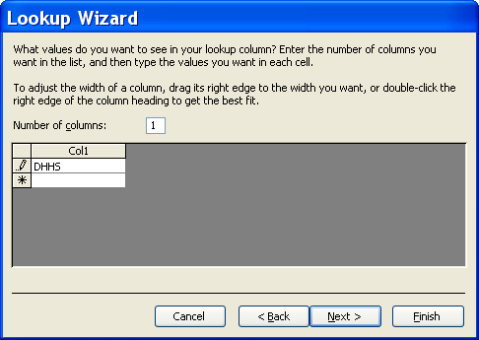
- In completing the Wizard, you will be asked for a label name. Access will automatically assign the Field Name. However, you may overwrite this if desired. Click FINISH.
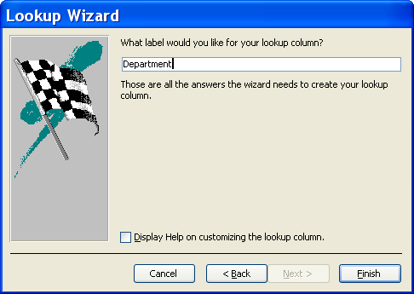
- To add a value to your Lookup list later on, click the name of the field containing the Lookup, and click the LOOKUP tab in the PROPERTIES area.
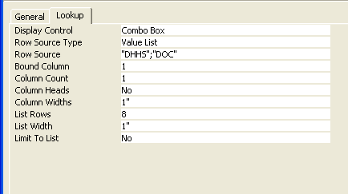
- Click in the ROW SOURCE line, and press the END key on your keyboard.
- Type a semi-colon (;) followed by the new value to add enclosed with “quotations”.
- Click the SAVE button.

Lesson Example
You want to limit data entry in the Department field to a specific list of values.

STEPS

- In Design View of the Students table, click in the DATA TYPE area of the Department field.
- Click the down arrow in DATA TYPE, and click LOOKUP WIZARD.
- In the first screen of the Wizard, click I WILL TYPE IN THE VALUES THAT I WANT. Click NEXT.
- Verify 1 column, and press the TAB key.
- Type the following Departments, pressing TAB after each.
DHHS
DOC
- Click NEXT.
- Verify the label is DEPARTMENT, and click FINISH. Note that the DATA TYPE is now TEXT.

EXERCISE:

1) Add the value Muskie to the lookup values for the Department field. (HINT: Click the Lookup tab in the Field Properties area).

2) On Your Own: Make the Title field a Lookup field including the following values:

Auditor
Case Manager
Clerk Typist II
Data Entry Specialist
Director
Mental Health Worker II
Planning and Research Assistant
Social Worker

3) Save your changes, and close the Students table.

Data Entry in a Table

OVERVIEW
Once the desired field properties are set, you may perform data entry directly within a table. One thing to note about entering data in Access is that you do not have to save your work. As you move from field to field, Access will automatically save for you.

STEPS

- From Table Design view, click the VIEW button . You will go to Datasheet View, and your insertion point will be in the first field of the first record.
- If data already exists in the table, you must click the NEW RECORD button ; otherwise, you will overwrite the existing entry.
- Type an appropriate entry into the first field of the new record. Press the TAB key to move to the next field in the record.
Helpful Hint:

You may resize the columns in your table in order to view the full entries by moving your mouse pointer between column headings and double-clicking.
- When you have reached the end of the record, the TAB key will move you to the first field of the next record.
- To enter data in an AutoNumber field, simply press the TAB key. HINT: The field itself will say “AutoNumber”, and the number will not appear until other data is entered in the record.
- To enter data in a field with a default value, if the data is correct, simply press the TAB key. If not, type the correct entry before pressing TAB.
- To enter data in a field with an input mask, type the data without the characters. For example, a phone number would require you only to type 2075551212.
- To enter data in a field including a Lookup list, either begin typing the beginning of the entry you desire until it appears, then press TAB or click the drop-down arrow and click the desired entry, then press tab.
- To place a checkmark in a Yes/No field, either click the checkbox with your mouse or press the SPACEBAR. Clicking again or pressing your spacebar again will toggle the checkmark on and off.
- To leave a field empty, simply press the TAB key to move past the field. However, if the field property is set to required, Access will display an error message asking for an entry of some kind.

Lesson Example
You would like to enter a student to your table.

STEPS

- Open the Students table by double-clicking it in the Database window.
- Press the TAB key to move off the AutoNumber field.
- Type Maria, and press TAB.
- Type Fitzgerald, and press TAB.
- Type the letter D, and press TAB.
- Type the letter C, and press TAB.
- Type Riverview, and press TAB.
- Type Augusta, and press TAB twice (the second time to keep the default state of ME).
- Type 04330, and press TAB.
- Type (207) 287-5555, and press TAB.
- Type 05/05/1945, and press TAB.
EXERCISE:

1) Enter the following student into your table:

Sherry Peterson
DHHS
Data Entry Specialist
11 High St.
Houlton, ME 04730
(207) 733-6000
10/05/1975

2) On Your Own: Enter the following student:

Richard Plourde
DOC
Clerk Typist II
5 Fifth St.
Concord, NH 03303
(603) 603-6033
02/16/1962

3) Close the Students table.

CREATING FORMS

OBJECTIVES: Create an AutoForm in Access.
Add data to form.
Create a form using the Wizard.

Creating an AutoForm
Did You Know?

From the FORMS object in the Database Window, you may click the NEW button in the toolbar and select from three different AutoForm layouts: Columnar, Tabular, or Datasheet.
OVERVIEW

Rather than entering data directly into a table, you may create a form based on a table with which you may perform data entry. Depending on your choices, this form can allow the person entering to focus on one record at a time and/or see all fields on a single screen, making entry easier and reducing errors. Any entry into the form goes directly into the original table. By using the AutoForm feature, you can create a form quickly and easily.

STEPS

- Be sure that you are in the TABLES object in the Database Window.
- Click the name of the table for which you wish to create a form.
- Click the AUTOFORM button in the toolbar. Access will create a columnar form that includes all fields in the selected table. Whichever form format was last used will be applied automatically.
- As you close the form, you will be asked if you wish to save it. Click YES.
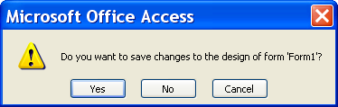
- Type an appropriate name for the form, and click OK.
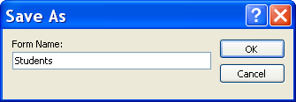

Lesson Example
You would like to create a quick form based on the Students table.

STEPS

- Click the Students table in the TABLES object in the Database Window.
- Click the AUTOFORM button.
- Click the SAVE button and name the form Students. Click OK.
- Close the form.

EXERCISE:

1) Create an AutoForm based on the Classes table.

2) Save the form as Classes, and close the form.

3) On Your Own: Create a form based on the Instructors table.

4) Close the form without saving.

Data Entry Using a Form

OVERVIEW
An Access database can store enormous amounts of data. That data must be entered correctly in order to ensure that accurate information is extracted from the database. Data entry within a form is like data entry within a table, Access automatically saves as you go. In addition, all field properties set in the original table will exist in the form.

STEPS
- Open the desired form.
- To add a new record, click the NEW RECORD button at the bottom of the form, and type the data in the first field.
Helpful Hint:

The ENTER and ARROW keys will also move you from field to field.

- Press TAB to move to the next field, and continue entering data and pressing TAB until the record is complete.
- To enter data to any field, find the appropriate record and move your insertion point into the field. Pressing the TAB key to move to the desired field will select any existing data, then typing will replace the previous entry. Clicking in the desired field with your mouse will place an insertion point in the field, so you may add to the field without replacing the existing entry.

Record Navigation
OVERVIEW

Access allows you to easily move from one record to another. The navigation buttons are located at the bottom of the form and includes tools to help you move between records.

Current Record
Total Number of Records Record
STEPS

- To move forward one record, click the single right arrow .

- To move back one record, click the single left arrow .

- To move to the very beginning, click the arrow pointing to the left with the line in front of it.

- To move to the end, click the arrow to the right with the line after it.

- To go to a particular record, click the current record number and type in the number you want, press ENTER.

- To go to the next blank record, click the right arrow with the asterisk .

Keyboard Commands:

- TAB moves forward a field at a time.

- SHIFT + TAB moves back one field at a time.

- HOME brings you to the beginning of a record.
- END brings you to the end of a record.

- CTRL + HOME brings you to the beginning of the first record.

- CTRL + END brings you to the end of the last record.

Lesson Example
You have received a new student to be added to the database.

STEPS

- Click the FORMS object in the Database Window.
- Double-click the STUDENTS form.
- Click the NEW RECORD button.
- Press TAB to move to the FirstName field.
- Type Marianne, and press TAB.
- Type Gagnon, and press TAB.
- Type M, and press TAB.
- Type S, and press TAB.
- Type 295 Water St., and press TAB.
- Type Augusta, and press TAB.
- Because ME is already in the State field, press TAB.
- Type 04330, and press TAB.
- Type (207) 626-0000, and press TAB.
- Type 05/04/1954, and press TAB.

EXERCISE:

1) Add the following records using the Students form:

Janice Veilleux Francis Paradis
DHHS DHHS
Mental Health Worker II Planning and Research
DDPC Assistant
Bangor, ME 04401 200 Main St.
(207) 561-3000 Lewiston, ME 04240
01/10/1981 (207) 783-8000
12/12/1944

Heather Harris Gregory Hansen
DOC Muskie
Auditor Clerk Typist II
Riverview 295 Water St.
Augusta, ME 04330 Augusta, ME 04330
(207) 287-5000 (207) 626-5226
09/06/1969 05/05/1955

2) Navigate to the 3rd record in the Students table.

3) Move to the first record.

4) On Your Own: Move to a blank record and add the following student:

Alicia Newell
DHHS
Clerk Typist II
169 Lancaster St.
Portland, ME 04101
(207) 877-1010
08/28/1958

5) Close the Students form.

Creating a Form Using the Wizard
OVERVIEW

As is the case with any wizard, the Form Wizard allows you to create a custom form quickly and easily.

STEPS

- Click the FORMS object in the Database Window.
- Double-click CREATE FORM BY USING WIZARD.
- In the first screen of the wizard, select the table or query from the TABLES/QUERIES drop-down field.
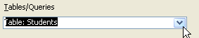
- Select the fields to be added to the form. To select one field, click on the field and then click . To add all fields, click . Click NEXT.
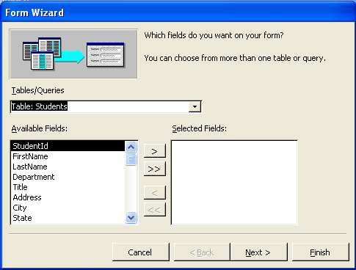

- Select a layout for the form, and click NEXT.
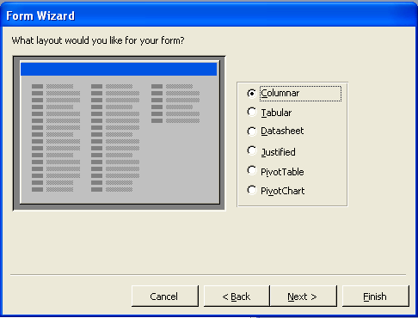
- Select a style for the form, and click NEXT.
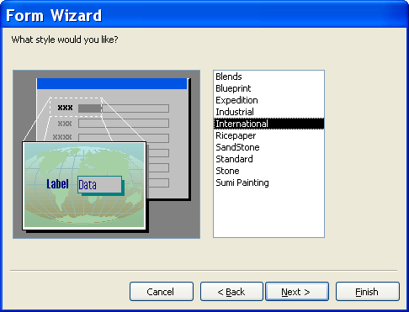

- Type a title for the form, and click FINISH.
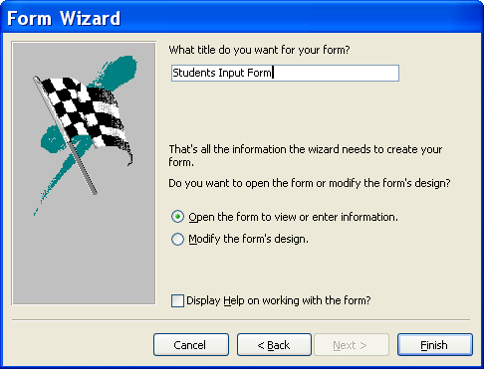

Lesson Example
You would like to create a form with a different appearance.

STEPS

- Click the FORMS object in the Database Window.
- Double click CREATE FORM BY USING WIZARD.
- Select the Students table from the TABLES/QUERIES drop-down list.
- Choose all fields from the Students table. Click NEXT.
- Select the Columnar layout and click NEXT.
- Select the style of your choice and click NEXT.
- Type Student Input Form as the title and click FINISH.

EXERCISE:

1) Add the following student using your new form:

Sheila Davis
DHHS
Director
161 Marginal Way
Portland, ME 04101
(207) 877-1100
07/17/1967

2) Close the form.

3) On Your Own: Create a form based on the Instructors table that includes all the fields and use the Justified Layout.

4) Name the form Instructor List.

5) Close the form.

EDITING DATA IN A FORM

OBJECTIVES: Edit and delete records.
Filter records.

Find

OVERVIEW
When your database contains a large number of records, it can be difficult to find a specific piece of information. Access has a tool that enables you to find a record if you know the data in one of its fields.

STEPS
- Click in the field by which you want to search.
- Click the FIND button .
- Type the entry you wish to find for the selected field in the FIND WHAT text box.
- Click FIND NEXT.
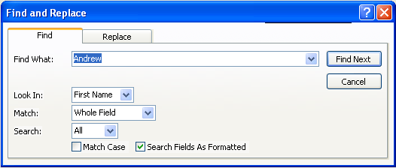
- If the record you were seeking appears, click CANCEL or the CLOSE button . If this is not the correct record, click FIND NEXT again.
- To search by a portion of the entry, click the MATCH drop-down list, and select START OF FIELD or PART OF FIELD before clicking FIND NEXT.
- To search the records from the bottom of the list to the top, in the SEARCH drop-down select UP. Change it back to ALL if necessary. You may click LESS to hide that portion of the dialog box if desired.

Editing Records

OVERVIEW
Helpful Hint:

You may need to move the FIND AND REPLACE dialog box to see the record Access finds. Simply click and drag the Title Bar of the box.
Any entry in your database may be modified if the data changes for some reason.

STEPS
- In a table or a form, find the record to be changed.
- To overwrite the entry in a field, TAB to the field needing to be changed (this will highlight the data in that field). Type the new data.
- To change only a portion of the entry in a field, click in the field to be changed. Making sure your insertion point is properly placed, type any additional data, and/or delete data to be removed.
- To undo a change to a field, if you have not yet moved to another field, the ESC key will return you to the original entry. If you have moved to another field, click the UNDO button in the toolbar.

Lesson Example
Marianne Gagnon called in with a change of address.

STEPS

- Click the FORMS object in the Database Window.
- Double-click the Students form.
- Click in the LastName field of the current record.
- Click the FIND button, and type Gagnon.
- Click FIND NEXT.
- Change her address to 400 Congress St. Portland, ME 04101 and her telephone number to (207) 780-8000.

EXERCISE:

1) Change Janice Veilleux’s last name to Jones.
2) Change Sherry Peterson’s title to Clerk Typist II.
3) On Your Own: Change Maria Fitzgerald’s birthdate to 04/04/1945.

Filtering

OVERVIEW
A filter allows you to display only those records containing the field entry you select. For instance, if you wish to see only those records with Augusta in the City field, a filter will hide any other records from view.

STEPS
- From a table or form, find a field with the entry on which you want to filter, and click in that field.
- Click the FILTER BY SELECTION button . The object will show that you have applied a filter in the Status bar at the bottom.
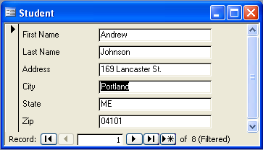
- To display all records again, click the REMOVE FILTER button .

Deleting Records

OVERVIEW
On occasion, you may need to eliminate a record altogether. You may or may not have the ability to do this in your particular database, depending on your permissions. However, if you are able, the process is very simple.

STEPS
- Find the record to be deleted.
- Click the RECORD SELECTOR to the left of the record.
In a form:
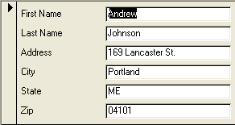
In a Table:
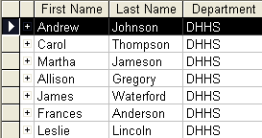
- Click the DELETE RECORD button in the toolbar. Or, press DELETE on your keyboard.
- Click YES to confirm the deletion.
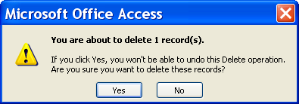

Lesson Example
You are asked how many students work for DHHS.

STEPS

- In the Students form, find the record of any student with DHHS in the Department field. You may use the navigation buttons or find.
- Click in the Department field.
- Click the FILTER BY SELECTION button. How many students work for DHHS? _________
- Click the REMOVE FILTER button.

EXERCISE:

1) Filter by the city of Portland. Remove the filter.

2) Delete the record of Francis Paradis.

3) On Your Own: Filter by Clerk Typist IIs.

4) Remove the filter.

5) Close the form.

BASIC QUERIES

OBJECTIVES: Create a query using the Wizard in Access.
Create a query in Design View.
Add criteria to query.

Creating a Query with the Wizard

OVERVIEW
One of the most powerful features of Access is the query, which allows you to ask questions of your information. Access then uses your questions to generate a subset of the data in your database. The date may be drawn from multiple tables.

STEPS

- Click the QUERIES button in the Objects bar.
- Double-click CREATE QUERY BY USING WIZARD.
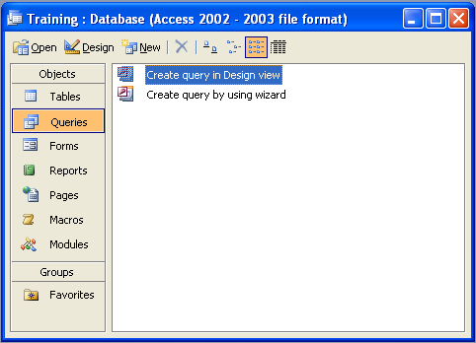
- Select the table or query on which to base the new query from the TABLES/QUERIES drop-down list. Click each desired field in the list of AVAILABLE FIELDS, and click to add the field to the query. To select all fields, click. Click NEXT.
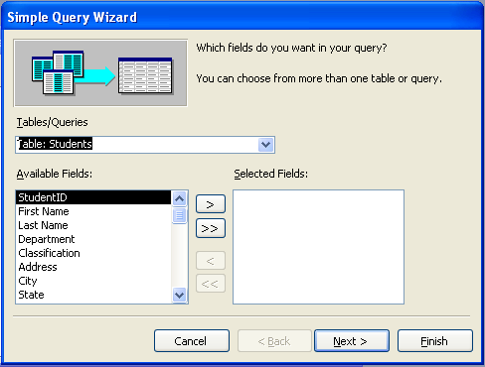
- Type a name for the query. Click FINISH.
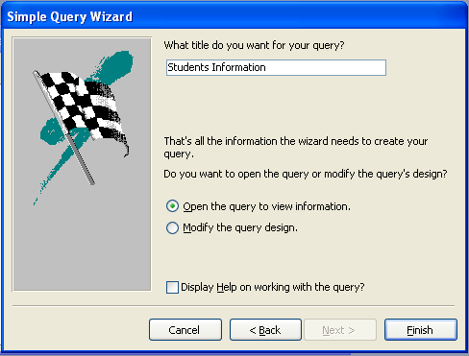

Lesson Example
You would like to create a student phone list.

STEPS

  - Click the QUERIES object in the Database Window.
  - Double-click CREATE QUERY BY USING WIZARD.
  - Select the Students table from the TABLES/QUERIES drop-down list.
  - Double-click FirstName, LastName, and Telephone to send them into the SELECTED FIELDS area. Click NEXT.
  - Name the query Student Phone List, and click FINISH.
  - Close the query.

EXERCISE:

1) Create a query that lists all student names and addresses.

2) Name the query Student Address List.

3) Close the query.

4) On Your Own: Create a query with student names and birthdates.

5) Name the query Student Birthday List.

6) Close the query.

Creating a Query by Design
OVERVIEW

The Query by Example Grid, or QBE Grid, appears in Design View of a query at the bottom of the window. It allows you to customize the information included in your results, called the dynaset, in Access. There are several rows within the grid that are identified below.

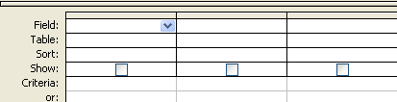

Field - Displays the names of the fields selected.

Table - The name of the table the field above is coming from.

Sort - Allows you to sort a field or fields in ascending or descending order.

Show - When the box is checked, the field will appear in the dynaset. When the box is NOT checked, the field does not appear in the dynaset.

Criteria - When you are looking for specific information, you fill in your requirements in the criteria row. If you fill in the criteria row for more than one field, this becomes an AND criteria, meaning that all records must match all the field requirements.

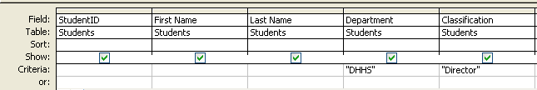

Or - This row is similar to the Criteria row, but allows you to ask for one criteria or another.

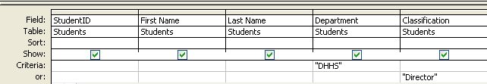

STEPS

- Click the QUERIES object in the Database Window.

- Double-click CREATE QUERY IN DESIGN VIEW.

- Click on a table and click the ADD button . Repeat this step for all the tables you wish to include in the query. Once all necessary tables have been added, click the CLOSE button .

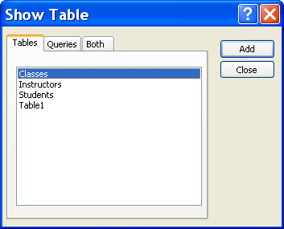

- From your field list(s) add fields to the QBE grid by doing one of the following:

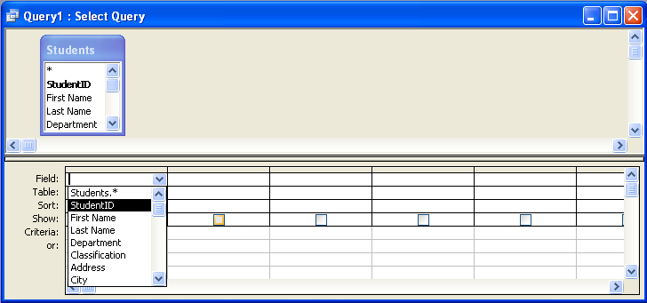
Ⓐ Double-click on each field name
Ⓑ Click and drag each field name to the grid

Ⓒ Click in the next available Field name line in the grid, click the arrow to see your list of fields, and click the desired field

- To choose all fields, double-click on the table name at the top of the box, and drag the list to the QBE grid.

- To select several fields, hold down the CTRL key and click each field, then click and drag to the first Field Name box.

- To select a consecutive series of fields, click on one field then hold down the SHIFT key and click on the last field in the group.

- If you find that you need fields from a table not appearing at the top, click the SHOW TABLE button in the toolbar, double-click the table you wish to add, then click the CLOSE button . Add the fields using the techniques described above.

- To rearrange the order of your fields, move your mouse pointer to the gray line above the field name in the QBE grid until it becomes a small black arrow pointing down.

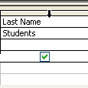

Click once. The mouse pointer will change to a white arrow. Click and drag with this pointer until a black, vertical line appears where you want the field to go. Release the mouse button, and the field will move.
Did You Know?

Sorting priority among multiple sorted fields goes from left to right.
- To remove fields from the QBE Grid, point to the horizontal gray bar above the field name until your mouse pointer becomes a black arrow pointing down. Click once to select the column, then press DELETE on your keyboard.

- To hide fields from view in your dynaset without removing them from the QBE Grid, click the check box in the SHOW row to remove the checkmark.
Did You Know?

For some advanced query types, the VIEW button will not complete the query action. In these cases, you must use the RUN button .

- To sort by a particular field, click in the SORT row of the field and click the down arrow to open the drop-down list, and select either Ascending or Descending. Ascending is alphabetical or chronological; Descending is the reverse.

- To look for specific information, type the text in the AND row of the field or the OR row.

- To run the query, click on the RUN button (the exclamation point) or the VIEW button .

- To return to Design View in order to make changes, click on the VIEW button .

- To save your query for future use, click the SAVE button , then name the query appropriately.

Lesson Example
You would like to see which students work in Augusta.

STEPS

  - Click the QUERIES object in the Database Window.
  - Double-click CREATE QUERY IN DESIGN VIEW.
  - Double-click the Students table. Click CLOSE in the Show Table window.
  - Double-click each of the following fields to add them to the QBE Grid: FirstName, LastName, City.
  - Click in the SORT row of LastName and select ASCENDING.
  - In the CRITERIA row of the City field, type Augusta.
  - Click the RUN button in the toolbar.
  - Click the SAVE button, and name the query Augusta Students.
  - Return to Design View by clicking the VIEW button.
  - Click in the SHOW row to remove the checkmark from the City field.
  - Run the query again.
  - Save and close the query.

EXERCISE:

1) Create a query in design view based on the Students table that includes the following fields: FirstName, LastName, Title, City.

2) Sort by the LastName field.

3) In the Criteria row of Title, type Director, and in the Criteria row of City type Portland. Run the query.

4) Return to Design View, and move the criteria for City to the Or line. Run the query and note the difference.

5) Close the query without saving.

6) On Your Own: Create a query in design view based on the Students table that includes the following fields: FirstName, LastName, Address, City, State, ZipCode.

7) Sort the query by ZipCode, and add a criterion of ME in the State field.

8) Run the query.

9) Save the query as Maine Student Addresses.

10) Close the query.

BASIC REPORTS

OBJECTIVES: Create a report using the Wizard.

The Report Wizard
OVERVIEW

Reports are objects created in Access for the purpose of printing specific information in a certain format. Reports may be created using AutoReport, the Report Wizard or in Design View. One of the greatest advantages of Access is that it always reports the most current information from your table. If a name or address changes, or you no longer need a particular record, changes to the table will automatically be reflected when you create or open a report. The Report Wizard provides the easiest and most efficient option for creating a report.

STEPS
  - With all tables closed, click the REPORTS button in the OBJECTS bar.

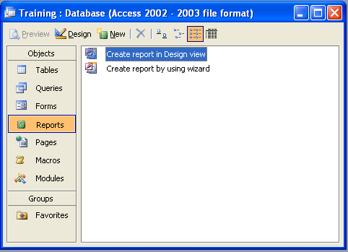

  - Double-click CREATE REPORT BY USING WIZARD.

  - Click the down arrow and select the table or query from which the report will be generated.

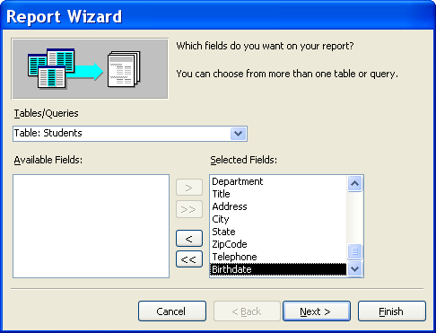

  - Click the name of each field to include in your report followed by the button. Or, double-click each field name. To include all fields, click the button. Click NEXT.

  - If applicable, choose the field(s) by which to group. For example, if you want the report to display classes by each instructor, you would group by InstructorID. Click NEXT.

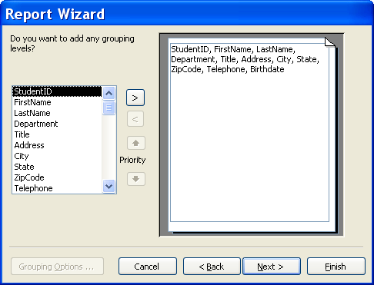

  - Select the field(s) by which to sort.

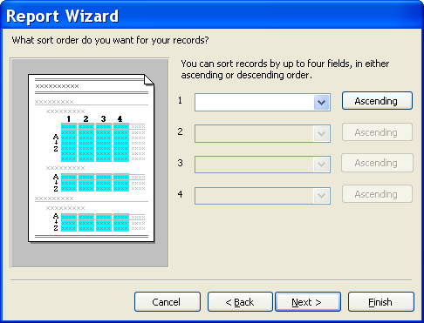

  - If you chose to group in the previous step, and you have numeric fields in your report, you may add summary information by clicking the SUMMARY OPTIONS button . You are able to calculate the sum, average, maximum, and/or minimum of any or all number or currency fields by clicking the desired check boxes, then clicking OK. Click NEXT.

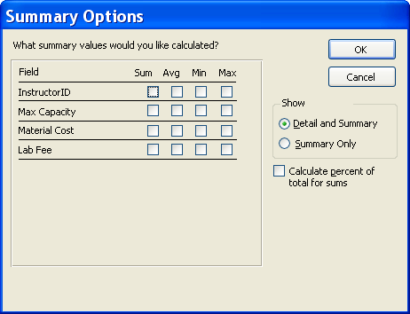

8. Choose a layout and orientation for the report. If you want all fields to fit on a page, keep the checkmark in that option. Click NEXT.

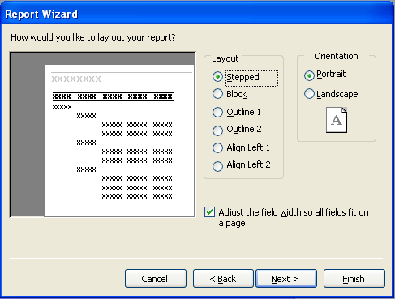

9. Select a style for your report. Click NEXT.

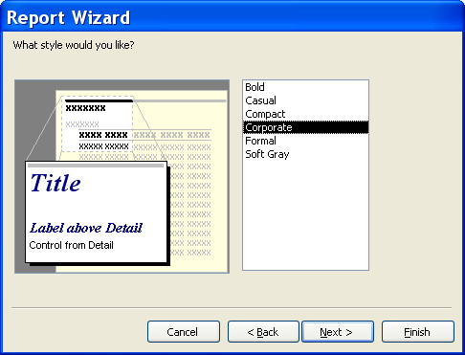

- Type a name for the report. Keep in mind that this name will appear at the very top of the printed report. Click FINISH.

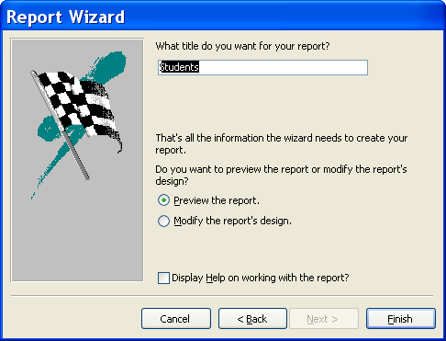

Lesson Example
You would like to print out a student list by Title.

STEPS

    - Click the REPORTS object in the Database Window.
    - Double-click CREATE REPORY BY USING WIZARD.
    - Click the TABLES/QUERIES drop-down arrow, and select the Students table.
    - Double-click the following fields to send them into the SELECTED FIELDS area: StudentID, FirstName, LastName, and Title. Click NEXT.
    - Double-click the Title field to choose it as the grouping field. Click NEXT.
    - Select LastName from the first sort drop-down list, then FirstName. Click NEXT.
    - Select the OUTLINE 1 layout and LANDSCAPE orientation. Click NEXT.
    - Select the CORPORATE style. Click NEXT.
    - Type Students by Title for a title. Click FINISH.
    - Print the report by clicking the PRINT button .
    - Close the Report.

EXERCISE:

1) Create a report using all of the fields from the Student Birthday List query.

2) Choose no grouping field, and sort by Birthdate.

3) Select a Layout and Style of your choice.

4) Name the report Students Birthdays. Close the report.
5) On Your Own: Create a report based on the Student Phone List query using all fields and making any other selections you like.
6) Name the report Student Phone List.
7) Close the report.

Label Reports
OVERVIEW

Since a database is set up to track information about people, places, and things, Access enables you to quickly create mailing labels for any correspondence you may send to a large group.

STEPS

- From the REPORTS window, click the NEW button .

- Click LABEL WIZARD, then click the drop-down list to select the table or query the address information is in. Click OK.

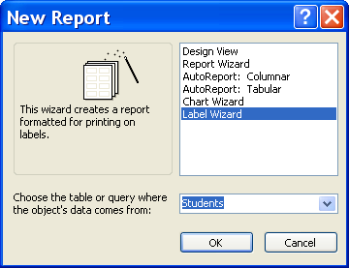

- Click the appropriate button for unit of measure and label type, then click the drop-down to select the manufacturer of the labels you will be using.

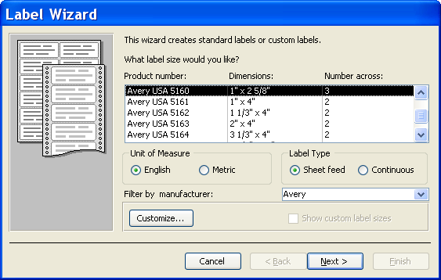
Unit of Measure
Label Type

- Scroll through the list of Product numbers to find the stock number of your labels, and click on it. Click the NEXT button.

- Make the desired font choices, and click NEXT.

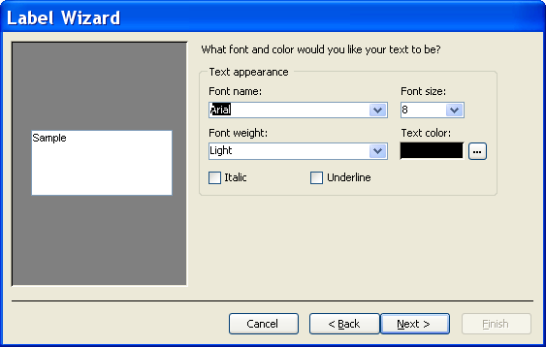

- One by one, send the necessary fields into the PROTOTYPE LABEL by clicking the field name, then clicking the button. Or, double-click the field name. Do not forget to put spaces, carriage returns (enter), and punctuation between fields as needed. Click NEXT.

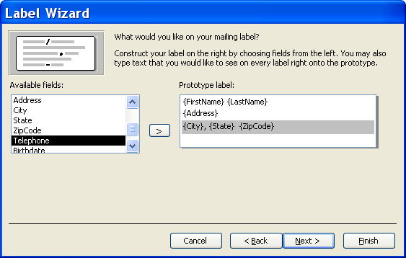

- Double-click on the field by which you wish to sort the labels. You may choose more than one sorting field. The post office would prefer that you sort by zip code. Click NEXT.

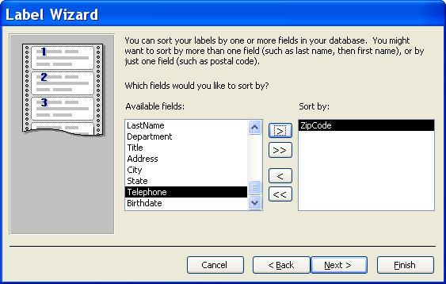

- Type a name for the label report, and click FINISH.
Did You Know?

You may send your finished label report to Microsoft Word in order to change the label text to all caps (as the Post Office requests) by clicking the PUBLISH TO WORD button in the toolbar, then selecting all of the text and clicking FORMAT, CHANGE CASE, ALL CAPS, OK.
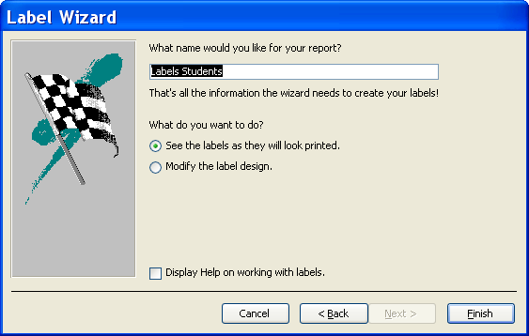

- Insert labels into your printer, and click PRINT.

Lesson Example
You want to send class confirmation letters to your students. Rather than address your envelopes by hand or recreate the student address list in Word, you decide to generate the labels in a label report.

STEPS

- From the REPORTS window, click the NEW button.

- Click LABEL WIZARD, then click the drop-down list to select the Students table. Click OK.

- Click Avery USA 5160. Click NEXT.

- Make any font choices you like, and click NEXT.

- Double-click the FirstName field and press the spacebar. Click the button to select LastName and press ENTER. Click for Department and press ENTER. Double-click Address and press ENTER. Double-click City, type a comma and space, click for State and press the spacebar twice, then click for ZipCode. Click NEXT.

- Double-click on the ZipCode field then the LastName field to sort the labels. Click NEXT.

- Keep the default name for the report, and click FINISH.

- Look through your labels, and close the report.

EXERCISE:

1) Make file folder labels for each student. Use Avery 5266 labels, and use the StudentID, LastName, and Title fields.

2) Save the labels as Student Folder Labels.

3) Close the report.

4) On Your Own: Create Avery 5160 labels for Students including the FirstName, LastName, Department, and City fields, and save them as Student Interoffice Labels.

5) Close the report.

GIVE IT A TRY!

OBJECTIVE: Practice the lessons learned in class.

EXERCISE:

Refer to Lesson 1 for assistance

- Create a blank database.
- Name the database My Database.
- Close the database.
- Open the Training database.
Refer to Lesson 2 for assistance
- Create a table in Design View with the following fields:
Title Text
Author Text
Copyright Date/Time
Publisher Text

- Save the table as Books, and have Access add a primary key.
- Close the Books table.
Refer to Lesson 3 for assistance
- Open the Instructors Table in Design View, and add the following fields:
Address Text
City Text
State Text
ZipCode Text
HomePhone Text
HireDate Date/Time
AssignedLab Text

- Default the State field to ME.

- Add an Input Mask to the HomePhone field.
- Format the HireDate to be a Short Date and add an Input Mask.
- Make the AssignedLab field a Lookup that includes: Augusta, Bangor, Lewiston, and Portland.
- In Datasheet View of the table, add the following records:
Shelley Fournier
222 Western Ave.
New Gloucester, ME 04260
(207) 926-5555
06/26/1996
Portland

Michael Beaulieu
476 State St.
Auburn, ME 04210
(207) 783-4747
12/12/2000
Lewiston
- Close the table.
Refer to Lesson 4 for assistance
- Create an AutoForm based on the Instructors table.
- Save the form as Instructor Form.
- Add the following records:
Kelly Thomas James Morse
86 Main St. 328 Forest Ave.
Bangor, ME 04401 Portsmouth, NH 03802
(207) 941-2345 (604) 555-4321
02/22/2002 10/10/1998
Bangor Portland

Refer to Lesson 5 for assistance
- Change Kelly Thomas’ address to 88 Main St. and Michael Beaulieu’s phone number to (207) 783-7474.
- Filter to show only the records of instructors assigned to Portland lab.
- Remove the filter.
- Close the form.
Refer to Lesson 6 for assistance
- Create a query in design view using the following fields from the Instructors table: FirstName, LastName, Address, City, State, and ZipCode.
- Run the query.
- Go back to Design View and add a criterion to only return instructors who live in Maine. Run the query.
- Return to Design View and remove the criterion.
- Save the query as Instructor Addresses.
- Close the query.
Refer to Lesson 7 for Assistance
- Create a report based on the Instructor Addresses query. Use all of the fields, do not group, sort by ZipCode, and use any other Wizard options you like.
- Print and close the report.

DELETING

OBJECTIVE: Maintain organized database files.

Deleting Databases
OVERVIEW

You may delete an entire database through Microsoft Access.

STEPS

1. Close the database, but remain in Access.

2. Click the OPEN button .

3. Click once on the name of the database you want to delete.

4. Press the DELETE key on your keyboard.

5. Click YES to delete, or NO to change your mind.

Lesson Example
You no longer need your Training database.

STEPS

  - Close the Training database, but remain in Access.
  - Click the OPEN button.
  - Click once on Training, and press DELETE on your keyboard.
  - Click YES to confirm the deletion.
  - Delete the remaining databases you have created.

NICE TO KNOW

Access Help Features

OVERVIEW
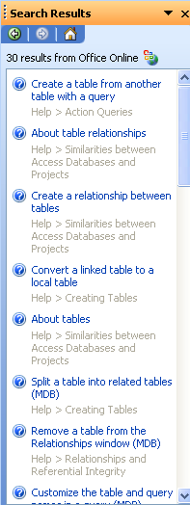
Microsoft Access contains several different types of help to assist you when you have difficulty with the program. The Office Assistant is an interactive help device that comes in the form of a cartoon character. It allows you to type a question or phrase related to your problem, and it will search through lists of topics for one related to your issue. However, this requires that you are very familiar with Access terminology.

STEPS

- Click the HELP button or click on the TYPE QUESTION FOR HELP entry box in the upper right corner.

- Type your question.
- Either press ENTER or click SEARCH.
- Click on one of the options available to receive additional information on that topic.

- To close the Help Box, click the CLOSE button in the upper right corner of the Task Pane.

Mouse Pointers
 | Text Selector - appears while among text; click to place insertion point or click and drag to select a section of text
 | Field Selector - appears on the left side of a field in Datasheet View; click to select the contents of the field
 | Column Selector - appears when pointing at field names in Datasheet View; click to select an entire column
 | Row Selector - appears in the gray box to left of a record in Datasheet View; click to select the entire record
 | Column Resize - appears between field names in Datasheet view or on a vertical border in Design View of a Form or Report; click and drag to increase or decrease width
 | Row Resize - appears on a horizontal border in Design View of a Form or Report; click and drag to increase or decrease height
 | Normal Select - allows you to click to choose an object; also allows you to click and drag a rectangle to select a group of objects
 | Move - in Design View of a Form or Report, this pointer appears when you point at the middle of a selected control; click and drag to move the control
 | Move Separately - appears when pointing at the upper left corner of a selected control; allows you to click and drag a label separately from a text box and vice versa
 | Horizontal Resize - appears when you point at a resizing handle (small black square) on the edge of a control; click and drag away from the object to enlarge, toward the object to make smaller
 | Diagonal Resize - see above
 | Vertical Resize - see above

Toolbar Buttons

Print prints the active object. Be careful if your object contains many records!
Print Preview shows you what your active object will look like on paper.
Spell check will check for spelling errors.
Cut removes text or an object and places it on the Clipboard, so it may be placed elsewhere.
Copy places a copy of the selected text or object on the Clipboard, so it may be copied to another location.
Paste takes the item from the Clipboard and places it at the location of your insertion point or selection.
Format Painter allows you to copy the formatting of selected text to other text in your database.
Undo will undo the last action taken.
The Office Assistant provides you with interactive help regarding Access.
Delete will remove the selected object from your database.
Sort Ascending puts your records in alphabetical, chronological, or numeric order based on the active field.
Sort Descending sorts records backwards.
AutoFilter removes any record not including the selected entry.
The Filter button becomes activated when AutoFilter is used. Pushing this button will remove the current filter. When Filter by Form is used, this button will turn on the filter once criteria are established, then turn it off when you wish to see all records.
Find lets you search for an entry.
New Record sends you to a blank record for data entry. Some databases require a different button to be used.
Delete Record will remove the active record.

Keyboard Shortcuts

Keystroke Combination | Effect
F1 | Opens Access Help
F6 | Moves from Design Grid of Table to Properties section
F9 | Updates the active object
F11 | Brings the Database Window to the front
Tab | Moves you ahead one field
Shift + Tab | Moves you backward one field
Enter | Moves you ahead one field
Spacebar | Toggles a checkmark on and off in a Yes/No field
Ctrl + Alt + down arrow | Opens a drop-down list
Ctrl + Tab | Moves you out of a subform to the next form field
Ctrl + Home | Sends you to the beginning of the first record
Ctrl + End | Sends you to the end of the last record
Ctrl + ' | Copies the previous record's entry into the current field
Home | Sends you to the beginning of the active record
End | Sends you to the end of the active record
Arrow (Cursor) Keys | Send you one field in the arrow's direction

