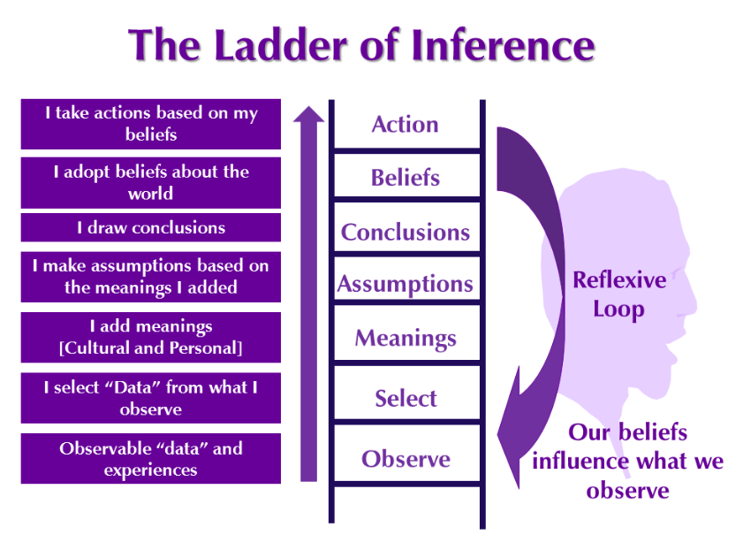

Activity:
Using the Ladder of Inference reference above think of a situation and complete your ladder below. Keep this activity handy as we will relook at this later in the training and address potential changes to impact outcomes.

Action

Beliefs

Conclusions

Assumptions

Meanings

Select

Observe

Activity 2
Let’s reflect on your thinking in the interaction you described previous. In this grid, identify 5 alternative assumptions as to why this person acted the way they did. Try to come up with positive or neutral assumptions about their behavior. For each of these assumptions, what could be an alternative course of action for you? Then for each action determine if that action would result in building or maintaining the relationship with this person. When done, print off and consider how you may interact with this person in the future

Why did the person act the way they did?  My alternative assumptions about their behavior | Alternative Course of Action  Based on my assumption, would I develop a different action? | Will this action serve to build or maintain my relationship with them?

