
Department of Human Services
Health & Environmental

Testing Laboratory

NEWSLETTER

MORBIDITY REPORT
Disease Period Covered: 1/1/99 to 6/18/2000

MEASLES (RUBELLA) 0
MUMPS 0
RUBELLA 0
CRS (Congenital Rubella Syndrome) 0
DIPHTHERIA 0
TETANUS 0
PERTUSSIS (With Campobello 45) 36
HIB 0

Data derived from the Maine Bureau of Health Immunization Program, Weekly Morbidity of confirmed cases.

WHAT YOU WILL FIND IN THIS ISSUE:

- Quality Assurance 2
- Black Mold Hazardous to Your Health (Stachybotrys) 2&3
- The Risk of Hantavirus Infection in New England 3
- Forensic Chemistry 3&4
- Bioterrorism Preparedness Planning 4&5
- State of Maine PFGE Lab Initiates Salmonella Outbreak Investigation 5&6
- News From The Organic Section 6
- West Nile Virus 8,9&10

Quality Assurance

By: Richard French

Laboratory Certification
After 30 plus years Mike Sodano has pulled up anchor and set sail for new waters. The “new face in town” is John Nims.

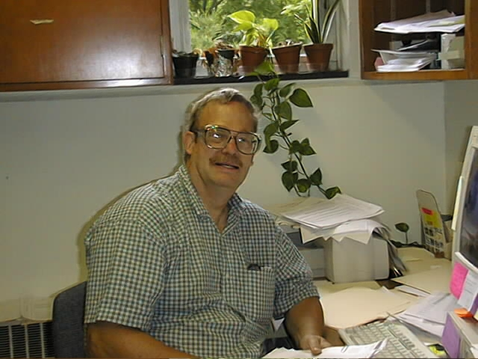
John Nims at his Desk.
John really isn’t new, many of you have dealt with John, in his capacity as a supervisor and analyst in the DEP laboratory and after consolidation of the DEP lab and PHL, as the supervisor of the inorganic section with an expertise in environmental automated analysis. John also brings to the job many years of expertise analyzing solid waste and wastewater samples. This is a real plus for a Wastewater Laboratory Certification program. If you have questions on certification, give John a call and introduce yourself. He will be glad to hear from you. John can be reached at 287-1929. He has voice mail so leave him a message.

Lead and Copper
With the warm weather beginning again, this signals the start up of the lead and copper-sampling program. The mandatory June samples (TE4’s) have been or in the process of being sent out. The next batch of samples will be sent out the end of June to be sampled during the warm summer months but no later than September 30, 2000. The last batch of samples is to be sent out the end of July for sampling by September 30, 2000 or in the month of June 2001. If you receive TE4 sample kits from a laboratory, these are mandatory compliance samples. Do not return these kits empty to the laboratory unless you have contacted Dana Ivers at the Division of Health Engineering(DHE) and he has instructed you to do so. The phone number for the Lead and Copper Compliance program is 287-6472. If you are instructed by DHE to return the kits empty, please indicate this on the enclosed 141-A form and return it with the bottles. If you have further questions on the Lead and Copper program, please contact the DHE at the number listed above.

Proficiency Sample Testing
All Laboratories analyzing drinking water samples in the State of Maine for compliance purposes need to be certified by the State of Maine, EPA, of NELAC for each parameter it is testing for. Part of the certification process is analyzing proficiency samples. The EPA provided these, at no cost, but now have to be provided at cost by NIST approved providers. NELAC requires that two proficiency samples per parameter be satisfactorily analyzed each year. The EPA presently requires only one per parameter each year by October 31st.The State of Maine will require two per parameter. Another requirement is that if you use more that one method of analysis for a parameter, you must analyze proficiency samples by both methods (furnace and ICP for metals examples). Because of this you may require more than one set of proficiency samples. Here at HETL we require three coliform samples for three different methods. Another requirement is that the proficiency samples be analyzed as routine samples in the regular sample stream. If you only run samples once than you treat the proficiency samples the same way. This must also be indicated in the raw data. Laboratory inspectors will be specifically asking a laboratory to demonstrate this during the evaluation. A good proficiency-testing program can be a substantial cost to a laboratory and should be budgeted. The HETL has an annual contract with ERA to provide the necessary proficiency samples twice a year for drinking water, wastewater/solids, and radiation parameters. We also have a contract with NSI to provide the drinking water herbicide samples. Question on certification and proficiency samples can be directed to John Nims at the above number.

Stachybotrys the Black Mold that Could be Hazardous to Your Health
By: Jemelie Bessette

Multiple infants dying of pulmonary hemosiderosis recently, in the Cleveland area, have caused the need for investigation of environmental bioaerosols in private homes. The patients involved had bleeding in the lungs, followed by other symptoms of chronic cough, nose bleeds, fever and congestion with anemia, some cases ending in fatality. The common factor found between several of these case studies was a black moist mold called Stachybotrys chartarum.

Stachybotrys is a saprophytic mold that grows on cellulose products of wood or paper, such as gypsum board, ceiling tiles, carpeting, cardboard, along with straw, grass and cotton items. The mold has been found in areas of flooding and other high moisture circumstances, as in poor foundation drainage, high interior humidity caused by poor ventilation of dryers and bathrooms. The mold prefers a humidity of 55% or higher. When allowed to grow, it produces mycotoxins in its spores, which are air born bioaerosols that can be inhaled into the lungs. These mycotoxins possibly cause the blood vessels of rapidly growing lung tissue in newborns to weaken, resulting in hemorrhage. Other individuals with chronic exposure to the mycotoxins, report symptoms of sore throat, headaches, fatigue, dermatitis, diarrhea, intermittent hair loss and general malaise.
Eliminating the moisture problem in the home is the best way to prevent the growth of Stachybotrys. If there is a moisture problem, it should be corrected, by repairing leaks and cracks along with providing adequate drainage. Gutters can also help channel water away from foundations. Vents to the outside for bathrooms and dryers should be installed. The relative humidity should be no higher than 40 %. As long as there is sufficient moisture, the environment will support the growth of the mold.

Once the moisture problem has been identified and corrected the contaminated area should be disinfected. If the area is greater than two square feet of contamination a professional should be consulted. Safety apparatus should be used when removing and cleaning the area. Rubber gloves, rubber boots and face masks should be worn. All disposable material should be discarded into garbage bags. The surface should be cleaned with a disinfectant solution of one cup household bleach to one gallon of water. A little dish soap can be added to clean dirt and oil from the smooth materials, which gives the mold a better surface to adhere to.

Our laboratory will perform identification of Stachybotrys as part of an environmental culture upon request. Again, the best way to take care of adverse side effects of Stachybotrys is to eliminate the moisture problem. For questions or more information please contact the Mycology Department at the Health and Environmental Testing Lab at (207) 287-2727.

The Risk of Hantavirus Infection in

New England
By: Tsun-Kong Lee, Dr. P.H. State Microbiologist

In May 1993, an outbreak of respiratory disease occurred in the southeastern United States which focused national attention due to the large number of fatalities in young healthy adults. The disease was quickly identified as being due to hantavirus pulmonary syndrome (HPS) with 33 cases and 17 fatalities. The vector was the deer mouse and the infection was acquired from virus excreted in mouse urine, saliva and droppings via aerosol . Although the case-fatality rate has been estimated to be about 40-60%, only about 217 cases have been diagnosed from 30 states as of May 1999.

Only a few fatal cases have been reported from the East Coast to date. New York state reported two cases in 1994 and 1995. The rodent vector is believed to be the white-footed mouse which serves as the reservoir for ticks causing Lyme disease and ehrlichiosis. Although about 8 % of deer and white-footed mice are infected, the known cases are believed to be very low. The first documented case in New England was reported in a 61-year old Vermont state employee in February 2000. The patient survived respiratory distress, and heart, liver and kidney failure over a three week period before recovering.

Since the most common source of virus transmission is probably through inhalation of the virus contained in dust contaminated with mouse urine and feces CDC has recommended that closed buildings such as cabins and unused garages should be aired out first before cleaning . Dust should not be swept up or vacuumed up without first wetting down the area with general purpose disinfectants or mixing at least one cup of household bleach with one gallon of water. The virus contains a lipid envelope which is quickly destroyed by disinfectants. The contaminated mouse and bedding debris can then be collected with a wet towel before mopping or sponging the area safely with soap and water. These precautions should reduce the small risk of infection with hantavirus even further when coming into contact with potentially contaminated areas.

Animal Rabies in Maine-2000

By: Tsun-Kong Lee, Dr. P. H. State Microbiologist

In 1998, a record number of 248 positive rabies cases was diagnosed from 11 counties. The five counties without terrestrial rabies were Aroostook, Hancock, Penobscot, Piscataquis and Washington. In 1999, although the total number of positive cases was only 208, the raccoon epizootic had expanded into new counties of Hancock, Penobscot and Piscataquis leaving only Aroostook and Washington counties unaffected.

In current year 2000, 68 positive cases have been diagnosed as of May 31, 2000. This compares with 69 positive cases in 1999. The highest number (29) of positive cases has been from Penobscot county since its first reported case was reprted from Newburgh in May 1999. Two interesting items were noted this year. A rabid coyote and two rabid bobcats were diagnosed for the first time among the wild animals. The coyote was from Corinna (Penobscot) and both bobcats were from Abbott (Piscataquis) and Parsonfield (York). The second item was that a rabid raccoon was diagnosed in Calais (Washington) in mid-May 2000. This was the first case seen in this county and the strain of rabies virus was identified as being the Mid-Atlantic strain by monoclonal antibody testing. Prior to this case, the closest towns in Hancock county with raccoon rabies were Mariaville, Amherst, and Franklin representing the areas threatening Washington county to the east.

Forensic Chemistry
Christopher P. Montagna, Chemist III

The past year has been a challenging and enlightening time for the Staff of the HETL. Long hours of dedicated service redefined the laboratory and the services provided to the State’s Criminal Justice Agencies. During this time, the HETL experienced a dramatic increase in evidence submissions. * In addition, the HETL is now the States sole provider of controlled substances analysis for the first time in decades. In light of the increased caseload, the HETL is making attempts to improve efficiency and turn-around time. To this end, the lab purchased new instrumentation for both the alcohol and drug analysis units. In August, the alcohol unit went on-line with an automated headspace analysis unit. This technology provides greater efficiency for the alcohol analysis unit. The addition of a second full-time drug analyst and auto-sampler for the lab’s GC/MS provide timely analysis of controlled substances.

*INCREASE IN EVIDENCE SUBMISSIONS

1998 1999 as of June 2000
Drugs in Urine 126 159 119
Blood/Breath Alcohol 1,335 1,811 792
Controlled Substances 150 649 526

In addition, the HETL’s Laboratory Director, John “Jack” Krueger, is now a member of the American Society of Crime Laboratory Director’s (ASCLD). ASCLD is an organization of forensic laboratory directors from across the country. As a member, Jack will be able to establish contacts with other directors and share information concerning current events and issues faced by forensic laboratories. This opportunity for increased communication will assist the HETL as it continues its advances into the 21st century.

Bioterrorism Preparedness Planning

By: Jim Martin

In 1998 the president launched the first national effort to create a biological weapons defense for the United States. The Federal Bureau of Investigation is the lead federal agency tasked with directing the interagency response to acts of bioterrorism. International and domestic events drew attention to chemical and biological threats. Iraq used chemical weapons on Iran and its own citizens, and appeared to be concealing a biological weapons program. The Japanese cult Aum Shinrikyo used sarin nerve agent in the Tokyo subway. They were not successful in their multiple attempts to release anthrax and botulinum toxin. Domestically, in 1994 in an attempt to win a local election and seize political control, the religious cult Rajneeshee contaminated restaurant salad bars with Salmonella typhimurium in a scheme to incapacitate local voters in the town of Dalles and the county of Wasco in Oregon. Since 1998, there has a dramatic rise in biological hoaxes attributable to the flurry of anthrax threats. The first wave of anthrax hoaxes followed the well-publicized arrest of an individual linked to a white supremacist group. He threatened to release “military-grade anthrax” in Las Vegas. The anthrax that he did posses proved to be a harmless veterinary strain. The resulting sensational media coverage had the unintended consequence of popularizing this agent resulting in numerous subsequent hoaxes.

In December 1998 the CDC established the Bioterrorism Preparedness and Response Activity (BPRA), to lead an agency-wide effort to prepare for and respond to acts of terrorism that involve actual, threatened, or suspected uses of biological or chemical agents. In February 1999, CDC announced a cooperative agreement for Public Health Preparedness and Response. This announcement focused on strengthening four components of biological and chemical terrorism: Detection of Unusual Events, Investigation and Containment of Outbreaks, Coordination and Communication and Laboratory Diagnosis.

Besides naturally occurring disease, the possibility that biologic and chemical agents can be used against the civilian population in terrorist attacks must be addressed. Terrorist use of biological or chemical weapons may be unannounced, or involve overt acts that are announced or otherwise immediately recognized. Absent any immediate evidence or notification of an attack by a perpetrator, the first indications of an attack could be an outbreak of some uncommon illness or an abrupt, significant increase in the incidence of commonly observed symptoms. The speed in which the outbreak is detected, analyzed, understood and addressed, will determine the timeliness and effectiveness of the medical and public health response and hence the extent and severity of the impact upon the health and well-being of the affected community. An unannounced release of a highly communicable disease could afflict many hundreds or thousands of individuals over a wide geographic area. In addition to problems associated with the delayed detection of an agent, many of the agents most likely to be used are not commonly seen as clinical or public health threats in the U.S. It is the role of the HETL to provide laboratory and consultative support to other responsible agencies associated with emergencies resulting from terrorist incidents.

The list of biological agents available to cause mass casualties is small and would probably include one of the classic biological agents. The probability of occurence is low; however the consequences of a possible sucessful deliberate release of an infectious disease into the community is serious. The aerosol route is the most likely for a large-scale attack, with stability and capability to be dispersed (particle size) being necessary. Plague, anthrax, tularemia and Brucella species are examples of some pathogens that many nations during the Cold War developed into stockpiles of munitions capable of delivering these agents. There is no evidence at this time, that any nation has provided biological weapons expertise to a terrorist organization.

The initial response to a terrorist attack or threats associated with Weapons of Mass Destruction will be a local responsibility, falling on State and local agencies. This laboratory is a part of state government, an agency that is looked upon as being capable and necessary in providing assistance to other agencies, allowing them to perform their mission. It has always possessed the historic mission of protecting the health of the citizens within its state. The HETL is a state public health laboratory that is also part of a national network of federal and state public health laboratories. In the event of a chemical or biological attack, rapid diagnosis will be critical so that prevention and treatment measure can be implemented quickly. The HETL is part of a multi-level network of laboratories that will be used to provide the most immediate diagnosis of a biologic agent. The HETL has entered into cooperative agreements with the Centers for Disease Control and Prevention and other public health laboratories located in other states for mutual assistance that would be given upon request. The network will ultimately include hospital, commercial reference laboratories, State and local health laboratories, and highly specialized federal facilities. This will not only enhance public health capacity to address bioterrorism, but also contribute to the overall public health capacity to address naturally occurring infectious.

The HETL has a multi faceted role in meeting the challenges associated with responding to threats associated with Weapons of Mass Destruction. The HETL must provide consultative, as well testing and referral services to those responsible agencies charged with responding and managing a real or threatened terrorist attack. The HETL will be responsible for providing technical and laboratory support to medical, law enforcement, public health officials and hospital laboratories. It will also have the responsibility to accept collected samples for testing and referral, and to insure that evidentiary protocols are followed. The HETL will be responsible for agent isolation and diagnostic testing within its core capacity level of capability, to provide results on a need to know basis, to minimize false positives, to protect higher level laboratories from sample overload and to provide assistance to hospital laboratories. The HETL’s area of responsibility is statewide but its role also has national as well as international significance

The HETL is building on its existing capability in planning and preparing to manage a request to provide assistance for those infectious diseases could be deliberately released into the community and that are also endemic worldwide, including within the United States. These actions will contribute to the overall public health capacity to address naturally occurring infectious diseases where exposure to them is possible when traveling to an endemic area, by consuming contaminated foods, or by handling products from contaminated animal sources. The possibility has always existed that the HETL would receive these infectious diseases as part of its historic public health mission. To test for and monitor the prevalence of infectious diseases.


State of Maine Pulsed Field Gel Electrophoresis Laboratory
Initiates International Salmonella Thompson Outbreak Investigation
Affecting New England and Canada

By: Donna Wrigley MT(ASCP),BS (MB)

On March 7th , the Pulsed Field Gel Electrophoresis Laboratory (PFGE) posted an outbreak alert on the CDC’s PulseNet listserv computer. There was an unusual number of Salmonella thompson isolates that had been received by the HETL within a time span of three months starting in December. Two isolates were received at the beginning of December, five isolates in February, and one more collected on March 2nd. Gel plugs were made of these isolates and PFGE analysis was performed. The DNA patterns were indistinguishable. A subsequent call to the regional PulseNet laboratory in Massachusetts revealed an unusually large number of Salmonella thompson isolates, over twenty, had been received in Massachusetts and that they were in the process of pulsing them. At this point, DNA patterns for Salmonella ser. thompson had not been routinely submitted to the CDC’s PulseNet and it had not been established as to whether PFGE was useful with this serotype. Some serotypes, such as Salmonella enteriditis, have very little clonal variability. Differences in DNA banding patterns is more important than similarities in determining the difference between a true outbreak cluster from random events. Since all of the Salmonella thompson isolates had indistinguishable banding patterns using two different restriction enzymes, it was difficult to determine if this were a true outbreak cluster, particularly in light of the fact that there was no supporting epidemiological evidence. One of the PulseNet coordinators, recommended that I post the .tif file (gel image file containing the DNA patterns) to the listserv computer for distribution to all participating PulseNet laboratories throughout the United States.

Several states responded to the posting ( Ma, VA, KS, CT, TX, and MN) with the primary concentration of matching isolates coming from the New England area. Ontario Canada also had an unusual increase in Salmonella thompson. They had contacted the CDC to obtain a copy of the DNA pattern that was posted to the listserv. The CDC sent Maine’s posting containing the .tif file to Ontario for comparison to their isolate patterns. The Canadian isolates matched the DNA patterns from Maine.

Disease Control had interviewed the patients in Maine and did not find a link. The isolates were widely distributed all over the state. In Massachusetts, a cluster was potentially linked to a specific restaurant associated with college students in Amherst. CDC’s Epidemiology department in collaboration with the involved state Public Health Laboratories and Epidemiology departments have not found a common link among the various cases with the exception of the individuals in this one group.

Isolates from the Maine cluster sent to CDC for complete serotyping were also sent by the CDC to Ontario Canada for phage typing. CDC repeated the PFGE on these and other isolates sent to them by other Public Health Laboratories. They included additional restriction enzymes for the analysis. Throughout the outbreak region, two separate clusters appeared to be forming.

There have been no new cases of Salmonella thompson in Maine since March 2nd. There are also no new updates on the national or international investigation at this point.

PulseNet surveillance has dramatically expanded throughout the United States including 45 states and Canada. Sharing of information across state lines and internationally has lead to better information and tracking of outbreaks. More foodborne pathogens are being added to the PulseNet database in order to increase it’s effectiveness in preventing major outbreaks.

News From The Organic Section
By: Larry Boston (Organic Supervisor)

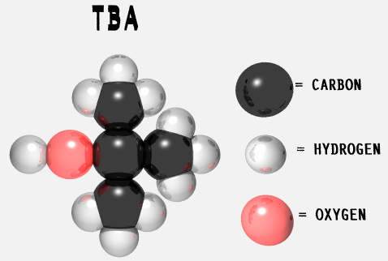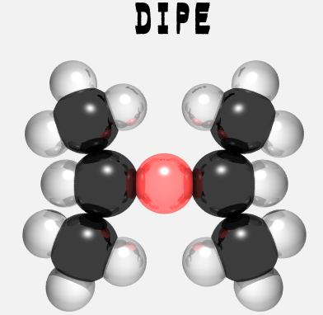

The organic section is now performing tests for several additional oxygenated compounds in addition to MTBE. The four additional compounds added to our test are TAME, DIPE, ETBE and TBA. The new test code with these additional compounds added to the MBTEX test is OBTEXW for water and OBTEXS for soils. There are several acronyms associated with the oxygenates, some of which are not unique to the compound that I have listed, so I have provided the full names associated with the abbreviated names at the end of this article. TAME, DIPE and ETBE are gasoline additives. TBA is gasoline additive and also a breakdown product of MTBE.
One of the major problems with some of the oxygenates such as MTBE is that they are very water-soluble and also biodegrade slowly. Therefore their water concentrations can rise rapidly, even after a small spill. There are many alternative available for oxygenates each of which must be evaluated for its potential for rapid transport into the water system after as spill and also for potential health risks. The Internet is a good resource for tracking the studies, but finding information is getting more difficult as more websites are created.
The purpose of the oxygenates in gasoline is to reduce the levels of nitrogen oxides and hydrocarbons that react with sunlight to produce ozone. There is limited literature available on how oxygenates reduce these pollutants in air, but one study on the web page given below shows that the oxides of nitrogen are not reduced but the hydrocarbons are reduced. (1)
Ozone has a dual role in the environment, therefore scientific discussions of Ozone can be confusing. Ozone is harmful in near the surface but protects us from ultraviolet radiation in the upper atmosphere. Near the Earth’s surface however ozone can cause respiratory problems, especially for persons with lung problems and asthma. (2)(3)

TAME = Tertiary Amyl Ether CH₃ (CH₂)₄ O (CH₂)₄CH₃

DIPE = Diisopropyl Ether

ETBE = Ethyl T Butyl Ether CH₃CH₂ O C (CH₃)₄

TBA = Tertiary Butyl Alcohol (CH₃)₃ COH

- Web site http://www.ec.gc.ca/emission/3-9e.html
- Web site http://www.dnr.state.mo.us/deq/apcp/faqozone.htm
- Web site http://www.epa.gov/airnow/health

West Nile Virus
By: Beth Pritchard MT (ASCP) MS

Department of Virology

HISTORY
The outbreak of West Nile (WN) virus in the metropolitan New York City area during the summer and fall of 1999 raised the issue of preparedness of the local, state and national public health agencies that deal with vector-borne diseases. The Centers for Disease Control (CDC ) and the United States Department of Agriculture (USDA) organized a meeting last November to review the current state of knowledge and to provide guidance in implementing programs to monitor WN virus activity and to prevent future outbreaks. Enhanced surveillance of WN virus was established in those states identified as being at a higher risk for being affected because of bird migration. These include Massachusetts to Texas along the Atlantic and Gulf coasts as well as the areas of the Caribbean and Central and South America. Bird and mosquito populations are being actively monitored in those areas. The veterinary and human health-care providers were notified in these areas to be on the alert for neurologic disease in horses and other animals and viral encephalitis in humans. Laboratories in the "at risk" region were trained and provided with reagents for IgM and IgG ELISAs as well as virus isolation and detection.

EPIDEMIOLOGY
West Nile Fever has been commonly found in humans, birds and other vertebrates in Africa, Eastern Europe, West Asia and the Middle East since it was first isolated in the West Nile district of Uganda in 1937. An arbovirus (arthropod borne) of the flavivirus genus along with dengue and St. Louis encephalitis virus, this virus' transmission cycle involves mosquitoes feeding on infected birds, followed by transmission of WN virus to humans and animals while taking a blood meal. In humans, the incubation period is 5-15 days. Symptoms include acute fever, severe myalgias, headache, conjunctivitis, lymphadenopathy and a roseolar rash (1). Case fatality rates with WN infection range from 3 - 15% and are highest in the elderly population (5). The introduction of West Nile Virus (WNV) into the northeastern United States in the late summer and fall of 1999 in New York City presents the possibility of WN virus becoming endemic in the northeastern U.S. The major vector in NYC was the Culex pipiens mosquito (2). WN virus is classified as a bio-safety level 3 agent (3). There has been one laboratory-acquired infection reported in the late 1950s in which exposure was by the aerosol route (4). Dr. Susan Wong, (New York State Department of Health), in a recent training update on arthropod-borne diseases in the Northeast stated they feel comfortable treating diagnostic sera as BSL 2 material. CDC has confirmed the BSL-2 designation for serums. Serum does not have to be heat inactivated, but must be handled under a BSL-2 safety cabinet for testing. CSF and tissues must be handled under BSL-3 precautions.

WORKING CASE DEFINITION OF WEST NILE ENCEPHALITIS (2)
The following definition of WN virus was used in the 1999 New York outbreak. This definition is only a public health tool used for surveillance of health events in populations. It is not intended for use in clinical diagnosis or management decisions in individual cases.

- Confirmed Case

A confirmed case of WN encephalitis is defined as a febrile illness associated with neurologic manifestations, ranging from headache to aseptic meningitis or encephalitis, plus at least one of the following:
- Isolation of WN virus from, or demonstration of WN viral antigen or genomic sequences in tissue, blood, CSF, or other body fluid.
- Demonstration of immunoglobulin M (IgM) antibody to WN virus in CSF be IgM- capture EIA,
- A >4-fold serial change in plaque-reduction neutralization test (PRNT) antibody titer to WN virus in paired, appropriately timed serum or CSF samples,
- Demonstration of both IgM (by EIA ) and IgG(screened by EIA and confirmed by
antibody to WN virus in a single serum specimen.

- Probable case

A probable case is defined as a compatible illness (as above) that does not meet any of the above laboratory criteria, plus at least one of the following:
- Demonstration of serum IgM antibody against WN virus (by EIA);
- Demonstration of an elevated titer of specific IgG antibody to WN virus in convalescent-phase serum (screened by EIA and confirmed by PRNT).

- Non-case

A non-case is defined as an illness that does not meet any of the above laboratory criteria, plus:

- A negative test for IgM antibody to WN virus (by EIA) in serum or CSF collected 8-21 days after onset of illness, and/or
- A negative test for IgG antibody to WN virus (by EIA or PRNT) in serum collected > 22 days after onset of illness

WHAT'S HAPPENING IN MAINE
At this time it is not known whether Maine is at risk of infection with WN virus. Bird migration patterns as well as environmental factors determine the geographical area affected. At this time the Maine Health and Environmental Testing Lab is forwarding all samples to a reference lab (CDC or Massachusetts Public Health Lab) for screening and confirmation. All specimens must be shipped to HETL as "diagnostic" samples, packed appropriately, and accompanied by a CDC form 50.34. Only known positive material such as controls require a permit from the USDA.

The Clinton administration announced May 25th that there will be an additional $5 million for states and local services to expand surveillance activities for the West Nile virus. $3.1 million of this will be used to enable parts of the country not yet trained and equipped get ready to diagnose West Nile virus. Maine may be able to offer diagnostic testing in house in the future and provide "real time" testing.

Serologic testing for patients who have mild symptoms, such as fever and headache, or are asymptomatic and/or report mosquito bites is not necessary. The likelihood of West Nile infection in these patients is extremely low, especially in the absence of an outbreak. Even in areas where transmission of West Nile virus is known to occur, only a small proportion of the mosquitoes are likely to be infected. Since there is no specific treatment for WN viral infection, patients with mild symptoms do not require specific diagnostic testing. However, asymptomatic or mildly ill patients should be advised to seek additional medical attention if they develop more severe symptoms such as confusion, muscle weakness, severe headache, stiff neck or photophobia (4).

VETERINARY SPECIMENS
Dead or ill birds found should be brought to the attention of the Maine Bureau of Resource Management as quickly as possible. Please contact the office of Henry Hilton, Animal Damage Control Coordinator, Maine Department of Inland Fisheries and Wildlife, at 287- 5252 or fax them at 287-6395 if you have concerns regarding dead or ill birds.
The federal veterinarian, Steve Ellis must be contacted if an animal is suspected of West Nile virus infection, e.g. horses, etc. Time is critical for tissue and CSF specimens since virus isolation may be attempted. Dr. Ellis or his office can be contacted at 287-7632.

WEST NILE VIRUS IS A "REPORTABLE DISEASE"
Because the recent cases in New York are the first ever diagnosed in the United States, WN virus is not on the list of nationally notifiable diseases maintained by the Council of State and Territorial Epidemiologists (CSTE) in consultation with CDC. However WN virus cases should be reported to CDC using the event code #10056 via the National Electronic Telecommunications System for Surveillance (NETSS). The case should fit the "confirmed" or "probable" definition as stated above and in the Epidemic/Epizootic West Nile Virus in the United States: Guidelines for Surveillance, Prevention, and Control, Appendix D.

FOR MORE INFORMATION

On the CDC web site, http://www.cdc.gov/ncidod/arbovirus-pubs.htm you will find the following publications put together by the Division of Vector-Borne Infectious Diseases, CDC:

- Epidemic/Epizootic West Nile Virus in the United States: Guidelines for Surveillance, Prevention and Control

- Guidelines for Arbovirus Surveillance in the United States

- CDC Data and Specimen Handling (DASH) section form 50.34 for submission of laboratory specimens (23k)

REFERENCES

- "West Nile Fever: Classical Clinical Description", teleconference, March23, 2000. Training and Education Committee of the Assoc. of Public Health Laboratories (APHL), handout p.6.
- "CDC Guidelines for surveillance, prevention and control of West Nile infection: U.S. MMWR Morbidity and Mortality Weekly Report 2000: 49: 25-8.
- "The West Nile Virus Outbreak of 1999 in New York: The Flushing Hospital Experience," D.S. Asnis, R. Conetta, AA. Teixeira, G. Waldman and B. Sampson: Clinical Infectious Diseases, 2000: 30:413-418.
- "Reporting Suspected Cases of Viral Encephalitis and West Nile Virus Testing, a template for mailing to hospitals", State of New York Department of Health, May 4, 2000.
- "CDC answers your questions about WEST NILE ENCEPHALITIS", http://www.cdc.gov/ncidod/dvbid/arbor/West_Nile_QA.htm , page 3_
CLINICAL SAMPLE REQUIREMENTS FOR WEST NILE VIRUS

The Maine Health and Environmental Testing Laboratory will be forwarding diagnostic specimens to CDC at this time.

SAMPLES
- Spinal fluid (CSF)
-Volume - at least 1.0 ml
-Collect at time of onset, or as close as possible.
-Tests available: Serology for screening (EIA for IgM); Confirmation by virus culture, plaque neutralization, or pcr.
-Handling and storage: Handle with BSL 2 precautions; freeze immediately at -70 C and ship on dry ice if possible.

- Paired sera
-Acute sera (S1) Ideal timing is 10 days after onset. Sera can be collected sooner, but false negative results may occur if collected sooner.
-Convalescent sera (S2) Collect 2-3 weeks after acute sera.
-Volume: At least 0.5 ml separated serum
-Tests available: Serology for screening(EIA for IgM and IgG)
-Handling and storage: Handle with BSL 2 precautions; serum may be shipped on wet ice, but if you're shipping it with CSF, freeze all samples at -70 C.
Note: We encourage collecting serum at onset, at 10 days, and 2-3 weeks.

- Tissues Prior arrangements with the HETL laboratory must be made.
-Brain tissue: include various regions, i.e. cortex, midbrain and brainstem
-Handling and storage: individual specimens should be divided. Half should be frozen, the other half put in formalin Use BSL 2 precautions;
-Tests available: isolation of virus, immunohistochemistry, gross pathology, histopathology, rt-pcr
-Tissues will be processed at CDC
Note: If samples have been collected freeze immediately and notify the HETL laboratory.

FORMS
CDC 50.34 ("DASH" form)

SHIPPING
Ship all samples as diagnostic unless West Nile virus has been diagnosed. Avoid freeze-thaw situations. If you have both CSF and serum, send frozen. Dry ice is preferred but if it is not available, use wet ice. If you have just serum, it can be sent on wet ice without freezing it.

IMPORTANT INFORMATION TO ACCOMPANY SAMPLES
All samples, submitted for the CDC form 50.34 must accompany testing. This is also known as "the D.A.S.H. form", and is available at the web site www.cdc.gov/ncidod/dvbid/pubs.htm . The Maine HETL will be glad to send or fax this form to you as needed. The pertinent information on this standard form that is necessary for interpretation of serologic findings is as follows:
No sample will be sent without his information.
- Onset date
- Date of sample collection,
- Unusual immunological status of the patient (e.g., immunosuppression);
- Address and travel history of prior vaccination with a flavivirus (e.g., yellow fever, Japanese encephalitis, or Central European encephalitis);
- Brief clinical summary with suspected diagnosis (e.g., encephalitis, aseptic meningitis)

Health & Environmental Testing Laboratory

221 State Street •12 State House Station Telephone: (207) 287-2727
Augusta, Maine 04333 Fax: (207) 287-6832

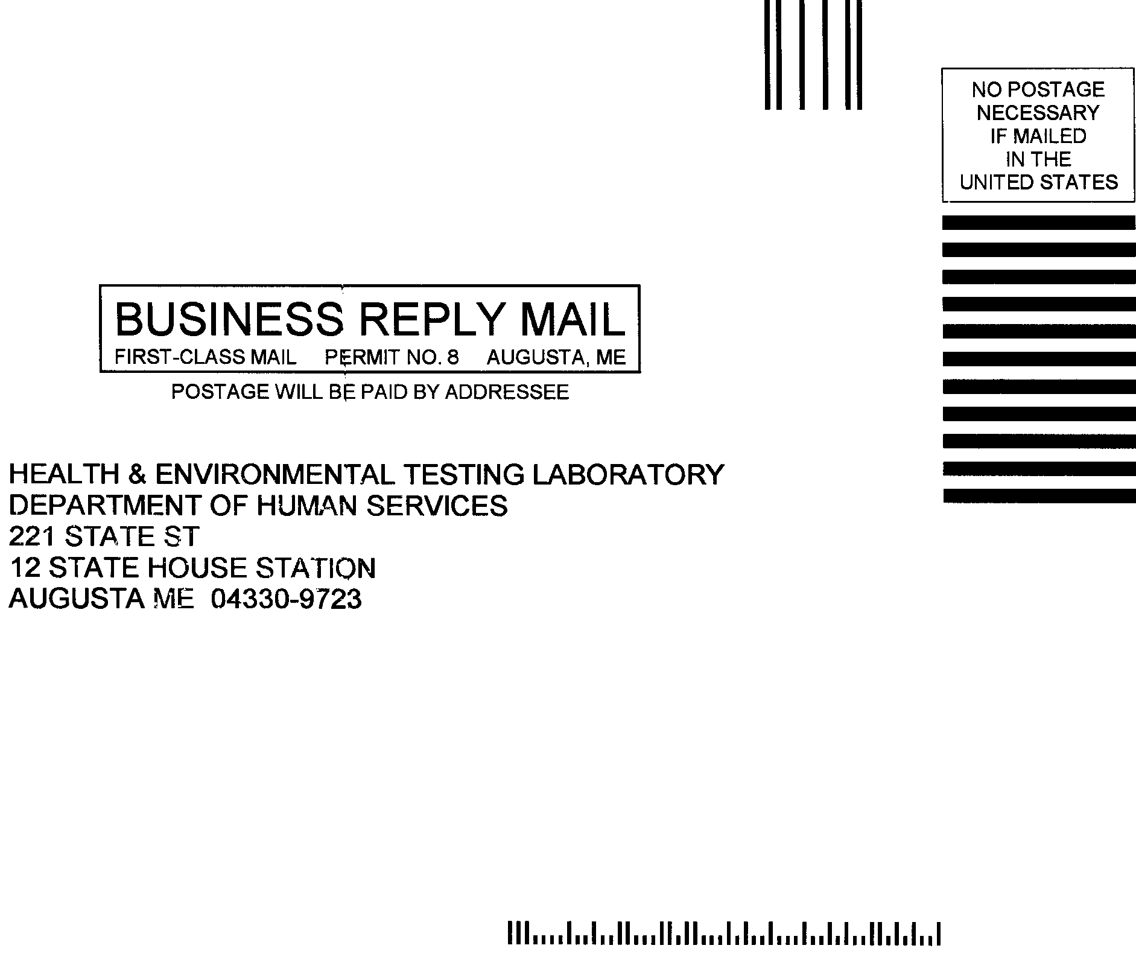

PRSRT STD
U.S. POSTAGE
PAID
PERMIT NO..8..
AUGUSTA, MAINE

MAINE HEALTH & ENVIRONMENTAL LABORATORY NEWS
Division of Health & Environmental Testing Laboratory
Bureau of Health
Maine Department of Human Services
State House Station 12, Augusta ME 04333
Telephone: (207) 287-2727 Fax: (207) 287-6832

Governor - Angus S. King, Jr.
Commissioner - Kevin W. Concannon
Director, Bureau of Health - Dora A. Mills, MD, MPH
Deputy Director, Bureau of Health - Philip W. Haines, Dr. P.H.
Chief, Laboratory Services, HETL - John A. Krueger, MS, CHE
Editors - John A. Krueger & Vincent Prescott

 cut along dotted line

PLEASE FILL OUT THIS FORM FOR:
•Change of address •Removal from our mailing list •Additions to our mailing list •Questions/Comments
When you are finishing simply cut this half of the page off (along the dotted line) and drop into any mailbox.
If mailing address below is incorrect, cross off the what is wrong and print the correct information in the spaces to the right.

Name/Company/Organization:
Address:
Address:
City: State: ZIP
If you no longer want to be on our Newsletter mailing list, please check the box below.
- Please remove me from the mailing list.
If you would like to add an address to our mailing list, please write it below.

This space is provided for anyone who wants to speak his or her mind. All suggestions, questions, comments welcome!!!

