2011 Central District Public Health Improvement Plan

Central District Coordinating Council (DCC) Vision: A healthy population served by comprehensive, well coordinated, public health services.

Phase 1 Central District Public Health Improvement Plan (DPHIP) Purpose:
- Improve health of district residents
- Improve the district public health system
- Reduce avoidable hospitalizations
- Inform the state health plan (& link to Community Health Improvement Plans in Phase 2)

- using the District Public Health System Assessment + ‘Call to Action’ District Performance Report (see appendices A & B )

Guiding Principles:

- Maximize impact & use of limited resources
- Use evidence based strategies & population-based interventions
- Involve multiple sectors
- Address district disparities
- Strengthen & assure accountability

This Phase 1 is a 2-year plan. Phase 2 will incorporate priorities indentified in district Healthy Maine Partnership (HMP) Community Health Improvement Plans to be completed in spring 2011.

Central District Priorities and Phase 1 Actions

Priority District Need/Issue:
Essential Public Health Service (EPHS) #7 - Linking people to needed personal health services and assure the provision of health care when otherwise unavailable

Our needs in the Central District:
- Link people to primary care, especially
    - under/uninsured populations
    - opiate addicted population
    - behavioral health population
    - working poor

- Provide mental health & substance abuse care within primary care practices & primary care within behavioral health practice sites
- Improve appropriate use of health care system & preventive care by district residents
- Address needs of aging population, especially medication management

Goal #1:
Link people to primary care in the district

Strategies:
1A. Compile and regularly update a web-based directory of Central District providers and community resources.

1B. Work with Central District providers to make information on open practices readily available and easily accessible.

1C. Develop and expand linkages between health care providers and other Central District services.

Goal #2:
Link people to behavioral health services in the district

Strategies:
2A. Support and assist with other efforts in the Central District to close gaps and remove
barriers.

2B. Research barriers to access to care in the Central District.

Goal #3:
Build district capacity for integrated behavioral health (includes substance abuse & mental health) and primary care

Strategies:
3A. Identify people in the Central District who participate on workgroups that are addressing this goal.

3B. Promote and support Central District integration initiatives.

3C. Inventory and assess current integration efforts and practices.

4D. Encourage models of effective integrated primary care & behavioral health in both
settings.

Goal #4:
Better educate and engage users of health care in the district

Strategies:
4A. Convene a group of key stakeholders to identify barriers to patient awareness and engagement and to identify opportunities for improvement in the Central District.

4B. Develop effective messages on the importance of being informed about and engaged in one’s own care.

4C. Develop effective messages on how to navigate health care systems and how to access available services.

Phase 1 Priority Action:
  - Develop EPHS #7 Workgroup work plan and work commitments
Lead: LeeAnna Lavoie Measure: Workgroup logic models & timelines

- Develop & implement medication management messaging campaign encouraging patient engagement in their own care
Lead: Dr. Roger Renfrew Measure: Campaign delivered to target audiences

Priority District Need/Issue:
EPHS #4 - Mobilizing community partnerships to identify and solve health problems

Our needs in the Central District:
Make better connections to maximize use of effective work and streamline efforts for greater impact. Especially
    - strengthen links to education system and those targeting youth (ages 18 & under)
    - reach schools not served by school health coordinators
    - increase education sector participation in the DCC

Goal #5:
Strengthen partnerships with groups and service providers that work with youth in the district

Strategies:
5A. Identify groups and service providers that target youth in the Central District, along with opportunities to reach them at their meetings and through their networks.

5B. Develop and conduct outreach to identified groups/providers to discuss their public health role and to strengthen ties to the DCC.

5C. Work with Central District schools to use priority public health messages. (e.g. dental health, physical activity)
5D. Advocate for more health education and physical activity in Central District schools.

Phase 1 Priority Action:
  - Connect DCC to newly formed District Youth Council
Lead: Paula Thomson Measure: Attend District Youth Council meetings & report back to DCC; invite DYC representatives to DCC

Priority District Need/Issue:
EPHS #3 – Inform, educate, and empower people about health issues

Our needs in the Central District:
Provide clear, timely, accurate, effective, and well-coordinated health messages that dispel misinformation and are available through multiple channels.
Especially that
    - reach priority populations (mental health, substance abuse, working poor, other people with health disparities)
    - involve Local Health Officers and municipalities
    - use communication evidence and best practices

Goal #6:
Develop district system to coordinate and distribute important public health information

Strategies:
6A. Set up Central District communication and coordination system.

6B. Develop articles for Central District municipalities to add to community newsletters.

6C. Conduct educational programs for Local Health Officers (LHOs) on priority topics.

6D. Identify and make accessible health evidence and best practices resources.

Phase 1 Priority Action:
  - Form new DCC Workgroup to address EPHS #3 goals
Lead: Bill Primmerman Measure: Form workgroup; develop work plan & commitments

  - Use District Public Health Unit Updates and DCC website to communicate important information to DCC, LHOs, and district partners
Lead: Paula Thomson Measure: Regular updates sent via email; regular updates to DCC website
  - Use District Public Health Unit Updates and DCC website to communicate health evidence & best practices resources to DCC, LHOs, and district partners
Lead: Paula Thomson Measure: Regular updates sent via email; set up resources section on DCC website

  - Conduct 1-2 LHO certification & training programs in 2011
Lead: Paula Thomson Measure: training sessions held; LHOs’ evaluations

Priority District Need/Issue:
Vaccination Coordination and Support (EPHS #3, #4, & #7)

Our needs in the Central District:
Set up an effective communication and mobilization network in the district to continue to improve vaccination rates. Especially
    - develop and distribute consistent messages throughout the district
    - share accurate and timely information to support district vaccination efforts
    - maintain and build on the 2009-2010 successful school vaccination infrastructure

Goal #7:
Develop a communication and mobilization network through the DCC to support vaccination efforts and improve vaccination rates in the district

Strategies:
7A. Establish DCC Vaccination Workgroup to serve as vaccination contacts and communication/mobilization network for the Central District.

7B. Identify, develop, and distribute consistent and useful vaccination messages for use in the Central District.

7C. Support and promote Central District vaccination efforts.

7D. Review vaccination rates and set vaccination targets for the Central District.

7E. Facilitate discussion on Medical Reserve Corps and volunteer/emergency preparedness options & develop recommendations for the DCC.

Phase 1 Priority Action:
  - Establish DCC Vaccination Workgroup & communication network
Lead: Donna Guppy & Measure: Workgroup membership covering all district;
Paula Thomson regular workgroup communication
DPHIP Evaluation, Update Process, and Integration with Local and State Plans

HMP Community Health Improvement Plans (CHIP) are scheduled to be completed in June 2011. The DCC will ask district HMPs to present their plans and any identified important district issues to the DCC at the July quarterly meeting. Other DCC partners will be invited to do so as well. Using these community and partner plans, we will discuss and identify any new priorities to be included in the DPHIP.

In October 2011, the DCC will review progress of DPHIP implementation to date and incorporate priorities identified in community and partner plans. The DCC will update the DPHIP to use in 2012.

In addition, the DCC will provide input to the State Health Plan and HealthyMaine 2020 in 2011 and 2012. The District Liaison will incorporate this DPHIP into the state DPHIP template, to be submitted with other DPHIPs to the State Coordinating Council for Public Health.

Thanks very much to all who helped develop this first
Central District Public Health Improvement Plan!
Appendix A: District Public Health System Assessment
see Draft Central Local Public Health System Assessment (LPHSA) at http://www.maine.gov/dhhs/boh/olph/lphd/district5/CentralLPHSAResport-10-09.pdf

Central District Public Health Systems Assessment
Overall Summary

Overview
Central District Public Health Systems Assessment took place on March 24, 31 and April 8 meeting for approximately 3.5 hours each time. A total of 34 individuals participated in at least one of the three meetings with an average attendance of 21. Because a limitation of this process is that the scores are subject to the biases and perspectives of those who participated in the process, the planning group attempted to recruit broadly across the district. Individuals at the meetings represented HMPs, health care providers, hospitals/VA, emergency management agency, social service agencies, state agencies, mental health, law enforcement, United Way, and schools. Faith-based community, elderly groups and other vulnerable population groups, colleges and environmental health groups are potential gaps in representation.

Summary of Scores  EPHS |  |  | Score
1 | Monitor Health Status To Identify Community Health Problems | 36
2 | Diagnose And Investigate Health Problems and Health Hazards | 55
3 | Inform, Educate, And Empower People about Health Issues | 36
4 | Mobilize Community Partnerships to Identify and Solve Health Problems | 24
5 | Develop Policies and Plans that Support Individual and Community Health Efforts | 43
6 | Enforce Laws and Regulations that Protect Health and Ensure Safety | 40
7 | Link People to Needed Personal Health Services and Assure the Provision of Health Care when Otherwise Unavailable | 25
8 | Assure a Competent Public and Personal Health Care Workforce | 30
9 | Evaluate Effectiveness, Accessibility, and Quality of Personal and Population-Based Health Services | 39
10 | Research for New Insights and Innovative Solutions to Health Problems | 21
Overall Performance Score |  |  | 35

Appendix B: ‘Call to Action’ District Performance Report

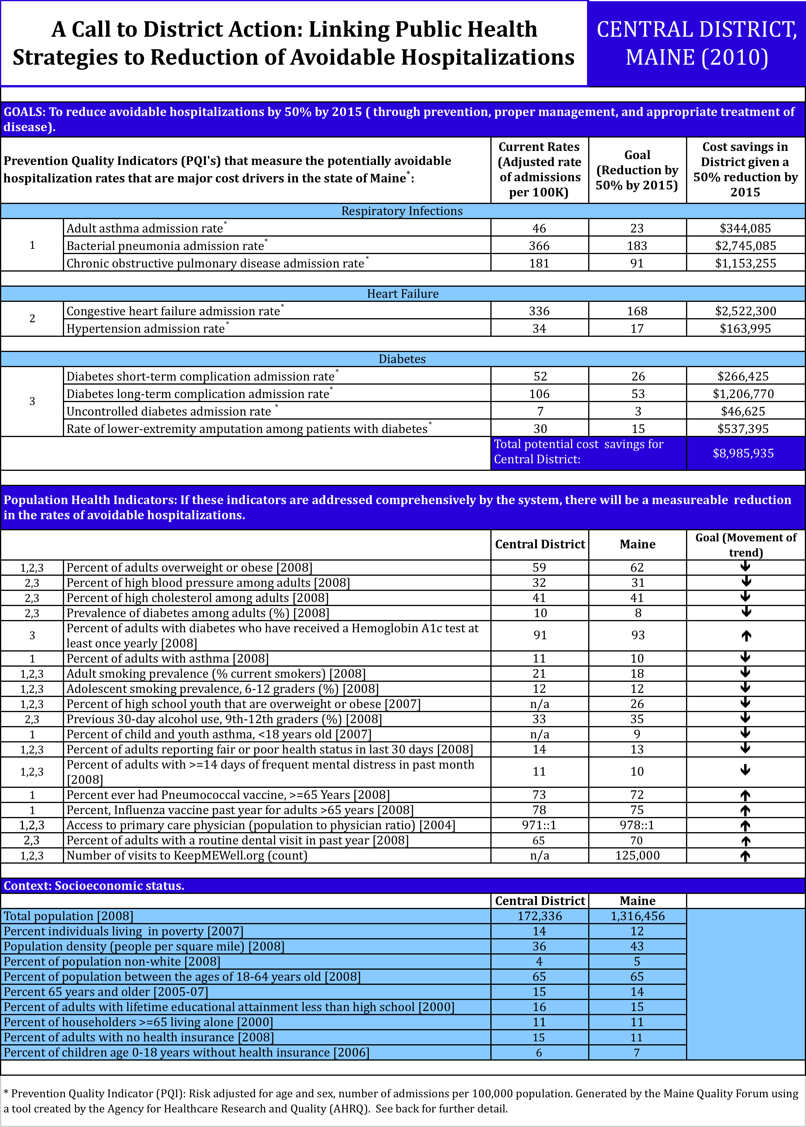
What are Preventable Hospital Admissions?

The federal agency for Healthcare Research and Quality (AHRQ) has identified many hospitalizations
that can be avoided with good preventive and primary care and when patients actively participate in their
car and engage in healthy lifestyle behaviors. For example, patients with diabetes may be hospitalized
for diabetic complications if their conditions are not adequately monitored (e.g., regular foot exams and
blood tests) or if they do not receive the patient education needed for appropriate self-management.
Failures to prevent, detect, and properly manage disease result in avoidable costs to the system. In
Maine we could save up to $71 million if preventable hospitalizations were avoided. National experts
have identified 14 types of preventable hospitalizations; eight of these measures account for the majority
of costs associated with avoided hospitalizations in Maine and so are targeted for reduction in Maine’s
District Performance Reports:

Diabetes with short term complications: All non-maternal/non-neonatal discharges of age 18 years and
older with ICD-9-CM principal diagnosis code for short-term complications (high blood sugar levels, coma).

Diabetes with long term complications: Discharges age 18 years and older with ICD-9-CM principal
diagnosis code for long-term complications (renal, eye, neurological, circulatory, or complications not
otherwise specified).

Uncontrolled diabetes: All non-maternal discharges of age 18 years and older with ICD-9-CM principal
diagnosis code for uncontrolled diabetes, without mention of a short-term or long-term complication.
Lower extremity amputation among patients with diabetes: All non-maternal discharges of age 18 years
and older with ICD-9-CM procedure code for lower-extremity amputation in any field and diagnosis code of
diabetes in any field.

Chronic obstructive pulmonary disease COPD): All non-maternal discharges of age 18 years and older with
ICD-9-CM principal diagnosis code for COPD.

Congestive heart failure (CHF): All non-maternal/non-neonatal discharges of age 18 years and older with
ICD-9-CM principal diagnosis code for CHF.

Bacterial Pneumonia: All non-maternal discharges of age 18 years and older with ICD-9-CM principal
diagnosis code for bacterial pneumonia.

Adult asthma: All non-maternal discharges of age 18 years and older with ICD-9-CM principal diagnosis code
of asthma.

Hypertension: All non-maternal discharges of age 18 years and older with ICD-9-CM principal diagnosis code
of hypertension.

Technical specifications for calculating each of these measures, including exclusions that may apply, can be
found at www.qualityindicators.ahrq.gov/TechnicalSpecs41.htm#PQI41.

Why are Preventable Hospital Admissions Included in District Performance Reports?
Hospitalization is an expensive and the most serious portion of health care treatment. Reducing
preventable hospitalizations improves health care quality and shifts the focus of care to more
appropriate and less costly settings. But effective strategies require a community-wide response by
clinicians, public health experts, consumers, and community organizations. Maine’s public health
districts serve a critical role in bringing these sectors together to determine where the system is not
working and what combination of efforts are needed to impact the rate, and associated costs, of
preventable hospitalizations in their communities. The District Performance Reports are intended to
jumpstart and focus those conversations and serve as a tool for tracking success.

How are the rates and costs of preventable hospitalizations calculated?
Rates of preventable hospitalizations are calculated using the state’s all-payer hospital discharge
database and specifications established by the Agency for Healthcare Research and Quality (AHRQ).
Associated costs for these admissions also are estimated based on AHRQ accounting methodologies
that can be found at: http://www.ahrq.gov/qual/kt/maptool/maptoolsumm.htm.
Appendix C: Other Statewide Healthy Maine Partnership Recommendations

The following section was submitted by Healthy Communities of the Capital Area on behalf of the Maine Network of Healthy Communities for inclusion in each DPHIP:

Introduction:
This first Central District Health Improvement Plan is based on important beginning strategies and steps to improve the health of Maine community members within Kennebec and Somerset Counties. It is important also to note that within the Central Public Health District and across the state, there are overarching issues that cannot go unmentioned as they are core public health initiatives that should be included in a public health improvement plan.

Child Care
The experiences a person has between birth and 5 years of age have a profound impact on his/her long term health and well being. With 85% to 90% of all Maine Preschoolers needing out of home care for parents to work, the availability of good childcare has never been more important.
“High Quality Early Education and Child Care For children improves their health, and promotes their learning and development.” --American Academy of Pediatrics."

HeadStart
Head Start builds and supports the capacity of parents and expectant families to understand the benefits of and access to preventative health care for their children. Head Start provides on-going preventative health education to parents in order to support healthier choices and outcomes for themselves, their families and their communities (e.g. obesity, tobacco cessation, substance abuse prevention, domestic violence, child and adult mental health, State health goals for immunizations, dental health). Head Start reduces the long term costs of health care for the most at-risk population in the State of Maine by supporting the goals of Maternal and Child Health State Plan and the Maine Center for Disease Control and Prevention.

Home Visitation
Home Visitation programs use an evidence-based approach and model to work with expectant and new families in their homes to ensure positive health outcomes for the children and their families and to reduce the incidence of Adverse Childhood Experiences (ACEs), known contributors to adult chronic diseases. These prevention-focused programs address issues such as oral health, prenatal care, perinatal depression, well-child visits and immunizations, and support parents to raise their children in emotionally and physically safe and nurturing environments, Home Visiting impacts the overall health of the child right from the start and reduces the societal costs, both in human and economic terms, of the less than optimal health and development of Maine's children.

School-based Health Centers
Maine’s twenty seven school-based health centers are well positioned to contribute to the achievement the objectives of the State Health Plan. They provide quality primary and preventive health services and education to students where they are, in schools. By providing easily accessible and student-friendly services that are selected by each community, school-based health centers help to prevent more serious illnesses and inappropriate costly hospitalizations and emergency room visits.

Substance Abuse
Substance Abuse is a critical public health issue for the state of Maine.
The rate of heavy drinking among young adults in Maine is 12%, and has been steadily increasing since 2005; this is higher than the national average of 7%. At 32%, young adults have the highest rate of binge drinking (5 or more drinks) compared to other Mainers and binge drink at a higher rate than the national average of 25% (2008 BRFSS).
Alcohol and other drug misuse is Maine’s primary health problem. There were over 21,000 admissions to treatment recorded by the Maine Treatment Data System in FY 2009. 38% of individuals admitted to treatment had one or more arrests in the previous 12 month period; 25% were homeless; 26% unemployed; 95% were White; 2% Black; 2% American Indian / Native Alaskan; and 1% Other. Between 70 -90% of child welfare spending is related to parental substance use problems.

Teen Pregnancy
The teen pregnancy rate in Maine has moved from one of the highest in the country to one of the lowest. This is due to evidence based investments in factual sex education, availability of contraceptives, and sustained attention. To take any attention away from this issue would result in the teen and other unintended pregnancy rate increasing, putting more pressure on social programs from MaineCare to SNAP. Programs to prevent unintended pregnancy are evidence based, and have proven to work in Maine; they need to continue to be sustained.

