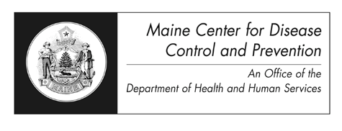

Maine Center for Disease Control and Prevention (Maine CDC) 220 Capitol Street
11 State House Station Augusta, Maine 04333-0011
(207) 287-3771
Fax : (207) 287-1093 TTY Users: Dial 711 (Maine Relay)

Application for Copy of Non-Certified Original Birth Certificate

The Maine CDC vital records office requires the following information to process your request. Applicants must be 18 years of age or older and born in the State of Maine. Fill out the form below and print, or print and then fill out the form using black ink. Please complete as many items as known, required information is marked (*required).

Name of Child after Adoption: Gender: Male

(First)
(Middle)
(Last) (*required)
Female

Date of Birth: City/Town of Birth:
(mm/dd/yyyy) (*required)

Adoptive Father or Co-Parent’s Name:
(First) (Middle) (Last)

Adoptive Mother or Co-Parent’s Name:

Year of Adoption:

(First) (Middle) (Last)

The search requires a non-refundable fee of $10.00 (checks made payable to the Treasurer State of Maine) which includes one non-certified copy of the original birth certificate, if found. A copy of your current birth certificate must be submitted with this application.

Name of Applicant:
(First) (Middle) (Last)
Address of Applicant:
(Mailing address) (City/town) (State and zip)

Daytime Phone Number: Email:

Signature: Date:

Relationship to Adoptee: Subscribed and sworn before me, in my presence, day of , 20 ,
Notary Public in and for the (County) of (State) of .

Notary Signature Notary Name (Printed) My Commission Expires

Official Use Only
Certificate Number
Date Received
Date Issued

S:\vrdmin\Appl Orig Birth Certificate for Adoption.pdf R 04/2014

