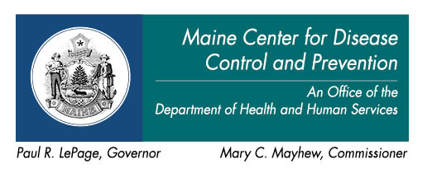
Oral Health Program
286 Water Street, 5th Floor
11 State House Station
Augusta, Maine 04333-0011
Tel: (207)287-3121/Fax: (207)287-7213
TTY Users: Dial Maine Relay 711

Lending Library

Books
TITLE |  | Quantity
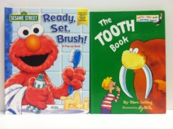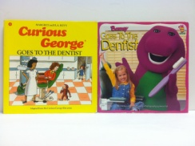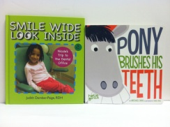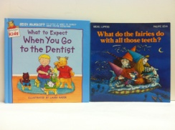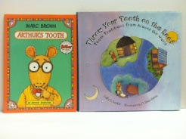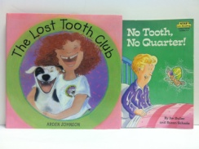
Arthur’s Tooth by Marc Brown |  | 1
Arthur Tricks the Tooth Fairy by Marc Brown |  | 1
Barney Goes To The Dentist by Linda Cress Dowdy |  | 1
Bruce’s Loose Tooth (Fun With A Moose and a Goose) by Eileen Landay |  | 1
Bruce the Moose Fits In by Bill Wood and Bruce the Moose |  | 3
Brush Your Teeth Please (A Pop-Up Book) by Joshua Morris |  | 1
Bugs Bunny Goes to the Dentist by Seymour Reit |  | 1
Clark the Toothless Shark (A Pop-Up, Pull-Tab Book) by Corinne Mellor |  | 1
Colgate Superstar’s Bright Idea by the Colgate-Palmolive Company |  | 4
Curious George Goes to the Dentist by Margret and H.A. Rey |  | 1
Doctor DeSoto by William Steig |  | 1
Dr. Rabbit and Friends (Collection of Song Lyrics) by the Colgate-Palmolive Company spiral/laminated |  | 2
Dr. Rabbit Wants to Say by Kelly Woods Lynch |  | 5
Feeling Fit, That’s It! By JoAnne Nelson |  | 1
Going to the Dentist by Anne Civardi & Stephen Cartwright |  | 1
Good for Me! (All About Food in 32 Bites) by Marilyn Burns |  | 1
Growing Up With My Teeth by Kenneth R. Whitcomb, D.D.S. |  | 1
Horray for Teeth! by Gina Shaw |  | 1
How Peter Molar Looked For A Smile by Jan & Stan Barton Bohonek |  | 1
How to Care for Your and Your Children’s – TEETH – by Sharon Earl, R.D.H. |  | 1
I Lost My Tooth In Africa by Penda Diakite |  | 3
I’m Going to the Dentist by the Colgate Oral Care Division |  | 1
Little Rabbit’s Loose Tooth by Lucy Bate |  | 5
Look Who’s Cooking by Marci and John Carafoli |  | 1
Loose Tooth by Steven Kroll |  | 1
Maisy, Charley, and the Wobbly Tooth by Lucy Gousins |  | 3
Molly and the Slow Teeth by Pat Ross |  | 1
My Bright Smile by Kelly W. Lynch 2 are spiral-bound & laminated |  | 3
Books (Cont.)
TITLE |  | Quantity
My Dentist Makes Me Smile by Leslie Craig R.D.H. small book |  | 1
My Dentist Makes Me Smile (Coloring Book) by Leslie Craig R.D.H. |  | 3
My Friend the Dentist by Jane Werner Watson |  | 1
My Tooth Is About to Fall Out by Grace Maccarone |  | 1
My Wiggly, Jiggly Tooth (a story about losing your first baby tooth) by Joanne and Tracy |  | 1
No Tooth, No Quarter! By Jon Buller |  | 1
One Morning in Maine by Robert MCCloskey |  | 2
Open Wide by Laurie Keller 3 in hard cover |  | 4
Pony Brushes His Teeth by Michael Dahl |  | 3
Ready, Set, Brush (a Sesame Street Pop-up Book) by the American Dental Association |  | 1
Smile! How to Cope with Braces by Jeanne Betancourt |  | 1
Smile Wide Look Inside – Nicole’s Trip to the Dental Office by Judith Dember-Paige, RDH 1 Spanish |  | 4
So Many Things To See! (From the Producers of Mister Rogers’ Neighborhood) by Frank D’Astolfo |  | 1
“So Who’s Dr. Rabbit?” by Patricia C. McKissack and Roberta L. Duyff |  | 2
Super heroes Super Health Cookbook by Mark Saltzman, Judy Garlan & Michele Grodner |  | 1
Taryn Goes to the Dentist by Jill Krementz |  | 1
The Berenstain Bears And Too Much Junk Food by Stan & Jan Berenstain |  | 1
The Berenstain Bears Visit The Dentist by Stan & Jan Berenstain |  | 3
The Crocodile And The Dentist by Taro Gomi |  | 1
The Little Lost Tooth by Marian W. Jensen |  | 1
The Little Princess Gets a Toothache (Kit) by Nancy Hall, Inc. book, toothbrush & holder with timer |  | 1
The Lost Tooth Club by Arden Johnson |  | 2
The Story of the Tooth Fairy by Tom Paxton |  | 1
The Tooth Book by Theo. LeSieg 1 small book, 2 medium |  | 3
The Tooth Book (A Guide to Health Teeth and Gums) by Edward Miller |  | 3
The Tooth Fairy by Kristen Hall |  | 2
The Tooth Fairy by Sharon Peters |  | 1
The Tooth Survival Book by the American Dental Association |  | 3
The Tooth Tree by Nicholas Heller |  | 1
The Tooth Trip (An Oral Experience) by Thomas McGuire, D.D.S. |  | 1
The Tooth Witch by Nurit Karlin |  | 1
The Tusk Fairy by Nicola Smee |  | 2
The Wee Kitten Who Sucked Her Thumb by Mary L. Tufts |  | 1
Those Icky Sticky Smelly Cavity-Causing but…Invisible Germs by Judith Anne Rice English/Spanish |  | 1
Throw Your Tooth on the Roof (Tooth Traditions from Around the World) by Selby B. Beeler |  | 1
Tooth Decay and Cavities by Dr. Alvin Silverstein, Virginia Silverstein, and Laura Silverstein Nunn |  | 3
Tooth Paste (From Start to Finish) by Tanya Lee Stone |  | 1
What do the fairies do with all those teeth? by Michael Luppens |  | 2
What Happened to Mike? By Lynda Love Christensen |  | 1
What to Expect When You Go to the Dentist by Laura Rader |  | 1
You Can’t Put Braces on Spaces by Alice Richter & Laura Joffe Numeroff) |  | 2
Your Guide to Children’s Oral Health by the American Dental Association |  | 2
Your Guide to Health Teeth by the American Dental Association 3 English / 2 Spanish |  | 5
Teaching Aids
TITLE |  | Quantity
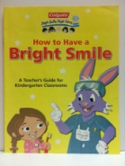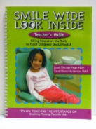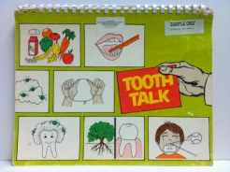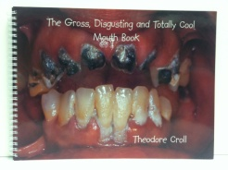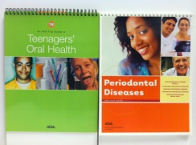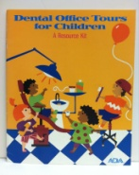
Adventures at Camp Loosetooth (Teacher’s Guide) with Bruce the Dental Health Moose by Maine DHHS – Office of Dental Health) |  | 2
Building for the Future: Nutrition Guidance for the Child Nutrition Programs by the U.S.D.A. |  | 1
Dental Office Tours for Children (A Resource Kit) by the American Dental Association |  | 1
How to Have a Bright Smile – A Teacher’s Guide for Kindergarten Classrooms by the Colgate-Palmolive Company |  | 1
Jody Says… large, spiral-bound & laminated |  | 1
Jody Says, “Love Your Teeth” (Teacher’s Workbook) by the Arizona Office of Dental Health |  | 1
Nick and Kathy’s First Trip to the Dentist large, spiral-bound & laminated |  | 1
Periodontal Diseases – an ADA Flip Guide |  | 1
Smile Wide Look Inside Teacher’s Guide (tips on Teaching the Importance of: Brushing, Flossing, Fluoride Use) by Judith Dember-Paige, RDH & Carol Manocchi-Verrino, MAT) |  | 1
Teenagers’ Oral Health – an ADA Flip Guide |  | 1
The Gross, Disgusting and Totally Cool Mouth Book by Theodore Croll |  | 3
Tooth Talk – A Teacher’s Guide-Flip Chart for Use with Grades K-3 by the American Society of Dentistry for Children |  | 1
Video
TITLE |  | Quantity
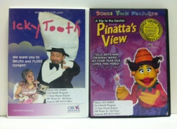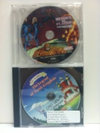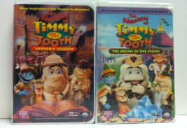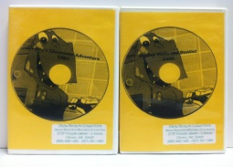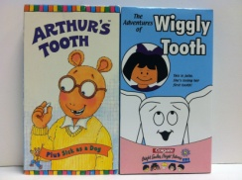
CD – Real Talk About Smoking |  | 1
DVD – A Trip to the Dentist Through Pinatta’s View (with Bonus Fun Features) Approx. 30 min. |  | 1
DVD – Chew on This! Oral Health Choices for Teens |  | 1
DVD – Dr. Rabbit and Friends (Collection of Song Lyrics) by the Colgate-Palmolive Company |  | 3
DVD – Dr. Rabbit and The Legend of Tooth Kingdom Running Time 16 min. |  | 2
DVD – Dudley – Brushing Magic |  | 1
DVD – Dudley’s Classroom Adventure |  | 2
DVD – Dudley Goes to Camp Brush and Floss Running Time 5:49 |  | 1
DVD – Dudley Visits the Dentist |  | 2
DVD – Heroes vs. Plaque |  | 1
DVD – How To Have A Bright Smile (Mini Video 5:19)/Dr. Rabbit and Friends (Sing-Along Songs 18:52) |  | 1
DVD – I Can’t Breathe. A Smoker’s Story. Pam Laffin 1969-2000 Running Time 19:30 |  | 1
DVD – Icky Tooth |  | 3
DVD – Max’s Magical Delivery |  | 1
DVD – Nothing but the Tooth Running Time 7:50 |  | 1
DVD – Women And Tobacco: Seven Deadly Myths Running Time 17 min. |  | 1
VHS – ADA’s Orthodontics Running Time 5:30 |  | 2
Video (Cont.)
TITLE |  | Quantity
VHS – ADA’s It’s Dental Flossophy, Charlie Brown Running Time 5:26 |  | 2
VHS – ADA’s Prevention Ages 1-5 Running Time 5:30 |  | 1
VHS – ADA’s Sealants Running Time 5 min. |  | 1
VHS – ADA’s Taking Care of Your Teeth And Gums Running Time 5 min. |  | 1
VHS – ADA’s The Video Project – Classroom Discussion Guide for Good Oral Hygiene Habits – Middle/Jr. High |  | 1
VHS – Adventures at Camp Moosetooth #1, #2, #3 |  | 1
VHS – Arthur’s Tooth Approx. 15 min. |  | 1
VHS – Basic Screening Surveys: An Approach to Monitoring Community Oral Health |  | 3
VHS – Bright Smiles, Bright Futures – An Oral Health Parent Education Video |  | 1
VHS – Bruce The Dental Health Moose: Adventures At Camp Loosetooth c.3 |  | 1
VHS – Bruce The Dental Health Moose: Adventures At Camp Loosetooth c.4 |  | 1
VHS – Bruce the Moose Magical Good Food Show Running Time 45 min. |  | 1
VHS - Bruce the Moose’s Bountiful Good Food Kitchen – 4 shows Approx. 17 minutes each |  | 1
VHS – Dental Defenders vs. Cavity Creeps Running Time 6 min. |  | 1
VHS – Dr. Rabbit Comes to School Running Time 12 min. |  | 15
VHS – Dr. Rabbit’s World Tour Running Time 13 min. |  | 1
VHS – “Fantastic Fluoride” Running Time 9 min. |  | 1
VHS – “Fluoride: The Magnificent Mineral” Running Time 13 min. |  | 1
VHS – Jody Says “Love Your Teeth” |  | 1
VHS – Media Sharp’s Analyzing Tobacco & Alcohol Messages Running Time 7:35 |  | 1
VHS – National Institute of Dental Research’s “Prescription for Periodontal Health” |  | 1
VHS – Real Talk About Smoking (Just Real Maine Kids Talking About Smoking) |  | 1
VHS – Seal in a Smile Running Time 5 min. |  | 1
VHS – Sooper Puppy “Puff of Smoke” (Primary – 3rd grades) Running Time 16 min. |  | 1
VHS – Take Time for Teeth Running Time 6:43 |  | 7
VHS – The Adventures of Timmy The Tooth “Spooky Tooth” Running Time 29 min. |  | 1
VHS – The Adventures of Timmy The Tooth “The Brush In The Stone” Running Time 34 min. |  | 1
VHS – The Adventures of Wiggly Tooth Running Time 13 min. |  | 2
VHS – The Incredible Ride (Importance of Brushing) Running Time 15 min. |  | 3
VHS – The Sparkles’ Space Adventure |  | 1
VHS – Tobacco: Something To Chew On Running Time 18 min. |  | 1
VHS – Toothbrushing With Charlie Brown Running Time 4:53 |  | 1
VHS – VERMONT’S Baby Bottle Tooth Decay Initiative |  | 1
VHS – WCSH-TV News Report On Fluoride In Water Running Time 3 min. |  | 1
Puppets
TITLE |  | Quantity
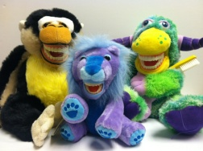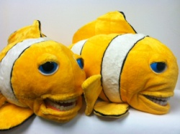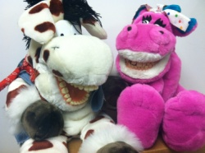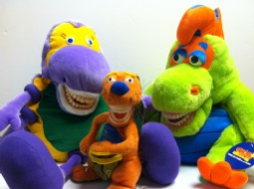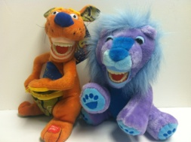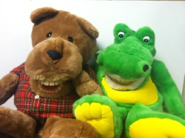
Dental Aid Puppets
Alli Gator (large puppet) |  | 1
BG Roo The Aussie Toothfairy (small stuffed animal) |  | 1
Brown Bear (large puppet) |  | 1
Elephants (large puppets) |  | 4
Farley Flossisaurus with water-squirter (large puppet) |  | 1
Finn Z. Fish with water-squirter (large puppet) |  | 2
Mojo Monkey with water-squirter (large puppet) |  | 2
Molar Z. Monster (large puppet) |  | 1
Cowboy Horse (large puppet) |  | 1
Princess Dragon (large puppet) |  | 1
Purple Flying Bug Boo with water-squirter (large puppet) |  | 1
Rasta Lion (small stuffed animal) |  | 1
Roary Z. Lion (small puppet) |  | 2
Hand Puppets
Chef Combo (medium puppet) |  | 1
Maine Moose (medium puppet) |  | 1
Stuffed Animals
Baby Dinosaur in leather clothes (small) | 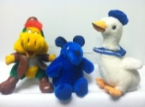 | 1
Baby Sailor Duck (small) |  | 1
Dark Blue Mouse (small) |  | 1

Created: 11/08/12

S:\SOHP\List of Lending Library Materials.docx

DHHS
Non-Discrimination Notice

The Department of Health and Human Services (DHHS) does not discriminate on the basis of disability, race, color, creed, gender, sexual orientation, age, or national origin, in admission to, access to, or operations of its programs, services, or activities, or its hiring or employment practices. This notice is provided as required by Title II of the Americans with Disabilities Act of 1990 and in accordance with the Civil Rights Act of 1964 as amended, Section 504 of the Rehabilitation Act of 1973, as amended, the Age Discrimination Act of 1975, Title IX of the Education Amendments of 1972 and the Maine Human Rights Act and Executive Order Regarding State of Maine Contracts for Services. Questions, concerns, complaints or requests for additional information regarding the ADA may be forwarded to DHHS’ ADA Compliance/EEO Coordinators, 11 State House Station – 221 State Street, Augusta, Maine 04333, 207-287-4289 (V), 207-287-3488 (V), 1-800-606-0215 (TTY). Individuals who need auxiliary aids for effective communication in program and services of DHHS are invited to make their needs and preferences known to the ADA Compliance/EEO Coordinators. This notice is available in alternate formats, upon request.

