

MANAGE PROVIDERS

The ImmPact2 Immunization Registry is a population-based Web application containing consolidated demographic and immunization history information. ImmPact2 is able to perform a variety of functions for health care providers, including, but not limited to:
- ADA compliancy
- VFC Annual Agreement Integrated with Org/Site Management
- Comprehensive client and vaccine management
- Fully integrated VMBIP/Vaccine Management
- Integrated Optical Character Reader Technology
- Time savings data entry Page designed (integrated administration and batch entry SCREEN - 5 pages down to 1)
- CASA-Like Reports (Up To Date Report and Immunization Coverage Reports )
- Program Activity Tracker (Track VFC and Program related interventions across all 12 Grant Components)
- Medicaid Well Child Forms
- Medicaid Contact Management Functionality
- Obesity Data Collection and Connections to Medicaid Data Collection
- School Access (View Only Currently)
- Ability to Import/Export the Vaccine Schedule for centralized maintenance and contracting
- CDC Annual Report Generation- Non validated Dose Collection (Collect doses from WIC, HeadStart, Schools, etc. and validate in Provider Offices)
- Ability to create forms online and store within the Database
- Ability to import past CASA/Co-CASA
- Data Exchange (outbound completed, inbound pending)
- VPD Surveillance Initiation Form (2008 deliverable)
- Hep B. Surveillance Functionality (slated for 2009)
ImmPact2 is provided free of charge to health care providers in Maine. To use the registry, providers are required to participate in an ImmPact2 training session and sign an enrollment agreement.

The following instructions were developed for use as a resource within your practice.

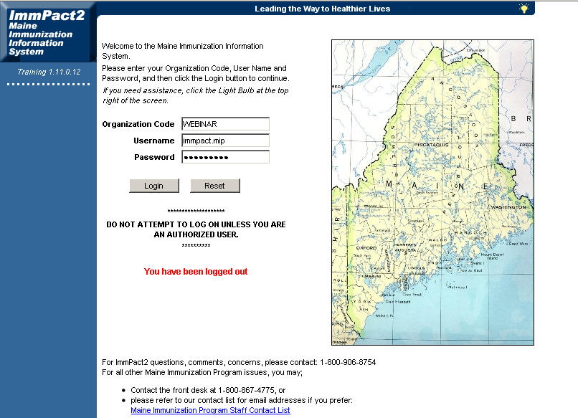
Logging into ImmPact2 requires an Organization Code, Username and Password.
In this case we will use what is displayed above. After entering the login information, click Login.

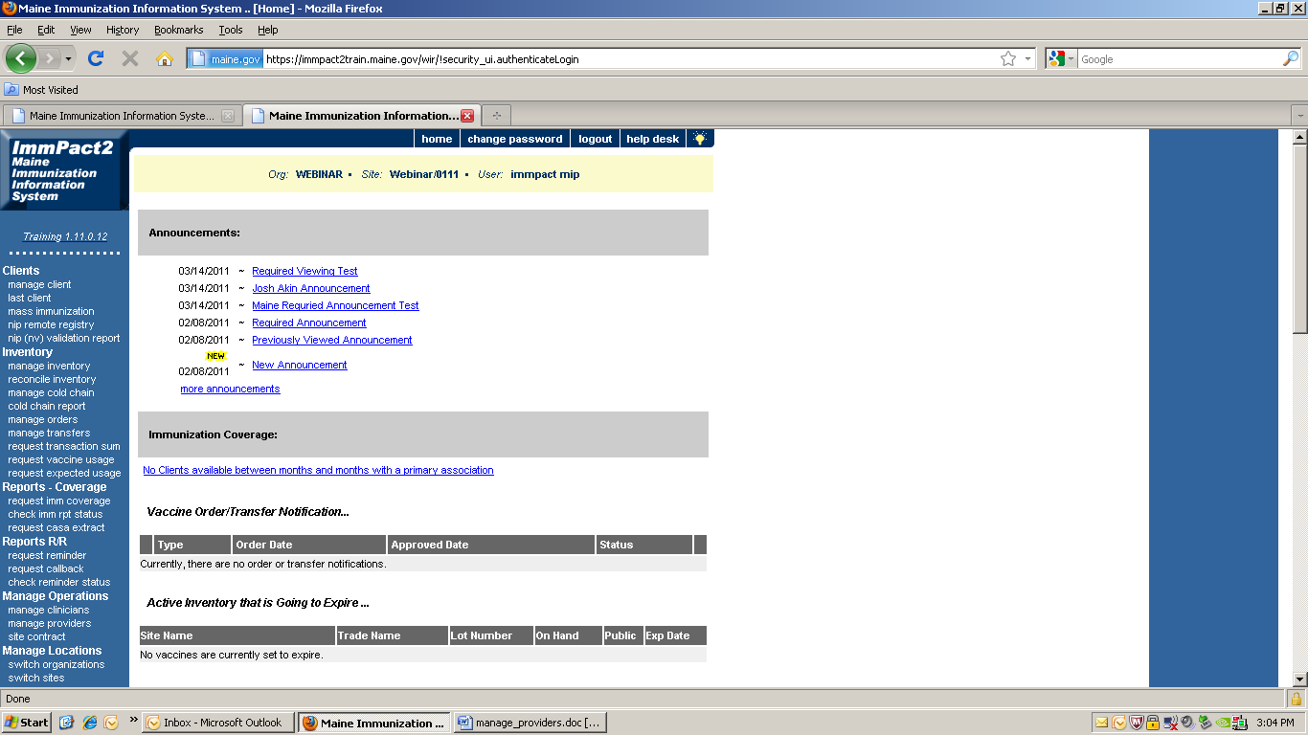
Under Manage Operations in the blue margin to the left of the screen you will want to click on manage providers.
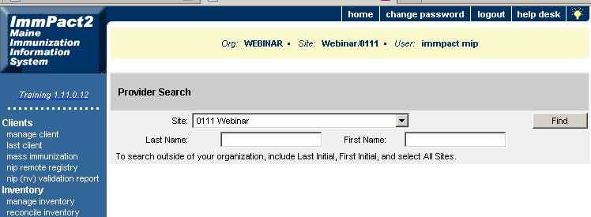

The Provider Search screen will appear.
If adding a new provider, you will want to select All Sites from the Site drop down. Search for the provider in the system by typing in the first three letters of their last name and the first three letters of their first name, and then click the Find button.
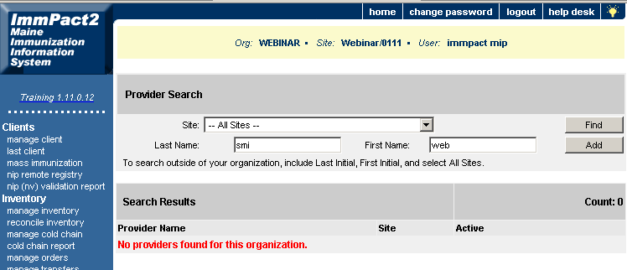

If the provider is not in the system already, then click the Add button.
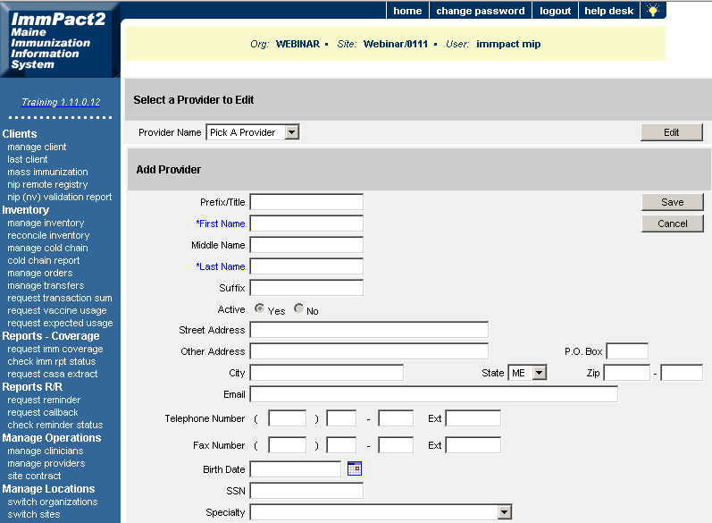
This is the Edit Provider screen. Fill out the First Name, Last Name, Suffix (MD, DO etc.), and the License Number and DEA Number if known.

NOTE: All fields highlighted blue are required fields that must be filled.
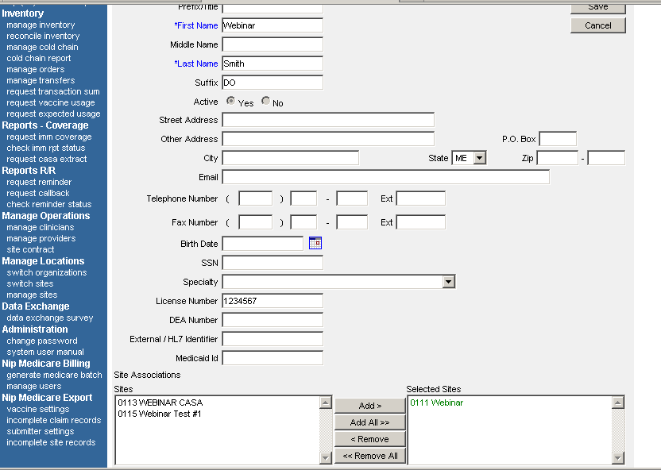

Select the site from the Site Associations box and move it to the Selected Sites box by clicking Add.

Click Save.
[Check that the change have been saved] 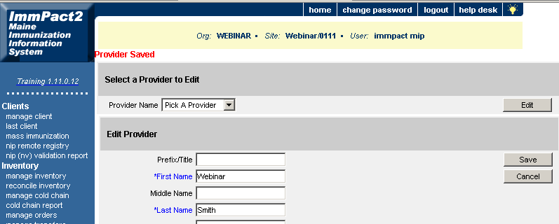

Provider Information has saved.

To Edit a Provider
Under the header Manage Operations click the Manage Providers link in the blue margin to the left of the screen.
Type in the first three letters of the last name and the first three letters of the first name then click Find.
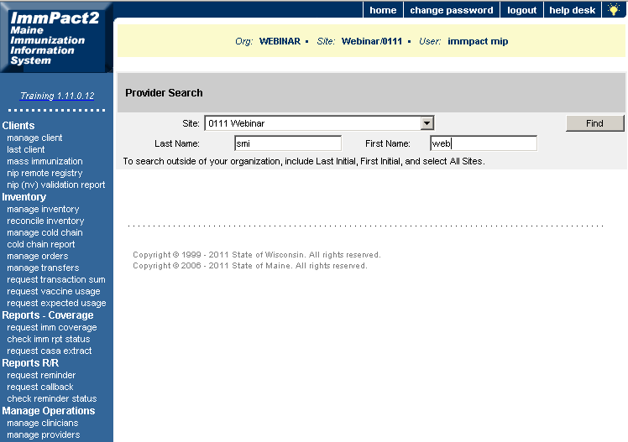

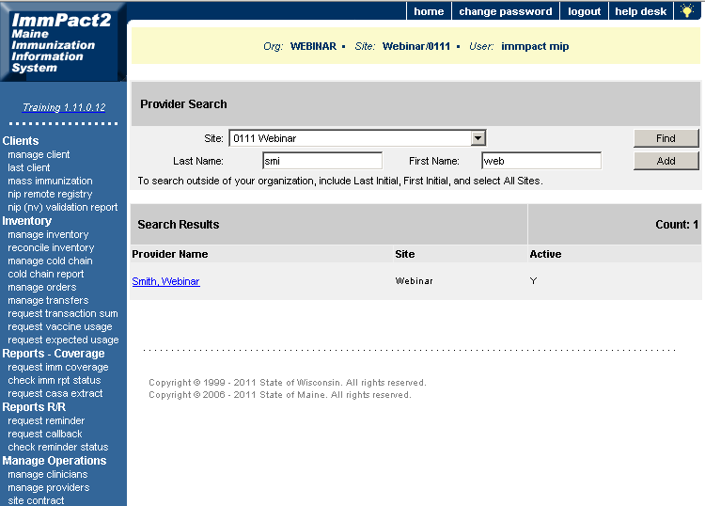

Click on the name highlighted in blue.

The Edit Provider screen will appear where changes can be made if needed. When changes have been made, click Save and this will update the providers information.

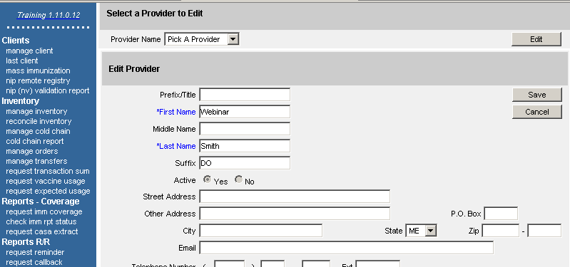

NOTE: All fields highlighted blue are required fields that must be filled.

[Check that the change have been saved]
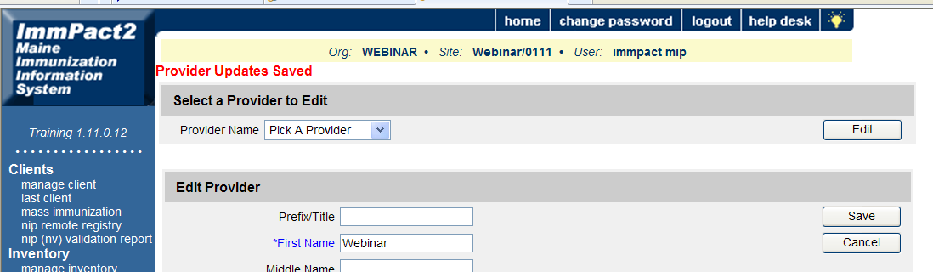

Deleting or Disassociating a Provider from your site

Under the header Manage Operations click the Manage Providers link in the blue margin to the left of the screen.
Type in the first three letters of the last name and the first three letters of the first name then click Find.

Select the Provider by clicking the highlighted blue name of the correct Provider.
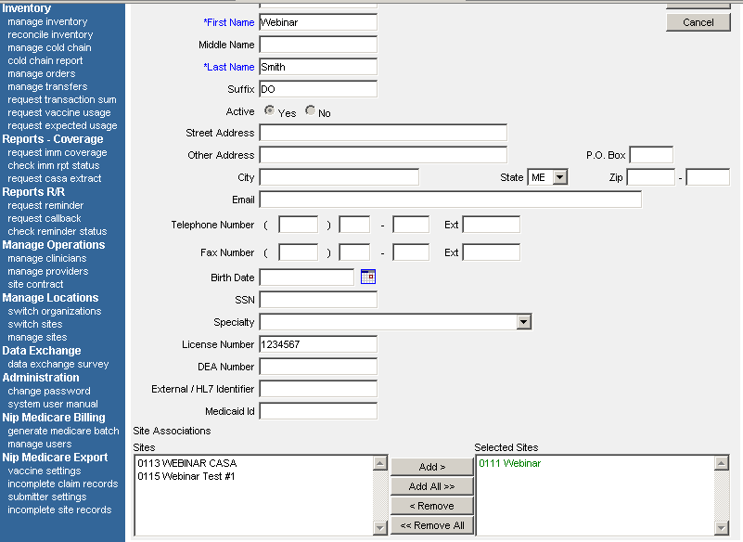
2.

Select the site name from the Selected Sites box on the right, click Remove and the site will move back to the Sites box on the left.
Click Save.

