

MANAGE CLINICIANS
The ImmPact2 Immunization Registry is a population-based Web application containing consolidated demographic and immunization history information. ImmPact2 is able to perform a variety of functions for health care providers, including, but not limited to:
- ADA compliancy
- VFC Annual Agreement Integrated with Org/Site Management
- Comprehensive client and vaccine management
- Fully integrated VMBIP/Vaccine Management
- Integrated Optical Character Reader Technology
- Time savings data entry Page designed (integrated administration and batch entry SCREEN - 5 pages down to 1)
- CASA-Like Reports (Up To Date Report and Immunization Coverage Reports )
- Program Activity Tracker (Track VFC and Program related interventions across all 12 Grant Components)
- Medicaid Well Child Forms
- Medicaid Contact Management Functionality
- Obesity Data Collection and Connections to Medicaid Data Collection
- School Access (View Only Currently)
- Ability to Import/Export the Vaccine Schedule for centralized maintenance and contracting
- CDC Annual Report Generation- Non validated Dose Collection (Collect doses from WIC, HeadStart, Schools, etc. and validate in Provider Offices)
- Ability to create forms online and store within the Database
- Ability to import past CASA/Co-CASA
- Data Exchange (outbound completed, inbound pending)
- VPD Surveillance Initiation Form (2008 deliverable)
- Hep B. Surveillance Functionality (slated for 2009)
ImmPact2 is provided free of charge to health care providers in Maine. To use the registry, providers are required to participate in an ImmPact2 training session and sign an enrollment agreement.

The following instructions were developed for use as a resource within your practice.

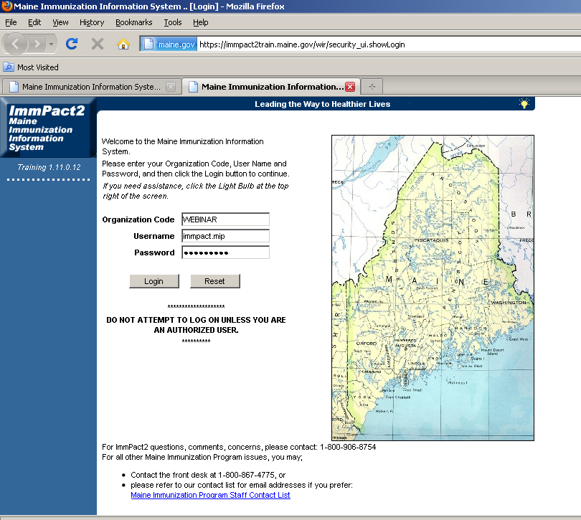
Logging into ImmPact2 requires an Organization Code, Username and Password.
In this case we will use what is displayed above. After entering the login information, click Login.

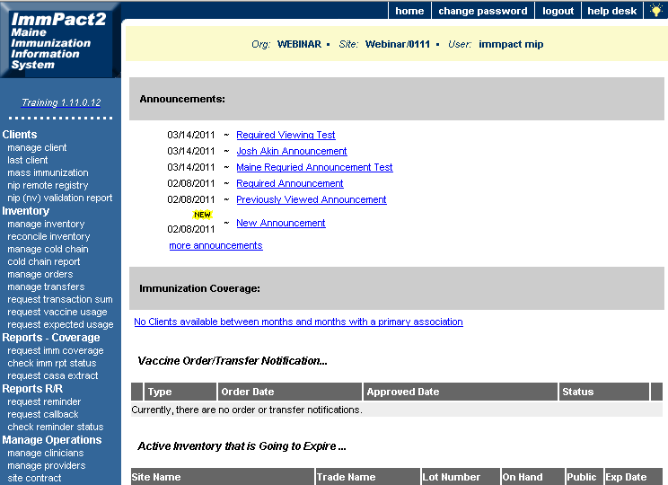

Any urgent messages must be opened and read before moving forward.
Under Manage Operations in the blue margin to the left of the screen click on manage clinicians.

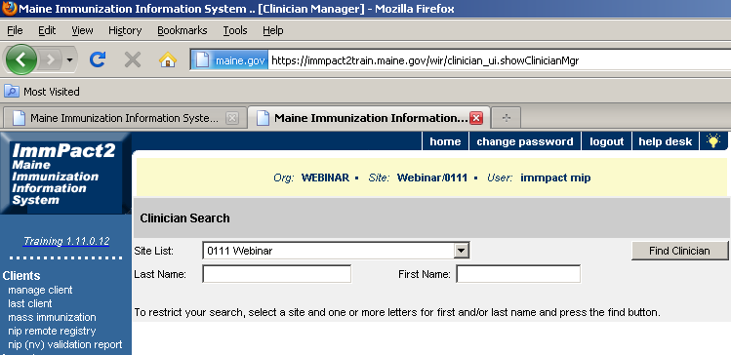
The Clinician Search screen will appear.
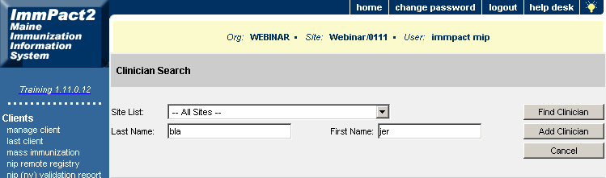

If adding a new clinician, you will want to select All Sites from the Site List drop down. Search for the clinician in the system by typing in the first three letters of the last name and the first three letters of the first name and then click the Find Clinician button.
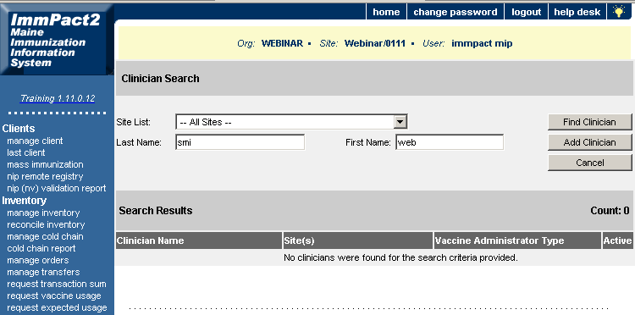

If there is no return for a name, click the Add Clinician button to the right of the screen to add a new clinician.

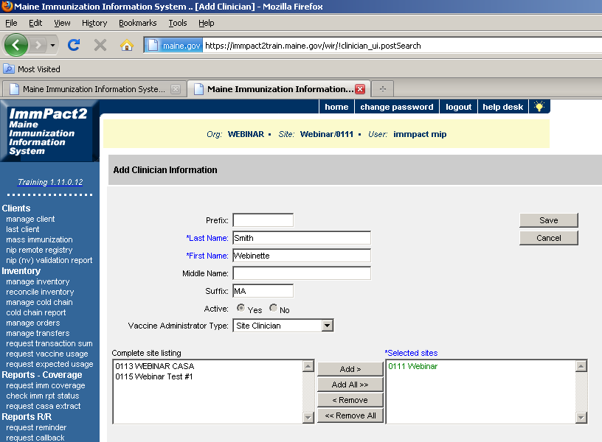

Complete the Last Name, First Name, and Suffix and select your site from the Complete site listing box and click Add to move it over to the *Selected sites box. Click Save.
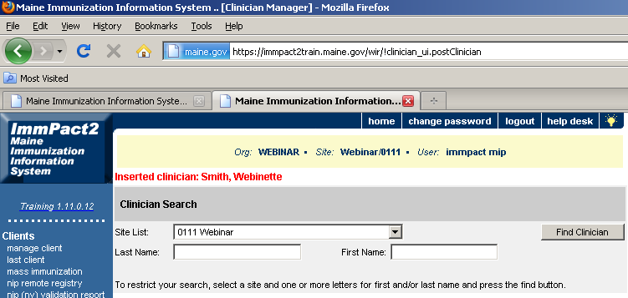

New clinician has saved successfully.

To Edit a Clinician
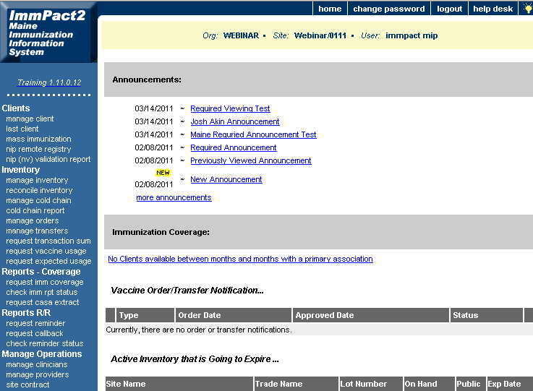

Under Manage Operations click the Manage Clinicians link in the blue margin to the left of the screen.
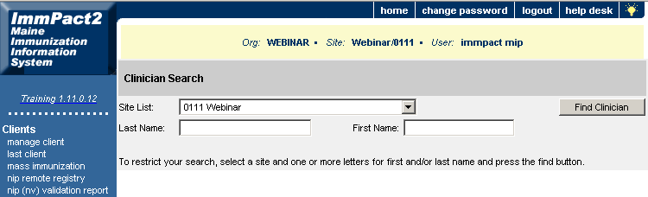

Type in the first three letters of the last name and first name, then click Find Clinician.
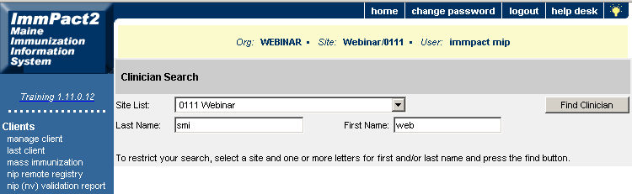

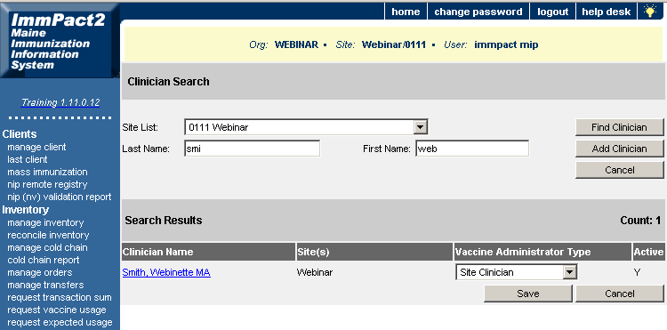

Click on the name highlighted in blue

The Edit Clinician Information screen will appear where you can make any changes needed. When changes have been made, click the Save button and this will update the clinicians information.
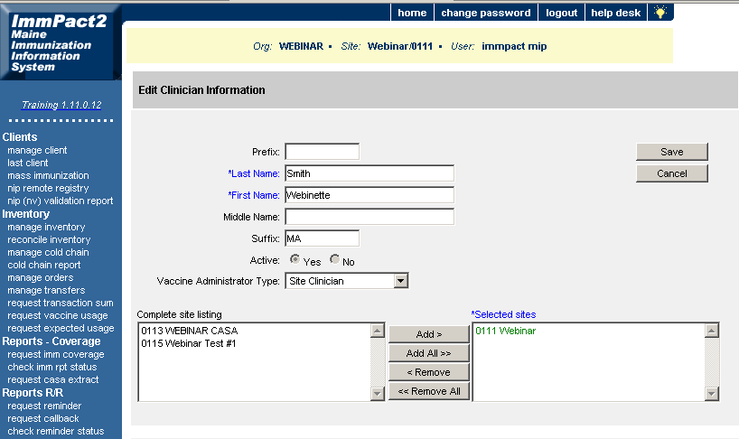

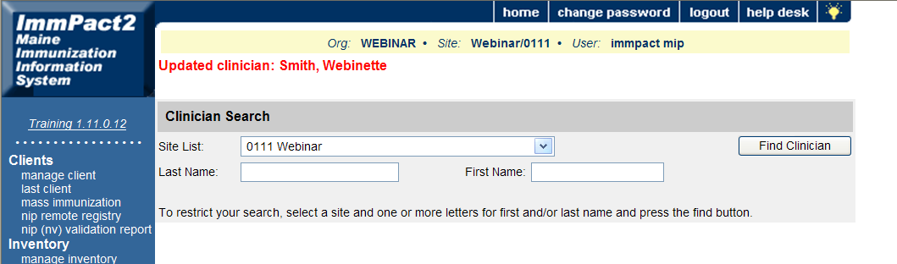

Deleting or Disassociating a Clinician from your site
Under Manage Operations click the Manage Clinicians link in the blue margin to the left of the screen.

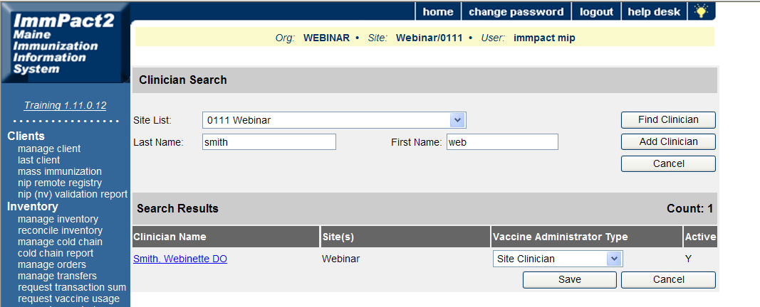

Search by the first three letters of the last name and the first three letters of the first name. Select the Provider’s name highlighted blue.
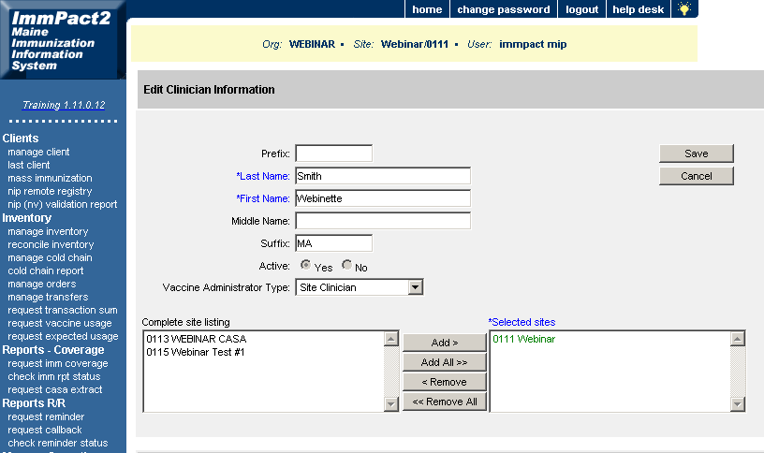

3.
2.
Select from the Vaccine Administrator Type drop down and choose the blank spot above the Site Clinician option. Then select the site 0111 Webinar from the “Selected sites” box and click Remove and the site will move over to the complete site listing box to the left. Click Save

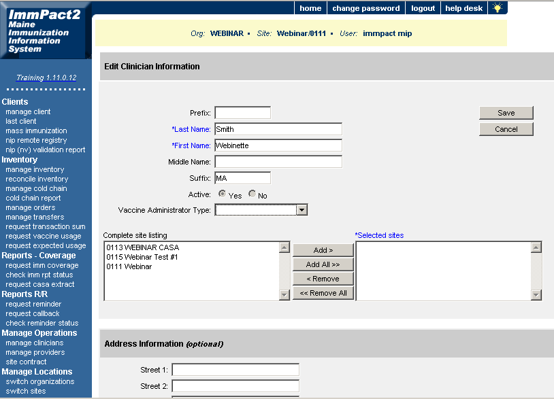
4.
1.
5.

Now the 0111 webinar has been moved to the complete site listing box click save.


