Data Logger Quick Reference Guide
Software Installation

Step 1 – Go to link below on Internet

http://www.logtagrecorders.com/software/downloadlinkpage.htm

Step 2 – Click on link Click here to download LogTag Analyzer Software

Step 3 – Click Save File

Step 4 – Click OK to Run Download Installation

Step 5 – Select English as Language and Click OK

Step 6 – Welcome to the LogTag Analyzer Setup Wizard will appear on screen. Click Next.

Step 7 – Read through and accept the terms in the License Agreement. Click Next to continue.

Step 8 – Click Browse to install to a different folder. When correct folder is chosen click Next.

Step 9 – Click Install

Step 10 – Click Finish to complete.

Data Logger Quick Reference Guide
Preparing for LogTag Use

The Maine Immunization Program has prepared your LogTags for use. LogTags are programmed with high and low temperature recommendations and are labeled either as Refrigerator or Freezer. Please be sure to put correct type of LogTag unit into corresponding storage unit. This will ensure that the alarm function of the LogTag will work appropriately.

Step 1 – Attach Glycol Probe to LogTag. The plug at end of long cord fits into hole on the side of the LogTag device.

Step 2 – Place Glycol Probe in a central location in your vaccine storage unit. Run the long cord to the outside of your unit. LogTag recorder should be placed in a location outside of the storage device where temperatures can be read without having to open the door to the unit. Attach with included zip ties and/or Velcro if necessary.

Step 3 – Press and hold the START button on the LogTag. The words STARTING will flash several times on the screen. Let go of START button once the words STARTING remain solid.

Step 4 – Your LogTag is now recording.

Step 5 – Maine Immunization Program sites must continue to record temperatures twice daily. In addition, Minimum/Maximum temperature recording must be taken once a day, preferably in the morning. To retrieve these recordings, click the REVIEW button on the LogTag. Record Minimum/Maximum temperatures and click the START button to return to viewing current temperatures.

Data Logger Quick Reference Guide
Downloading Temperatures

Step 1 – Detach LogTag from Glycol Probe.

Step 2 – Insert the LogTag Interface Cradle into a USB port on the computer with the LogTag software.

Step 3 – Open LogTag Analyzer Program.

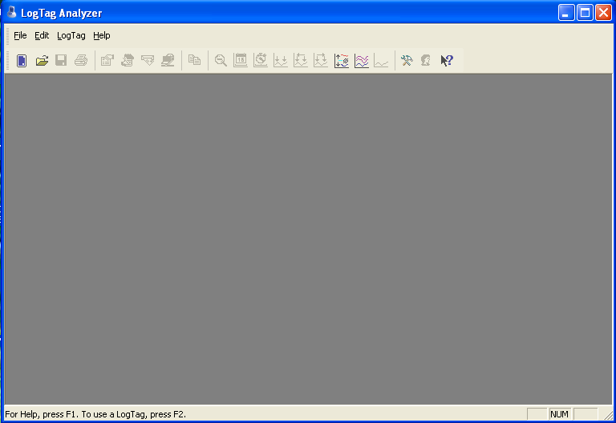

Step 4 – Insert LogTag into the LogTag Interface Cradle. Recorded temperatures will automatically download and save to a file on your computer labeled as LogTag Data with start and end record dates.

Step 5 – The recorded temperatures will now appear as a graph on the LogTag Analyzer screen under the Chart tab.

There are several ways to view your data.

- Chart – A display of the data in a time versus temperature chart.
- Data – A listing (spreadsheet style) of the time versus temperature data.
- Summary – A summary of the data, including averages, ranges, alert results, LogTag identification data, and other information.
- Day Summary – A summary of the day statistics for display loggers.
- Report – A summary of the data, including alarm status, LogTag identification, configuration data, recorded data, and other information.

Step 6 – Review your recordings to verify temperatures were within recommended range for the entire recording period. The Maine Immunization Program recommends viewing the Report tab. Click on the Report Tab on the bottom of the screen.

If both Low and High temperatures are OK, indicated by a GREEN CHECKMARK, continue to step 8.

Step 7 - If temperatures have been recorded outside of recommended temperature range, Low and/or High temperatures will say FAIL, indicated by a RED X. Scroll further down on the Report page to view the total amount of time temperatures were outside of range. Contact the vaccine manufacturer with this information immediately. You must notify the Maine Immunization Program after speaking with the manufacturer. The Maine Immunization Program will give guidance on how to proceed.

Step 8 (MUST BE DONE AT LEAST EVERY 80 DAYS) – Once temperatures have been viewed, the LogTag must be setup for the next use. Click on the Access LogTag button (LogTag Icon) in the upper left corner of the screen.

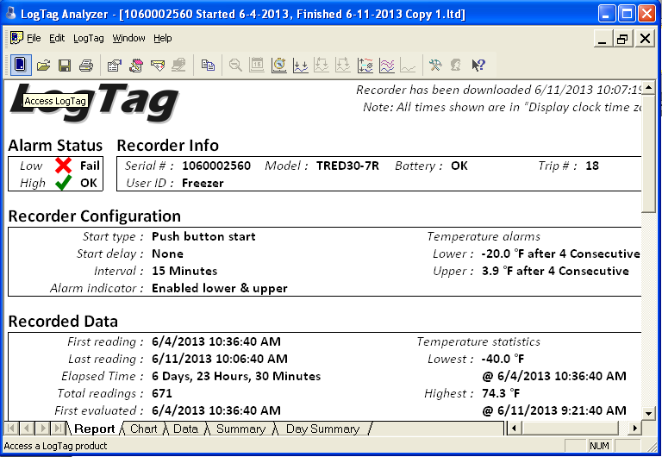

Step 9 – The LogTag access wizard will appear on the screen. Click Next to continue.

Step 10 – The LogTag access wizard will automatically locate the LogTag during step # 2.

If the LogTag wizard does not locate the LogTag:

- Close LogTag Analyzer Program.
- Remove LogTag from Interface Cradle.
- Remove LogTag Interface Cradle from USB port, wait 5 seconds, reinsert LogTag Interface Cradle into USB port.
- Open LogTag Analyzer Program.
- Insert LogTag into LogTag Interface Cradle.
- Retry LogTag Access Wizard.

Step 11 – The LogTag has been programmed by the Maine Immunization Program to required CDC specifications.

DO NOT MAKE CHANGES ON THIS SCREEN.

Verify the LogTag battery is OK in the upper right corner. If LogTag battery is low, lettering will be indicated in RED.

Click Next.

Step 12 – The LogTag will automatically reconfigure. Once finished, a message will appear at the top of the screen - The LogTag(s) below are now ready to start/be started. Click Close to exit the LogTag access wizard.

Step 13 – Remove the LogTag from the LogTag Interface Cradle and reconnect the LogTag to the Glycol Probe attachment. Press and hold the START button on the LogTag. The words STARTING will flash several times on the screen. Let go of START button once the words STARTING remain solid.

Your LogTag is now recording.

The Maine Immunization Program requires LogTag temperature recordings be downloaded and reviewed at least once a month.

Data Logger Quick Reference Guide
Frequently Asked Questions

Why does the Maine Immunization Program now require a digital data logger to record temperatures?

In response to recent scientific studies, the Centers for Disease Control and Prevention (CDC) now strongly recommends the use of a digital thermometer with a bio safe glycol-encased or similar temperature buffered probe. The thermometer should also be able to provide and store data monitoring information set at programmable intervals in an active display that allows for reading temperatures without opening the unit door. This means that the digital data logging thermometer probe should be able to remain in place and not be disturbed during data reading and recording. A detachable probe facilitates downloading temperature data without removing the probe from the storage unit, and should simplify daily use and minimize operator cause of temperature variability.

If we have our own digital data logger are we required to use the LogTag provided by the Maine Immunization Program?

No, as long as the current digital data logger includes the following:

• Hi/Low alarm for out-of-range temperatures;
• Current temperature, as well as minimum and maximum temperatures;
• Reset button
• Low battery indicator;
• Accuracy of +/- 1°F (0.5°C);
• Memory storage of at least 4000 readings, device will not rewrite over old data and
stops recording when memory is full;
• User programmable logging interval (or reading rate).

Do we have to record Minimum/Maximum temperatures?

Yes. Based on recent CDC recommendations, it is now a requirement of the Maine Immunization Program to record minimum/maximum temperatures once a day (preferably in the morning). New temperature recording forms were included in this digital data logger mailing. These new forms include a space to record the daily minimum/maximum recordings. Please keep these on file. ImmPact does not include for these addition recordings, but will be updated in the future. You will still need to record your temperatures twice daily in ImmPact.
What if I don’t have access to the internet?

A LogTag disc is included in the digital data logger mailing. This disc includes the software to download the LogTag Analyzer Program. However, a more recent version with updates is located on the LogTag website at:

http://www.logtagrecorders.com/software/downloadlinkpage.htm

Do I have to save my LogTag recordings?

The Maine Immunization Program requires temperature recordings to be saved for a total of 3 years. It is not required to save the LogTag recordings if you are saving the hard copies of your paper temperature forms, but it is STRONGLY recommended.

I noticed my LogTag has the word ALARM on the screen. What do I do?

THERE IS NO AUDIBLE ALARM ON THE LOGTAG DATA LOGGERS!!!

If your LogTag has the word ALARM on the screen, your temperatures have gone outside of recommended range. Please do the following IMMEDIATELY:

- Download your LogTag data
- Contact the vaccine manufacturers for information on vaccine viability
- Contact the Maine Immunization Program for guidance
- Don’t forget to document all steps taken

Can I create a password for my LogTag?

DO NOT CREATE A PASSWORD FOR YOUR LOGTAG! This information is not confidential. If you create a password and forget it, you will not be able to retrieve data for your LogTag. The LogTag must be mailed back to the manufacturer for reset. The Maine Immunization Program will not pay for replacement data loggers.

Why isn’t my LogTag data downloading?

There are several reasons your data may not download. Please try the following before calling the Maine Immunization Program for guidance:

- Close LogTag Analyzer Program.
- Remove LogTag from Interface Cradle.
- Remove LogTag Interface Cradle from USB port, wait 5 seconds, reinsert LogTag Interface Cradle into USB port.
- Open LogTag Analyzer Program.
- Insert LogTag into LogTag Interface Cradle.

Why can’t I start my LogTag?

The start button is located on the front of the LogTag. Press and hold the start button. The words STARTING will begin flashing. Continue to hold the button until the words STARTING stop flashing and remain on.

The start button on your LogTag may not be perfectly on center. If you run your finger over the area, you will be able to feel a bump. This is the button you need to hold down.

Why has my LogTag stopped recording?

The LogTag has enough memory to record at 15 minute intervals for 80 days only. You must clear the memory at least every 80 days, but we recommend to clear the memory at least once a month. Please refer to step 8 of the instructions to clear the memory and re-start the LogTag for use.

Why are my temperature recordings wrong?

Before starting your LogTag, make sure you attach the glycol probe. The LogTag will only record temperatures if the probe is attached. If you start the LogTag without the probe attached, the screen will show a temperature of -199.9. The LogTag records every 15 minutes. If you forget and start the LogTag without the probe attached, plug the probe in and the next reading will show correctly on the screen.

Should I return my old thermometers?

Continue to use both your current thermometers and the LogTag for the first 5 days to ensure accuracy of the new thermometers. After the 5 days, you can remove the old thermometers and start to use the LogTag exclusively. Please be aware of the new Maine Immunization Program requirement that provider offices must have a set of certified calibrated thermometers both in their refrigerator and a back-up set of certified calibrated thermometers. Please re-calibrate your current thermometers to ensure you have 2 sets of certified calibrated thermometers at all times.

