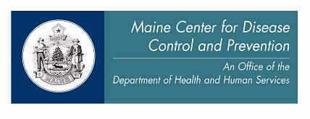

State of Maine
CAREWare User Guidance Manual
For Part B Providers
Version 5

Updated April 2013

Maine CDC (the Ryan White Part B grantee) and Ryan White Part C grantees in Maine agreed to establish a centralized CAREWare reporting system in mid-2007. This collective system allows for better data quality and an unduplicated count of PLWHA receiving services within the state. Users access the database through a secure connection to the State server and then by running the CAREWare client tier from their workstations. Once the secure connection to the state server has been engaged, the client tier connects each user to the business and data tiers, which are stored on a secure State of Maine server.

Definitions of services are consistent with definitions provided by the Health Resources and Services Administration in response to the Ryan White Treatment Extension Act of 2009.

This guidance document was prepared by Tara Thomas, Data & Quality Specialist for the Ryan White Part B Program, with input from Gen Meredith, former Ryan White Part B Coordinator. The US Department of Health and Human Services, Health Resources and Services Administration, HIV/AIDS Bureau’s RW CAREWare Version 4.0/4.1 User Manual dated January 2006; How to Use the CAREWare ADAP Drug Services Module dated May 2007; and the most recent Ryan White HIV/AIDS Program Services Report Instruction Manual contributed to this document.

This document describes how data are required to be entered as a contractual requirement for Part B Providers. Some Providers may impose additional data entry requirements on their staff.

Updates to this guidance will be made periodically and highlighted.

Contents

User Agreements 4
Troubleshooting 5
Logging into CAREWare 6
To Enter the State System: 6
To Log into CAREWare 8
Software updates 10
Main Menu 13
Add Client 14
Find Client 18
Client Report 20
Demographics 21
Common Notes and Provider Notes 21
Name, address, phone 22
HIV status and risk factors 22
Ethnicity and race 23
Case Notes 24
Printing Case Notes 31
Printing Multiple Case Notes 31
Services 33
Entering Services 35
General Guidance for Logging Services 35
Logging Assessments 37
Logging Client Certifications 38
Logging Discharges 39
Editing Services 41
Annual Review 42
Annual Screen 42
Insurance 43
Federal Poverty Level 44
HIV Primary Care 45
Housing/Living Arrangement 46
Annual RSR View 47
Encounters 48
Labs 48
QA 50
Medical and Insurance 51
Logging Off 52

User Agreements

Each year, CAREWare users are required to sign an agreement that states the following, and violating any of these Standards may be grounds for suspension or termination of access:

- I understand that CAREWare is contractually required for Ryan White Part B data collection.
- I understand that users are required to apply for a SecurID card to access the state system and that SecurID cards and their PINs may never be shared or used without appropriate authorization.
- I understand that CAREWare passwords may never be shared. If a password is accidentally disclosed, I must change it immediately or contact the database administrator to do so.
- I shall not falsify data entered into CAREWare.
- I shall not share data from CAREWare with individuals for personal use or to any individuals who have no duties related to the data entered in CAREWare.
- I understand that when I add a new client to the CAREWare system, I may see other clients who are listed in the database, in order to determine if the new client is a match with an existing client (i.e., a client who I may share with another agency).
- I understand that while adding new clients to the system, it is possible that I will learn information about other individuals with similar demographic characteristics (name, gender, date of birth) as the clients I enter, who are not in fact clients of my agency (i.e., limited information about a non-disclosed person with HIV).
- I agree that I will not attempt to add anyone to the database, unless he or she is a new client to my agency (i.e., I will not ‘phish’ for client names through the CAREWare system).
- I agree that if, through adding a client to the CAREWare system, I view information for which I do not have a Release of Information, that information is confidential, and I agree not to discuss, transmit, or narrate it.
- I understand that unauthorized or willful disclosure of CAREWare information will be considered grounds for disciplinary action, up to and including termination or prosecution.
- I understand that the database administrator may track unlawful and/or unauthorized access to client-level data.
- I shall not place sensitive data in the “Common Notes” box.
- I will not grant data sharing requests in CAREWare unless a valid Release of Information is on file, and there is a demonstrated need to share the information.
- I will terminate data sharing immediately if a client revokes his or her authorization.
- I agree that client demographic data shall be reviewed and updated as needed, and at least annually.
- I understand that periodic update trainings are required for all CAREWare users.

Troubleshooting

When you experience any problem in CAREWare:

- Check your e-mail to see if you have been sent a message from the database administrator about any known issues. If you have no CAREWare e-mails, proceed to step 2.

- Shut your computer down completely (do not just log off) and restart it. If you continue to have problems, proceed to step 3.

- If you cannot get into the state system (Juniper) and you are getting an error about your account, follow the steps in the bullet below. If you can get into the state system, proceed to step 4.
  - Call the state Office of Information Technology at 624-7700 and use the following script:
  - I’m an outside contractor for the state. I’ve locked my Juniper account. The error message is (read error message – if you know for sure that your PIN is working, let them know that you need your Active Directory password reset).
- Note: It’s best not to mention CAREWare when you contact OIT. Most technicians will not even know what CAREWare is.

- If you can get into the state system (Juniper) and you have remembered to click the “Start” button to run the Secure Application Manager, but you cannot access CAREWare, please contact the database administrator by sending an e-mail to tara.thomas@maine.gov. If possible, please copy and paste your error message into the e-mail, otherwise describe the problem you’re having in as much detail as possible.

If you have locked your account:

If you have locked your account in the state system (Juniper), you will need to call the state Office of Information Technology to have it reset. Follow the directions in step 3 above.

If you have locked your CAREWare account, contact the database administrator by sending an e-mail to tara.thomas@maine.gov

Logging into CAREWare

This is a two-step process with two sets of user names and passwords
- Enter the State System
- Log into CAREWare

To Enter the State System:

If you have a CAREWare Server Connection icon on your desktop, double-click it to bring you to: https://secure.maine.gov/

The screen will look like this:

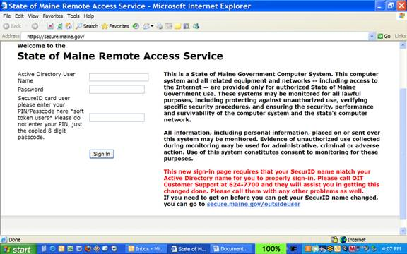

Note that there are THREE boxes to sign in.

- In the first box, enter your Juniper user name (usually firstname.lastname)
- In the second box, enter the case-sensitive Active Director password you got from OIT
- In the third box, enter the 4-digit PIN assigned from OIT followed immediately by the number on the display of your SecurID card at that time (no spaces between the PIN and displayed numbers)

If you can’t get into Juniper from here:
- Call the state Office of Information Technology at 624-7700 and use the following script:
- I’m an outside contractor for the state. I’ve locked my Juniper account. The error message is [read error message – if you know for sure that your PIN is working, let them know that you need your Active Directory password reset].
- Note: It’s best not to mention CAREWare when you contact OIT. Most technicians will not even know what CAREWare is.

If everything works correctly, you will be taken to a page that looks like the graphic below. Click “Start.”
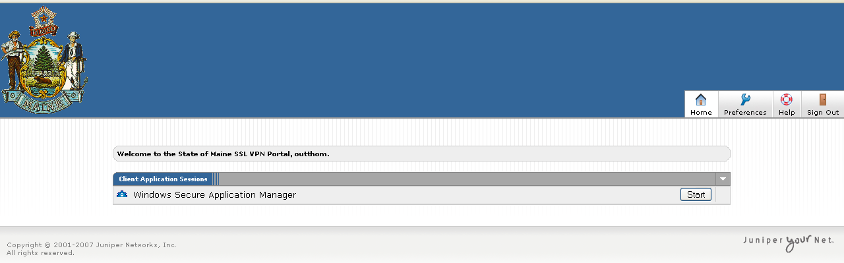

You will notice a small connection icon in your task bar, near the clock:

This means that you have successfully logged into the state system.

To Log into CAREWare

Minimize your web browser by clicking the minus sign in the upper right corner. DO NOT CLOSE THE WEB BROWSER!

Back on your desktop, double click the “Run RW CAREWare 4.1” icon (it still says this even after upgrading to version 5):

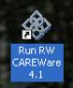

You will be taken to the CAREWare login screen:

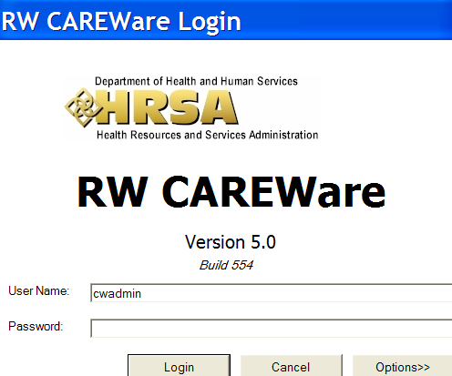

When you log in to CAREWare, you will need to enter your CAREWare user name, which is different from the user name you use with your SecurID. Each CAREWare user name is set up by agency and position (for example, OUFPCCM1) to make it easier to reassign accounts due to turnover.

Your CAREWare password expires every 90 days. Passwords have to be at least 8 characters long and contain at least two non-letter characters. (You do not use your SecurID card for this process.)

If you want to change your password yourself, you can do so from the Main Menu, after you have signed into CAREWare. Click on the box labeled “My Settings” and it will allow you to change your password. Remember that the password must be 8 characters long, with at least two non-letter characters. This password will expire in 90 days.

Password updates

Passwords are valid for 90 days. When your password expires, you will get a message requiring you to change it. DO NOT FORGET TO WRITE DOWN YOUR NEW PASSWORD AND STORE IT IN A SECURED LOCATION. If you lose your password, only the Database Administrator can reset it. Please note that you can switch between two passwords – one for 90 days, then a second for 90 days, then back to the first.

Software updates

When the whole CAREWare system is updated at the State level, your computer will need to be updated, too. When you log in, you will see a screen that looks like this:

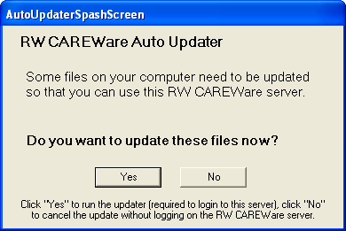

→ Always Select YES.

It will take a few minutes to synchronize the update files, and then you should get a screen that looks like this:

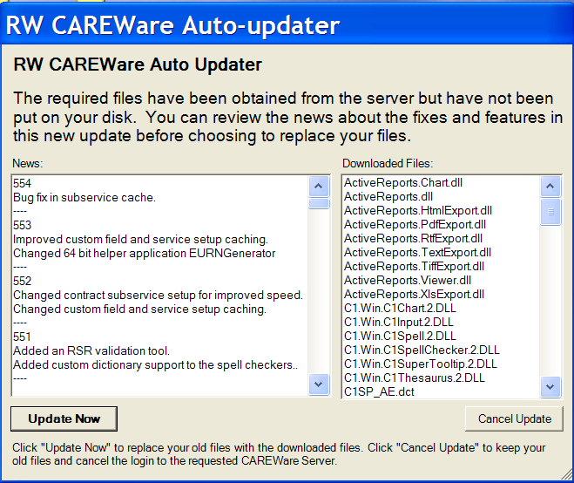

Click UPDATE NOW

You should get a message stating that the update was successful:

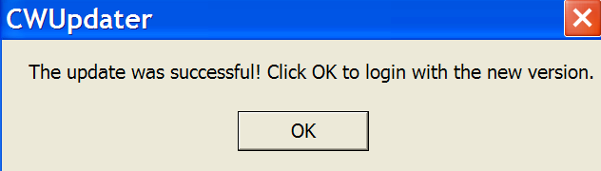

Click OK

You’ll be returned to the login screen to login again, now using the latest version.

Timeout message

For security reasons once CAREWare is running, your session can only remain inactive for 30 minutes. If you get up from your desk and leave CAREWare running, you’ll come back to find this message:

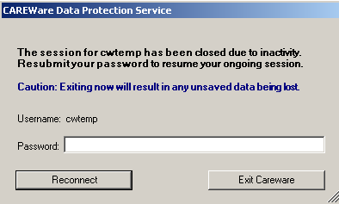

Re-entering your password and clicking Reconnect will take you back to the screen you were working on before your session became inactive.

Main Menu

The main menu will look something like this:

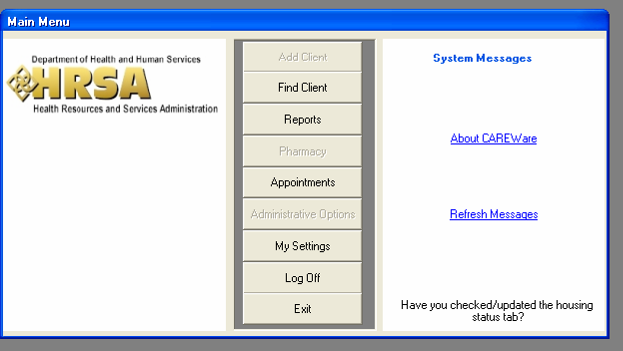

Messages from the CAREWare administrator will appear at the bottom of the space labeled “System Messages.” In the picture above, the system message reminds users to check/update the housing status tab. Announcements about upgrades or deadlines will also appear here.

“My Settings” will bring you to a screen where you can change your password or update your phone number or e-mail address.

If you select “Log Off” you will be signed out of CAREWare and return to the Login Screen. “Exit” completely closes CAREWare.

Add Client

Only clients who do not have a record in CAREWare need to be added to the database. If a client has been discharged and returns for services, you simply need to reactivate the client’s record.

To add a new client, select “Add Client” from the main menu and the following box will appear.

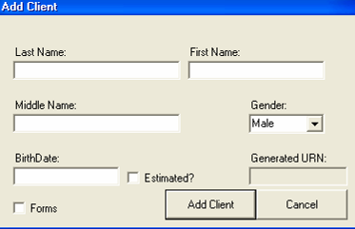

Enter the complete, legal last name and first name of the client. Note that although the field is labeled “Middle Name,” the middle initial will suffice.

It is essential to use the client’s full legal name and correct date of birth to ensure that the client is not counted twice in state data.

Select the appropriate gender and enter the complete date of birth. Estimated birth dates should never be used.
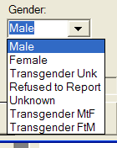
The options for gender are:
- Male
- Female
- Transgender Unknown
- Transgender MTF
- Transgender FTM
- Refused to Report

Click “Add Client.”

If the client is already in the system (because he or she received services elsewhere or because the client’s name, gender, and birth date closely match another client in the system) a warning box like the one on the next page will appear.

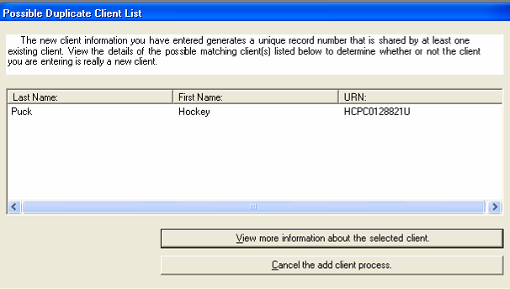

You may choose to cancel the “add client process” here, or view more information about the selected client.

Confidentiality Note - “fishing” for information:

The “Add Client” process is the only time a user may preview the database to see if a person is listed in the database as receiving services elsewhere. To uphold the strictest confidentiality, it may be prudent for agencies to designate a single person to enter all new clients for that agency. All individuals with permission to add clients must sign a special confidentiality agreement for the state.

In the event that someone views information on a person who is not actually a client of your program, you must log information viewed in a Disclosure Log and notify the Database Administrator immediately.

If you choose to view more information about the selected client, a box like the one on the next page will appear, showing the client’s race, ethnicity, address, and phone number. Compare this information to your client’s information.
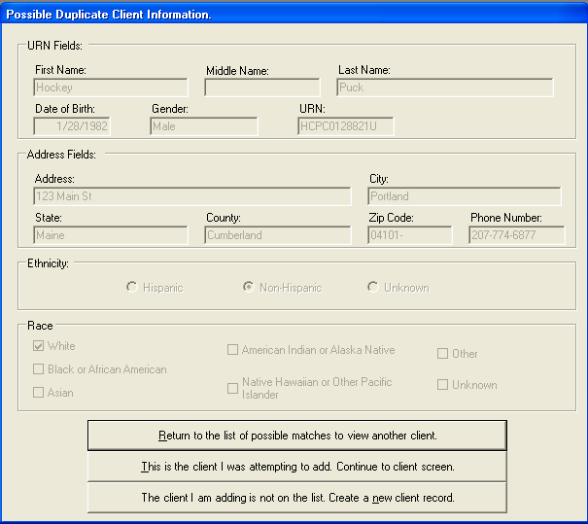

- If the information in the “Possible Duplicate Client Information” box matches that of your client, select the button labeled, “This is the client I was attempting to add.”

- If there were multiple clients on the list of possible duplicates, you may return to the list by selecting the top button, “Return to list of possible matches to view another client.”

- If your client is someone else entirely, you may select the bottom option, “The client I am adding is not on the list.”
If the client you are trying to add closely matches another client already in your database (either because the client already has a record in your database, or because it is a close match) a screen like this will appear:

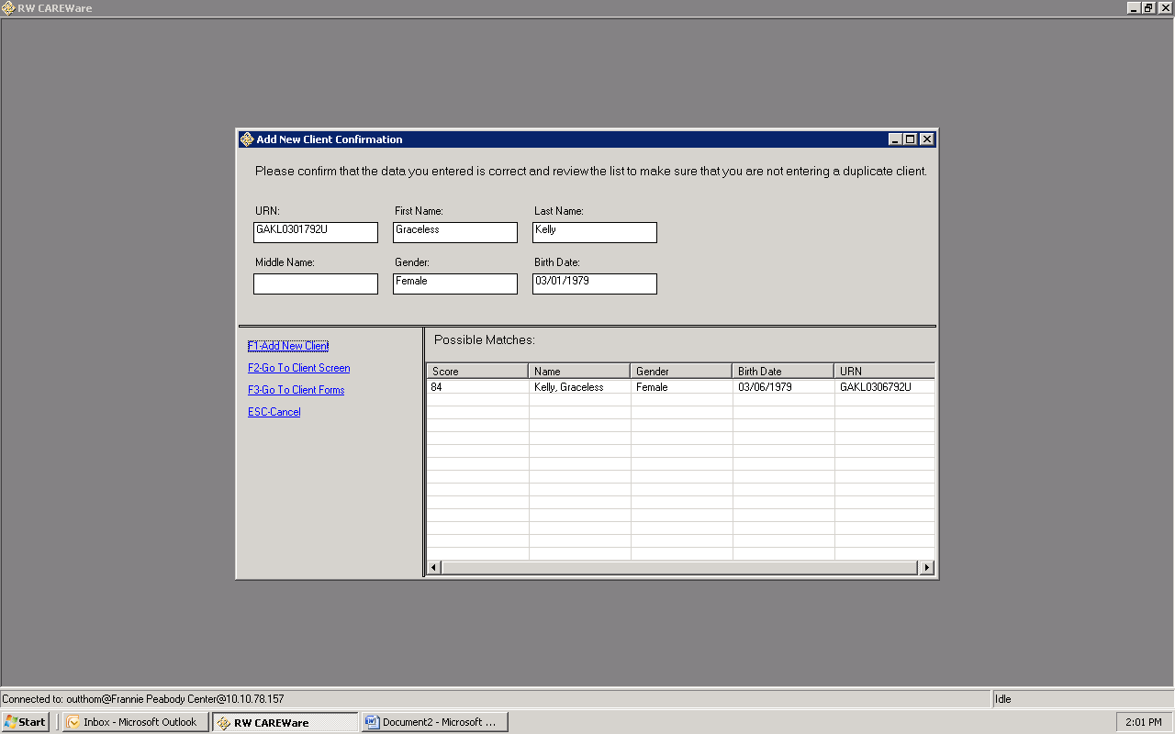

- Click option F1 if client is not a duplicate, but a new client with closely matching info.
- Select possible match from the list, then click option F2 if client should be matched to the record already in the system. From here, you will be taken to the “Demographics” screen in the client’s record.

Find Client

The “Find Client” screen looks like this:

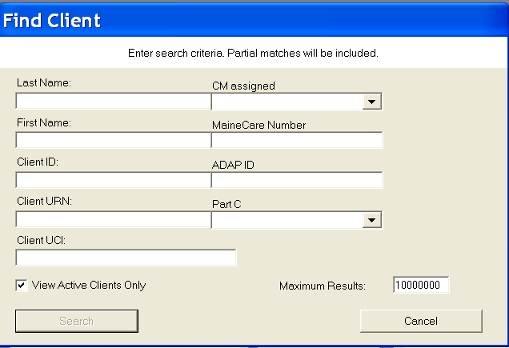

You can search by a full name, or just an initial. If you select your name from the “CM Assigned” drop box, your entire caseload will show up.

Note: If you want to search by client ID, you must use the complete ID as entered in CAREWare. For example, Frannie Peabody Center uses five-digit file numbers as the client ID. If a staff member typed the file number without the zero(es) at the beginning, the client he or she was searching for would not be found.

If you need to find a client who has been discharged, you must uncheck the box marked “View Active Clients Only.”

Once you have entered the search criteria you want, click “Search.”

A box labeled “Search Results” like the graphic on the next page will appear:

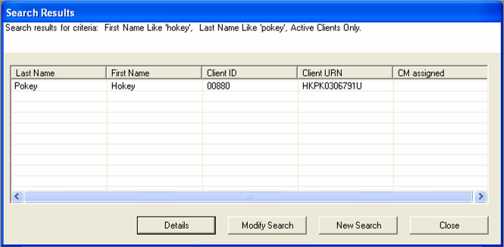

To open the client’s record, select the client and double click on the client’s name or click the “Details” button.

If you want to find someone else, click the “New Search” button.

Client Report

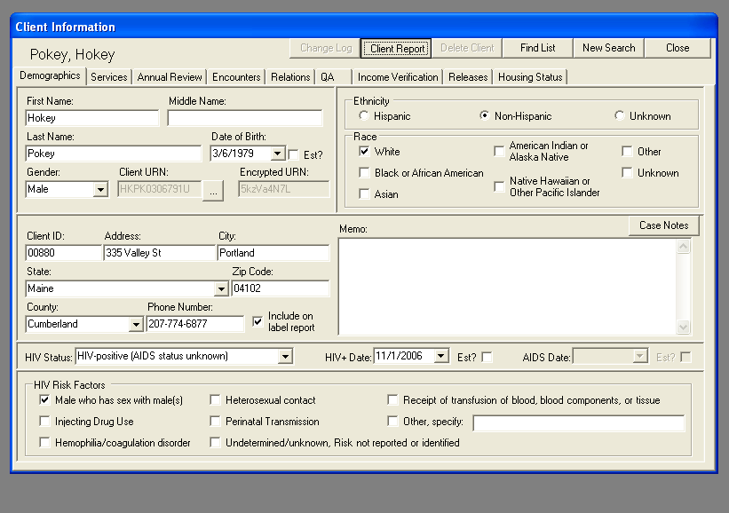

From any screen in CAREWare, you may select the “Client Report.” When you click on this button, a box will appear like the one below:

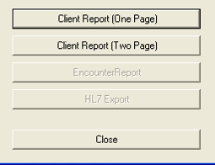

If you select the one-page report, you will get a report that includes the client’s Demographic and Annual data. The two-page report will also include the “income” screen and the “releases” screen. You can print the report by selecting the button labeled “Print” in the menu bar at the top of the screen.

Demographics

The first screen in a client’s record is the “Demographics” screen. It looks like this:

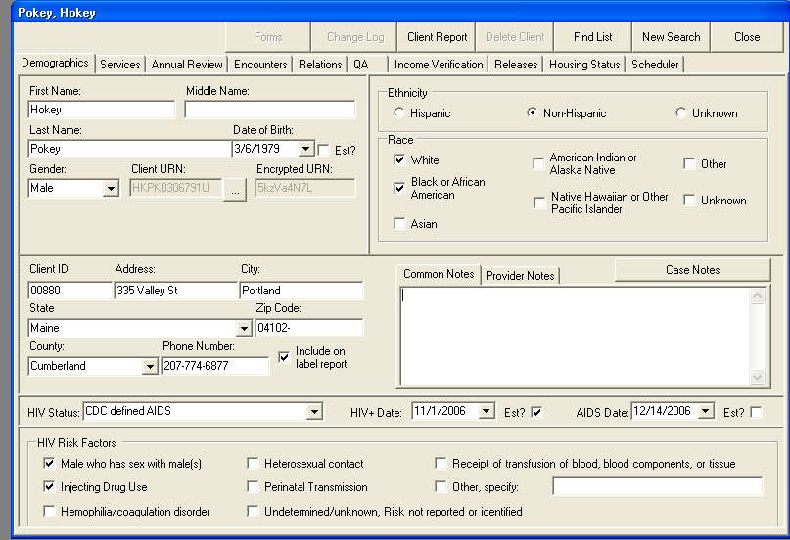

Demographic fields required for Part B reporting:
- Gender
- Date of Birth
- Ethnicity
- Race
- County and Zip Code
- HIV Status
- HIV Date/AIDS Date
- HIV Risk Factors

Common Notes and Provider Notes

Anything you enter in the large box on the Demographics screen when the tab “Common Notes” is pulled forward is viewable to anyone with access to CAREWare who serves this client at any agency.

NOTE: Due to a bug in the system, anything entered in the large box on the Demographics screen when the tab “Provider Notes” is pulled forward is also viewable to anyone with has access to CAREWare who serves the client.
Please keep this in mind when entering information in this box and use appropriate discretion.

Name, address, phone

The name fields should always contain the client’s full legal name. If the client has a nickname, please enter that in the large “Common Notes” box. If a client completes a legal name change, you may change this information directly in CAREWare (as long as your user account has permission to do so). If the client has not legally changed names, put the new name in the “Common Notes” box, as you would a nickname.

Please update the address and phone number fields as necessary. If you change your client’s address, please make sure you update his or her county information. You can look up counties by town using this website: http://www.maine.gov/local/

Please note that if you serve a client being served by another agency, the other agency will automatically view the same demographic data. If you update the address, that update will automatically appear on the demographic screen for any other provider serving that client. If you update an address, please make certain you make note of it in the “Common Notes” box, so that any other providers will know the date the address was changed.

If the box labeled “Include on label report” has a checkmark in it, the client’s name and address will appear on the “Mailing Labels” list from the Reports screen. This Mailing Labels report may be used for agency newsletters or other mailings. If you do not want the client to appear on the label report (because the client does not want mailings, or because the address is no longer valid), make sure you uncheck the box.

Note: Although contact information is shared across providers for common clients, the “Include on Label Report” check box is unique to your agency. For example, if a client gives you permission to send mailings and you check the box, you do not need to be concerned about the client receiving mailings from ADAP without permission. Just because you have the box checked, it will not be checked for ADAP unless an ADAP staff member checks the box as well.

HIV status and risk factors

The options we use for HIV status are: HIV-positive, not AIDS; HIV-positive (AIDS status unknown); and CDC-defined AIDS. If you select anything else, the client will be counted as HIV-negative in reporting. In order for a client to meet the CDC definition of AIDS, we must have written verification from a medical provider that the client has an AIDS diagnosis. If this documentation is not on file (even if you know that the client has an AIDS diagnosis), the HIV status should be set to “HIV-positive, AIDS status unknown.” Please note that date of initial HIV diagnosis and AIDS diagnosis should also be entered on this screen. These dates may be estimated.

Enter the HIV risk factors at the time of intake. If, during the course of working with the client, you learn more about a client’s exposure to HIV, these risk factors may be updated at any time. Multiple risk factors may be selected.

Data Note:

If a client states that he or she contracted HIV through heterosexual contact, that client must identify heterosexual contact with an at-risk partner (IDU, MSM, known HIV+), otherwise select “other” and specify “presumed het” in the comment field. Note that a client cannot have both heterosexual (at-risk) and presumed heterosexual risk factors.

Ethnicity and race

All clients must have both an Ethnicity and at least one Race selected. Information will be entered from the client’s intake, but you may update it as needed. Multiple races may be selected. The following definitions are required for all Federal reporting:

- White (not Hispanic) is an individual having origins in any of the original peoples of Europe, the Middle East, or North Africa, but not of Hispanic ethnicity.
- Black or African American (not Hispanic) is an individual having origins in any of the black racial groups of Africa, but not of Hispanic ethnicity.
- Hispanic or Latino(a) is an individual of Mexican, Puerto Rican, Cuban, Central or South American, or other Spanish culture or origin, regardless of race.
- Asian is an individual having origins in any of the original peoples of the Far East, Southeast Asia, or the Indian subcontinent, including, for example, Cambodia, China, India, Japan, Korea, Malaysia, Pakistan, the Philippine Islands, Thailand, and Vietnam.
- Native Hawaiian or Other Pacific Islander is an individual having origins in any of the original peoples of Hawaii, Guam, Samoa, or other Pacific Islands.
- American Indian or Alaska Native is an individual having origins in any of the original peoples of North and South America (including Central America), and who maintains tribal affiliation or community attachment.

Case Notes

As of March 1, 2012, you must log all case notes in CAREWare. Case notes must be entered within 15 days of the contact with the client.

Agencies may request, in writing, exceptions to completing case notes in CAREWare in the following situations:
- Client is also an employee of the agency
- Case Manager has requested a reasonable accommodation for a physical limitation associated with extensive typing

Note that even when demographic, service, and clinical data is shared between providers, case notes will always remain private and visible only to staff with appropriate permissions at the agency where the note originated.

To access case notes from Demographics, click on the button labeled “case notes.”

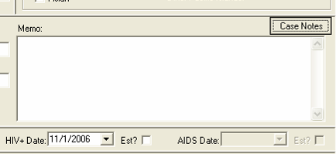

You will be taken to a screen that looks somewhat like the picture on the next page:

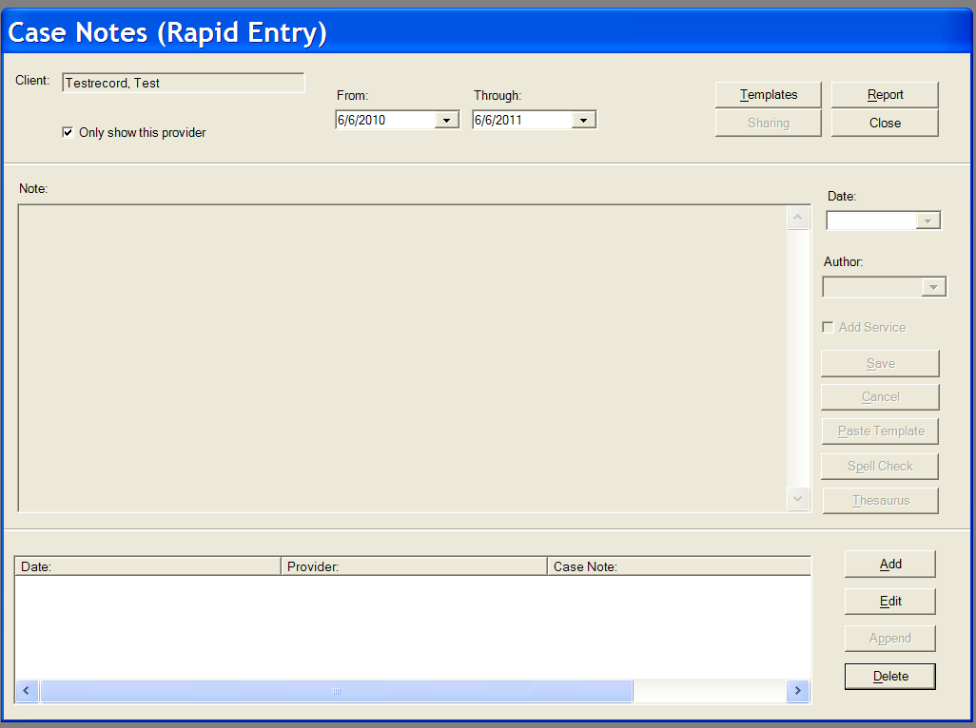

If the client has previously written case notes stored in CAREWare, they will appear in the lower box.

To enter a new case note, click “Add.”

The large “Note” box will become active and turn white:

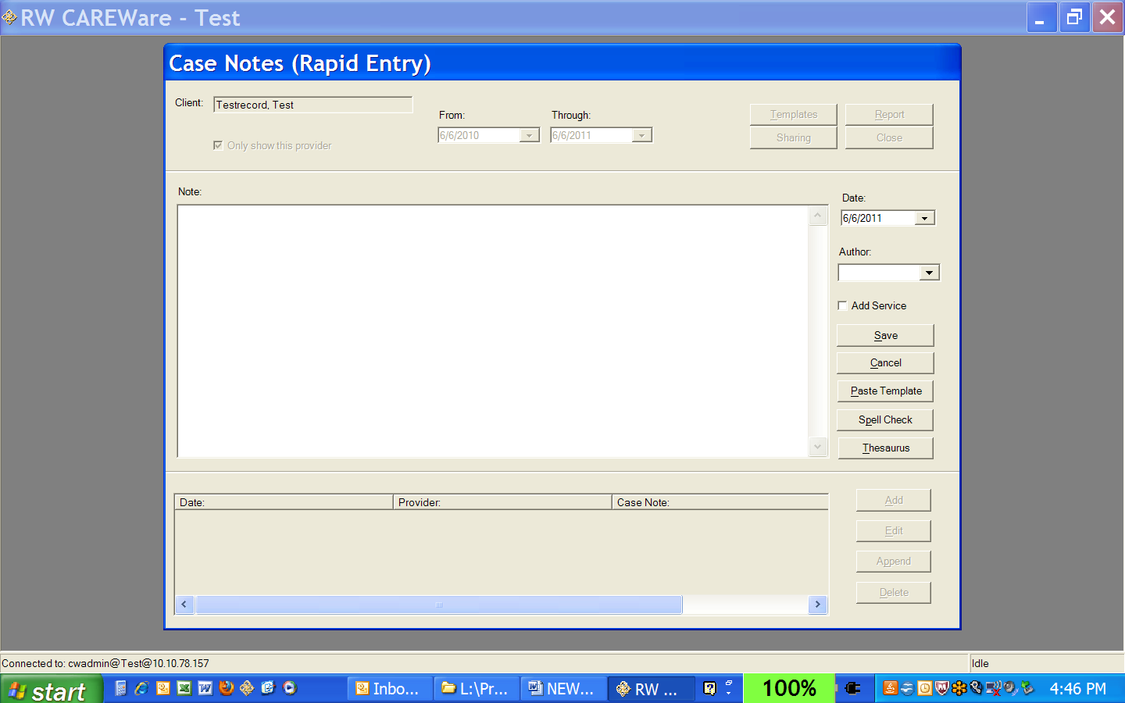

Case managers are required to use the available case note templates. Click the button labeled “Paste Template”:

A smaller box titled “Case Note Template Select” will pop up on your screen listing the two types of templates available:

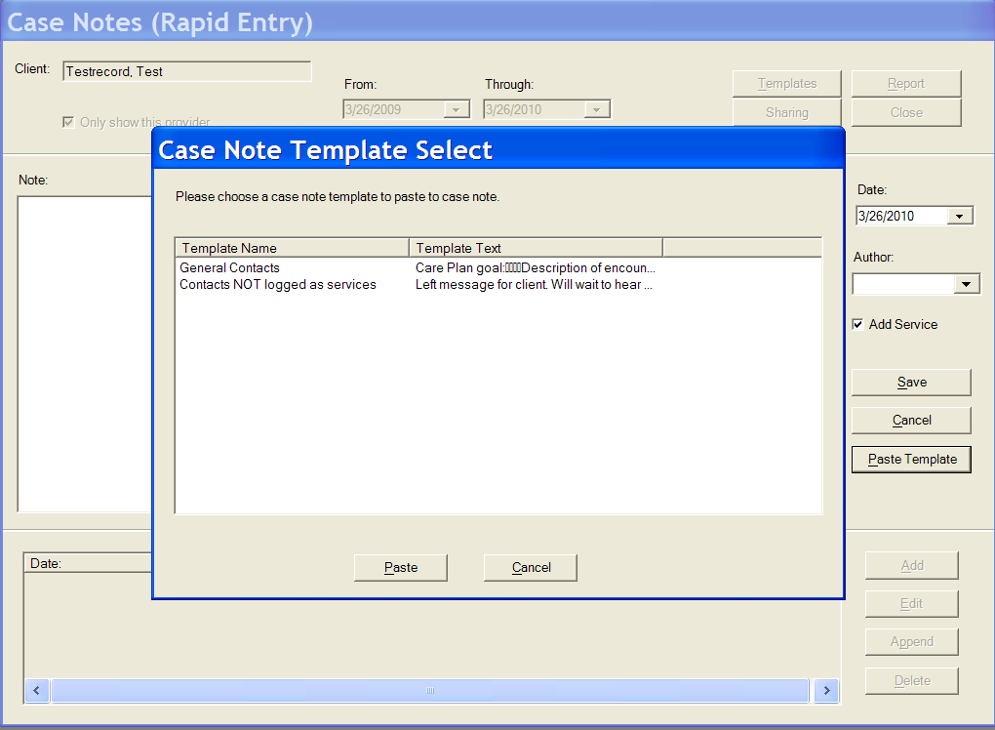
When to use each template:

Use the General Contacts template to document any contact with the client or on the client’s behalf that relates to a goal from the care plan, a need identified in the assessment, and supports treatment adherence.

Use the Contacts NOT logged as services template when you need to document an action that is not covered by Part B and therefore should not be logged as a service, such as:
- Phone messages
- Letters, other mailings, e-mails
- Dispensing assistance or dropping items at a client’s house (outside of a home visit)
- Picking up items for a client (food, prescriptions, etc.)
- Scheduling case management visits without working on a care plan goal
- Any activity that does not relate to a care plan goal and a need identified on the assessment

Select the appropriate template and click the button labeled “Paste”

The template for General Contacts looks like this:

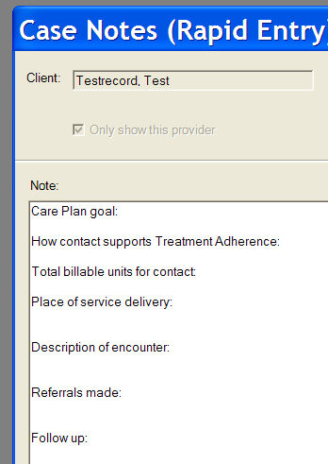

Fill in the appropriate information. Note that Spell Check and a Thesaurus are available on the right hand side of the Notes box, for your convenience.

Remember:
- You are not the client’s biographer
- Case notes are legal documents that may be subpoenaed
- Clients may review their records at any time

Keep notes concise.
Never identify another individual’s status in a client’s notes.

The template for Contacts NOT Logged as Services looks like this:

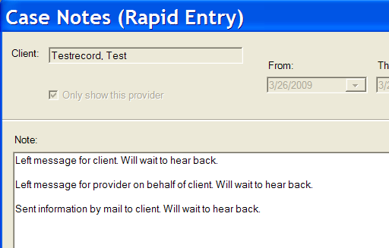

Delete the options that don’t apply and add any necessary detail.

When you have completed your note, select your name from the “Author” list on the right hand side of the screen:

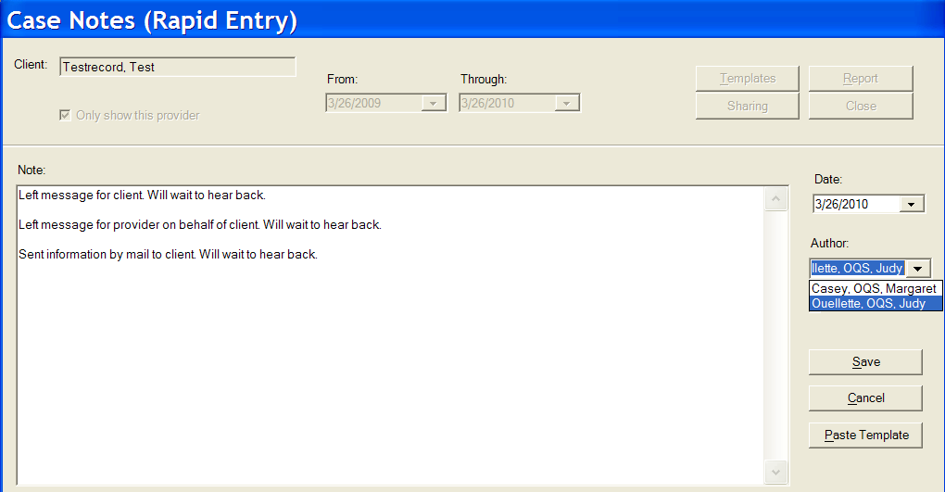

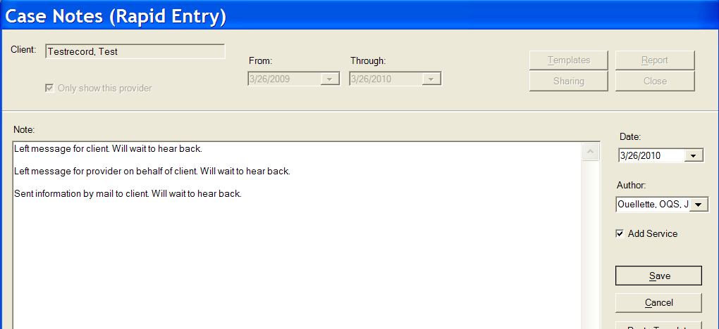

Note: If the “Add Service” box is checked when you click on “Save,” you will automatically be brought to a new entry on the Services screen.

Case note editing permissions have been enabled for all case managers. Please review the policy below regarding this permission change:

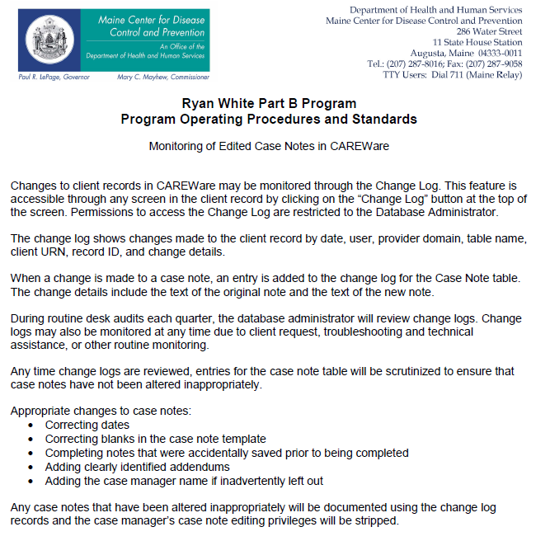

Printing Case Notes

When you print your case notes, enter the date range you want in the “From” and “Through” boxes at the top of the screen. The date range defaults to one year. If you want to print one note, put the same date in the “From” and “Through” boxes. Click on the “Report” button.

The case note report looks like this:

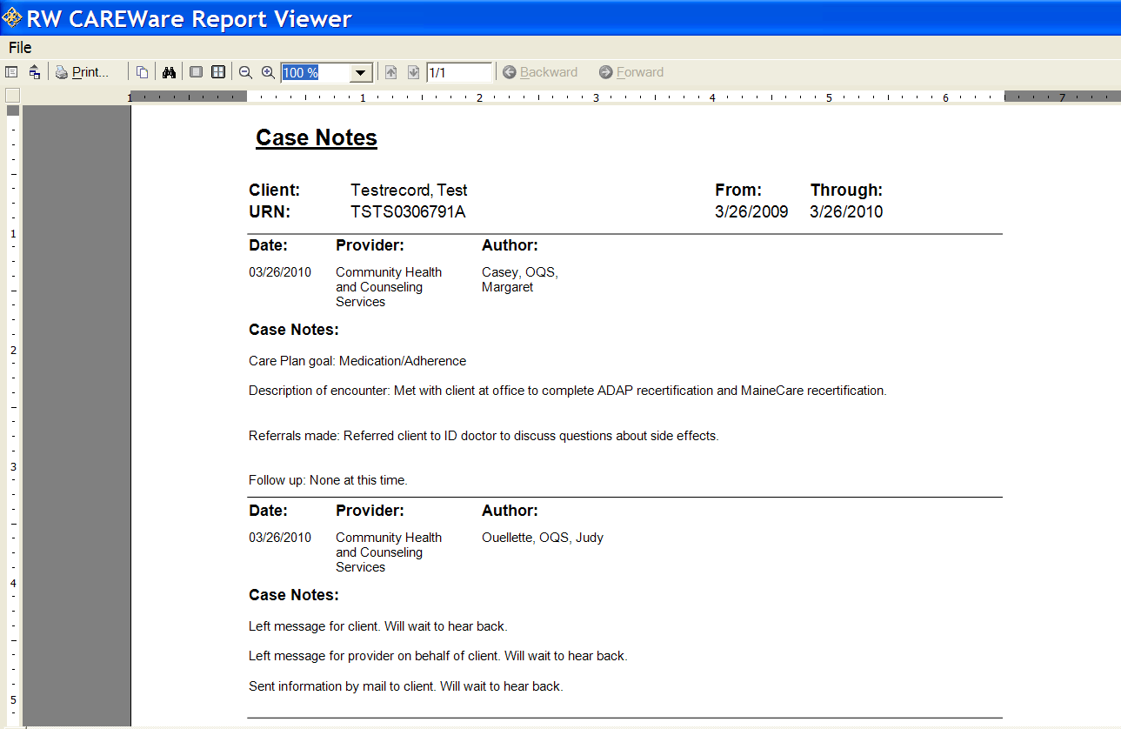

To print your case notes, select the button labeled “Print” in the top menu bar.

Printing Multiple Case Notes

CAREWare now supports a reporting function that allows you to print multiple case notes at once. To access this feature, you must select “Reports” from the main menu. You will be brought to a screen that looks like the picture on the next page:

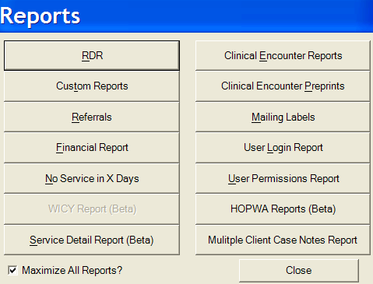

Select “Multiple Client Case Notes Report”

You will be taken to a screen that looks like this:

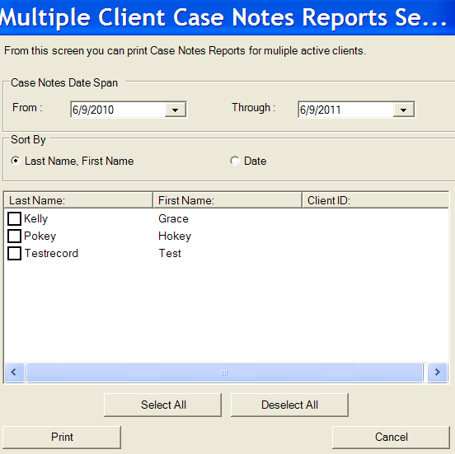

Note that ALL ACTIVE CLIENTS being served by your agency will appear in the client list. (If your client’s enrollment status has been set to anything other than “active,” the client will NOT appear.)

- Set the date span for the notes you wish to print.
- Check the box(es) for any client(s) whose notes you want to print.
- Click “Print” and you will be brought to a screen where you can preview the notes. From here, you can copy, export, or print the case notes.

Services
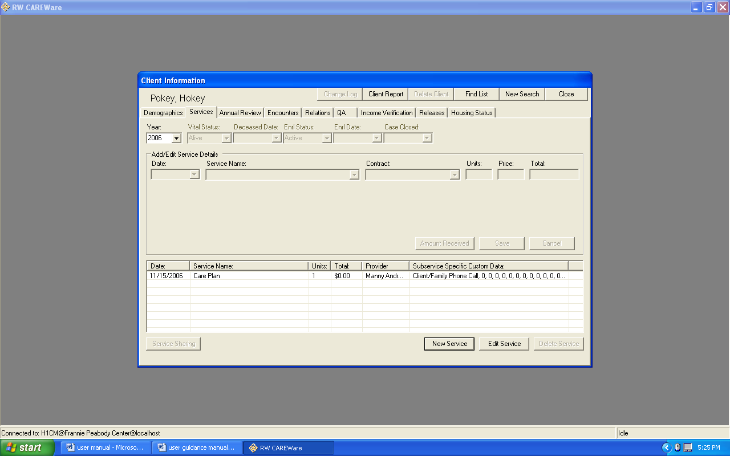
You must log all services in CAREWare within 15 days of the contact.

Service fields required for Part B reporting:
- Enrl Status
- Enrl Date
- Deceased Date or Case Closed date for discharged clients
- Individual service entries for each client

If you are entering services for a new client, make sure you enter the client’s status information and enrollment (intake) date at the top of the screen.
- The defaults are a Vital Status of “Alive” and an Enrollment Status of “Active.” It’s possible for a client to be deceased and still be an active case, as you may still be doing case management, charting, etc. for a deceased client.
- Once the Enrollment Status is set to “Inactive/Case Closed,” you can’t enter any more services without resetting the Enrollment Status to “Active.”
- The Enrollment Date should be the date of intake. Note that the enrollment year is used by CAREWare for the Ryan White Program Data Report to determine if this client is new in the current year or not.

Please also note that you can only view services for one year at a time. If you need to view/edit/enter services for a prior year, you must change the year selected in the pull-down next to the client’s status.

Phone messages, mailings, e-mails, dropping off items at a client’s house (outside of a home visit), picking up items for a client (food, prescriptions, etc), and scheduling are not client contacts, and therefore services should not be entered. Case notes should document these activities.

Entering Services

The following are the only required Medical Case Management service codes for Part B:

Code | Service Name | Units | Definition
1000 | Care Plan | 1 unit =  15 minutes | This service should be logged when a case manager completes a care plan with the client.
1100 | Client Certification | 1 unit =  15 minutes | This service should be logged when a case manager completes a semi-annual certification with the client.
1200 | Referral and monitoring service from care plan | 1 unit =  15 minutes | This service should be logged when a case manager coordinates a referral for a client, facilitates the client’s link to a service identified in the care plan, follows up to ensure that a client has received a service identified on the care plan, or screens for barriers related to accessing a service identified on the care plan. This includes collateral contacts.
1300 | Comprehensive assessment | 1 unit =  15 minutes | This service should be logged when a case manager completes an intake, re-intake, or annual assessment.
1400 | Temporary coordination for institutionalized client | 1 unit =  15 minutes | This service should be logged for time-limited assistance not to exceed 45 days coordinating a client’s transition into or out of institutionalized care (including hospitals, assisted living, rehabilitation facilities, and correctional facilities) as long as these services relate to the client’s care plan and needs identified on the assessment. This includes collateral contacts.
1800 | Discharge | 1 unit | This service should be logged when a client is discharged from Part B case management.

General Guidance for Logging Services

To enter a new service, click “New Service” at the bottom of the screen. The service entry fields will turn white so you can fill them in.

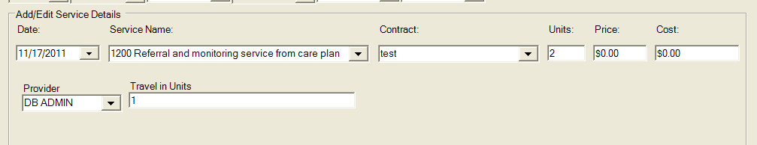

Enter the date by typing it, or selecting it on the pull-down calendar, as shown in the graphic on the next page.

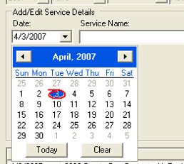

Type the code for the service in the box labeled “Service Name.”

Ignore the “Contract” box.

All services except 1800 Discharge are measured in time; 1 unit = 15 minutes. Enter the total units of time spent working with or on behalf of the client in the “Units” box.

Ignore the “Price” and “Cost” boxes.

In the “Provider” box you can select your name from the pull down, or type it in the box. Even if you are not the assigned case manager, you must enter your name.

Enter the total amount of time spent traveling to and from the appointment, if any, in the “Travel in Units” box. This time should NOT be included in the “Units” box. A unit is 15 minutes.

EXAMPLE:
In the picture below, the case manager had a 30-minute contact with the client. It took the CM a total of an hour to get to and from the appointment.

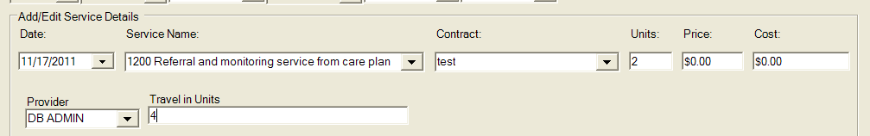

Logging Assessments

Service 1300 Comprehensive Assessment is logged like most other services, but it also includes an extra box to identify the type of assessment and acuity score.

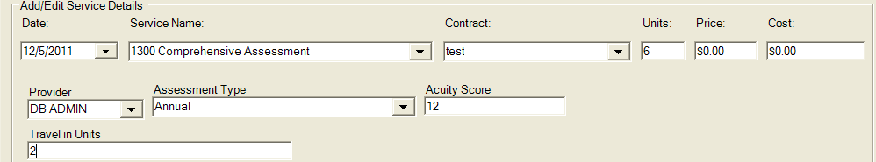

For type of assessment:
- Select “Intake” if the client is accessing case management with your agency for the first time.
- Select “Reintake” if the client has been discharged from services with your agency for one year or more.
- Select “Annual” if this is the routine annual assessment of an active client.

For acuity score, enter the total acuity score for the client from the assessment document:

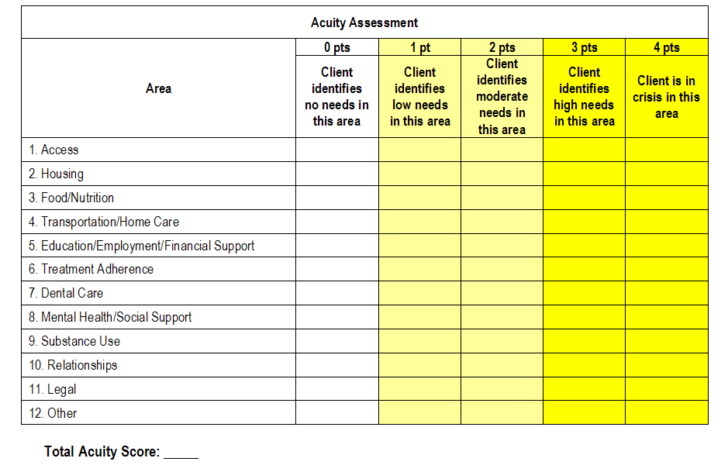

Logging Client Certifications

Service 1100 Client certification is logged like most other services, with required fields for travel time. In addition, you must document the client’s care status.

Documenting Care Status:

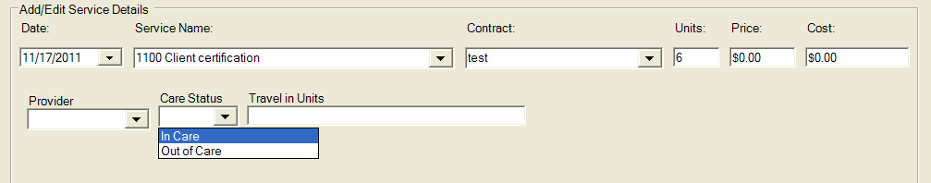

Care Status is determined when completing the “Care Status Tracking” section of the Semi-Annual Client Certification form.

A client is “In Care” if:
- The client has seen a doctor within the last six months, OR
- The client has had a CD4 and/or Viral Load within the last six months, OR
- The client is taking meds

Otherwise, select “Out of Care”

Logging Discharges

There are several steps to logging discharges.
- Log service 1800 Discharge
- At the top of the screen, change the client’s Vital Status (if appropriate). If the client has died, the Deceased Date box will become active and you must enter the date (or approximate date) of death.

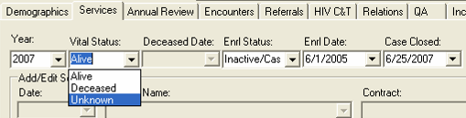

- Change the client’s Enrollment Status to the type that most accurately reflects the situation and enter the discharge date in the box labeled “Case Closed”:

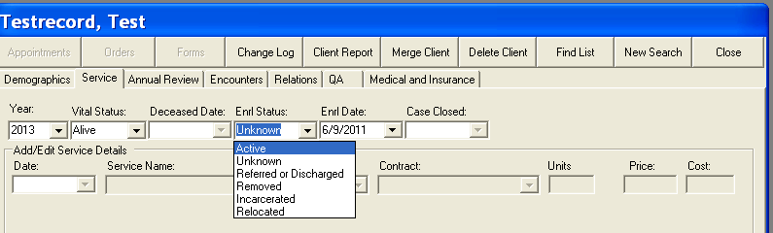

Use one of the following:
  - Referred or Discharged —The client was referred to another program or services and will not continue to receive services at this agency; the client became self-sufficient and no longer needed Ryan White Program-funded services; the client voluntary left your program; or the client refuses to participate.
  - Removed—The client was removed due to violation of rules.
  - Incarcerated
  - Relocated/Moved
  - Unknown—The client has been “lost to care.”

- Click on the QA tab and change the CM Assigned to “Discharged.”

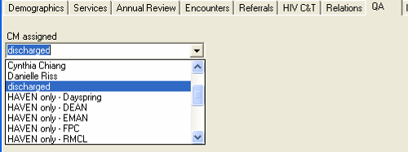

Editing Services

You may edit previously entered services either by double clicking on the service or by selecting the service and clicking “Edit Service.”

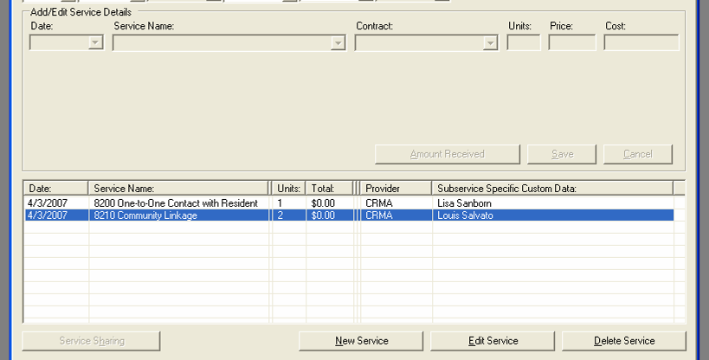

When the previously logged service opens, the entry may edit faster if you click on the “Services” tab before you edit the entry. When you are done, click “Save.” If you need to edit another entry for the same client, click on the “Services” tab before selecting the next entry.

Some individuals can delete services. If you have permission to do this, be careful because there is no way to retrieve a service deleted by mistake.

Annual Review

Annual Screen

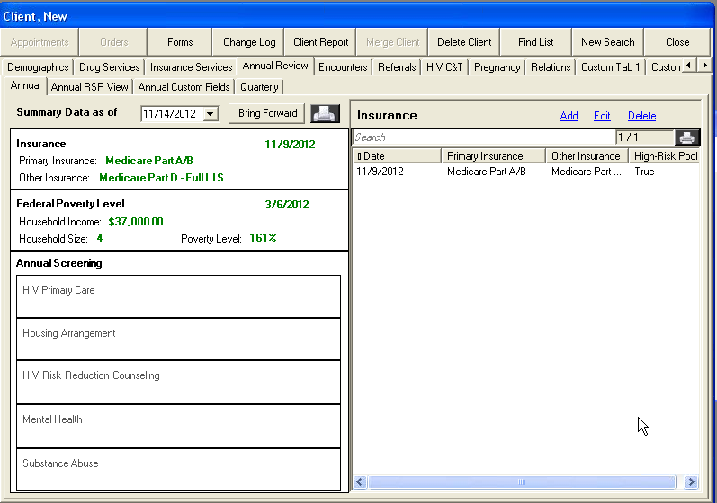

If you click on a block on the left (Insurance, Federal Poverty Level, HIV Primary Care, Housing Arrangement, HIV Risk Reduction Counseling, Mental Health, Substance Abuse), all of the data related to that item will show on the right. In the illustration above, Insurance was selected, and there is currently only one entry for insurance. You can add, edit, or delete insurance records by clicking the links.

If you click the link labeled “Add,” a new, light blue box will appear to enter the information for that category with a date and save it.

You will notice that the drop-down menus are limited. This is because these fields are tied specifically to federal reporting. All of the Annual Review fields should be entered after the first semiannual certification is completed and then reviewed and updated each time the semiannual certification is completed with the client.

Annual Review fields required for Part B reporting:
  - Insurance types
  - Primary HIV Medical Care
  - Housing/Living Arrangement
  - Household Income (for all members of the client’s legal household)
  - Household Size (legal household as defined by Ryan White Part B)

Insurance

Any time a client experiences a change in insurance (primary or other types), you should add a new insurance record. Select “Insurance” on the left, click the link labeled “Add” on the right and the light blue box will pop up on the right.

Enter the date of the change (most likely the date you are entering the information). Select the client’s primary insurance type – the medical insurance that provides the most reimbursement. Then check the boxes for all other insurance types that apply.

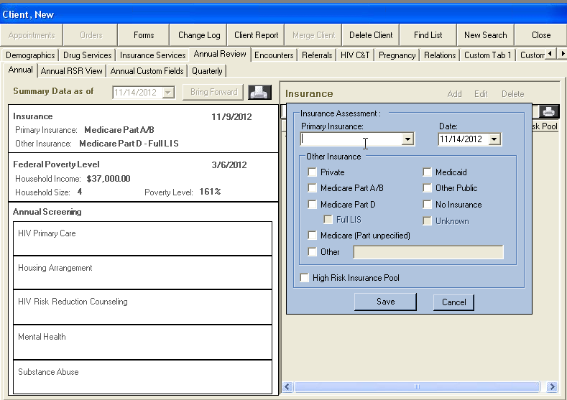

Federal Poverty Level

Ryan White Part B programs (including ADAP) define household as a family of two or more people related by birth, marriage, adoption, or other legally defined dependent relationship. We recognize that this definition may be different from other programs, such as HAVEN and MaineCare. All household size and income information entered in CAREWare must reflect the Ryan White Part B definition.

Dependent household members are people whom the head of household has a legal responsibility to support, or for whom the head of household has voluntarily extended support. These relationships are defined as legal adoptions and guardianships.
- Adopted family members must conform to the program requirements listed below for dependent children.
- Guardianship status must be supported by court documents defining the guardian relationship/responsibility.

Therefore, “Household Size” should reflect the client and any legal dependents.

The “Household Income” should reflect the income for all of the people counted in “Household Size.” All income, from full- or part-time employment, produced by all dependents must be declared as part of the household income.

When the income has been verified:
- Select “Federal Poverty Level” on the left.
- Select the link labeled “Add” on the right. A light blue box like the one below will pop up.
- Enter the date of the most recent verifying document as the date, then update the household income and household size as appropriate.

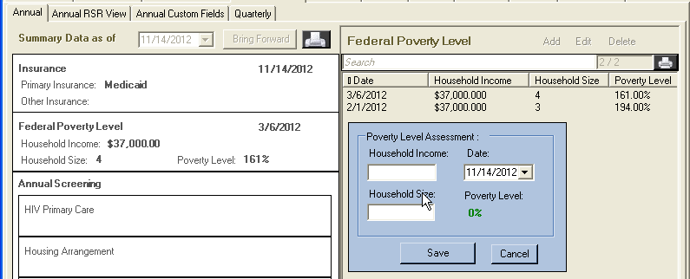

HIV Primary Care

When you select one of the “Annual Screenings” on the left and click “Add” on the right, the light blue box that appears looks like this:

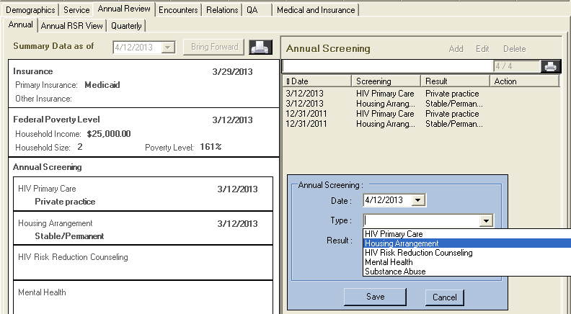

Select HIV Primary Care and the following Results appear:

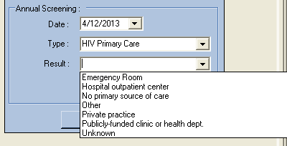

Housing/Living Arrangement

You will update housing/living arrangements in the same way that you update HIV Primary Care. Please bear these definitions in mind as you select housing types:

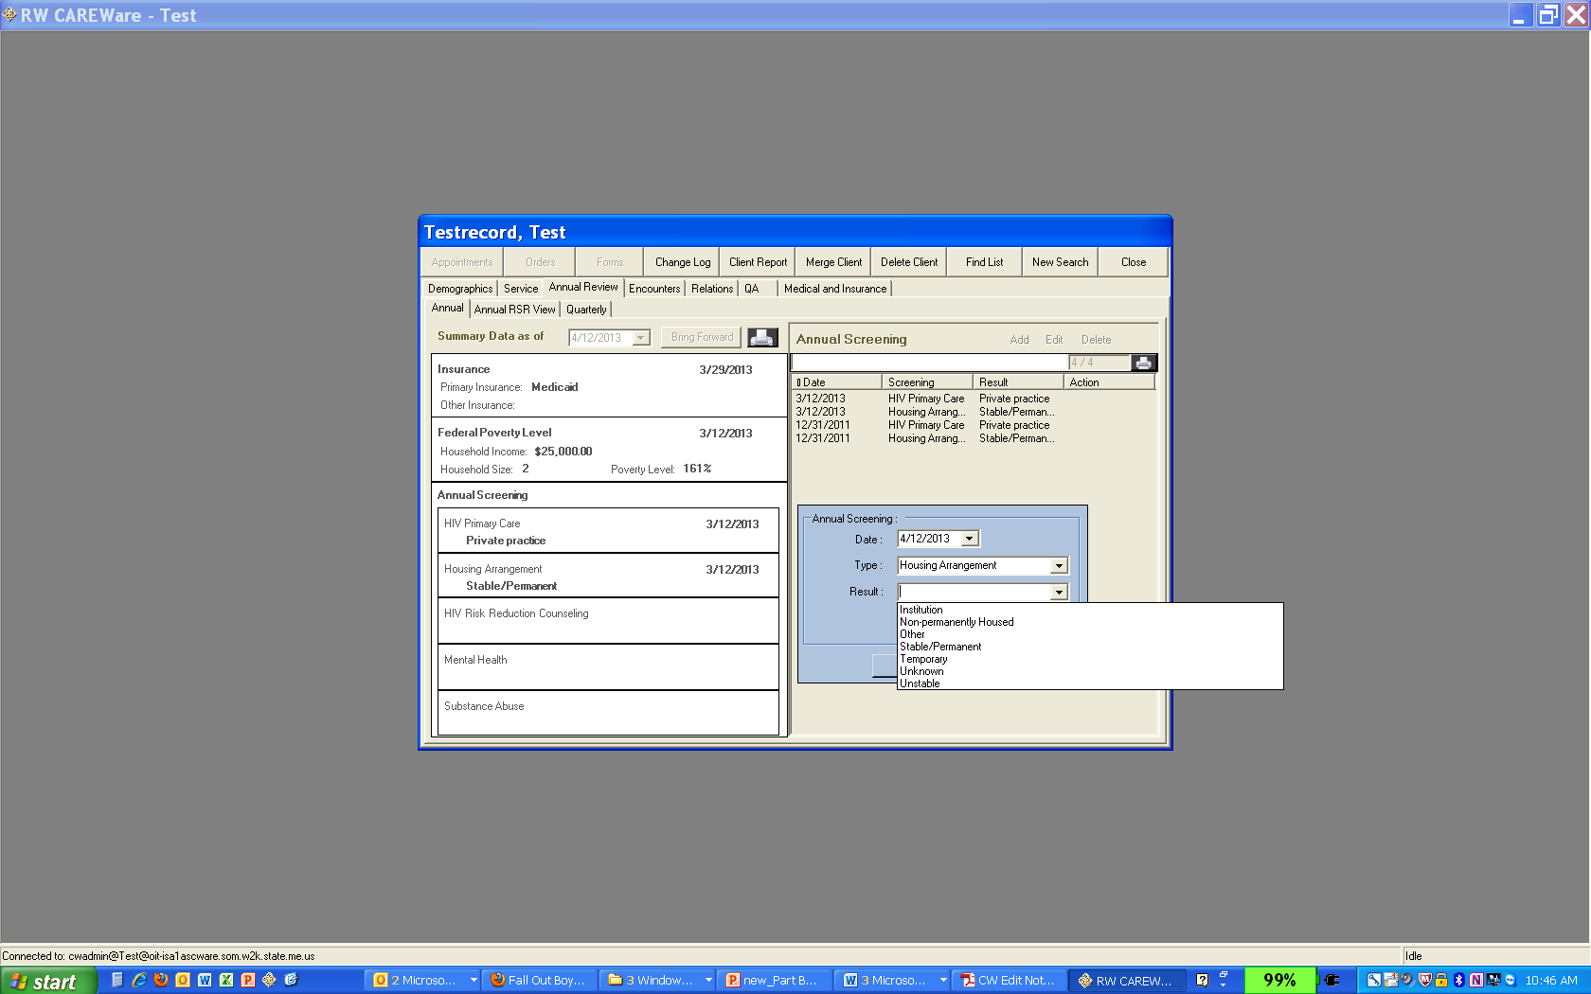

Nonpermanent Housing includes:
- Transitional housing
- Temporarily staying with friends or family (couch surfing)
- Hotel or motel (not paid for with emergency shelter voucher)
- Other temporary arrangement

Unstable Housing Arrangements include:
- Emergency shelter
- Place not designed for, or ordinarily used as, a regular sleeping accommodation for people (vehicle, abandoned building, bus/train station/airport)
- Hotel or motel paid for with emergency shelter voucher

Although there is an option for “institution” in the Housing/Living Arrangement, you should not use this option

Instead use:
- Stable Permanent Housing for institutional setting with greater support and continued residence expected (psychiatric hospital or other psychiatric facility, foster care home or foster care group home, or other residence or longterm care facility)
- Nonpermanent housing for temporary placement in an institution (e.g., hospital, psychiatric hospital, or other psychiatric facility, substance abuse treatment facility, or detoxification center)
- Unstable Housing for jail, prison, or a juvenile detention facility

Annual RSR View

The Annual RSR View subtab gives a summary of the most recent entries for each variable:

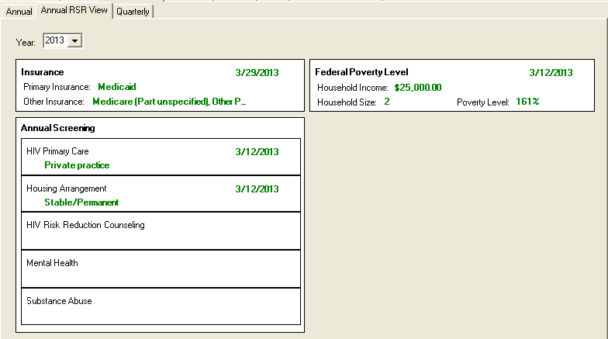

Encounters

Labs

Part B case managers are required to collect clients’ CD4 and Viral Load test results during the SemiAnnual Certification process. These lab results must be entered into CAREWare through Encounters | Labs.

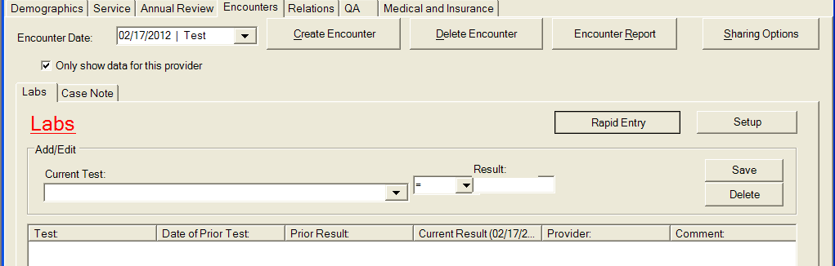

On the Labs screen, click the button labeled “Rapid Entry” and you will be taken to a screen that looks like this:

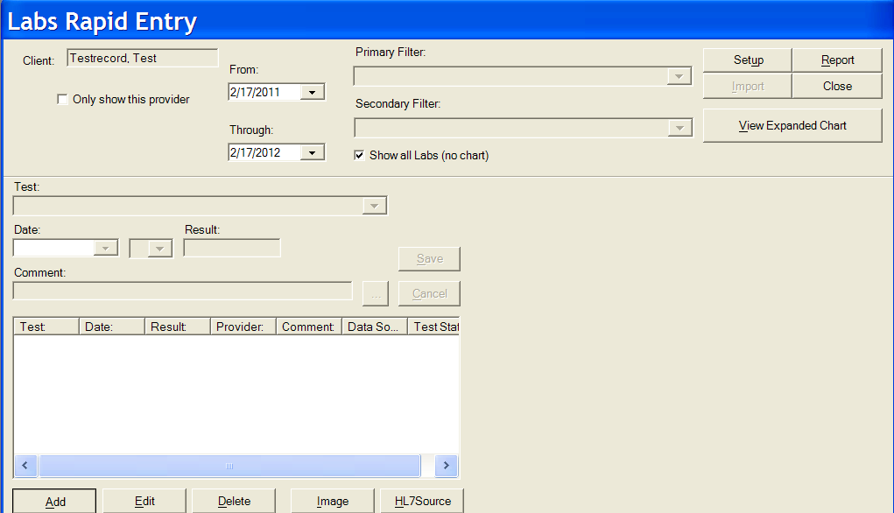
Click the button labeled “Add” at the bottom of the screen. The “Test” box will become active. Select the type of test, enter the date of the lab, enter the result, click “Save.”

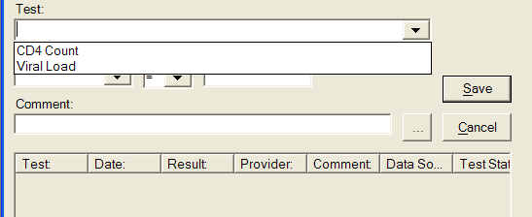

QA

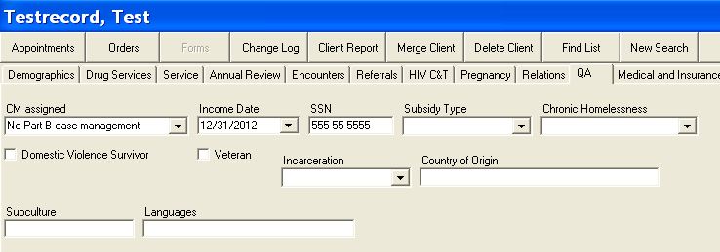

QA fields required for Part B reporting:
- CM Assigned
- Income Date

Income Date must be less than one year old for all active Part B clients.

Medical and Insurance

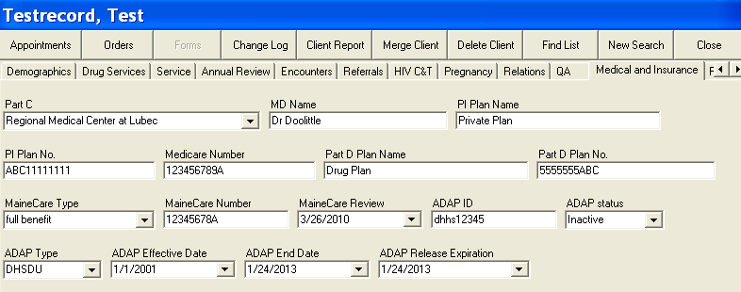

Medical and Insurance fields required for Part B reporting:
- Part C
- MD Name
- All insurance information that applies

Note: All ADAP data are updated by ADAP staff only. If you see information that you believe is outdated, please contact ADAP staff to update it. If you make changes to ADAP fields, you may cause errors that could jeopardize a client’s ability to receive meds.

Logging Off

Step 1:

When you have finished using CAREWare, exit from the program by selecting Exit from the main menu:

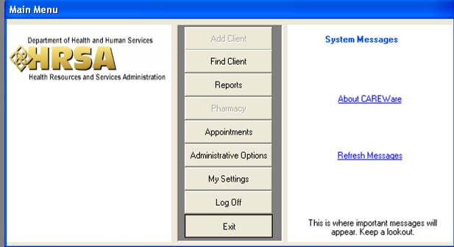

Step 2:

Maximize your web browser by selecting it from your task bar and click on the icon labeled “Sign Out.”

You will see a screen like this:

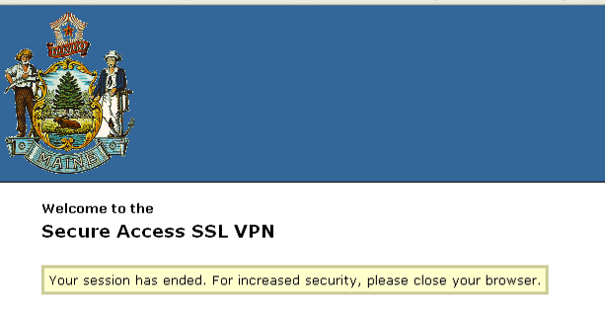

Close your browser.

