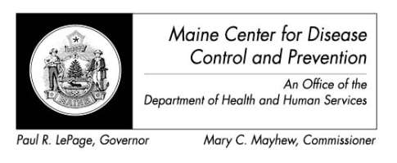
Maine Zika Report
February 17, 2016

Important Considerations
- The types of mosquitoes that can transmit Zika virus are NOT found in the state of Maine

Recent Global Updates
- 1/22/16 - CDC activated Emergency Operations Center (EOC) to respond to outbreaks of Zika in the Americas
- 2/1/16 – World Health Organization declared a Public Health Emergency of International Concern due to concerns over clusters of microcephaly and other neurological disorders in some areas affected by Zika
- 2/8/16 – CDC elevated EOC activation to Level 1 (the highest level)

Current Data – Maine (as of 2/17/2016)
Countries and Territories in the Americas with Active Zika Virus Transmission (CDC, 2/4/16)
- Travel-associated Zika virus disease cases reported: 0
- # of samples submitted for testing:11
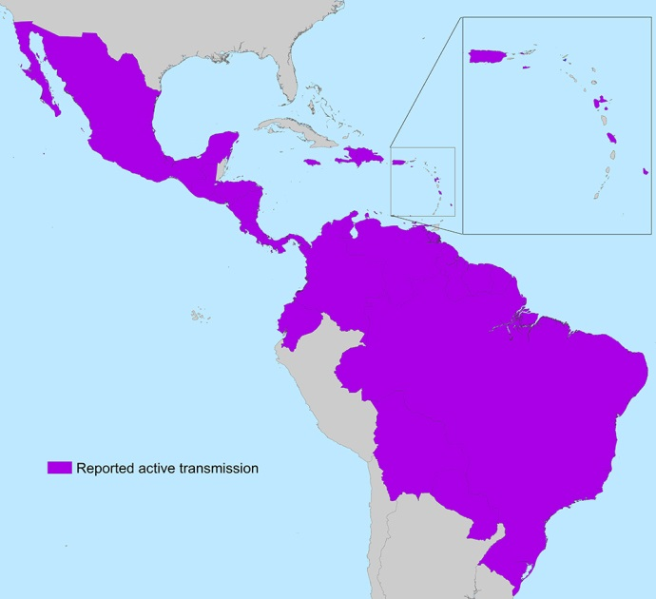
  - # samples negative: 2
  - # samples pending: 9

Current Data – US States (as of 2/10/16)
- Travel-associated Zika virus disease cases reported: 52
- Locally acquired vector-borne cases reported: 0

Current Data – US Territories (as of 2/10/16)
- Travel-associated Zika virus disease cases reported: 1
- Locally acquired vector-borne cases reported: 9

Countries currently affected by Zika
- Americas: Barbados, Bolivia, Brazil, Colombia, Costa Rica, Curacao, Dominican Republic, Ecuador, El Salvador, French Guiana, Guadeloupe, Guatemala, Guyana, Haiti, Honduras, Jamaica, Martinique, Mexico, Nicaragua, Panama, Paraguay, Puerto Rico, Saint Martin, Suriname, US Virgin Island, Venezuela

- Oceania/Pacific Islands: American Samoa, Samoa, Tonga

- Africa: Cape Verde

All Countries and Territories with Active Zika Virus Transmission (CDC, 2/5/16)

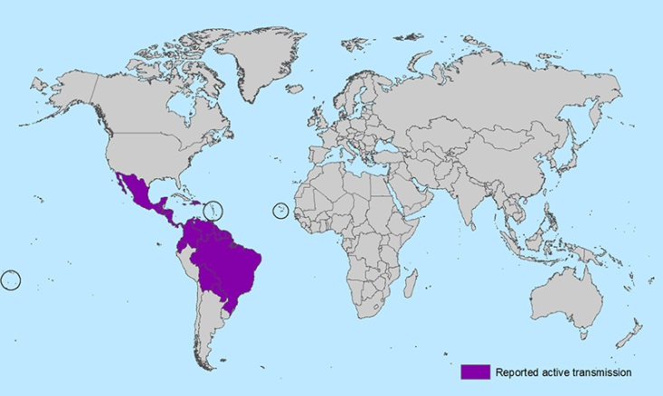

Zika FAQ’s

- What are the symptoms of Zika virus?
  - The most common symptoms of Zika are fever, rash, joint pain, or conjunctivitis
  - Only about 1 in 5 people infected with Zika virus become ill, so providers should consider other more common causes of illness (ie influenza)

- Who does Maine CDC recommend testing for?
  - Pregnant women who traveled to a potentially Zika affected area regardless of whether they developed symptoms
  - Sex partner of a pregnant women or a woman attempting to become pregnant, when the partner travelled to a potentially Zika affected area

- Who else can be tested?
  - Symptomatic individuals who travelled to a Zika affected area can be tested, but testing does not affect clinical treatment

- How is Zika transmitted?
  - The most common route is through the bite of an infected mosquito
  - Sexual transmission is also a possibility although it is not well understood.
    - The length of time the virus can be found is semen is not well understood, so out of an abundance of caution CDC is recommending abstaining or using condoms correctly and consistently, particularly during pregnancy until more is known about the risk
    - There is no evidence that women can transmit Zika to their sex partners

- How long does it take to get test results?
  - Samples are sent to CDC Fort Collins for testing. Due to the high demand for testing results may take up to 4-6 weeks.

- Where are the mosquitoes that can carry Zika virus found?

Approximate distribution of Aedes aegypti and Aedes albopictus in the United States
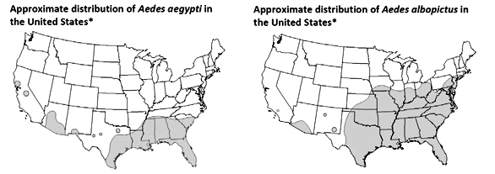

Maine CDC is following federal CDC guidelines for Zika virus. Up to date information and guidelines can be found at www.cdc.gov/zika

