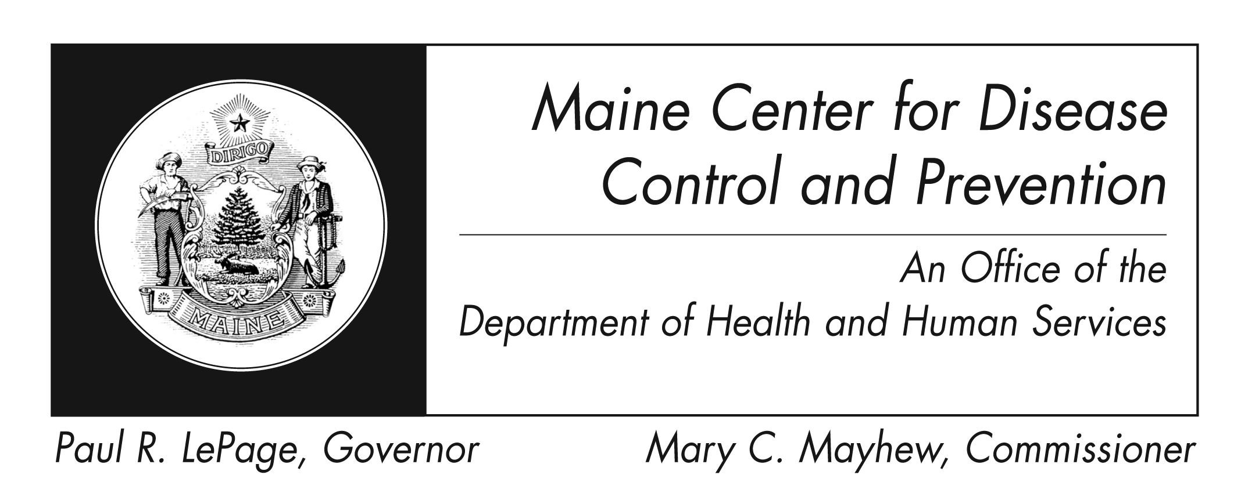
Tetanus
Fact Sheet

What is tetanus?
Tetanus, also known as lockjaw, is a disease caused by Clostridium tetani bacteria. It causes painful muscle stiffness and can be deadly.

How do you get it?
The bacteria live in the environment, including soil, dust, and manure. It can get into your body through broken skin. Some breaks in skin are more likely to get infected (e.g. wounds in contact with dirt, feces, or saliva; puncture wounds like from a nail, and burns). Tetanus can occur in newborns if the mother is not immune and the umbilical cord is cut with a dirty instrument.

What are the signs and symptoms?
A common first sign is spasms of the jaw muscles (lockjaw). Other symptoms are fever, sweating headache, sudden muscle tightening, painful muscle stiffness, trouble swallowing, and seizures.

How soon do symptoms occur?
The time between exposure to the first symptom ranges from three days to three weeks and is usually about eight days.

What are the complications?
Complications include spasm of the vocal cords and/or the muscles you use to breathe, making breathing harder to do. You can fracture your spine or long bones, or get high blood pressure or fast heart rate. Blood clots in the lungs and pneumonia could occur. About 10-20% of people with this disease will die.

How will I know if I have it?
There are no lab tests to confirm tetanus. A healthcare provider will diagnose tetanus based on clinical signs and symptoms.

How long can someone spread it?
Tetanus is not spread from person to person.

How is it treated?
Tetanus should be treated quickly with human tetanus immune globulin (TIG). If this is not an

option, equine antitoxin should be given. Antibiotics may also be given.

How can I prevent it?
- Vaccine is the best way to prevent this disease. A few types of child and adult vaccines are offered, and booster shots are urged throughout life.
- Having tetanus does not protect you from getting it again. Someone with tetanus should still get the vaccine.
- All wounds should be cleaned well. See your healthcare provider for wound care.

Where can I get more information?
For more information contact your healthcare provider or local health center. You can also contact the Maine Center for Disease Control and Prevention by calling 1-800-821-5821 or check the federal Centers for Disease Control and Prevention website - http://www.cdc.gov.

