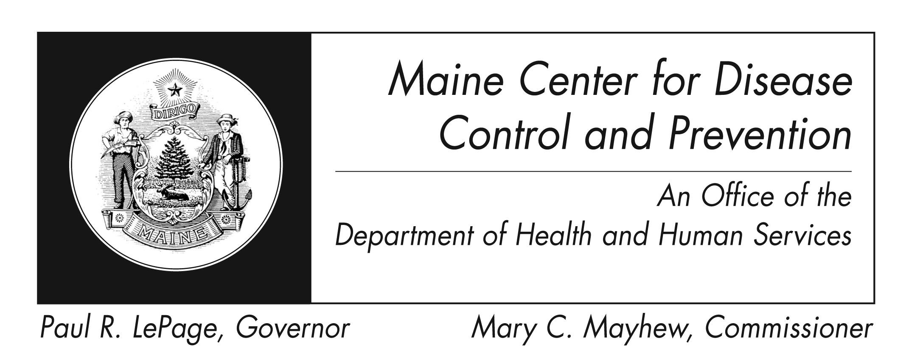
Rubella (German Measles)
Fact Sheet

What is rubella?

It is an illness caused by the rubella virus.

Who can get it?

Anyone who is not immune from previous rubella infection or vaccination can get rubella. Because most people have now been vaccinated, rubella is rare in the United States.

What are the symptoms?

Illness is often mild and causes a rash that starts on the face and spreads to the body. The rash usually lasts for 3 days. Rubella can also cause fever, swollen glands, and conjunctivitis. Older children and adults often experience joint pain that can last a long time. Some people with rubella may not have any symptoms and may not know they had it.

How soon do symptoms appear?

Symptoms often start 14 days after infection, but this period can range from 12-23 days after infection.

Are there complications?

The most serious complication is infection during pregnancy which can result in miscarriage, fetal death or serious problems for the fetus called congenital rubella syndrome. Other complications are rare but can include internal bleeding and swelling of the brain.

How is it spread?

Rubella is spread by mucus or droplets from the nose or throat of an ill person when they cough or sneeze. Surfaces of items, like toys, can also spread the virus if someone who is sick touches them without washing their hands, and someone else then touches the same surface and rubs their eyes, mouth, or nose.

How long can an ill person spread the disease?

Rubella virus can be spread up to 7 days before the rash until 7 days after the start of rash.

What is the treatment?

There is no specific treatment. Supportive care should be given as needed. If someone becomes very ill, they should seek medical care. If someone seeks medical care, they should call their doctor first so that they don't have to sit in the waiting room for a long time and get other people sick. People with rubella should stay home until 7 days after the onset of the rash to prevent spreading the illness to others.

How do I protect myself and my family?

The vaccine for measles, mumps and rubella (usually referred to as MMR) is the best way to prevent rubella. Other ways to prevent rubella and other infections are:

Wash hands well and often with soap

Teach children to wash their hands

Do not share eating utensils

Clean shared surfaces (doorknobs, tables, counters, toys) often

Where can I get more information?
For more information contact your healthcare provider or local health center. You can also contact the Maine Center for Disease Control and Prevention by calling 1-800-821-5821 or visiting http://www.maine.gov/dhhs/mecdc/. The federal Centers for Disease Control and Prevention website - http://www.cdc.gov – is another excellent source of health information.

