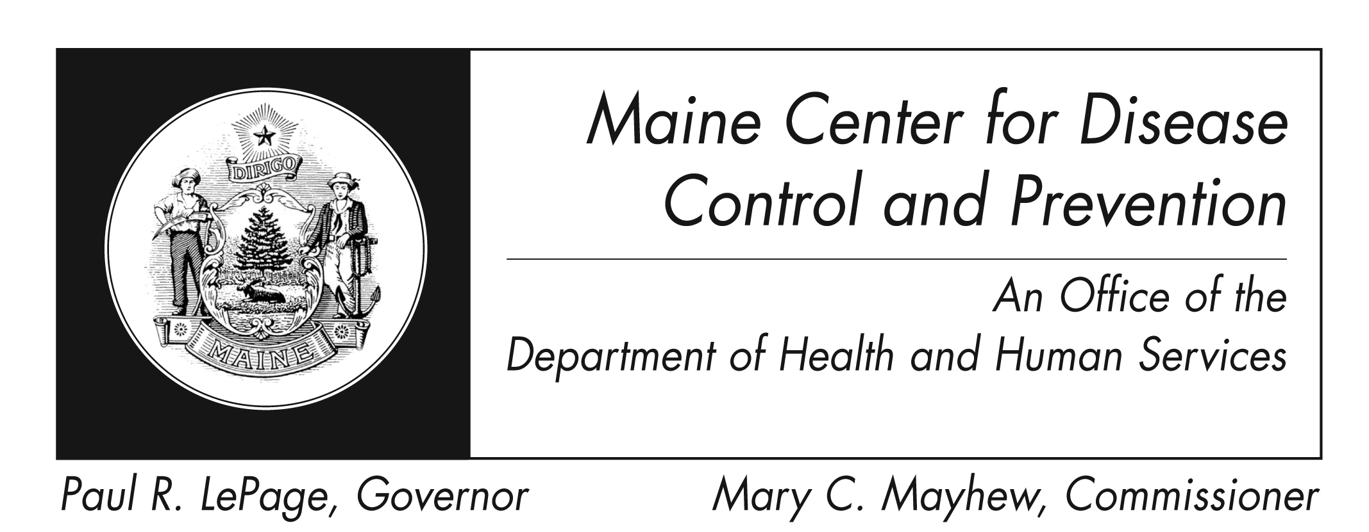

Pertussis
Fact Sheet

What is pertussis?
Pertussis, or whooping cough, is caused by bacteria called Bordetella pertussis. Pertussis can be very serious, especially in infants. It mainly affects the breathing.

What are the signs of pertussis?
The first signs of pertussis are similar to a cold (sneezing, runny nose, low-grade fever, and a cough). These signs start 5 to 21 days after exposure. After one or two weeks of illness, the cough gets worse with symptoms that may include:
- A sudden, uncontrollable cough where one cough follows the next without a break for breath.
- A high-pitched whooping sound when breathing in after a coughing episode. Whooping is less common in infants and adults.
- Vomiting after coughing
- Exhaustion
Over time, coughing spells become less frequent, but may continue for several weeks or months.

How do you catch pertussis?
Pertussis is spread from person to person through the air. A person has to breathe in droplets from an infected person to get sick. For example, a person may catch pertussis by standing close (less than 3 feet away) to an infected person who is coughing or sneezing.

When and for how long can a person spread pertussis?
Pertussis is most likely to spread to others early in the illness. Persons with pertussis can no longer spread the disease once they have completed 5 days of treatment with antibiotics. However, persons with pertussis who do not take antibiotics can spread the disease during the first 21 days they are sick.

What are the complications?
Severe pertussis is more likely in infants than in older children or adults. The most common complication of pertussis is pneumonia. Seizures, swelling of the brain and death are rare but possible.

Who gets pertussis?
People of all ages can get pertussis, even people who have been vaccinated or have had pertussis infection in the past. It is most common in school-aged children and teenagers, but cases in adults also occur. Older children and adults usually have less severe illness, but they can still spread the disease to infants and young children.

Is there any treatment?
Pertussis can be treated with antibiotics. Treatment should be started early to prevent the spread to others and can lessen the symptoms of illness. A cough may continue for many weeks after treatment especially if treatment wasn’t started until late in the illness. Pertussis bacteria die off naturally after three weeks of coughing. Antibiotics are not recommended if a person has already been coughing for 21 days or more.

Why did my healthcare provider tell me or my child to stay home for 5 days?
You can still spread pertussis to others until you take 5 days of antibiotics. Disease can spread quickly in schools or the workplace.

What will happen if I do not want to take the antibiotics?
If you do not take the antibiotics, you will need to stay away from others for 21 days after you start to become sick. This includes staying home from daycare, school, work or events.

Is there a lab test for pertussis?
Yes. To test for pertussis, your healthcare provider may insert a swab (like a long q-tip) into your nose. The lab will test the material on the swab to see if they can find the bacteria that causes pertussis.

Is there a vaccine for pertussis?
Yes, there are vaccines. The childhood vaccine is called Dtap, and the Pertussis booster for adolescents and adults is called Tdap.

People who catch pertussis after being vaccinated have milder illness and are much less likely to be hospitalized or die from the disease.

Vaccines prevent 200,000 cases of pertussis each year in the US. Talk to your healthcare provider about getting vaccinated against pertussis.

How can pertussis be prevented?
Vaccinate all children on time. Speak with your healthcare provider to see if you should get a booster vaccine. This is the best way to prevent pertussis.

Other ways to prevent pertussis are to:
- Avoid close contact with others who are sick or coughing
- Wash your hands often
- Stay at home if you are ill
- Cover your cough with a tissue or cough into your sleeve
- Use routine cleaners and disinfectants to remove these bacteria from surfaces or objects.
- See your healthcare provider if you have signs of pertussis or have been in close contact with someone who has pertussis.

Where can I get more information?
For more information contact your healthcare provider or local health center. Infectious Disease Epidemiology website: http://www.maine.gov/dhhs/mecdc/infectious-disease/epi/index.shtml
The federal Centers for Disease Control and Prevention website - http://www.cdc.gov – is another excellent source of health information.

