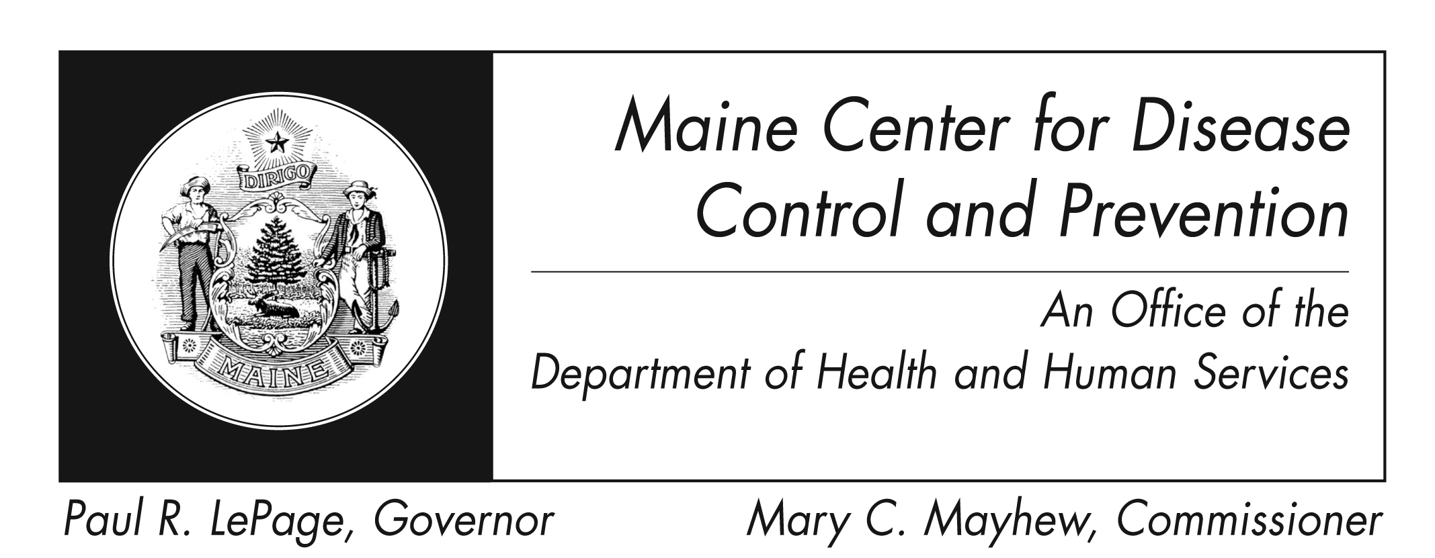
Dengue
Fact Sheet

What is Dengue?
Dengue (pronounced den' gee) is a disease caused by any one of four closely related viruses (DEN-1, DEN-2, DEN-3, or DEN-4).

How is it spread?
Dengue is passed to people by the bite of a mosquito that is infected with a dengue virus. It cannot be spread directly from person to person.

What are the signs and symptoms?
Primary symptoms are high fever, severe headache, severe pain behind the eyes, joint pain, muscle and bone pain, rash, and mild bleeding (i.e. nose or gums bleed, easy bruising). Generally, younger children and those with their first infection do not get as sick as older children and adults.

A more severe type of dengue (dengue hemorrhagic fever or DHF) has a high fever lasting from 2 to 7 days. After the fever subsides, symptoms include vomiting, severe abdominal pain, and difficulty breathing. Bleeding can lead to failure of the circulatory system and shock, followed by death, if it is not corrected.

How is it treated?
There is no specific medication for treatment of a dengue infection. Persons who think they have dengue should use only non-aspirin pain relievers. They should also rest, drink plenty of fluids, and consult a physician. If they feel worse in the first 24 hours after fever declines they should go immediately to the hospital for evaluation

How common is it?
Dengue is found in at least 100 countries in Asia, the Pacific, the Americas, Africa, and the Caribbean. An estimated 50 to 100 million infections occur yearly, including 500,000 DHF cases and 22,000 deaths, mostly among children.

Nearly all dengue cases in the continental United States are travel related. Most dengue cases occur in US citizens who live in Puerto Rico, the US Virgin Islands, Samoa, and Guam.
How can I prevent it?
There is no vaccine for preventing dengue. The best way to prevent dengue is to eliminate the places where mosquitoes lay eggs, like containers (tires, plastic jugs) that hold water.
People who travel to or live in tropical places with dengue should:
- use air conditioning when possible
- make sure window screens are free of holes
- use EPA recommended repellant, such as one containing 20--30% DEET as the active ingredient while indoors or out
- wear long sleeves and pants
- sleep with a bed net
Risk of infection differs by country. Check with your healthcare provider or visit the CDC travel website at http://wwwnc.cdc.gov/travel for information on the country you plan to visit.
Where can I get more information?
For more information contact your healthcare provider or local health center. You can also contact Maine Center for Disease Control and Prevention by calling 1-800-821-5821, or visit the Maine Center for Disease Control and Prevention website: www.maine.gov/idepi. The federal Centers for Disease Control and Prevention Dengue website - www.cdc.gov/dengue/ – is another excellent source of health information.

