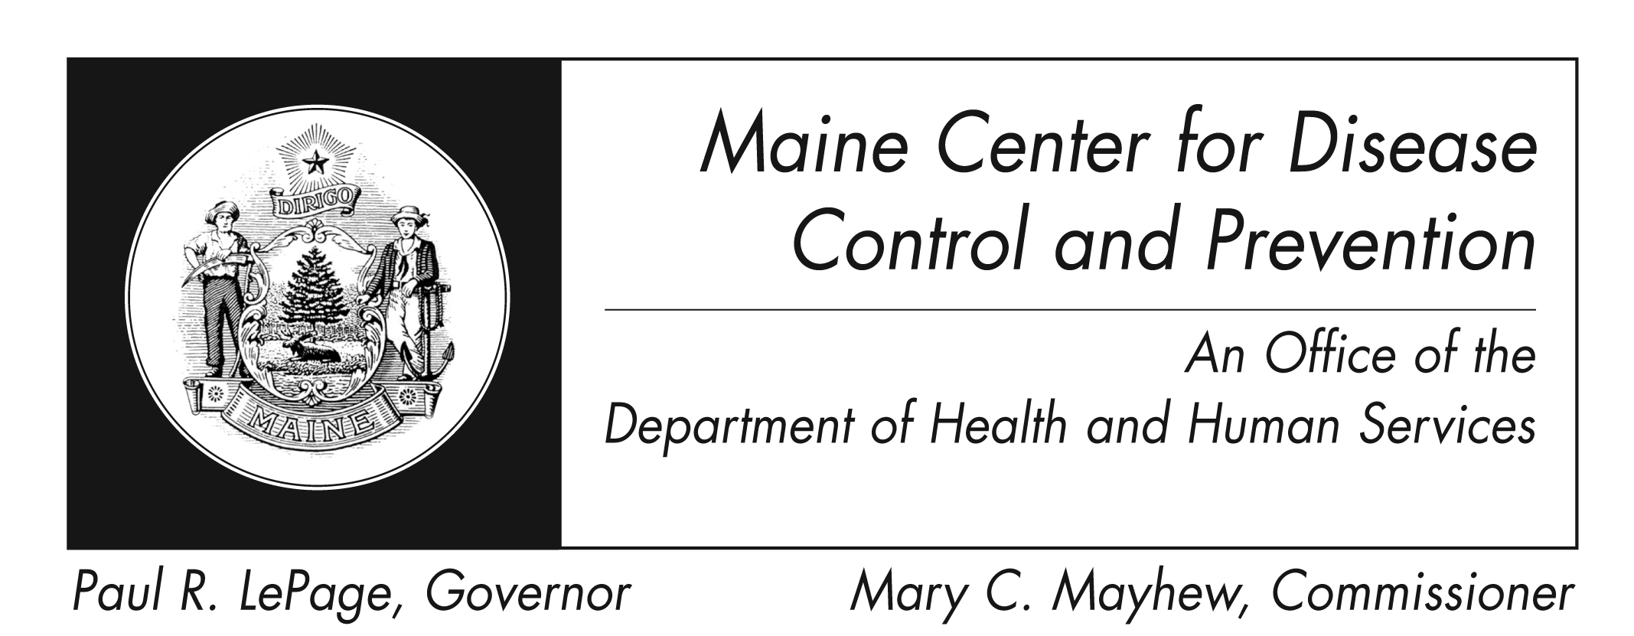
Botulism
Fact Sheet

What is botulism?
Botulism is a serious, sometimes fatal illness caused by botulinum nerve toxin. This toxin – is produced by a kind of bacteria. Botulism is always considered a medical emergency. It can cause death by paralyzing the muscles used to breathe.

How do you get it?
It cannot be passed from one person to another.

People can get it in different ways:
- By eating food contaminated with the poison
- From the toxin produced when a wound is infected with the bacteria
- When a baby eats or drinks something that contains spores of the bacteria
- By accidental overuse of botulinum toxin that is being used for medical or cosmetic purposes
It is also believed that botulism toxin could be used as a weapon – by putting it in food on purpose or by releasing it into the air.

What are the symptoms?
Symptoms of botulism are the same, regardless of how people get it. They include double vision, blurred vision, drooping eyelids, slurred speech, difficulty swallowing, dry mouth, and muscle weakness. Infants with botulism can appear sleepy, feed poorly, become constipated, and have a weak cry and weak muscles. These are all symptoms of the muscle paralysis caused by the toxin. Without treatment, people with botulism may go on to develop paralysis of the arms, legs, trunk, and the muscles used for breathing.

How soon do symptoms appear?
When botulism is caused by contaminated food, symptoms usually appear within 18 to 36 hours. However, they can start as soon as 6 hours or as long as 10 days later.

Can botulism be treated?
Intensive care in a hospital is the primary treatment for all forms. That may include measures designed to help the patient breathe. If the illness is identified quickly, botulism can be treated with an antitoxin, which blocks the action of the toxin. When people develop botulism from a wound, it may need to be surgically removed.

In severe cases, recovery from botulism can take weeks, or even months. The after-effects – which can include fatigue and shortness of breath – can last for years.

Can it be prevented?
Food-related botulism can be prevented through careful food-handling practices. Home-canned foods are a special source of concern. Wound botulism can be prevented by promptly seeking medical care for infected wounds and by not injecting street drugs.

What foods are commonly associated with botulism?
Botulism is most often associated with home-canned low-acid foods, such as asparagus, green beans, beets and corn. However, outbreaks of botulism from more unusual sources such as chopped garlic in oil, canned cheese sauce, chili peppers, and carrot juice have occurred. Improperly handled baked potatoes wrapped in aluminum foil, and home-canned or fermented fish have also caused outbreaks. Honey can contain the botulism bacteria, so children less than 12 months old should not be fed honey.

Where can I get more information?
You can contact the Maine Center for Disease Control and Prevention by calling 1-800-821-5821 or visit www.maine.gov/idepi. The federal Centers for Disease Control and Prevention website - http://www.cdc.gov – is another excellent source of health information.

