MOSQUITO TAKE HOME FACTS
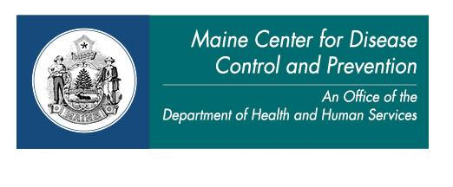
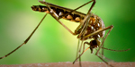
Habitat: Where do mosquitoes live?
- Bogs and swamps
- Stagnant (motionless)temporary pools, such as holes in trees where water can collect
- Non-natural containers, such as bird baths, old tires, kiddie pools, flower pots

Activity: When are mosquitoes most active?
- Mosquitoes are most active at dawn and dusk (in the early morning and early evening)

Diseases: Which diseases can mosquitoes cause?
Yes, mosquitoes can cause diseases, including:
- Eastern Equine Encephalitis (EEE)
- West Nile
- Jamestown Canyon

Symptoms of EEE/WNV: What can happen if an infected mosquito bites me?
*Most people infected will have no obvious symptoms
- Symptoms may appear 3-18 days after infection
- Mild symptoms:
  - Fever
  - Head and body aches
  - Lack of energy
- Severe symptoms:
  - Central nervous system involvement
  - Stiff neck, altered mental status, swelling of the brain, trouble breathing, paralysis, coma, death

Prevention: How do I protect myself?
- Wear long sleeves and long pants
- Use EPA-approved repellents on skin and clothes (repellents containing DEET, IR3535, picaridin, oil of lemon eucalyptus or permethrin)
- Take extra precaution at dawn and dusk (in the early morning and early evening)
- Use screens on doors and windows
- Drain artificial sources of standing water around your yard (old bird baths, old tires, kiddie pools, flower pots, etc.)

For more information:
- Maine CDC disease reporting and consultation line: 1-800-821-5821
- Maine CDC Vector-Borne Disease Website:
www.maine.gov/dhhs/mecdc/infectious-disease/epi/vector-borne/index.shtml
  - Disease.reporting@maine.gov
- Maine Medical Center Research Institute – Vector-Borne Disease Lab: 207-662-7142

