Mosquito Biology: 100
What is the first stage of a mosquito’s lifecycle?
A: Egg
Mosquito Biology: 200
True or False: Only female mosquitoes feed on blood?
A: True
Only female mosquitoes have a proboscis ( a long, jagged mouth part on the mosquito’s head) that is adapted for piercing skin, and only the females feed on blood. Male mosquitoes typically feed on plant nectar.
Mosquito Biology: 300
What is the long, feathery organ on the mosquito’s head used to hear and smell?
A: Antenna
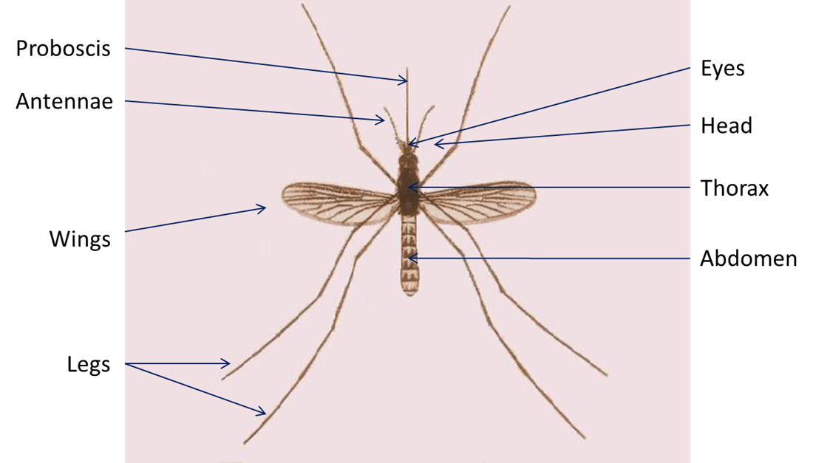

Mosquito Habitats: 100
True or false: All mosquitoes require water for their larvae to develop?
A: True; Larvae (larva) (also called wigglers or wrigglers) is the part of the mosquito lifecycle that comes after the eggs hatch. The larvae hang from the surface of water and breathe through tubes. The larval stage lasts for about 1 week.
Mosquito Habitats: 200
What man-made containers can mosquitoes use as larval habitats?
A: Buckets, cans, flower pots, or old tires (among other things)
Mosquito Habitats: 300
What is the favored habitat for mosquitoes carrying Eastern Equine Encephalitis (EEE)?
A: Bogs and swamps
Mosquito Protection: 100
When are mosquitoes most active?
A: At dawn and dusk (early morning and early evening)
Mosquito Protection: 200
What type of clothing should you wear when going outside to lessen your chance of getting bit by a mosquito?
A: Long sleeves and long pants
Mosquito Protection: 300
How often should you empty the water of containers like bird baths or pet bowls so that mosquito larvae won’t have time to complete their lifecycle?
A: At least once per week

Mosquito Diseases: 100
What are the two most common diseases carried by mosquitoes in Maine?
Eastern Equine Encephalitis (EEE) and West Nile virus (WNV)
Mosquito Diseases: 200
How does a human get a disease like EEE or West Nile virus?
A: Through a mosquito bite
Mosquito Diseases: 300
What is one symptom of EEE or West Nile virus?
A: Common symptoms include: fever, head and body aches, lack of energy, vomiting.
Serious symptoms include: disorientation, seizures, paralysis, coma, or death.
Final Jeopardy Question!
Do all mosquitoes carry diseases?
A: No, while all mosquitoes do not carry diseases, it is still important to be aware of the diseases mosquitoes CAN carry and how to prevent them.

