Synopsis
Influenza is a viral illness that typically occurs during the winter months. Characterized by the abrupt onset of constitutional and respiratory signs and symptoms, such as fever, muscle aches, headache, severe malaise, non-productive cough, sore throat, and runny nose, influenza is spread from person to person primarily by coughing and sneezing. Influenza-like illness (ILI) is a term used to describe illness that presents with the typical signs and symptoms of influenza, but that has not been confirmed as influenza by laboratory test. ILI is defined as fever greater than or equal to 100°F (37.8°C) and cough and/or sore throat in the absence of a known cause other than influenza.

Outpatient Influenza-like illness
Outpatient ILI data were collected through the U.S. Outpatient Influenza-like Illness Surveillance Network (ILINet), a collaborative effort between the federal CDC, Maine CDC, and local health care providers. During the 2009-10 season, 20 health care providers reported the number of patients seen in their practices and the number of those patients with ILI by age group on a weekly basis. Outpatient ILI visits peaked in November.

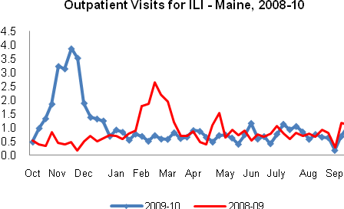

Syndromic Surveillance
During the 2009-10 season, an average of 15 Maine emergency departments report daily de-identified visit data. The data are classified into syndromes based on chief complaint. The ILI and fever

syndromes are used to get weekly percentage of visits for ILI and for fever. Emergency department visits for both ILI and fever peaked in November.

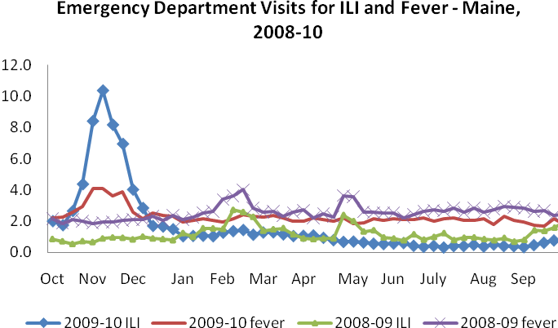

Hospital inpatients
Surveillance for inpatient respiratory illness admissions in Maine was conducted in collaboration with four hospitals. During the 2009-10 season, three hospitals reported the number of patients admitted to the hospital and the number of those patients admitted for influenza or pneumonia (P&I) using admitting diagnoses. One hospital reported the number of patients admitted to the hospital from the emergency department and the number of those patients admitted for respiratory illness using chief complaint. Hospital admissions for influenza, pneumonia, or respiratory illness were highest in December and again in March.

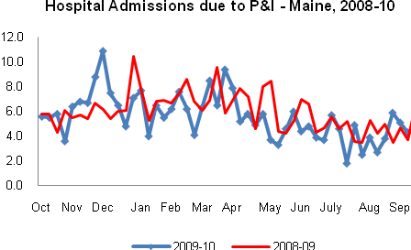

Laboratory Reporting
Maine CDC’s Health and Environmental Testing Laboratory (HETL) worked collaboratively with hospitals and private laboratories to collect specimens for respiratory virus testing and influenza positive isolate subtyping. HETL reported the number of specimens received for respiratory virus testing and the number positive by specimen collection date. During the 2009-10 season, 3,515 respiratory specimens were tested by HETL for influenza by culture and/or PCR. Of the specimens tested for influenza, 1,060 (30.2%) were positive for influenza (1,019 for influenza A [p H1N1], 1 for influenza A [H3], 38 for influenza A [subtype unknown], and 2 for influenza B).

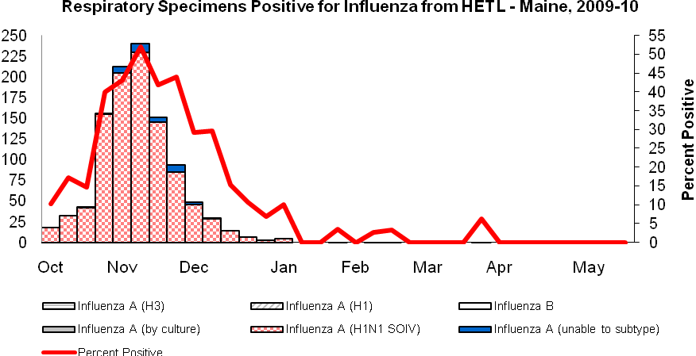

Two reference laboratories in Maine also participated in 2009-10 influenza surveillance activities. These laboratories submitted weekly reports of laboratory-confirmed influenza by culture or reverse-transcriptase polymerase chain reaction (RT-PCR) and number of specimens tested. During the 2009-10 season, 4,947 respiratory specimens were submitted for viral testing to these laboratories. Of these, 1,401 (28.3%) specimens were positive for influenza (1,398 for influenza A and 3 for influenza B).
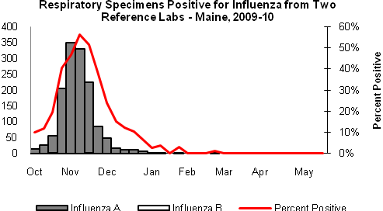
Outbreaks
Outbreaks of influenza or influenza-like illness are reportable by law in Maine. During the 2009-10 season, a total of 205 outbreaks of influenza were reported in Maine. Of these outbreaks, 10 were reported in long-term care facilities, 5 in acute care facilities, 178 in K-12 schools, 6 in a residential school or university, and 6 in other institutions. Outbreaks occurred in all regions of the state. Outbreak definitions can be found at http://www.maine.gov/dhhs/boh/influenza_surveillance_weekly_updates.shtml under Methods.

Death Certificates
The vital statistics offices of three Maine cities, Portland, Lewiston and Bangor, reported the number of death certificates in which pneumonia and influenza were mentioned as the primary or secondary cause of death. Data reported represent deaths that occurred in the reporting area, not the residence of the deceased. During the 2009-10 season, a total of 2,522 deaths were reported by three vital records offices. Of these, 241 (9.6%) were attributed to pneumonia or influenza. No influenza-associated pediatric deaths were reported in Maine during the 2009-10 season.

References

http://www.maineflu.gov
http://www.cdc.gov/flu/

