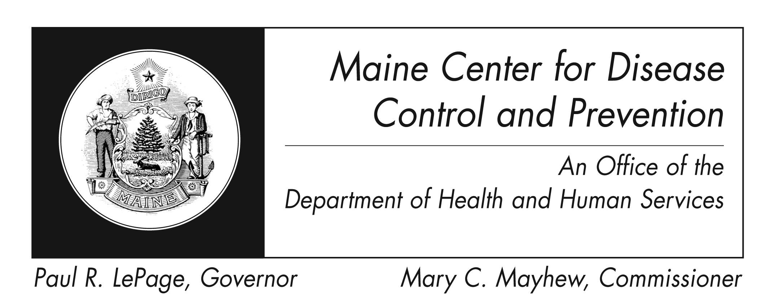
Hepatitis B
Fact Sheet

What is hepatitis B?
Hepatitis B is caused by a virus that attacks the liver. The virus, which is called hepatitis B virus (HBV), can cause lifelong infection, cirrhosis (scarring) of the liver, liver cancer, liver failure, and death.

How do you know if you have hepatitis B?
Only a blood test can tell for sure.

How is HBV spread?
HBV is spread when blood, semen or other bodily fluid infected with the hepatitis B virus enters the body of a person who is not infected. For example, HBV is spread through:
- birth (spread from an infected mother to her baby during birth)
- sex with an infected partner
- sharing needles, syringes, or other drug-injection equipment
- sharing items such as razors or toothbrushes with an infected person
- direct contact with the blood or open sores of an infected person
- exposure to blood from needlesticks or other sharp instruments
Hepatitis B is not spread through food or water, sharing eating utensils, breastfeeding, hugging, kissing, coughing, sneezing or by casual contact.

What are the symptoms of hepatitis B?
Sometimes a person with HBV infection has no symptoms at all. The older you are, the more likely you are to have symptoms. You might be infected with HBV (and be spreading the virus) and not know it.

If you have symptoms, they might include:
- yellow skin or yellowing of the whites of your eyes (jaundice)
- tiredness
- loss of appetite
- nausea
- abdominal discomfort
- dark urine
- clay-colored stools
- joint pain

How long does it take for symptoms to occur after exposure to HBV?
If symptoms occur, they occur on the average of 12 weeks (range 9-21 weeks) after exposure to hepatitis B virus. Symptoms occur in about 70% of patients. Symptoms are more likely to occur in adults than in children.

If I think I have been exposed to HBV, what should I do?
If you are concerned that you might have been exposed to HBV, call your health professional or your health department. If a person who has been exposed to HBV gets the hepatitis B vaccine and/or a shot called “HBIG” (hepatitis B immune globulin) within 24 hours, hepatitis B infection may be prevented.
Who is at risk for hepatitis B?
Those who:
- have sex with an infected person
- have multiple sex partners
- have a sexually transmitted disease
- are men who have sexual contact with other men
- inject drugs or share needles, syringes, or other drug equipment
- live with a person who has chronic Hepatitis B
- are infants born to infected mothers
- are exposed to blood on the job
- are hemodialysis patients
- travel to countries with moderate to high rates of Hepatitis B
Your risk is higher if your parents were born in Southeast Asia, Africa, the Amazon Basin in South America, the Pacific Islands, or the Middle East.

Is there a treatment for hepatitis B?
There are no approved medications available for acute (recently acquired) HBV infection. There are antiviral drugs available for the treatment of people with chronic HBV infection.

What does the term "chronic hepatitis B" mean?
Chronic hepatitis B means that you have a long-term infection; your body did not get rid of the virus when you were first infected. The risk of progressing to chronic infection depends on age (i.e., 2% to 6% of people over 5 years of age; 30% of children 1-5 years of age; and up to 90% of infants). People with chronic infection can infect others and are at increased risk of serious liver disease including cirrhosis and liver cancer. In the United States, an estimated 1.25 million people are chronically infected with HBV.

Can Hepatitis B be prevented?
Yes. The best way to prevent Hepatitis B is by getting the Hepatitis B vaccine. The Hepatitis B vaccine is safe and effective and is usually given as 3-4 shots over a 6-month period.

If you are pregnant, should you worry about hepatitis B?
Yes, you should get a blood test to check for HBV infection early in your pregnancy. This test is called hepatitis B surface antigen (HBsAg). If you test negative early in pregnancy, but continue behaviors that put you at risk for HBV infection (e.g., multiple sex partners, injection drug use), you should be retested for HBsAg close to delivery. If your HBsAg test is positive, this means you are infected with HBV and can give the virus to your baby. Babies who get HBV at birth might develop chronic HBV infection that can lead to cirrhosis of the liver or liver cancer.

If your blood test is positive, your baby should receive the first dose of hepatitis B vaccine, along with another shot, hepatitis B immune globulin (called HBIG) within 12 hours of birth. The second dose of vaccine should be given at 1-2 months of age and the third dose at 6 months of age. Your baby will then be tested for response to the vaccine at age 3-6 months.

Can I donate blood, organs, or semen if I have Hepatitis B?

No, if you have ever tested positive for HBV, experts recommend that you not donate blood,

organs, or semen.

How long can HBV survive outside the body?
HBV can survive outside the body at least 7 days and still be capable of causing infection.

What do you use to remove HBV from environmental surfaces?
You should clean up any blood spills - including dried blood, which can still be infectious – using a cleaning solution of one part household bleach to 10 parts water. Use gloves and eye protection when cleaning up any blood spills.

Where can I get more information?
For more information contact your healthcare provider or local health center. You can also contact the Maine Center for Disease Control and Prevention by calling 1-800-821-5821 or 1-800-867-4775 (Maine Immunization Program) or visiting the website:………………………………
http://www.maine.gov/idepi
The federal Centers for Disease Control and Prevention website - http://www.cdc.gov – is another excellent source of health information.

