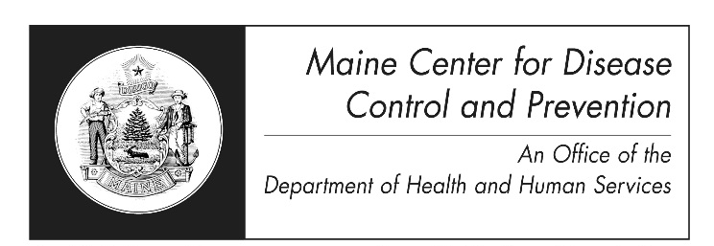
Q Fever
Fact Sheet

What is Q fever?
Q fever is a disease caused by a type of bacteria called Coxiella burnetii. Q fever is most often a disease of cattle, sheep, and goats, but other livestock, pets, and people can also get Q fever.

How is it spread?
Q fever usually occurs when a person breathes in dust containing the dried wastes of infected animals. Direct contact with infected animals and their blood, feces, urine, soiled materials such as straw or other bedding materials, and unpasteurized milk from infected cows or goats may also cause infection. Direct person-to-person spread is not very common but can happen. The risk of infection is greatest close to the source of bacteria, but there have been cases in people miles away from the source. This is because infected dust can travel in the air for several miles. Only about half of all people infected with the bacteria will become ill. Most people who get the disease get symptoms 2 to 3 weeks after exposure.

What are the signs and symptoms?
People with Q fever usually get high fevers (up to 105°F), bad headaches, feel tired, and have muscle aches. Some people also get confused, or get a sore throat, chills, sweats, cough, nausea, vomiting, diarrhea, stomach pain, or chest pain. The fever usually lasts for 1 to 2 weeks. Weight loss can occur and last for some time. People with severe disease may develop inflammation of the lungs (pneumonia) or liver (hepatitis). Chronic Q fever is more serious and can harm heart valves. It is more common in people with heart valve disease, blood vessel abnormalities, or who have a weak immune system. Most animals infected with Q fever do not have symptoms, but infection may cause abortion in sheep and goats.

How is it diagnosed?
Q fever is diagnosed with blood tests or by finding the bacteria in tissues using DNA detection methods.

How is it treated?
Most cases of acute Q fever will recover without treatment, but antibiotics can be used and work best when started within the first three days of illness. Long lasting (chronic) Q fever infection of the heart is very difficult to treat. Treatment may take several years. Sometimes surgery is needed to remove damaged heart valves.

Who gets Q fever?
Persons at highest risk for Q fever are those who work with animals that are infected, such as veterinarians, meat workers, sheep and dairy workers, and farmers.

What should I do if I think I have been exposed to the bacteria?
If you work with animals and have symptoms or if you think you have Q fever, you should contact your healthcare provider.

How can it be prevented?
- Wear a face mask and shield for contact with infected animals, especially while they are giving birth
- Do NOT consume non-pasteurized milk and milk products

Safety measures for persons who work with animals (veterinarians, meat processing plant workers, sheep and dairy workers, livestock farmers, and laboratory workers) include:
- Wear appropriate personal protective equipment
- Ensure correct disposal of infected materials, such as the placenta, other birth products and aborted fetuses of sheep and goats
- Restrict access to laboratories and barns with infected animals
- Use the correct method for bagging and cleaning work clothes

Where can I get more information?
For more information contact your healthcare provider or call Maine CDC at 1-800-821-5821. The U.S. Centers for Disease Control and Prevention website http://www.cdc.gov is another excellent source of health information.

