Norovirus Infections
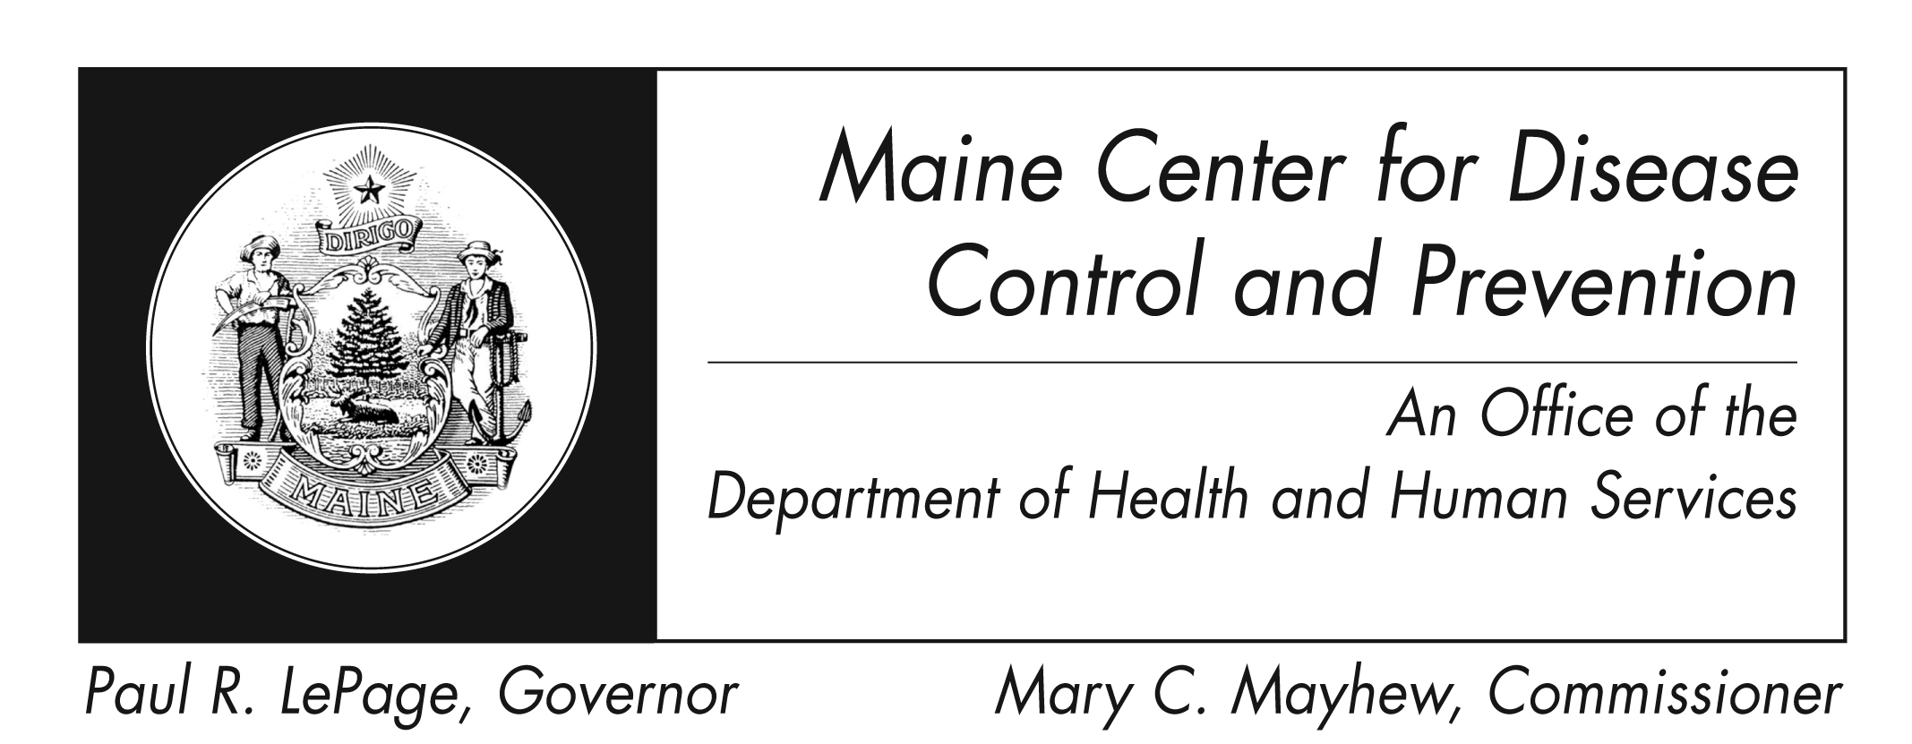
Fact Sheet

What are noroviruses?
Noroviruses are a group of viruses that cause diarrhea and vomiting in people.

What are the symptoms of illness?
The symptoms include nausea, throwing up (vomiting), diarrhea, and some stomach cramping. Sometimes people also have a low-grade fever, chills, headache, muscle aches, and tiredness. The illness often begins suddenly. The illness is usually short, with symptoms lasting 1 or 2 days. Children have more vomiting than adults.

When do symptoms appear?
Symptoms usually start about 24 to 48 hours after swallowing the virus, but can appear as early as 10 hours after exposure to the virus.

How do people become ill?
The virus is found in the stool (poop) or vomit of sick people. People can become sick with the virus in several ways, including:
- eating food or drinking liquids that are contaminated with norovirus;
- touching surfaces or objects contaminated with norovirus, and then placing their hand in their mouth;
- having close contact with another person who is sick, for example:
  - being present while someone is throwing up
  - sharing food or utensils
  - drinking waters or liquids from the same cup/bottle
  - caring for a sick person
  - shaking hands
Persons working in day-care centers or nursing homes should pay special attention to children or residents who are sick with diarrhea and vomiting. This virus is very contagious and can spread quickly in these settings.

Is the virus contagious?
Norovirus is very contagious and can spread easily from person to person. Both stool and vomit can spread the virus. Special care should be taken with young children in diapers who may have diarrhea.

How long can people pass the virus to others?
Sick persons can spread the virus from the moment they begin feeling sick and for at least 3 days after illness ends. Some people may be able to spread it for as long as 2 weeks after feeling better. It is important for people to use good hand washing and other hygienic practices even after they feel better.

Who gets sick?
Anyone can become sick. There are many different strains of norovirus, which makes it difficult for a person to become immune and they can become sick more than once. Some persons develop more severe illness than others because of differences in the virus and a person’s existing medical conditions.

How serious is the illness?
Illness is usually not serious, although people may feel very sick and throw up many times a day. Most people get better within 1 or 2 days, and they have no long-term health effects related to their illness.

Sometimes people are unable to drink enough liquids to replace the liquids they lost because of vomiting and diarrhea. These persons can become dehydrated and may need special medical attention. Symptoms of dangerous fluid loss include a decrease in urine, dry mouth and throat and feeling dizzy when standing up. Children who are dehydrated may cry with few or no tears and be unusually sleepy or fussy. This problem is usually only seen among the very young, the elderly, and persons with weak immune systems.

Is treatment available?
Currently, there is no medicine to treat norovirus. The virus cannot be treated with antibiotics, because antibiotics work to fight bacteria and not viruses.

Illness is usually brief in healthy persons. When people are sick with vomiting and diarrhea, they should drink lots of fluids to prevent dehydration. By drinking juice or water, people can reduce their chance of becoming dehydrated.

Can illness be prevented?
Yes. You can decrease your chance of illness by following these steps:
- Wash your hands often with soap and water and dry hands with a disposable towel
  - after toilet visits
  - after changing diapers
  - before eating or preparing food
  - after touching animals
- Carefully wash fruits and vegetables
- Cook oysters thoroughly before eating them
- Thoroughly clean and disinfect contaminated surfaces after an episode of illness by using a bleach-based household cleaner or EPA-registered disinfectant (http://www.epa.gov/oppad001/chemregindex.htm)
- Immediately remove and wash clothing or linens that may be contaminated with virus after an episode of illness (use hot water and soap and dry at highest temperature possible)
- Flush or discard any vomit and/or stool in the toilet and make sure that the surrounding area is kept clean
- Ill persons should not prepare food while they have symptoms and for 2-3 days after symptoms end

Should I work or go to school if I am sick?
- Persons employed in food service or who prepare food for others should not prepare food while they have symptoms and for 2-3 days after they recover from their illness
- Daycare and school-aged children should stay home while they have symptoms
- Healthcare workers should stay home while they have symptoms

Is a vaccine available?
No. There is no vaccine available for norovirus.

Norovirus in Maine
Norovirus is common in Maine and in the rest of the country. The federal CDC estimates that 21 million cases of acute gastroenteritis per year are due to norovirus. Because the virus is so common, especially in the winter months, the Maine CDC only investigates outbreaks. Outbreaks in nursing homes, schools and other community settings are not uncommon and occur every year.

Where can I get more information?
For more information contact your healthcare provider or local health center. You can also contact the Maine Center for Disease Control and Prevention by calling 1-800-821-5821 or visiting www.mainepublichealth.gov. The federal Centers for Disease Control and Prevention website - http://www.cdc.gov/norovirus – is another excellent source of health information.

