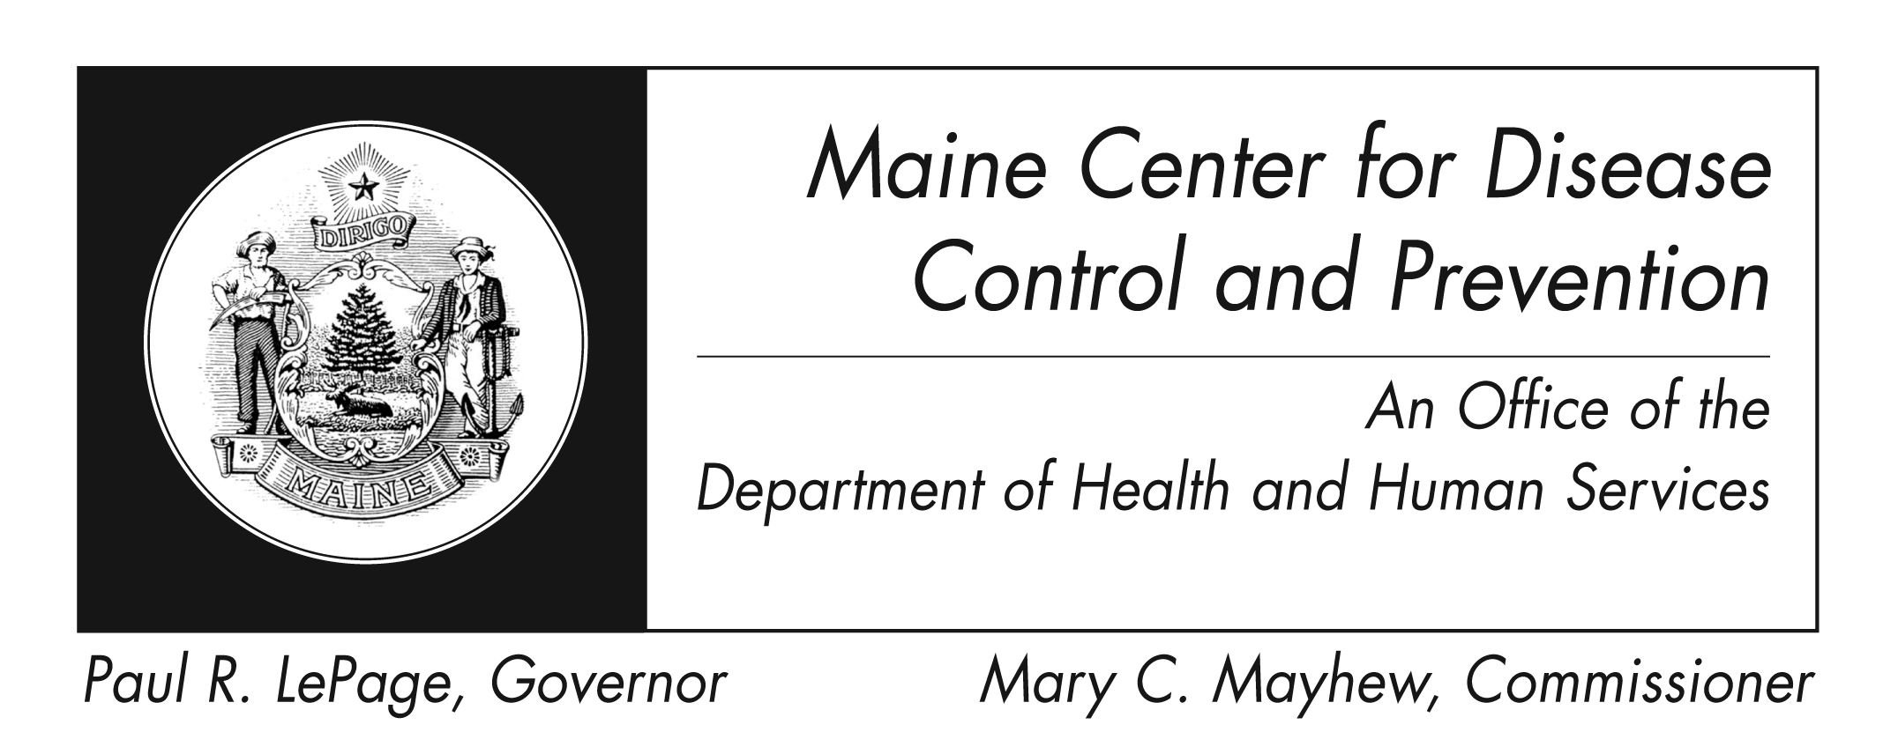
Hand, Foot, and Mouth Disease
Fact Sheet

What is hand, foot, and mouth disease?
Hand, foot, and mouth disease (HFMD) is a common illness of infants and children that is caused by a virus. The disease causes fever, blisters in the mouth and/or a skin rash. HFMD is often confused with foot-and-mouth (also called hoof-and-mouth) disease, a disease of cattle, sheep, and pigs, but the two diseases are caused by different viruses and are not related. Humans do not get the animal disease, and animals do not get the human disease. HFMD is caused by a group of viruses called enterovirus.

What are the signs and symptoms of HFMD?
The disease usually begins with a fever, poor appetite, fatigue, and sore throat. One or 2 days after fever onset, painful sores usually develop in the mouth. They begin as small red spots that blister and then often become ulcers. The sores are usually located on the tongue, gums, and inside of the cheeks. A non-itchy skin rash develops over 1–2 days. The rash has flat or raised red spots, sometimes with blisters. The rash is usually located on the palms of the hands and soles of the feet; it may also appear on the buttocks and/or genitalia. A person with HFMD may have only the rash or only the mouth sores.

How is HFMD spread?
Infection is spread from person to person by direct contact with the virus. Infectious virus is found in the nose and throat secretions, saliva, blister fluid, and stool of infected persons. The virus is most often spread by persons with unwashed hands and by contact with contaminated surfaces. Infected persons are most contagious during the first week of the illness. The viruses that cause HFMD can remain in the body for weeks after a patient's symptoms have gone away. This means that the infected person can still pass the infection to other people even though he/she appears well. Also, some persons who are infected and excreting the virus, including most adults, may have no symptoms.

Is HFMD serious?
HFMD is usually a mild disease and nearly all patients recover in 7 to 10 days without medical treatment. Complications are uncommon, but when they do occur, medical care should be sought. Serious complications can include viral meningitis, encephalitis or polio-like paralysis and may lead to hospitalization and very rarely, death.

Who is at risk for HFMD infection?
Everyone who has not already been infected with a virus that causes HFMD is at risk of infection, but not everyone who is infected with the virus becomes ill with HFMD. HFMD occurs mainly in children under 10 years old, but it can also occur in adults. Children are more likely to be at risk for infection and illness because they are less likely than adults to have immunity, or protection against, the viruses that cause HFMD. People who have been ill with HFMD can be infected again by one of the other viruses that cause HFMD.

How will I know if I have HFMD?
HFMD is one of many infections that result in mouth sores. However, health care providers can usually tell the difference between HFMD and other causes of mouth sores by considering the patient’s age, the symptoms reported by the patient or parent, and the appearance of the rash and sores. Samples from the throat or stool may be sent to a laboratory to test for virus and to find out which enterovirus caused the illness. However, it can take 2–4 weeks to obtain test results, so health care providers usually do not order tests.

How is HFMD treated?
There is no specific treatment for HFMD. Symptoms can be treated to provide relief from pain from mouth sores and from fever and aches:
- Fever can be treated with antipyretics (drugs that reduce fevers)
- Pain can be treated with acetaminophen, ibuprofen, or other over-the-counter pain relievers
- Mouthwashes or sprays that numb pain can be used to lessen mouth pain
Fluid intake should be enough to prevent dehydration (lack of body fluids). If moderate-to-severe dehydration develops, it can be treated medically by giving fluids through the veins.
How can I prevent HFMD?
The risk of infection can be lowered by following good hygiene practices. Good hygiene practices that can lower the risk of infection include:
- Washing hands frequently and correctly and especially after changing diapers and after using the toilet
- Cleaning dirty surfaces and soiled items, including toys, first with soap and water and then disinfecting them by cleansing with a solution of chlorine bleach (made by adding 1 tablespoon of bleach to 4 cups of water)
- Avoiding close contact (kissing, hugging, sharing eating utensils or cups, etc.) with persons with HFMD
What about work and daycare?
HFMD outbreaks in child care facilities occur most often in the summer and fall months and usually coincide with an increased number of cases in the community. There are no specific recommendations regarding the exclusion of children with HFMD from child care programs, schools, or other group settings. Children are often excluded from group settings during the first few days of the illness, which may reduce the spread of infection, but will not completely interrupt it. Exclusion of ill persons may not prevent additional cases since the viruses that cause HFMD can remain in the body for weeks after the patient's symptoms have gone away. This means that the infected person can still pass the infection to other people even though they appear well. Also, some persons who are infected and excreting the virus, including most adults, may have no symptoms. Some benefit may be gained, however, by excluding children who have blisters in their mouths and drool or who have weeping lesions on their hands. If an outbreak occurs in the child care setting,
- Make sure that all children and adults wash their hands frequently and thoroughly, especially after changing diapers or using the toilet.
- Thoroughly wash and disinfect contaminated items and surfaces, using a diluted solution of chlorine-containing bleach.
Where can I get more information?
For more information contact your healthcare provider or local health center. You can also contact the Maine Center for Disease Control and Prevention by calling 1-800-821-5821. The federal Centers for Disease Control and Prevention website - http://www.cdc.gov – is another excellent source of health information.

