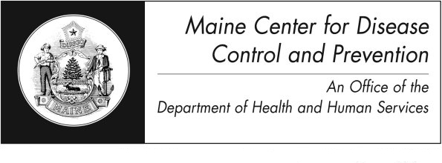
Shigellosis

Fact Sheet

What is shigellosis?
Shigellosis is an illness caused by bacteria called Shigella. There are several different kinds of Shigella. Shigella sonnei causes over two-thirds of the cases in the United States.

How is it spread?
Shigella bacteria are found in the stools of infected people when they are sick and for 1-2 weeks after recovering. People get shigellosis by swallowing the Shigella bacteria. This may happen when someone eats food or drinks water that is contaminated with the bacteria. Shigella spreads from person to person when people do not wash their hands with soap and water after using the toilet or changing a diaper. Family members and playmates of diapered children are at risk of becoming infected.

How does Shigella get into food and water?
Shigella may get into food if it is touched by someone with the disease who doesn’t wash his or her hands well with soap and water after using the toilet. The bacteria may get into vegetables if they are harvested from a field with sewage in it. The bacteria may get into water if sewage runs into the water or if someone with shigellosis swims in it. Flies can also spread this disease by breeding in infected feces and then touching food.

What are the signs and symptoms?
Most people will get bloody or watery diarrhea, fever, and stomach cramps a day or two after they swallow the bacteria. Symptoms usually end after 5 to 7 days. People with severe symptoms may require hospitalization, such as young children and the elderly.

How do I know if I have it?
Your healthcare provider may ask you for a sample of your stool to test in a laboratory.

How is it treated?
People with mild infections usually recover quickly without treatment. Antibiotics are sometimes used to treat severe cases. Medicine taken to stop diarrhea can make the illness worse.

How can it be prevented?
- Wash hands well with soap and water
- After using the toilet or changing diapers, and
- Before and after preparing foods or beverages
- Help toddlers and small children wash their hands after they use the toilet
- Clean diaper changing areas with a disinfectant such as household bleach or germ-killing wipes after use
- Throw away soiled diapers properly
- Keep children with diarrhea out of child care settings
- People with diarrhea should not prepare food or serve water for others
- When traveling, do not use ice or drink tap water. Avoid eating uncooked foods in countries where the water may not be safe and sanitation is poor
- Avoid swallowing pool water
- Do not swim if you have diarrhea. Children in diapers should not be in the water if they have diarrhea.

How common is it?
Shigellosis is most common in settings where hygiene is poor. Many cases are related to the spread of illness from person to person, especially among family members. In the developing world, shigellosis is far more common.

Where can I get more information?
For more information contact your healthcare
provider or local health center. You can also contact the Maine Center for Disease Control and Prevention by calling 1-800-821-5821 or www.maine.gov/idepi. The federal Centers for Disease Control and Prevention website - http://www.cdc.gov – is another excellent source of health information.

