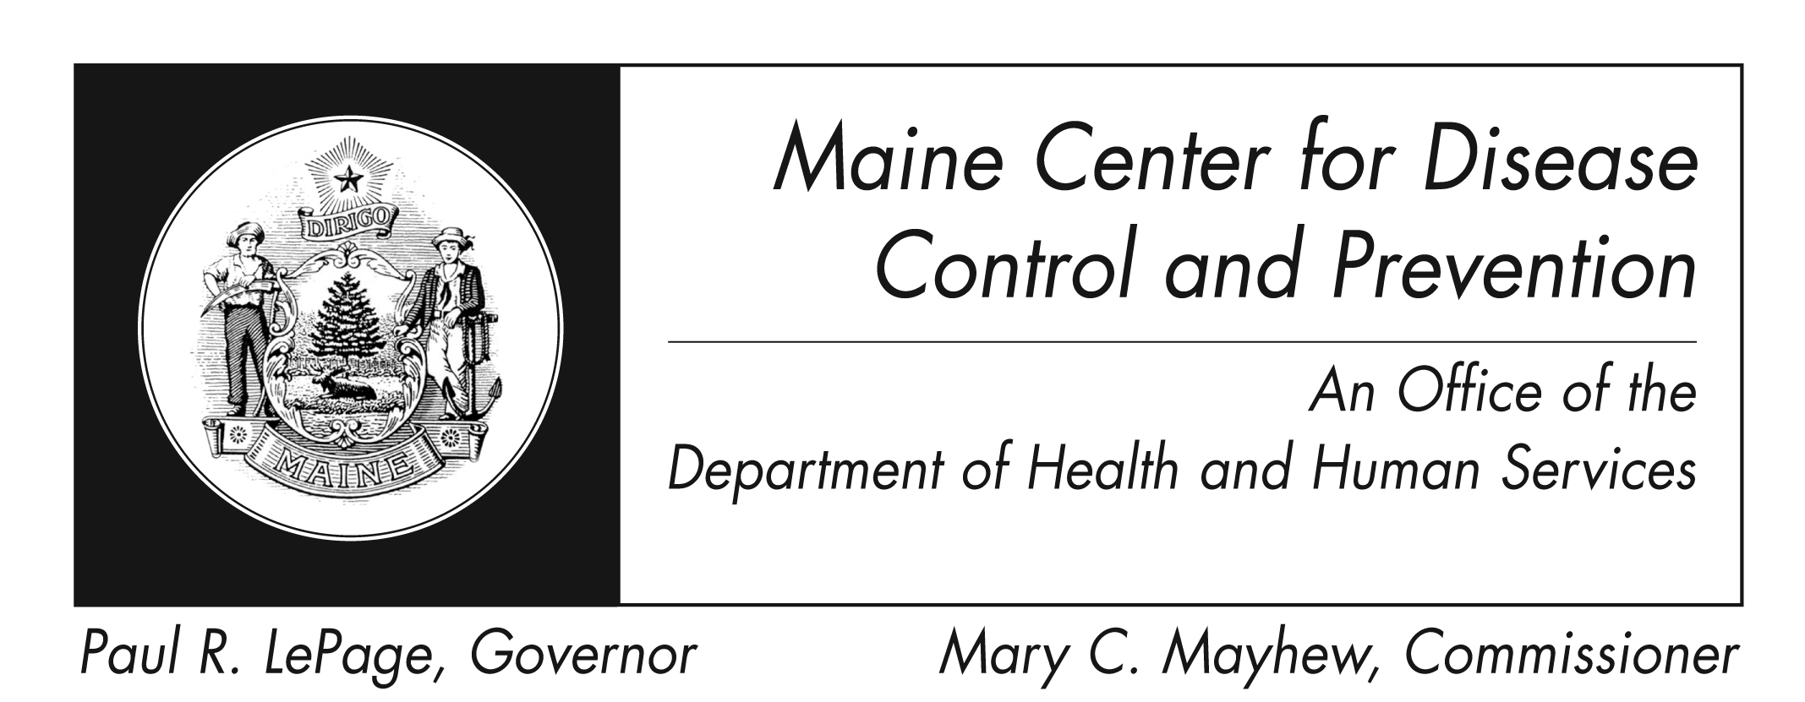
Mumps
Fact Sheet

What is mumps?

Mumps is a disease that is caused by the mumps virus.

How is mumps spread?

Mumps is spread by mucus or droplets from the nose or throat of an infected person, usually when a person coughs or sneezes. Surfaces of items (e.g., toys) can also spread the virus if someone who is sick touches them without washing their hands, and someone else then touches the same surface and then rubs their eyes, mouth, or nose.

What are the symptoms of mumps?

The most common symptoms are fever, headache, muscle aches, tiredness and loss of appetite followed by onset of swollen and tender glands under the ears, on one or both sides (parotitis).

How soon do symptoms appear?

Symptoms typically appear 16-18 days after infection, but this period can range from 12-25 days after infection.

Who can get mumps?

Anyone who has not either had previous mumps infection or been vaccinated can get mumps. Mumps used to be a common illness in infants, children and young adults. Now, because most people have been vaccinated, mumps is a rare disease in the United States. Of those people who do get mumps, up to half have very mild, or no symptoms, and therefore many do not know they had mumps.

Are there complications of mumps?

The most common complication is redness and swelling of the testicles in males who have reached puberty. Fortunately, this rarely leads to fertility problems.
Other rare complications include:
- Inflammation of the brain and/or tissue covering the brain and spinal cord
- Inflammation of the ovaries and/or breasts in females who have reached puberty
- Pregnancy loss, particularly in early pregnancy
- Hearing loss, usually permanent

How long is an infected person able to spread the disease?

Mumps virus has been found in respiratory secretions from 7 days before until 9 days after the onset of symptoms. Usually the patient is most infectious within the first 5 days. Therefore, mumps patients should be isolated for 5 days after glands swelling starts.

What is the treatment for mumps?

There is no specific treatment. Supportive care should be given as needed. If someone becomes very ill, they should seek medical attention and should call their doctor in advance so that they don't have to sit in the waiting room for a long time and possibly infect other patients.

How do I protect myself and my family?

Vaccine (usually referred to as MMR since mumps vaccine is given with measles and rubella vaccines) is the best way to prevent mumps. Other things people can do to prevent mumps and other infections is to wash hands well and often with soap and water, and to teach children to wash their hands too. Eating utensils should not be shared, and surfaces that are frequently touched (toys, doorknobs, tables, counters, etc) should also be cleaned often with soap and water, or with cleaning wipes.

Where can I get more information?
You can contact the Maine Center for Disease Control and Prevention by calling 1-800-821-5821 or check the federal Centers for Disease Control and Prevention website - http://www.cdc.gov.

