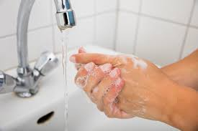

k  
ALL EMPLOYEES MUST

**WASH HANDS**

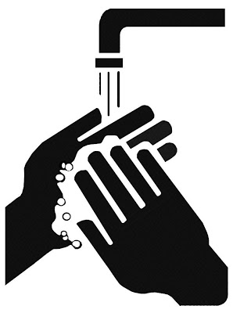

Dirty Hands Spread Disease

This is a regulation of the Maine Center for Disease Control and Prevention, Health Inspection Program

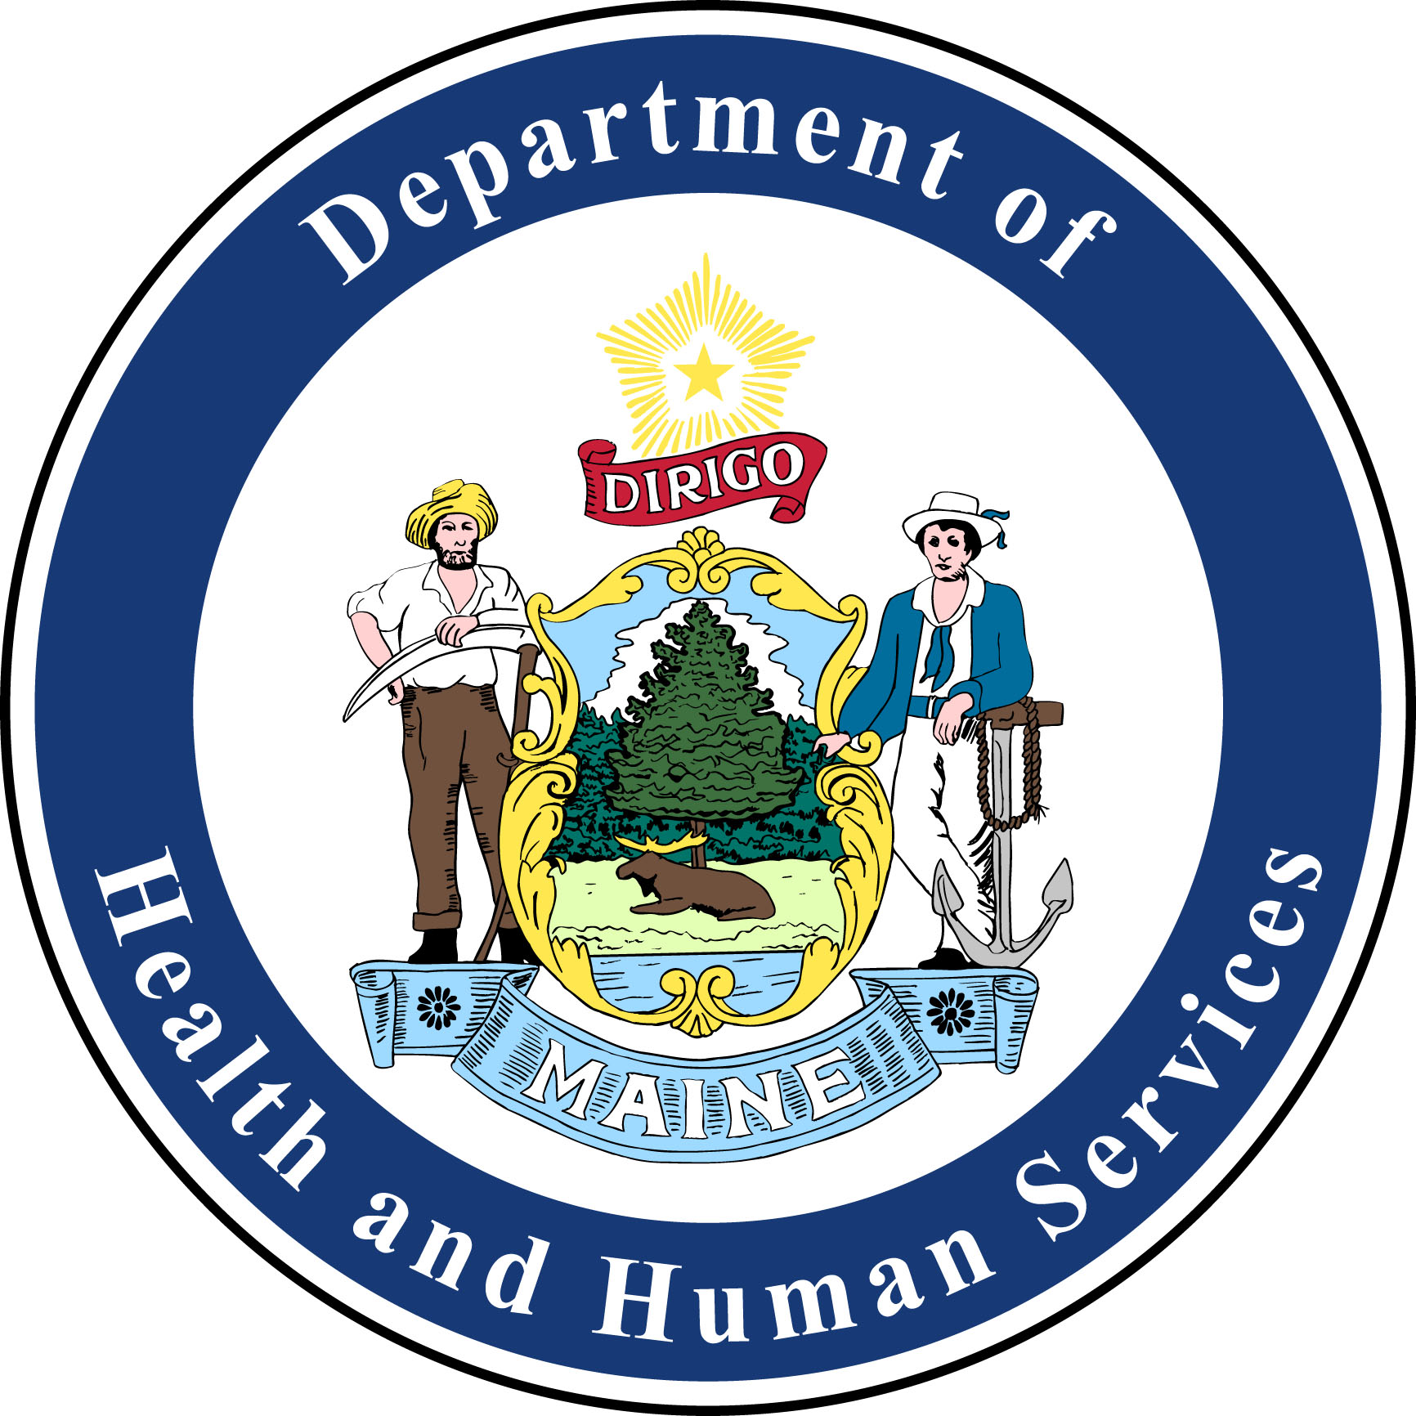

d  
ALL EMPLOYEES MUST

**WASH HANDS**



Dirty Hands Spread Disease

This is a regulation of the Maine Center for Disease Control and Prevention, Health Inspection Program

