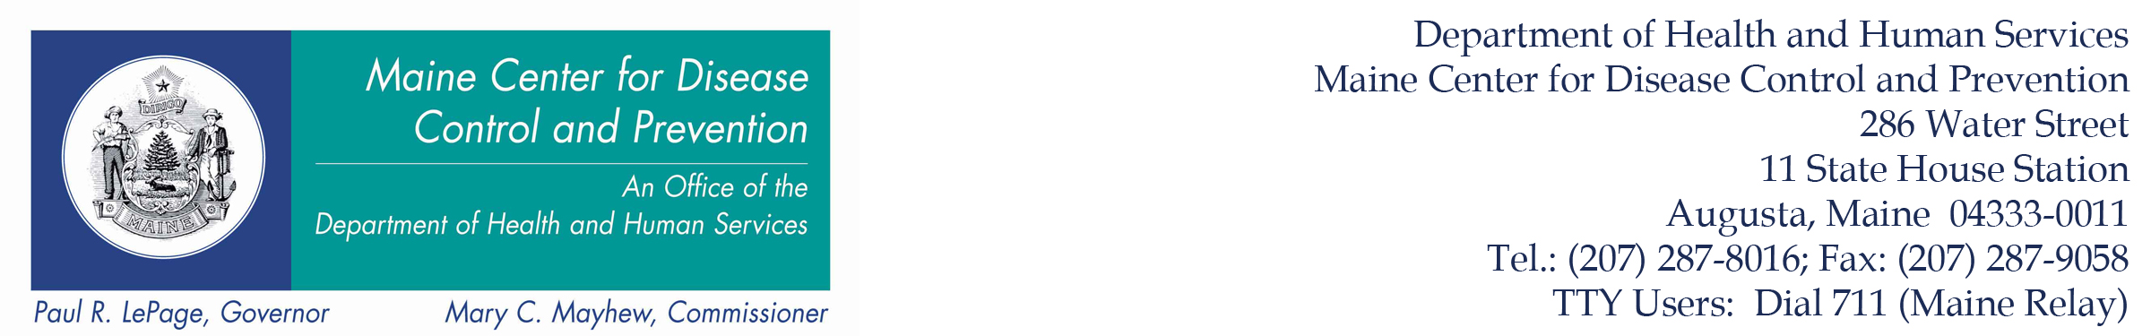
Tel. (207) 287-5671 Web Site Address: http://www.maine.gov/healthinspection Fax (207) 287-3165

HEALTH INSPECTION PROGRAM
CERTIFIED FOOD PROTECTION MANAGER REQUIREMENTS

Every eating establishment must employ on its staff a Certified Food Protection Manager (CFPM). Some establishments are exempt from this requirement as stated below. A Certified Food Protection Manager must be hired within 90 days of a new eating establishment opening or when a Certified Food Protection Manager leaves employment. Eating establishments must post in a conspicuous area the certification of the CFPM(s), and the certificate must be made available to the Department upon request.

Responsibilities of the CFPM
The responsibilities include training and implementing a program of food protection and education for each person in charge, so that he or she will be able to successfully complete the demonstration and knowledge required of the Maine Food Code.

In the event that during an inspection by a Regulatory Authority, the person in charge is not able to make the demonstration required by the Maine Food Code or there are multiple critical violations present during such inspection, the Department may thereafter require every person in charge for such eating establishment to be a Certified Food Protection Manager.

Certification Requirements
In the State of Maine, the following will be accepted as meeting the requirements for certification:
- Having written proof of completion of specialized training in the preparation and serving of safe food, such as ServSafe ® Food Protection Manager Certification from the National Restaurant Association Solutions, LLC, the National Registry of Food Safety Professionals, Prometric, and 360training.com Inc, AboveTraining/StateFoodSafety.com or equivalent; and,
- Receiving a passing grade on a competency test, approved by the National Conference for Food Protection (CFP). Such CFPM certification shall be renewed through re-training and re-testing every 5 years.

Exemptions
When considering the certification of a CFPM, the following establishments are exempt from the CFPM requirement:
    - Bed and Breakfast establishments with 5 rooms or less;
    - Bed and Breakfast and lodging establishments that serve a continental breakfast consisting of non-potentially hazardous baked goods, whole fruit or fruit sliced for same-day service, cereal, milk, juice, portion-controlled cream cheese, portioned-controlled peanut butter, and portion-controlled jam or jelly.
    - Temporary eating establishments that operate fewer than 14 days;
  - Establishments that serve or sell non-potentially hazardous pre-packaged foods;
    - Establishments that prepare only non-potentially hazardous foods;
  - Establishments that heat only commercially processed potentially hazardous foods for hot holding. No cooling of potentially hazardous foods;
  - Sporting, Recreational, or bear camps operating 90 days or less and serving only their own guests;
  - Eating Establishments which pose minimal risk of causing or contributing to foodborne illness, based on the nature of the operation and the extent of food preparation.

LS Rev 3-23-17

