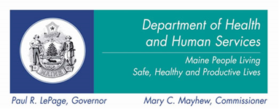

THE DEPARTMENT OF HEALTH & HUMAN SERVICES IS MOVING FROM 161 MARGINAL WAY, PORTLAND EFFECTIVE JANUARY 26, 2015.

PLEASE VISIT US AT OUR NEW LOCATION AT
151 JETPORT BOULEVARD, SOUTH PORTLAND.
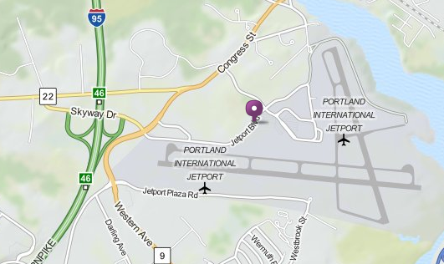

CONTACT US:
 151 JETPORT BLVD (207) 822-2000  www.maine.gov/dhhs
PORTLAND ME 04102-1946

OFFICE HOURS: MONDAY-FRIDAY 8am -5pm

Inbound and outbound bus service will be provided by the GREATER PORTLAND METRO via Route 5. For more information visit www.gpmetrobus.com or call (207) 774-0351.

