**Maine Economic Indicators**

October 2020

**Maine Department of Administrative and Financial Services**

**Office of the State Economist**

Amanda Rector, State Economist

Angela Hallowell, Economic Analyst

Maine Economic Indicators is a monthly report assembled by the Office of the State Economist that provides a synopsis of current economic trends and indicators for the state in comparison to New England and the United States. The intent of this report is to provide the public with a single document containing data aggregated from different sources typically used to track current economic and demographic conditions in the state.

The appendix provides comprehensive information related to the data presented herein. Data included in this report are assembled from various sources, subject to frequent revision, and provided in this report “as is” at the time of publication. Therefore, data presented in this report are subject to change over time.

**It is important to note that some data may precede the full onset of COVID-19. Please also note that changes in economic indicators cannot uniquely be interpreted as the impact of COVID-19.**

# Snapshot

Indicators in this section provide a summary of Maine’s current economic status. Figures for Maine are compared to New England and the United States. Sources are given in the appendix.

|  |  |  |  |  |
| --- | --- | --- | --- | --- |
| **Reference Period** |  | **Maine** | **New England** | **United States** |
| 2019 | Total population | 1,344,212 | 14,845,063 | 328,239,523 |
| 2018-2019 | Annual population percent change | 0.4% | 0.1% | 0.5% |
| 2010-2019 | Cumulative population percent change | 1.2% | 2.8% | 6.3% |
| 2019 | Average earnings per job | $51,980 | $71,826 | $64,180 |
| 2018-2019 | Average earnings per job percent change | 3.6% | 2.7% | 2.6% |
| September 2020 | Unemployment rate | 6.1% | 8.4% | 7.9% |
| September 2020 | Total private nonfarm employment | 491,200 | 5,940,200 | 119,917,000 |
| September 2020 | Labor Force | 681,209 | 7,991,946 | 160,143,000 |
| September 2020 | Labor Force Participation Rate | 60.9% | N/A | 61.4% |

**Annualized Percent Change from the previous quarter and Compound Annual Growth Rate (CAGR)**

|  |  |  |  |  |  |
| --- | --- | --- | --- | --- | --- |
| **Real GDP** | 2019:Q3 | 2019:Q4 | 2020:Q1 | 2020:Q2 | 2019:Q2-2020:Q2 |
| Maine | 4.6 | 2.4 | -5.0 | -34.4 | -9.8 |
| New England | 1.6 | 1.0 | -4.8 | -32.3 | -9.8 |
| United States | 2.6 | 2.4 | -5.0 | -31.4 | -9.0 |
| **Total Personal Income** | 2019:Q3 | 2019:Q4 | 2020:Q1 | 2020:Q2 | 2019:Q2-2020:Q2 |
| Maine | 3.1 | 3.7 | 4.5 | 41.0 | 12.0 |
| New England | 0.7 | 2.4 | 4.4 | 50.8 | 12.9 |
| United States | 2.6 | 3.5 | 4.1 | 34.2 | 10.4 |
| **Per Capita Personal Income** | 2019:Q | 2019:Q4 | 2020:Q1 | 2020:Q2 | 2019:Q2-2020:Q2 |
| Maine | 2.7 | 3.2 | 4.2 | 40.5 | 11.6 |
| New England | 0.5 | 2.2 | 4.3 | 50.7 | 12.7 |
| United States | 2.0 | 2.9 | 3.7 | 33.6 | 9.8 |
| **Wages & Salaries** | 2019:Q3 | 2019:Q4 | 2020:Q1 | 2020:Q2 | 2019:Q2-2020:Q2 |
| Maine | 4.04.2 | 4.6 | 3.5 | -28.8 | -5.3 |
| New England | 0.2 | 3.5 | 4.7 | -25.6 | -5.2 |
| United States | 1.6 | 4.9 | 4.4 | -25.8 | -4.7 |

# Annual Indicators

Indicators summarized below are updated annually on various release dates and provide a general summary of Maine’s demographic and economic status.

|  |  |  |  |  |
| --- | --- | --- | --- | --- |
| **Reference Period** |  | **Maine** | **New England** | **United States** |
| 2019 | Total population | 1,344,212 | 14,845,063 | 328,239,523 |
| 2018-2019 | Annual population percent change | 0.4% | 0.1% | 0.5% |
| 2010-2019 | Cumulative population percent change | 1.2% | 2.8% | 6.3% |
| 2019 | Births | 12,073 | 145,125 | 3,791,712 |
| 2019 | Deaths | 14,335 | 131,609 | 2,835,038 |
| 2019 | Net migration | 5,039 | 2,428 | 595,348 |
| 2018-2019 | Annual rate of total net migration  (Maine ranks 16th in the U.S.) | 5.6% | 0.00% | 1.8% |
| 2019 | Median age, years (American Community Survey) | 45.1 | 40.9 | 38.5 |
| 2019 | Associate degree: percent of population age 25 and above | 10.0% | 8.1% | 8.6% |
| 2019 | Bachelor’s degree: percent of population age 25 and above | 20.8% | 23.2% | 20.3% |
| 2019 | Graduate or professional degree: percent of population age 25 and above | 12.4% | 17.8% | 12.8% |
| 2019 | Percent of population below poverty level | 10.9% | 9.6% | 12.3% |
| 2019 | Median family income | $76,316 | $99,309 | $80,944 |
| 2019 | Median household income | $58,924 | $77,482 | $65,712 |
| 2019 | Per capita personal consumption expenditures | $47,351 | $53,985 | $42,757 |
| 2019 | Per capita disposable personal income | $45,508 | $60,060 | $44,276 |

# CEFC Forecast

The following section showcases highlights from the November 1, 2020 report of the Consensus Economic Forecasting Commission (CEFC), a commission of independent economists which meets twice annually to forecast Maine’s economy.

## Wage and Salary Employment

The CEFC forecasts wage and salary employment to fall by 8.0% in 2020 and gradually rise to 622.6 thousand in 2025.

## Total Personal Income

The CEFC forecasts total personal income will increase by 5.3% in 2020, driven by sharp increases in personal current transfer receipts including unemployment insurance and the “recovery rebate” stimulus checks, before declining in 2021 following the expiration of fiscal stimulus measures.

## Wage and Salary Income

Wage and salary income in Maine is projected to fall by 1.5% in 2020 as employment in middle- and high-wage jobs are expected to recover faster than low-wage jobs. In following years, the CEFC expects steady growth through 2025.

# Quarterly and Monthly Indicators

## Gross Domestic Product (GDP)

Real GDP in Maine fell by 34.4 percent from the preceding quarter (2020:Q1 to 2020:Q2), lower than New England (-32.4 percent) and the United States (-34.4 percent) and 41st in the country. The industries that contributed the largest decline in GDP were accommodation and food services (-7.09 percentage points) and health care and social assistance (-6.07 percentage points). Two sectors contributed slight gains in GDP: finance and insurance (+0.52 percentage points) and agriculture, forestry, fishing and hunting (+0.24 percentage points).

|  |  |  |  |
| --- | --- | --- | --- |
| **Reference Period** |  | **Maine** | **United States** |
| 2020:Q2 | Total GDP (Current dollars) | $61.5 billion | $19.5 trillion |

## Recession Indicators

On June 8, 2020, the National Bureau of Economic Research (NBER) declared that the United States was officially in recession starting in February.

### GDP-Based Recession Indicator Index (Hamilton)

The GDP-Based Recession Indicator Index is 100.0 percentage points (2020:Q2), indicating the economy remained in recession in Q2.

The index ranges from 0 to 100, and values above 67 provide a historically reliable indicator that the economy is in recession[1]. This method is purely objective in nature, rather than the NBER’s subjective recession analysis. This index is calculated with a one quarter lag, which allows for extra insight and accounts for data revisions to make dependable inference. This index does not get revised once it is published.

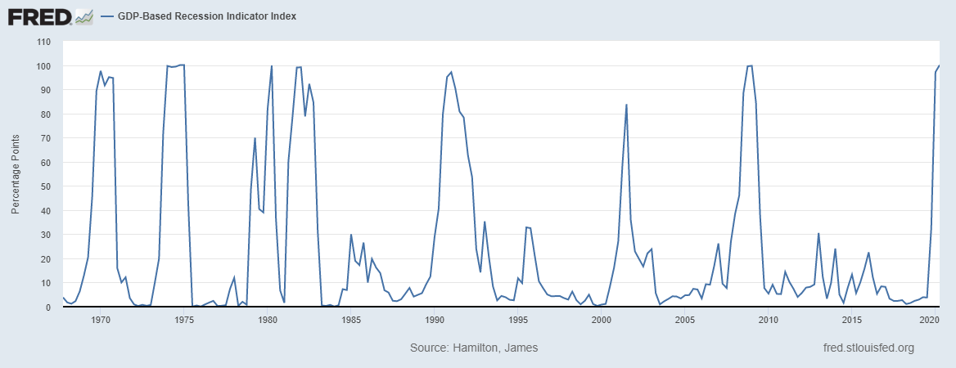

### Real-time Sahm Rule Recession Indicator

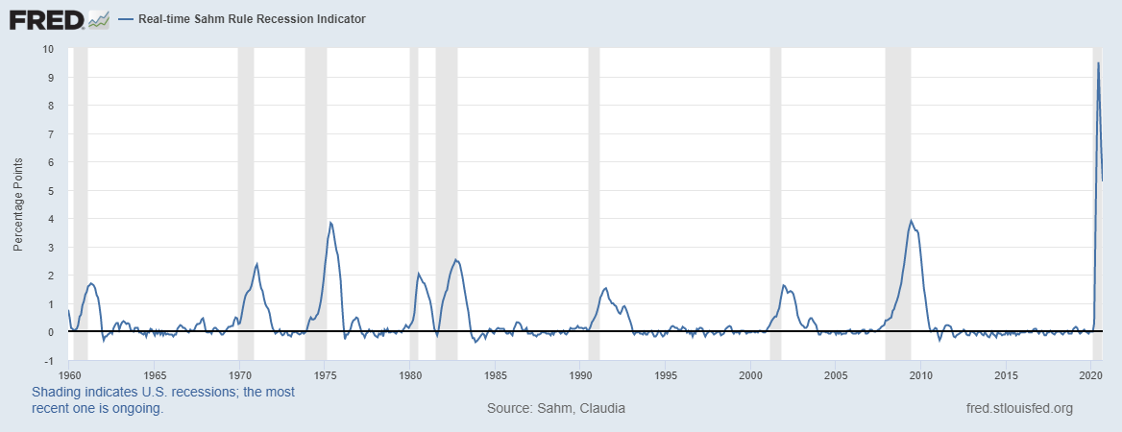Additionally, the Real-time Sahm Rule Recession Indicator[2] signals a recession when the 3-month moving average of the national unemployment rate (U3) rises by at least 0.5 percentage points relative to its low in the previous 12 months. In August 2020, this indicator showed that the three-month average of national U3 was 5.3 percentage points over its 12-month low. This is lower than the previous month, as the unemployment rate has fallen, however it still is a strong confirmation that the economy remains in recession.

## Labor Markets

The data for unemployment rates and labor force are derived from the Local Area Unemployment Statistics (LAUS) program and data for nonfarm payroll jobs are derived from the Current Employment Statistics (CES) program. The numbers presented below are estimates which vary month to month in either direction and are subject to substantial revision. The Maine Department of Labor cautions users to analyze general trends over several months as opposed to making conclusions based on changes month to month.

### Unemployment Rate: September 2020 = 6.1%

The unemployment rate fell in September to 6.1% in Maine, compared to 7.9% nationally. This drop comes along with a drop in overall labor force participation. The Maine Department of Labor cautions that the pandemic’s effect on survey operations has contributed to abnormally large error and labor misclassification, and estimates an alternative unemployment rate of 9.2% in Maine.

### Labor Force Participation Rate: September 2020 = 60.9%

Labor force participation rose in Maine in September, to 60.9%, below the nation’s 61.4 percent.

### Total Nonfarm Payroll Job Estimates: September 2020 = 597,400

Seasonally adjusted total nonfarm employment grew by 4,700 in Maine, by 65,800 in New England and by 661,000 nationwide in September. While private nonfarm jobs increased by 7,900 public sector jobs fell by 3,200 as schools made fewer hires than usual and Census operations ended. Maine’s employment level remains 8.0% below September 2019 levels, while New England and the U.S. fall below September 2019 by 8.3% and 6.4%, respectively.

## Housing

### Sales

Home sales were up 22.8% statewide in September compared to a year ago. Meanwhile, the median sale price of single-family homes in Maine was 19.6% higher than in September 2019, at $273,500. The greatest growth in median sale price occurred in several rural counties such as Washington, Lincoln, and Hancock counties, which all saw increases over 30%.

|  |  |  |  |  |  |
| --- | --- | --- | --- | --- | --- |
| **Geography** | **No. of Units Sold** | **One Year Change (units)** | **Median Sale Price** | **One Year Change (Price)** | **One Month Change (Price)** |
| Androscoggin | 135 | 7.1% | $205,500 | 9.2% | -8.7% |
| Aroostook | 78 | 8.3% | $114,700 | 20.7% | 13.6% |
| Cumberland | 471 | 19.2% | $365,000 | 12.3% | -7.6% |
| Franklin | 71 | 61.4% | $170,000 | 18.3% | -10.5% |
| Hancock | 139 | 51.1% | $289,000 | 37.6% | 15.6% |
| Kennebec | 217 | 4.3% | $209,300 | 21.7% | -4.0% |
| Knox | 108 | 89.5% | $276,000 | 1.1% | -6.6% |
| Lincoln | 99 | 76.8% | $360,000 | 50.9% | 22.3% |
| Oxford | 104 | 4.0% | $222,500 | 28.6% | 10.1% |
| Penobscot | 192 | 0.0% | $173,750 | 17.5% | -1.0% |
| Piscataquis | 48 | 14.3% | $143,500 | 8.3% | -22.4% |
| Sagadahoc | 57 | 26.7% | $283,500 | 9.5% | -4.7% |
| Somerset | 80 | 31.2% | $148,000 | 13.0% | -3.7% |
| Waldo | 67 | 28.9% | $250,000 | 9.4% | -4.6% |
| Washington | 78 | 69.6% | $172,450 | 57.1% | -4.2% |
| York | 347 | 24.8% | $368,000 | 15.2% | 1.3% |
| **Maine** | 2,291 | 22.8% | $273,500 | 19.6% | 1.3% |

### House Price Index

In the second quarter of 2020, the housing price index (HPI) in Maine, New England, and the U.S. continued to rise. According to the Federal Housing Finance Agency (FHFA), the HPI “measures average price changes in repeat sales or refinancing on the same properties.” Maine’s HPI increased by 0.4 percent from the previous quarter (2020:Q1 to 2020:Q2). Maine’s year-over-year HPI growth rate was higher than both the regional growth rate and the national growth rate at 6.5% compared to 4.6% in both New England and the U.S.

|  |  |  |  |  |
| --- | --- | --- | --- | --- |
| **Reference Period** |  | **Maine** | **New England** | **United States** |
| 2020:Q1-2020:Q2 | HPI percent change from previous quarter | 0.4% | 0.4% | 0.8% |

# Sentiment

The Michigan Survey of Consumers indicates that the index of overall consumer sentiment grew slightly in October, 1.0% month-over-month. This index remains 15.0% lower than October of 2019. The National Federation of Independent Business’s Small Business Optimism index also shows an increase in sentiment in September, up 3.8% month-over-month and coming in 2.2% above September 2019. October data are not yet available for the latter index.

# COVID-19 Indicators

## Traffic changes

Vehicle miles traveled (VMT) measures the amount of travel that has taken place for all vehicles throughout the state and can be interpreted as the sum of miles traveled across all vehicles. For the third week of October, statewide VMT was 5.9% lower than it was in the same week of 2019. This is up from the previous week (-8.9% week ending October 17). The VMT gap is largest in Piscataquis County (-12.4%) and Sagadahoc County (-8.0%) and smallest in Franklin (-1.6%) and Aroostook (-3.2%). Oxford County saw VMT levels 0.4% greater than the same week last year.

## Consumer Spending

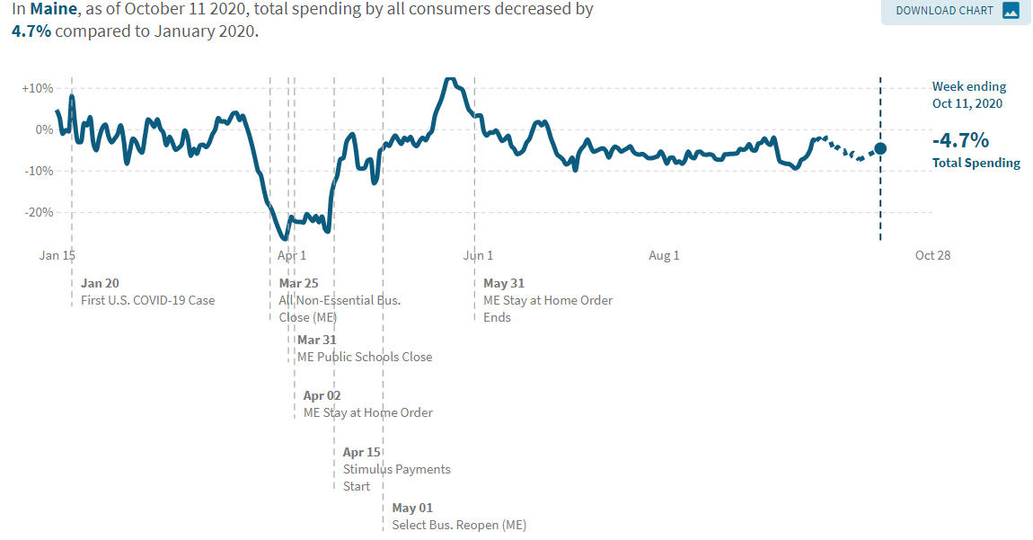Credit and debit transactions data[3] shows that consumer spending by Mainers as of October 11th is 4.7% below the average level of spending in January 2020, seasonally adjusted, compared to -3.7% nationally. Relative recovery in spending is primarily driven by spending on retail and grocery sales, as well as spending from low- and middle-income ZIP codes.

# Trade Outlook

In August 2020, total exports were down 21.9% in Maine and 14.9% nationwide compared to August 2019. Maine’s top trade partner was Canada, which accounted for 67% of imports and 56% of exports. Total imports to Maine were valued at $380,872,132 while exports totaled $241,205,462.

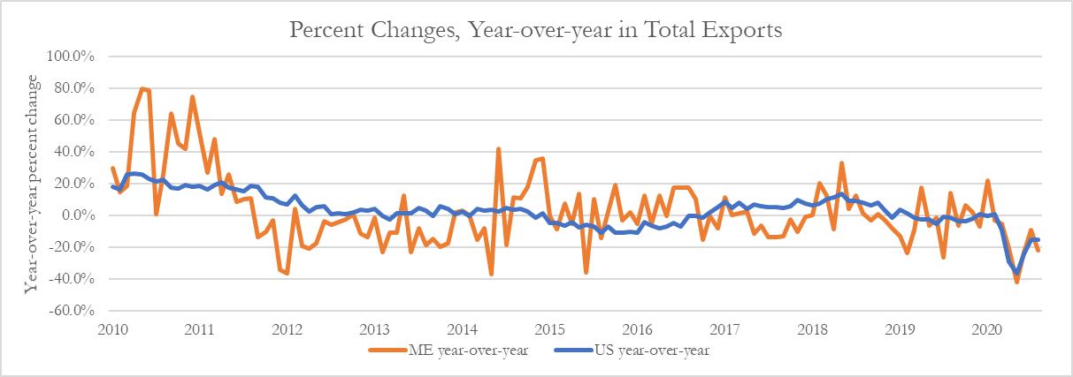

# 

# Appendix

## Data Sources

|  |  |  |  |
| --- | --- | --- | --- |
| **Indicator** | **Source** | **Reference Period** | **Release Date** |
| [Population: estimates and percent change](https://www.census.gov/programs-surveys/popest.html) | Census Bureau – Pop. Ests. | 2019 | December 30, 2019 |
| [Net migration: total and percent change](https://www.census.gov/programs-surveys/popest.html) | Census Bureau – Pop. Ests. | 2019 | December 30, 2019 |
| [Median age](https://www.census.gov/programs-surveys/popest.html) | American Community Survey 1 year | 2019 | September 17, 2020 |
| [Educational attainment](https://www.census.gov/programs-surveys/acs/) | Census Bureau – ACS 1-year | 2019 | September 17, 2020 |
| [Poverty level](https://www.census.gov/programs-surveys/acs/) | Census Bureau – ACS 1-year | 2019 | September 17, 2020 |
| [Income](https://www.census.gov/programs-surveys/acs/) | Census Bureau – ACS 1-year | 2019 | September 17, 2020 |
| [Per capita personal consumption expenditure](https://www.bea.gov/data/economic-accounts/regional) | U.S. Bureau of Economic Analysis | 2019 | October 8, 2020 |
| [Per capita personal income](https://www.bea.gov/data/economic-accounts/regional) | U.S. Bureau of Economic Analysis | 2020:Q2 | September 24, 2020 |
| [Average earnings per job](https://www.bea.gov/data/economic-accounts/regional) | U.S. Bureau of Economic Analysis | 2019 | September 24, 2020 |
| [CEFC Forecasts](https://www.maine.gov/dafs/economist/economic-forecasting) | Consensus Economic Forecasting Commission | 2020-2025 | November 1, 2020 |
| [Gross domestic product](https://www.bea.gov/data/economic-accounts/regional) | U.S. Bureau of Economic Analysis | 2020:Q2 | October 2, 2020 |
| [GDPNow](https://www.frbatlanta.org/cqer/research/gdpnow.aspx) | Atlanta Fed | 2020:Q3 | August 26, 2020 |
| [GDP-Based Recession Indicator Index](https://fred.stlouisfed.org/series/JHGDPBRINDX) | Hamilton, James/FRED | 2020:Q2 | October 30, 2020 |
| [Real-time Sahm Rule Recession Indicator](https://fred.stlouisfed.org/series/SAHMREALTIME) | Sahm, Claudia/FRED | September 2020 | October 2, 2020 |
| [Personal income: total, per capita, and wages and salaries](https://www.bea.gov/data/economic-accounts/regional) | U.S. Bureau of Economic Analysis | 2020:Q2 | September 24, 2020 |
| [Unemployment rate](https://www.bls.gov/data/#unemployment) | U.S. Bureau of Labor Statistics | September 2020 | October 20, 2020 |
| [Labor force participation](https://www.bls.gov/data/#unemployment) | U.S. Bureau of Labor Statistics | September 2020 | October 20, 2020 |
| [Nonfarm payroll job estimates](https://www.bls.gov/data/#employment) | U.S. Bureau of Labor Statistics | September 2020 | October 20, 2020 |
| [Housing price index](https://www.fhfa.gov/DataTools/Downloads/Pages/House-Price-Index.aspx) | Federal Housing Finance Agency | 2020:Q1 | August 25, 2020 |
| [Housing: Units and Median Sale Price](https://www.mainerealtors.com/page/975-891/press-releases) | Maine Association of REALTORS® | September 2020 | October 22, 2020 |
| [Index of Consumer Sentiment](http://www.sca.isr.umich.edu/) | Michigan Survey of Consumers | October 2020 | October 2020 |
| [Small Business Optimism Index](https://www.nfib.com/surveys/small-business-economic-trends/) | National Federation of Independent Businesses | September 2020 | October 2020 |
| Vehicle Miles Traveled | Maine Department of Transportation | October 24, 2020 | October 27, 2020 |
| [Consumer Spending](https://tracktherecovery.org/) | Affinity Solutions & Opportunity Insights | October 11, 2020 | October 2020 |
| [Imports & Exports](https://usatrade.census.gov/) | USA Trade Online | August 2020 | September 6, 2020 |
|  |  |  |  |

## Glossary

[Average earnings per job:](https://apps.bea.gov/regional/definitions/?regexp=&key=371) Total earnings, which is the sum of wages and salaries, supplements to wages and salaries, and proprietors’ income, divided by total full-time and part-time employment.

**Compound Annual Growth Rate:**

[Gross Domestic Product**:**](https://apps.bea.gov/regional/definitions/?regexp=&key=371)The measure of the market value of all final goods and services produced within a state in a particular period of time. GDP by state differs from national GDP for the following reasons: GDP by state excludes and national GDP includes the compensation of federal civilian and military personnel stationed abroad and government consumption of fixed capital for military structures located abroad and for military equipment, except office equipment. ***Real GDP****:* Real GDP by state is an inflation-adjusted measure of each state's gross product that is based on national prices for the goods and services produced within the state. The real estimates of gross domestic product (GDP) by state are measured in chained (2012) dollars.

[Housing Price Index](https://www.fhfa.gov/DataTools/Downloads/Pages/House-Price-Index.aspx)**:** A weighted, repeat-sales index, meaning that it measures average price changes in repeat sales or refinancing on the same properties.

[Labor Force Participation Rate](https://www.bls.gov/bls/glossary.htm)**:** The labor force as a percent of the civilian noninstitutional population ages 16 years and older.

[Net Migration Rate](https://www.census.gov/glossary/#term_Netmigrationrate)**:** The U.S. [Census Bureau](https://www.census.gov/glossary/#term_Netmigrationrate) defines the net migration rate as **t**he difference between the number of migrants entering and those leaving an area in a year, per 1,000 midyear population. May also be expressed in percent. A positive figure is known as a net immigration rate and a negative figure as a net emigration rate.

[Personal Consumption Expenditures by State](https://apps.bea.gov/regional/definitions/?regexp=&key=371)**:** A measure of spending on goods and services purchased by, and on behalf of, households based on households' state of residence divided by the resident population of the area.

[Personal Income](https://apps.bea.gov/regional/definitions/?regexp=&key=371)**:** Income that persons residing in the area receive in return for their provision of labor, land, and capital used in current production as well as other income, such as personal current transfer receipts. *Per capita personal income:* The personal income of a given area divided by the resident population of the area. *Per capita disposable personal income:* The income available to persons for spending or saving (personal income less personal current taxes) of a given area divided by the resident population of the area.

[Poverty Level](https://www.census.gov/topics/income-poverty/poverty/guidance/poverty-measures.html)**:** The U.S. [Census Bureau](https://www.census.gov/topics/income-poverty/poverty/guidance/poverty-measures.html) uses a set of money income thresholds that vary by family size and composition to determine who is in poverty. If a family's total income is less than the family's threshold, then that family and every individual in it is considered in poverty.

[Real Trade Weighted Value of the Dollar](https://www.dallasfed.org/research/econdata/rtwvd.aspx)**:** An index that calculates the inflation-adjusted value of the U.S. dollar against the currencies of countries with which the state trades.

[Total merchandise exports**:**](https://www.census.gov/glossary/#term_ExportsTotal) Total exports are calculated by adding domestic exports (goods that are grown, produced, or manufactured in the United States) to foreign exports (foreign-origin goods that have previously entered the United States, Puerto Rico, or the U.S. Virgin Islands for consumption, entry into a CBP bonded warehouse, or a U.S. [Foreign Trade Zone (FTZ)](https://www.census.gov/glossary/#term_ForeignTradeZoneFTZ), and at the time of exportation, have undergone no change in form or condition or enhancement in value by further manufacturing).

[Total Private nonfarm employment](https://www.maine.gov/labor/cwri/aboutCES.html)**:** Each month Current Employment Statistics (CES) surveys a sample of about 2,700 nonfarm private employers (plus federal, state, and local government employers) in Maine asking them to report the number of jobs, hours, and earnings of workers on their payroll during the week including the 12th day of each month. The sample accounts for just 7% of employers, but 34% of nonfarm jobs in the state because a high share of large employers are surveyed.

[Unemployment Rate](https://www.bls.gov/bls/glossary.htm)**:** Number of unemployed as a percent of the labor force. To be classified as unemployed, persons must be aged 16 years and older with no employment during the reference week, were available for work, except for temporary illness, and had made specific efforts to find employment sometime during the 4-week period ending with the reference week.

[Wages and Salaries](https://apps.bea.gov/regional/definitions/?regexp=&key=371)**:** Remuneration receivable by employees (including corporate officers) from employers for the provision of labor services, measured before deductions such as social security contributions, union dues, and voluntary employee contributions to defined contribution pension plans.

1. Created by Dr. James Hamilton, University of California San Diego
2. Created by Dr. Claudia Sahm, Federal Reserve Board of Governors
3. The Opportunity Insights Economic Tracker compiles credit and debit card spending to measure overall consumer spending in all states in the U.S. Note that this data collates spending by cardholders based in Maine, not by location of the transaction.