STATE OF MAINE
Department of Environmental Protection
Division of Environmental Assessment, Invasive Aquatic Species Program

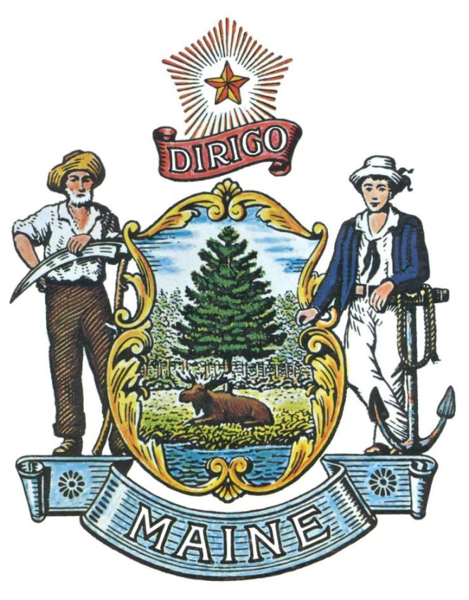

RFA# 202311232

Invasive Aquatic Plant Removal Cost Share Application

RFA Coordinator | All communication regarding the RFA must be made through the RFA Coordinator identified below.  Name: Denise Blanchette Title: Biologist II  Contact Information: denise.l.blanchette@maine.gov
Submitted Questions Due | All questions must be received by the RFA Coordinator identified above by:  Date: January 19, 2024, no later than 11:59 p.m., local time
Application  Submission Deadline | Applications must be received by the Division of Procurement Services by:  Submission Deadline: All applications (1-year applications and 2-year applications) are due on February 2, 2024, no later than 11:59 p.m., local time.  Proposals must be submitted electronically to: Proposals@maine.gov

RFA TERMS/ACRONYMS with DEFINITIONS

The following terms and acronyms, as referenced in the RFA, shall have the meanings indicated below:

Term/Acronym | Definition
Department/DEP | Department of Environmental Protection
RFA | Request for Application
State | State of Maine
IASP | Invasive Aquatic Species Program
CBI | Courtesy Boat Inspection
DASH | Diver Assisted Suction Harvesting
OSHA | Occupational Safety and Health Administration

Overview of the Grant Opportunity

Purpose and Background

The Department of Environmental Protection (Department/DEP) is seeking proposals to plan and manage the removal of known invasive aquatic plant infestations as defined in this Request for Applications (RFA) document. This document provides instructions for submitting proposals, the procedure and criteria by which the Provider(s) will be selected, and the contractual terms which will govern the relationship between the State of Maine (State) and the awarded Bidder(s). The Department awards Cost Share Grants to eligible organizations that conduct invasive aquatic plant control projects.

Grants will be awarded following DEP Invasive Aquatic Species Program’s priorities (Part I of the application):
- First-priority projects address incipient invasive plant infestations with potential for eradication or established infestations that present a high risk of spread in otherwise un-infested areas of the state, and take a regional or watershed approach to management.
- Second-priority projects aim to reduce spread of invasive aquatic plants within and between waterbodies, i.e., invasive plant removal near boat access points and in areas with high boat traffic. DEP uses boat inspection and vulnerability index data to assess risk of spread from specific waterbodies.
- Third-priority projects support annual removal to diminish extent of established infestations.
Please note: OSHA commercial dive standards apply to operations that compensate SCUBA and/or Surface Supplied Air divers for plant control work (link: OSHA Standards for Commercial Diving Operations).

Objectives for controlling these infestations include reducing the likelihood of spread to other waters, limiting the impact on natural habitat and human use of the water body, and maintaining property values. This grant opportunity is intended to support local removal programs that achieve local and statewide objectives of improving aquatic habitat impacted by invasive aquatic plants.

General Provisions

- From the time this RFA is issued until award notification is made, all contact with the State regarding this RFA must be made through the RFA Coordinator identified on the cover page of this RFA. No other person/State employee is empowered to make binding statements regarding this RFA. Violation of this provision may lead to disqualification from the application process, at the State’s discretion.
- Issuance of the RFA does not commit the Department to issue an award or to pay expenses incurred by an Applicant in the preparation of a response to the RFA. This includes attendance at personal interviews or other meetings, where applicable.
- All applications must adhere to the instructions and format requirements outlined in the RFA and all written supplements and amendments (such as the Summary of Questions and Answers), issued by the Department. Applications are to follow the format and respond to all questions and instructions specified in the “Submission Instructions” section of the RFA’s application.
- The Applicant shall take careful note that in evaluating its application submitted in response to this RFA the Department will consider materials provided in the application and internal Departmental information of previous contract history, if any, with the Applicant. The Department also reserves the right to consider other reliable references and publicly available information in evaluating the Applicant’s experience and capabilities.
- Following announcement of an award decision, all submissions in response to this RFA will be public records, available for public inspection pursuant to the State of Maine Freedom of Access Act (FOAA) (1 M.R.S. § 401 et seq.).
- The Department, at its sole discretion, reserves the right to recognize and waive minor informalities and irregularities found in applications received in response to the RFA.
- All applicable laws, whether or not herein contained, shall be included by this reference. It shall be the Applicant’s responsibility to determine the applicability and requirements of any such laws and to abide by them.

Eligibility to Submit Applications

Eligible organizations include municipal and county governments, quasi-municipal organizations (including water districts) and 501(c)(3)-eligible organizations.

This grant is for invasive aquatic plant control projects on infested lakes. Grant funds may be used only for the following:
- Manual control techniques such as placement of benthic barriers, plant removal by hand, and plant removal by hand with suction dredge (i.e., Diver Assisted Suction Harvest or DASH).
- Chemical plant control only if DEP has endorsed use of herbicides and according to DEP’s February 27, 2020 document regarding chemical control of established infestations. 2020 Document on Herbicides
- Plant surveys directly related to removal efforts, i.e., surveying infested areas prior to and/or after removal if needed to focus removal efforts or monitor efficacy of removal.
- Surface support directly related to the removal operation. The application must show how these expenses are integral to the removal operation.
- Other expenses directly related to invasive aquatic plant removal.

Awards

The Department anticipates making multiple awards as a result of this RFA process.
Applicants proposing invasive aquatic plant removal on multiple waterbodies should submit a single application containing all proposed waterbodies. The Department keeps a list of documented invasive aquatic plant infestations and encourages partnerships between watershed entities when addressing infestations in the same proposed waterbodies.
Applicants may apply for one or two years of performance.

- Appeal of Contract Awards

Any person aggrieved by the award decision that results from this Request for Applications may appeal the decision to the Director of the Bureau of General Services in the manner prescribed in 5 MRSA § 1825-E and 18-554 Code of Maine Rules, Chapter 120 (found here: Chapter 120). The appeal must be in writing and filed with the Director of the Bureau of General Services, 9 State House Station, Augusta, Maine, 04333-0009 within 15 calendar days of receipt of notification of contract award.

- Statute
Chapter 3 and Chapter 20-A in Maine Revised Statutes Title 38 charge the Department with developing programs to reduce the spread of and control invasive aquatic plants (https://legislature.maine.gov/legis/statutes/38/title38ch3sec0.html; https://legislature.maine.gov/legis/statutes/38/title38ch20-Asec0.html). Lake organizations removing infestations of invasive aquatic plants are contributing significant financial, volunteer, and in-kind resources to reduce the impact of the infestation. Revenue for preventing and managing invasive aquatic species in Maine is generated from an annual fee on motorized watercraft and seaplanes using inland waters. A statutory change in 2014 requires that the Department Commissioner use at least 20% of the Department’s dedicated Invasive Aquatic Plant and Nuisance Species Fund for eradication activities.

Activities and Requirements

- Project Purpose and Scope
The project purpose must provide a description of the overall work that will be done, including the following:
- the lake’s characteristics including physical attributes, beneficial use areas, aquatic habitat, swimming areas, boat access sites, and boating use areas.
- the invasive species targeted, its extent and how it threatens public access, recreational uses, or ecological integrity of the water body.
- Previous control strategies and actions and efficacy of those efforts.
- Proposed control strategies for this grant cycle. The control activities outlined should utilize proven and effective methods, indicate the likelihood of success, and include a plan for monitoring effectiveness of removal efforts.
Reviewers will consider the feasibility of project success, the potential for achieving long-term reduction of the infestation, and the clarity in explanation of grant expenditures. As much detail as possible must be included when describing the project. The Department prefers projects that provide multi-year planning and demonstrate how each year builds off the progress of previous work.
- Goals
The application must clearly and realistically state the ultimate goal(s) of the proposed project and include goals for spread prevention, early detection, and management.

- Objectives
The application must state primary activities to achieve goals for invasive plant spread prevention and early detection management and control. Please be specific in describing the location of the work, the people and resources needed and the time frame to complete the objectives.

- Monitoring
Annual plant surveys are essential to monitoring progress of a project. The application must describe the planned pre- and post-removal monitoring to assess effectiveness of management.

Applicants applying for the first time must have completed at least a Level 2 plant survey (boat ramps, areas of concentrated boat traffic and shallow, sheltered coves) per the Lake Stewards of Maine (LSM) Invasive Aquatic Plant Screening Survey Procedures and include a map in the application.

Returning applicants must provide a map of infested areas planned for management using Survey 123 or other Geographic Information System showing infested areas from the most recent survey. Grant funds support only plant surveys to direct plant removal during the removal activity.

- Local Resources
- Training and Experience
Applications should demonstrate trained and experienced staff and volunteers involved with the project. The application must explain whether specific elements of the program are locally developed and maintained or contracted to another entity. This description must be specific and detailed in describing the program. Important details include items such as number of boats and crew, contingency plans for equipment failure, the length of time the program has operated, tenure of current staff, and manager or contractor on the project.

The grant review team may consider the Applicant’s performance under past cost share grants and the organization’s experience in managing other projects and grants, if applicable, when reviewing the application. Applicants lacking experience with aquatic plant management should describe their capacity to manage the project, including examples managing other grants or projects.
- Cost and Match
Applicants must bring their own resources to the project in the form of cash and in-kind support (volunteer services or donations of goods and services). A minimum 20% cash match is required for each grant application proposal. Higher grant scores are given to applicants providing greater than the minimum match. The Department prefers projects that maximize local match and demonstrate strong community support and the ability to annually sustain invasive aquatic species prevention and control. If this is an established infestation requiring recurring management, the application must describe how the project will be sustained. This section of the application must detail all aspects of local support and funding that is included in the budget (Tables 1, 2, and 3 of the Application). Support letters are encouraged but not required.

Key Process Events

Submission of Questions

It is the responsibility of all Applicants and other interested parties to examine the entire RFA and to seek clarification, in writing, if they do not understand any information or instructions.

Applicants and other interested parties should use Appendix B (Submitted Questions Form) for submission of questions. Any questions must be submitted by e-mail and received by the RFA Coordinator identified on the cover page of this RFA, as soon as possible but no later than the date and time specified on the RFA cover page. Submitted Questions emails must include the subject line: “RFA# 202311232 Questions”. The Department assumes no liability for assuring accurate/complete/on time e-mail transmission and receipt.

Question & Answer Summary: Responses to all questions will be compiled in writing and posted on the State’s Division of Procurement Services Grant RFPs and RFAs website. It is the responsibility of all interested parties to go to this website to obtain a copy of the Question & Answer Summary. Only those answers issued in writing on this website will be considered binding.

Amendments

All amendments released in regard to this RFA will be posted on the Division of Procurement Services Grant RFPs and RFAs website. It is the responsibility of all interested parties to go to this website to obtain amendments. Only those amendments posted on this website are considered binding.

Application Submission

  - Applications Due: Applications must be received no later than 11:59 p.m. local time, on the date listed on the cover page of the RFA.
    - Any e-mails containing original application submissions or any additional or revised application files, received after the 11:59 p.m. deadline, will be rejected without exception.

- Submission Instructions: Applications are to be submitted electronically to the State’s Division of Procurement services at proposals@maine.gov.
  - Only applications received by e-mail will be considered. The Department assumes no liability for assuring accurate/complete e-mail transmission and receipt.
          - Application submission e-mails that are successfully received by the proposals@maine.gov inbox will receive an automatic reply stating as such.
  - E-mails containing links to file sharing sites or online file repositories will not be accepted as submissions. Only e-mail applications that have the requested files attached will be accepted.
  - Encrypted e-mails received which require opening attachments and logging into a proprietary system will not be accepted as submissions. It is the Applicant’s responsibility to check with its organization’s information technology team to ensure that security settings will not encrypt its application submission.
  - File size limits are 25MB per e-mail. Applicants may submit files across multiple e-mails, as necessary, due to file size concerns. All e-mails and files must be received by the due date and time listed above.
  - Applicants are to insert the following into the subject line of their e-mail submission: “RFA# 202311232 Application Submission – [Applicant’s Name]”.
  - Applications are to be submitted as a single, typed, PDF file, and must include all related documents identified on Appendix A (Application Form). Applicants are not to provide additional attachments beyond those specified in the RFA for the purpose of extending their response. Materials not requested will not be considered part of the application and will not be evaluated.

Application Evaluation and Selection

- Scoring Weights: The score will be based on a 100-point scale and will measure the degree to which each application meets the following criteria. Only complete applications will be reviewed and considered for award.

Scoring Criteria | Points Available
Eligibility | Pass/Fail
Project Purpose and Scope | 30 points
Goals | 10 points
Objectives  - Assessment and Prioritization of Infested Areas  - Strategy and Timeline | 20 points
Monitoring | 15 points
Local Resources  - Training/Experiences (15 points)  - Cost and Match (10 points) | 25 points
Total Points | 100 points

- Scoring Process: The Application Review Team will use a consensus approach to evaluate and score all sections listed above. Members of the review team will not score those sections individually but, instead, will arrive at a consensus as to assignment of points for each of those sections.

Failure to respond to all questions and instructions throughout the RFA may result in the application being disqualified as non-responsive or receiving a reduced score. The Department, and its evaluation team, has sole discretion to determine whether a variance from the RFA specifications will result either in disqualification or reduction in scoring of a proposal.

- Selection and Award: Notification of selection or non-selection will be made in writing by the Department. Issuance of this RFA in no way constitutes a commitment by the State to award a contract, to pay costs incurred in the preparation of a response to the RFA, or to pay costs incurred in procuring or contracting for services, supplies, physical space, personnel, or any other costs incurred by the Applicant.

The Department will determine awards based on final score and available funds. Higher scores will receive higher level of funding. If the total initial awards exceed available funding after scoring, the Department may decrease final awards based on the level of funding requested and available funds.

Applicants awarded through this RFA process will be required to submit, prior to the contract execution, a valid certificate of insurance on a standard ACORD form (or the equivalent) evidencing the awarded Applicant’s general liability, professional liability and any other relevant liability insurance policies that might be associated with the services provided as a result of this RFA.

APPENDIX A

RFA# 202311232
Invasive Aquatic Plant Removal Cost Share Application

APPLICATION FORM

The application may be obtained in a Word (.docx) format by double clicking on the document icon below.

APPENDIX B

RFA# 202311232
Invasive Aquatic Plant Removal Cost Share Application

SUBMITTED QUESTIONS FORM

This form should be used by Applicants when submitting written questions to the RFA Coordinator.

If a question is not related to any section of the RFA, enter “N/A” under the RFA Section & Page Number. Add additional rows as necessary. Submit this document in WORD format, not PDF.

Organization Name:

RFP Section & Page Number | Question

