STATE OF MAINE
Department of the Secretary of State
Bureau of Motor Vehicles
Information Services

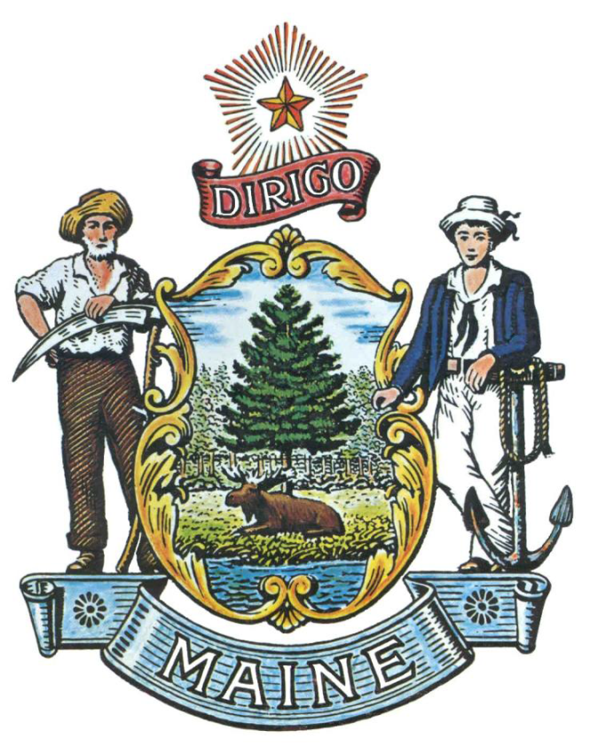

REQUEST FOR INFORMATION

RFI# 202001007

Driver License Examination Knowledge & Road/Skills Testing System

RFI Coordinator | All communication regarding this RFI must be made through the RFI Coordinator identified below.  Name: Marie Packard: Office Specialist II  Contact Information: Marie.Packard@maine.gov
Submitted Questions Due | All questions must be submitted to the RFI Coordinator identified above by:  Date: January 30, 2020, no later than 5:00 p.m., local time
Response Submission | Submission Deadline: February 14, 2020, no later than 5:00 p.m., local time  Submit to: Marie Packard@maine.gov

TABLE OF CONTENTS

PUBLIC NOTICE 3

RFI DEFINITIONS/ACRONYMS 4

PART I INTRODUCTION

- PURPOSE AND BACKGROUND 5
- CURRENT CONDITIONS 5
- CHALLENGE STATEMENT 6
- GENERAL PROVISIONS 6

PART II INFORMATION SOUGHT

- GENERAL INFORMATION 7
- FEEDBACK REQUESTED 8

PART III KEY RFI EVENTS AND PROCESSES

- QUESTIONS 9
- SUBMITTING THE RESPONSE 9

PART IV REVIEW OF RESPONSES RECEIVED 10

RFI APPENDICES AND RELATED DOCUMENTS

RESPONSE COVER PAGE 11
SUBMITTED QUESTIONS FORM 12

PUBLIC NOTICE

*************************************************

State of Maine
Department of the Secretary of State,
Bureau of Motor Vehicles, Information Services
RFI# 202001007
Driver License Examination Knowledge & Road/Skills Testing System

The State of Maine, Department of Secretary of State, Bureau of Motor Vehicles, Information Services, is seeking information regarding Driver License Examination Knowledge & Road/Skills Testing Systems.

A copy of the RFI, as well as the Question & Answer Summary and all other related documents to this RFI, can be obtained at the following website: http://www.maine.gov/dafs/bbm/procurementservices/vendors/rfis

Responses must be submitted to: Marie.Packard@maine.gov and be submitted by 5:00 pm, local time, on February 14, 2020.

*************************************************
RFI DEFINITIONS/ACRONYMS

The following terms and acronyms shall have the meaning indicated below as referenced in this Request for Information:

Term/Acronym | Definition
RFI | Request for Information
RFP | Request for Proposal
State | State of Maine
Department | Department of Secretary of State, Bureau of Motor Vehicles, Information Services
FOAA | Maine Freedom of Access Act
Respondent | Any individual or organization submitting a response to this RFI.
BMV | Bureau of Motor Vehicles
IS | Secretary of State, Information Services

State of Maine - Department of Secretary of State,
Bureau of Motor Vehicles, Information Services
RFI# 202001007
Driver License Examination Knowledge & Road/Skills Testing System

PART I INTRODUCTION

A. Purpose and Background

This Request for Information (RFI) is an information gathering and market research tool, not a formal solicitation of a specific requirement (such as in a “Request for Proposals” document). The Secretary of State, Bureau of Motor Vehicles, Information Services (“Department”) is seeking information regarding Driver License Examination Knowledge & Road/Skills Testing System from interested parties as defined in this RFI document. This is an opportunity for interested parties to help the Department better understand a marketplace and/or specific subject matter.

The Bureau of Motor Vehicles (BMV) is seeking market place options for Driver License Examination Knowledge & Road/Skills Testing Systems for use at BMV offices and other locations throughout the state. The system would consist of testing stations at which driver license applicants would be able to take tests of their knowledge of motor vehicle laws and safe operation. Acceptable testing systems will include commercial, non-commercial and motorcycle driver licenses. The road/skill test, including the GPS route of the road/skill test, will be recorded and scored on portable devices used by the BMV examiners. Data from the applicant knowledge testing as well as the road/skills testing will be made part of the record of the applicant and stored in Maine BMV Driver License System.

B. Current Conditions

Key functionality of the current testing applications includes:
- Electronic Knowledge Testing which includes foreign language, large print, voice-over and hard copy options
- Image capture functionality for Knowledge Testing
- Utilizes web services to capture information from the Knowledge and Road Skill testing applications and transmit data to the BMV database
- Wireless connectivity to download and upload road/skill tests, scoring, location of errors and GPS coordinates of the testing route
- Realtime reporting for all phases of Knowledge and Road Skill testing
- Integrated Mobile/Portable hardware for Road testing
- Secure VPN connection between hardware and application server

C. Challenge Statement

The RFI is intended to explore an overarching question: What options are available in the marketplace for Driver License Examination Knowledge & Road/Skills Testing Systems which will support the functionality required by the Department of the Secretary of State, Bureau of Motor Vehicles and in conjunction with Information Services?

D. General Provisions

- All contact with the State regarding this RFI must be made through the aforementioned RFI Coordinator. No other person/ State employee is empowered to make binding statements regarding this RFI.
- This is a non-binding Request for Information. Therefore, no award shall be made as a result of the RFI process.
- Issuance of this RFI does not commit the Department to pay any expenses incurred by a Respondent in the preparation of their response to this RFI. This includes attendance at personal interviews or other meetings and software or system demonstrations, where applicable.
- Issuance of this RFI in no way constitutes a commitment by the State of Maine to issue a Request for Proposal (RFP).
- All responses should adhere to the instructions and format requests outlined in this RFI and all written supplements and amendments, such as the Summary of Questions and Answers, issued by the Department.
- All submissions in response to this RFI will be considered public records available for public inspection pursuant to the State of Maine Freedom of Access Act (FOAA) (1 M.R.S. §§ 401 et seq.): State of Maine Freedom of Access Act
- All applicable laws, whether or not herein contained, shall be included by this reference. It shall be Proposer’s/Vendor’s responsibility to determine the applicability and requirements of any such laws and to abide by them.

PART II INFORMATION SOUGHT

The Department seeks information regarding Driver License Examination Knowledge & Road/Skills Testing System and welcomes responses to this RFI, including creative suggestions and feedback to enhance and expedite all future processes while providing efficient, reliable and high-quality outcomes. Respondents are not required to submit responses pertaining to every question, but the Department encourages interested parties to respond to any or all relevant aspects of the RFI.

The Department seeks detailed yet succinct responses that demonstrate the Respondent’s experience and/or familiarity with the subject matter. As this is not a competitive RFP process, Respondents must not provide any specific cost or customized pricing documentation in their response.

- General Information

Provide a brief overview of yourself and your organization, if applicable.

  - Please identify yourself and any organization you represent in this RFI.
    - Name of respondent
    - Organization and affiliation
    - Address (organizational, if responding on behalf of an entity)
    - Contact information (phone number(s) and email address)

  - Please identify your experiences in providing Driver License Examination Knowledge & Road/Skills Testing System

- Feedback Requested

Topics for Responders to Discuss:

- It is a requirement that the Driver License Examination Knowledge & Road/Skills Testing System be hosted On-Prem (i.e. locally in the IS data center hosted in Augusta, Maine). Discuss how this requirement will be met.
- It is a requirement that the Department retain ownership of all data and that all data be stored in the IS data center located in Augusta, Maine. Discuss how this requirement will be met.
- Procedures for the transfer of all data captured for Knowledge and Road/Skill Testing to the BMV database.
- The State of Maine does not follow the National model for Commercial Driver License Skill Testing. Discuss how Maine’s unique needs for items such as forms and scoring would be met.
- Foreign Language options
- Options for American Sign Language, large print and voice-over
- Maintaining and updating the Knowledge Skills question bank, including foreign languages and images, to meet the Federal and Maine BMV requirements.
- Options to send messages (examiner to examiner) within Knowledge and Road/Skill testing software
- Maintaining and managing standard Road/Skill routes for any given location
- Continuation of Knowledge and Road/Skill Testing when interruptions (loss of power, loss of internet, emergencies etc.) occur during testing
- Real-Time reporting capabilities including statistics and ad-hoc reporting
- Security of data in flight and at rest
- Storage requirements for housing software and data
- Hardware options/requirements associated with Knowledge and Road/Skill Testing systems.
- Mobile options for Knowledge and Road/Skill Testing. Include hardware such as laptops, tablets, toughpads, etc. as well as secure connectivity in your discussion.

PART III KEY RFI EVENTS AND PROCESSES

Questions

1. General Instructions
- It is the responsibility of each interested party to examine the entire RFI and to seek clarification, in writing, if they do not understand any information or instructions.
- Interested parties should use Appendix B – Submitted Questions Form – for submission of questions.
- The Submitted Questions Form must be submitted by e-mail and received by the RFI Coordinator, identified on the cover page of this RFI, as soon as possible but no later than the date and time specified on the RFI cover page.
- Submitted Questions must include the RFI Number and Title in the subject line of the e-mail. The Department assumes no liability for assuring accurate/complete/on time e-mail transmission and receipt.

2. Question & Answer Summary
Responses to all questions will be compiled in writing and posted on the following website: http://www.maine.gov/dafs/bbm/procurementservices/vendors/rfis. It is the responsibility of all interested parties to go to this website to obtain a copy of the Question & Answer Summary. Only those answers issued in writing on this website will be considered binding.

Submitting the Response

- Responses Due
Responses must be received no later than the date and time listed on the cover page of this RFI document.

- Delivery Instructions
Responses must be submitted to the RFI Coordinator, via e-mail, listed on the cover page of this RFI document.

- Response Format
Responses to this RFI may be developed in a manner that suits the respondent. A list of key questions is included within the RFI and all submissions, regardless of format will be reviewed. Respondents are asked to be brief and to respond to as many questions as possible within the RFI. Number each response to correspond to the relevant question or instruction of the RFI to allow comparison and clarity.

PART IV REVIEW OF RESPONSES RECEIVED

General Information

- The Department will review responses received for the purpose of gathering information and market research only. The Department will not score or rate responses received.

- The Department reserves the right to communicate and/or schedule interviews/presentations with Respondents, if needed, to obtain clarification of information contained in the responses received and/or additional information to enhance marketing research efforts.

APPENDIX A

STATE OF MAINE
Department of Secretary of State,
Bureau of Motor Vehicles, Information Services

RESPONSE COVER PAGE
RFI# 202001007
Driver License Examination Knowledge & Road/Skills Testing System

Lead Point of Contact - Name/Title:
Organization Name (if applicable):
Tel: |  |  | Fax:
E-Mail: |  |  | Website:
Street Address:
City/State/Zip:

APPENDIX B

State of Maine
Department of Secretary of State,
Bureau of Motor Vehicles, Information Services

SUBMITTED QUESTIONS FORM
RFI# 202001007
Driver License Examination Knowledge & Road/Skills Testing System

Organization/Responder’s Name:

RFI Section & Page Number | Question

* If a question is not related to any section of the RFI, state “N/A” under “RFI Section & Page Number”.
** Add additional rows, if necessary.

