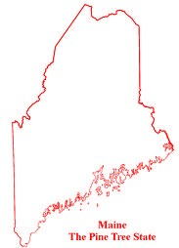It’s not your call
It’s Maine Law!

The legal age to purchase alcoholic beverages is
21

Providing alcohol to minors (under 21) is
ILLEGAL
Fines up to $2,000 and/or possible jail time and you may be
charged with a felony if a death or injury results.

Bureau of Alcoholic Beverages & Lottery Operations

The Department of Public Safety Liquor Licensing & Compliance Division
For more information about underage drinking prevention,
call the Office of Substance Abuse, Information & Resource Center 1-800-499-0027
www.maineosa.org
Division of Liquor Licensing and Enforcement 8 State House Station
Augusta, ME 04333-0008 Email: MaineLiquor@Maine.gov
Telephone: (207) 624-7220

