United States
Department of
Agriculture

Animal and Plant
Health Inspection
Service

Veterinary Services

Area Office New England

P.O. Box 787
160 Worcester-Providence Road, Suite 20
Sutton, MA 01590

508-363-2290

Toll Free:
866-873-2824

FAX 508-363-2272

When Do Animals Need ID?
Dear Sheep/Goat Producer:

By this time, you have received or shortly will receive your order of sheep and goat official ID tags; a mandatory identification requirement per the scrapie eradication program.

We hope these instructions will help to answer any questions you may have on re-ordering, tag use, and recordkeeping.

Order Free ID Tags through your USDA, APHIS, VS office in Sutton, MA:
--MAIL the order to the office
--FAX the order to: 508-363-2272
--PHONE the order to: 508-363-2290, or toll-free at 866-873-2824
Information required for your re-order:
--Name / Address / Phone
--Assigned Flock ID Number (example: MEX1234)
--Quantity

Orders may have a three-four week turn around so please plan accordingly.
(If you experience problems with the tagging pliers/applicator, please contact the tag company directly.)

Which Animals Require Tags?

Tags are assigned specifically to your flock, for your use only. NEVER give away or use your tags on any other animals. If a friend or neighbor needs ID tags, please refer them to this office. Sheep/goat ID tags are meant only for use in sheep and goats. Please refer to the backside of this letter, When Do Animals Need ID?, for additional information.

What Records Are Required?

Due to the nature of scrapie (the fatal brain-wasting disease of sheep and goats) and the long duration of the disease, records are required to be kept for a minimum of five (5) years. Recordkeeping can be simple or elaborate dependent upon your farm practices, but must include the following information (sample record sheet enclosed):

--Animal ID/tag number
--Sex
-- Acquisition/Disposition details: date acquired/sold/removed from flock; name and address of individual/facility

We thank you for working with us to make the scrapie eradication project a success.

*** Sheep/Goats of all ages headed to Auction Markets need Official ID Tags! ***

Animals headed to Slaughter House
Type Of Animal | Destination | ID Needed
Adult Sheep | Slaughter | Official identification required**
Adult Goat | Slaughter | Official identification required**
Lamb, under 18 months age | Slaughter | Not required but recommended
Kid goats, under 18 months age | Slaughter | Not required but recommended
**Official identification: Scrapie identification tags issued by USDA or the Maine Department of Agriculture; breed registration tattoos accompanied by breed registration certificates or other tattoos approved by the Department; or USDA-approved electronic identification devices.
NOTE: Animals traveling across states lines to attend a market will be sold as slaughter only unless consigned with current health certificate of veterinary inspection listing official IDs. Please contact your State Department of Agriculture for current animal health & testing regulations.

Animals on Change of Ownership:
Type Of Animal | Destination | ID Needed
Adult Sheep (animals less than 18 months of age moving direct to slaughter or those animals less than 18 months of age moving in slaughter channels do not need official identification) | Private Sale from Farm or on change of ownership | Official identification required**  (see above)
Adult Goats (animals less than 18 months of age moving direct to slaughter or those animals less than 18 months of age moving in slaughter channels do not need official identification) | Private Sale from Farm or on change of ownership | Official identification required**  (see above)

Animals going to the show or fair from out-of-state:
Type Of Animal | Destination | ID Needed
Sheep, all ages | Show or Fair | Official identification required**  (see above)
Goats, all ages | Show or Fair | Official identification required**  (see above)
Animals traveling to shows or fairs from out of state will require a current certificate of veterinary inspection listing official IDs. Please contact your State Department of Agriculture for current animal health & testing regulations.

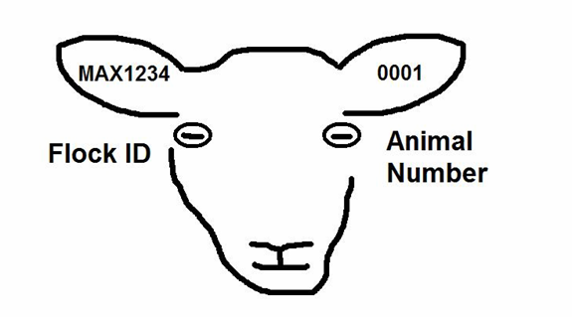
Record of Scrapie Tags Applied – Keep for 5 years

Flock ID | Animal ID | Other ID | Breed/Species | Sex | Age | Acquisition/Disposition & Date
Ex:  MEX1234 | 0001 | Fluffy | Suffolk  Sheep | F | 8 | Sold to Maine Slaughter Plant, Anytown, ME 03301  1-1-07
Ex:  MEX1234 | 0002 | Spot | Nubian Goat | M | 4 | Sold to Jane Doe, 12 Main St., AnyTown, ME 03301  5-10-07
EX: MEX1234 | 0003 | Kitty | Dorset Sheep | F | 2 | Bought from Jane Doe, 24 Main St., AnyTown, ME 03301  6-10-07

Record of Scrapie Tags Applied – Keep for 5 years

Flock ID | Animal ID | Other ID | Breed/Species | Sex | Age | Acquisition/Disposition & Date

