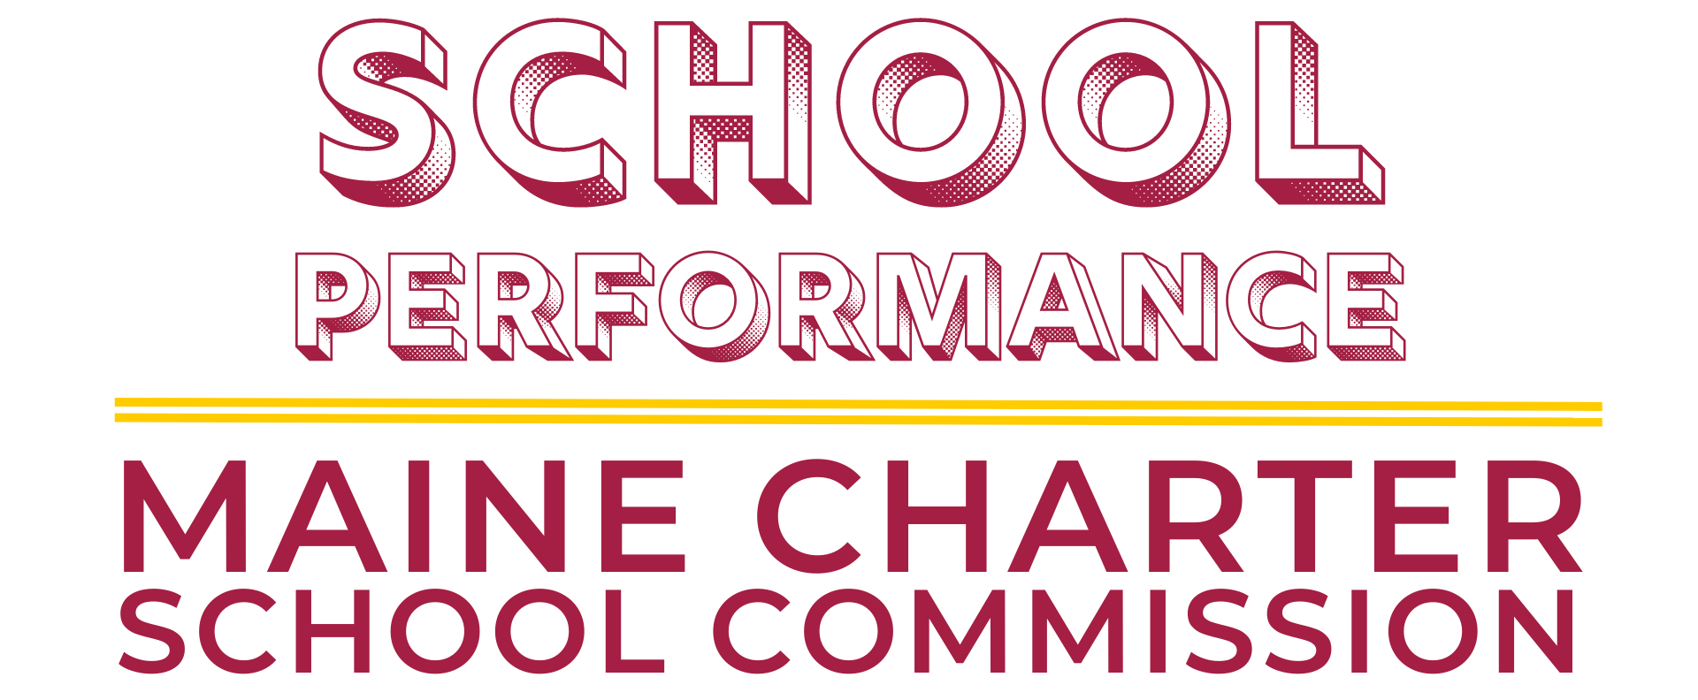
December 6 @ 3:30pm via Zoom
Members | Present
Tori Kornfield (Committee Chair)
Tom Keller
Jim Handy

Lana Ewing - Interim Executive Director
David Hartman - Deputy Executive Director
Amy Allen – Staff Designee

Item | Action | Discussion | Follow-up
Welcome
2021-22 DRAFT Annual Monitoring Reports
- Baxter Academy
- Fiddlehead School of Arts & Sciences
Student Academic Proficiency Amendment Proposal (Commission Meeting Agenda Item #10c)
Monthly School Portfolio Data Report
- Certified SY2022-23 Enrollment Data (Commission Meeting Agenda Item #8a)
- SY2022-23 Resident District Breakdown(Commission Meeting Agenda Item #8b)
- SY2022-23 Resident Town Breakdown (Commission Meeting Agenda Item #8c)
Next Meeting

