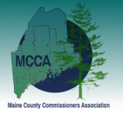
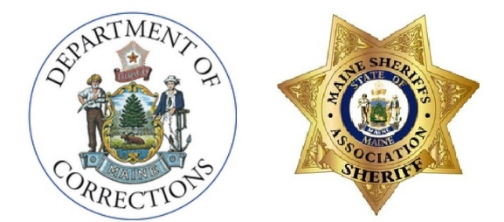
County Corrections Professional Standards Council
County Corrections Professional Standards Council
Draft Agenda - March 9, 2023

In Attendance:
Commissioner Gorden, Chair, MCCA
Sheriff Dale P. Lancaster, MSA
Sheriff Scott Nichols, MSA
Commissioner Norm Fournier, MCCA
Commissioner Randall Liberty, MDOC
Rebecca Graham, MMA
Steve French, MDOC
Guests:
Scott Ferguson, Kennebec County
Sheriff Todd Brackett, Lincoln County
Mary-Anne LaMarre, MSA

Commissioner Fournier moved that we accept 2/9/23 minutes as corrected. Sheriff Nichols seconded; Motion carried.
Commissioner Liberty was asked to discuss budget. He met with Maryann Turowski and there was discussion that change package could offer funding. Commissioner Liberty asked Commissioner Gorden for figures. Commissioner Liberty confirmed that they’re looking for a number for the two-year biennium budgets. MCCA will be providing numbers to MDOC. Commissioner Fournier noted that MCCA has a deadline of 3/15.
LD 4 discussion was led by Commissioner Liberty. Good effort to work together by MSA and MDOC. Commissioner Liberty noted that MDOC was responsible for assisting with jail standards’ advisory role.
Steve French noted jail advisory board was comprised of MSA, MCOPA, AG’s office, legislator, citizen, MDOC. Commissioner Fournier asked Steve French to circulate list of current members.
There was discussion about creating another subcommittee and this would be a subcommittee to develop recommendations to present to the Council, created from the existing Jail Advisory Committee.
Commissioner Fournier moved that we accept the jail standards advisory committee as a subcommittee of the Council, as advised by Commissioner Liberty. Rebecca Graham seconded the motion. Extensive conversation ensued to discuss committee composition and their potential roles. Motion carried with six in favor, one opposed. Sheriff Liberty asked how composition of board could be modified to garner support of all Council members.
Board to include:
  - One sheriff
  - One county commissioner
  - One police chief
  - One legislator
  - One AAG
  - One citizen
  - One MDOC
  - One jail administrator
  - One ADA
General consensus was in support with dissenting vote in agreement.

Sheriff Brackett reported out from his subcommittee. The committee looked at BARS and they’re looking at specific data points. They are working on putting together recommendations for the Council. They plan to meet with Commissioner Liberty to discuss BARS and evaluate if BARS is a sufficient platform to gather the data this Council needs. Other than BARS, there’s no single way to manage data and we’re looking at a separate data collector. It would be beneficial if in our data collection system had a single number that was identified individuals that every jail system could understand.
Sheriff Lancaster noted that the Council needs staffing. There was general agreement with the need for staffing. If we had our own system, which collected the data we wanted, we would establish consistency, and having staffing would enable us to drive that.
Council members discussed existing systems and how they work to identify an intake’s record. As this discussion progressed, Sheriff Brackett noted that opioid grant money may be an option for funding the Council for the purpose of staffing. Sheriff Brackett observed that it’s part of the finance subcommittee’s work to look for funding sources.
Commissioner Fournier moved that we adjourn at 12:18. Sheriff Nichols seconded the motion. Motion passed.

