Chart F-1

14,600.0

14,400.0

14,200.0

14,000.0

13,800.0

13,600.0

13,400.0

14,427.0 14,390.3

14,077.8 14,102.2 14,169.5

14,006.7

13,835.8
13,737.1 13,712.0

13,200.0
13,324.9

13,248.3 13,237.2

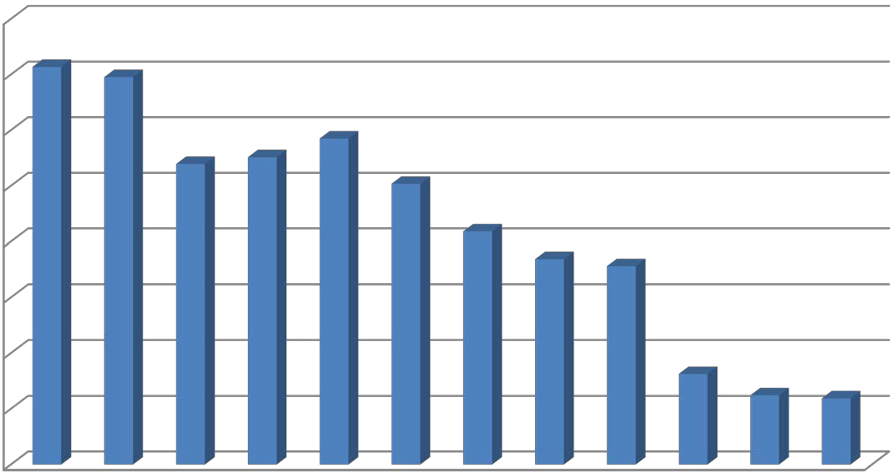
13,000.0

