STATE OF MAINE
MAINE BOARD OF TAX APPEALS
APPEALS OFFICE



Taxpayer’s Guide to Appearing before the Maine Board of Tax Appeals

October 2013

GENERAL INFORMATION

What is the Maine Board of Tax Appeals? The Maine Board of Tax Appeals (the “Board”) is an independent board within the Department of Administrative and Financial Services that provides taxpayers with a fair system of resolving disagreements with Maine Revenue Services (“MRS”). The Board is neither part of MRS nor subject to its control in any way. It consists of three Board members appointed by the Governor and confirmed by the Legislature, who are supported by an Appeals Office that conducts the initial review of appeals.

When can you appeal to the Board? If you have received an assessment, a denial of a refund request, or some other determination from MRS that you believe is incorrect, you must first ask MRS to reconsider that assessment, denial, or determination. MRS will then re-examine its assessment, denial, or determination and send you a reconsidered decision. If you disagree with MRS’s reconsidered decision, you can appeal to the Board if the amount of tax (including interest and penalties) in controversy when you asked MRS for reconsideration was $1,000 or more.

What is the deadline for appealing to the Board? You must file your appeal within 60 days of receiving MRS’s reconsidered decision.

Do you need an attorney or any other type of representative? No. The Board provides a fair and easy to understand system for resolving a disagreement between you and MRS without the need for a representative such as an attorney.

If you wish, however, you may have someone represent you before the Board. This can be an attorney, a certified public accountant, a public accountant, an enrolled agent, an enrolled actuary, or any other person you choose, such as a family member or friend. If you do decide to have someone represent you, you must submit a Power of Attorney form (“POA”) to the Board designating that person as your representative. Without the POA, the Board will not be able to communicate with the representative you have chosen. The POA form is included in the appendix to this Guide and can also be obtained from the Board’s Appeals Office (call 207-287-2864), or downloaded from the Board’s website at http://www.maine.gov/boardoftaxappeals.

Burden of Proof. The law makes it your responsibility to show that it is more likely than not that MRS has made a mistake in the assessment it issued against you or in denying the amount of your refund request. This responsibility is often referred to as having the “burden of proof.”

You must try to prove to the Board that it is more likely than not that MRS has made a mathematical mistake, a factual mistake, or a mistake in the interpretation of Maine’s tax laws. Simply stating that the assessment or refund denial is unfair or that you do not owe the tax assessed is not enough to show that the assessment or refund denial is incorrect. Instead, you need to present supporting legal authority (such as court cases or MRS rules and decisions) and/or factual evidence showing that it is more likely than not that the assessment or refund denial is incorrect. If you cannot show that it is more likely than not that MRS has made a mistake, the Board will uphold the assessment or refund denial.

For example, suppose you received an income tax assessment based on MRS’s belief that you are a Maine resident, but you think that the assessment is incorrect because, although you own property in Maine, you believe that you are a resident of New Hampshire. In order to show that it is more likely than not that MRS has made a mistake, you would need to present evidence showing your links to New Hampshire, such as information about your home there, your driver’s license, voter registration, social memberships, where your children go to school, and where you keep your pets. If you could not present this kind of evidence, the Board would likely uphold the assessment.

No Ex Parte Communications. The law forbids ex parte communications between you and the Board or its staff, and between MRS and the Board or its staff. An “ex parte” communication would occur if you or an MRS employee spoke to the Board or its staff without the other party being present, or if you or an MRS employee wrote a letter to the Board or its staff without sending a copy to the other party.

To avoid any ex parte communications, you must always send MRS copies of anything you send to the Board, and you must have no oral communications with the Board or any member of its staff without an MRS employee present. Likewise, MRS must send you a copy of everything it sends to the Board, and MRS employees may not speak with the Board or its staff unless you are present. The only exception to this rule is for communications limited to administrative or informational matters that are unrelated to the facts or issues involved in your appeal. An example of the type of communications permitted would be calling the Board to discuss how you were not able to attend a conference on the scheduled date.

HOW TO BRING AN APPEAL BEFORE THE BOARD

Filing Your Appeal. Filing an appeal with the Board is easy. Just send a letter to the Board saying that you appeal MRS’s reconsidered decision (but see the next section on requesting a conference). This letter is called a “Statement of Appeal.” The Statement of Appeal must notify the Board that you are appealing MRS’s tax assessment or its denial of your refund request. A sample Statement of Appeal letter is included in the Appendix to this Guide. You should make a copy of your Statement of Appeal and then send the original to the Board at:

Maine Board of Tax Appeals
134 State House Station
Augusta, ME 04333-0134

Although it is not required, you should also include a copy of the MRS reconsideration decision that you are appealing from for the Board’s reference.

Keep the copy for your records. It is a good idea to keep all documents relating to your appeal together in a file folder or box.

Requesting an Appeals Conference. An important decision you must make when appealing to the Board is whether to request an appeals conference. The appeals conference is an opportunity for you to appear before the Appeals Officer in person to state your position and to explain or address any evidence submitted by you or MRS. You may also have witnesses speak on your behalf at the appeals conference. The appeals conference may be conducted by telephone if it is inconvenient or impossible for you to appear in person.

If you wish to have an appeals conference you must request one in your Statement of Appeal or in a separate written request submitted within 20 days of filing your Statement of Appeal. There is a $100.00 fee for an appeals conference, which must be paid within 21 days of filing your Statement of Appeal.

If you do not request an appeals conference, no fee will be due and the Board will decide your appeal based only on the written materials submitted by you and MRS.

De Novo Review. The Board’s review of MRS’s tax assessment or refund denial is a “de novo” review. This means that the Board is not bound by what MRS has decided about the facts or law involved in your case, so you can raise facts and legal issues before the Board that MRS has already ruled upon. In addition, you (as well as MRS) may raise any other facts or legal issues before the Board. For instance, if MRS decides that you owe Maine use tax on your boat because the agency determined that the boat was present in Maine for more than 30 days in the first year following its purchase, you may still argue before the Board that your boat was here for less than 30 days that year.

Process after filing. After you file your Statement of Appeal, the Board’s Appeals Office will notify you in writing that it has received your statement and will notify MRS that you have filed an appeal. It will also assign an Appeals Officer to your case.

Case Management Conference. The Appeals Officer will schedule a case management conference with you and MRS. At the management conference, the Appeals Officer will work with you and MRS to identify: (1) the primary issues in the case; (2) the areas of agreement and disagreement between you and MRS, and (3) the witnesses and evidence that each party expects to bring to the appeals conference, if you requested one, in order to avoid either party being surprised and unprepared. Case management conferences will usually be conducted by telephone.

Submitting Information to the Board. Following the case management conference, the Appeals Officer will set a deadline for both you and MRS to submit all arguments, evidence, and any other information for the Board to consider in deciding the appeal. This information is usually due within 21 days following the case management conference. You must send MRS a copy of everything you submit to the Board, and MRS must send you a copy of everything it submits to the Board.

When submitting this information, keep in mind that this is one of your most important opportunities to make the Board understand why you think MRS has made a mistake. Be sure to include all of your reasons for claiming MRS made a mistake, and all of the support you have for those reasons.

Response to Information Submitted. After you and MRS have submitted your information to the Board and sent copies to each other, the Appeals Officer will give each party additional time, usually 14 days, to respond to the arguments and information submitted by the other party. Again, you must send a copy of your response to MRS and MRS must send a copy of its response to you.

The Appeals Conference. If you requested one, the Appeals Officer will schedule an appeals conference for you to present and explain your arguments and evidence to the Appeals Officer in person, and to have any witnesses testify on your behalf. MRS will also present the arguments it has to support its position, along with any supporting witnesses and other evidence. The Appeals Officer will conduct the appeals conference to ensure that both you and MRS have a chance to make your arguments and respond to the presentation made by the other party.

If you cannot attend your appeals conference in person, it can be conducted as a telephone conference.

After the Appeals Conference, or After the Submission of all Information and Responses. Once the appeals conference has been completed—or, if you did not request a conference, after all information and responses have been submitted—the Appeals Officer will examine the evidence that has been presented and prepare a recommended decision for the Board’s consideration. The Appeals Officer will send copies of that decision to both you and MRS for comments before submitting that decision to the Board. You and MRS must submit all comments regarding the recommended decision by a deadline that will be set by the Appeals Officer. Just as with all other materials submitted during the appeals process, you must send a copy of your comments to MRS at the same time you send the original to the Appeals Officer, and MRS will send a copy of its comments to you.

The Appeals Officer will consider the comments submitted by both you and MRS and he or she may modify the recommended decision based on those comments. If the Appeals Officer makes any significant chances to the decision, he or she will send copies of the modified recommended decision to you and MRS for review, and will give each party a final opportunity to submit comments (with copies to be sent to each other). Even if the Appeals Officer decides not to modify the recommended decision, he or she will still send you a written response to your comments.

Consideration by the Board and the Final Determination of your Appeal. After the comment period, the Appeals Officer will provide the Board with the recommended decision, copies of all comments received, and copies of any written responses that the Appeals Officer has made to those comments. The Board will then schedule a meeting to consider your appeal, and you will be notified of the date. You and MRS may attend the meeting.

You and MRS may also submit written statements to the Board explaining why you think the Appeals Officer’s recommended decision reaches the right or wrong result in your appeal. The statements may be no more than two pages in length in 12 point font on 8.5 by 11 inch paper (standard sized letter/copier paper), and must be delivered to the Board at least five business days before the meeting. Also, you and MRS may request that the Board allow you each to make an oral statement at the meeting in support of your positions. These statements are limited to 10 minutes in length. Requests to make an oral statement must be in writing and must also be delivered to the Board at least five business days before the meeting. Please note that the Board will not automatically grant a request to make an oral statement at the meeting. Instead, the Board will only grant such a request if the Board members believe they need to hear more from you and MRS in order to make a fair decision on your appeal.

You must send a copy of your written statement and request to make an oral statement to MRS at the same time you send them to the Board.

At the meeting, the Board will consider the recommended decision, the comments submitted concerning that decision, the parties’ written statements, and, if allowed, the parties’ oral statements. The Board will then decide your case. The Board may: (1) adopt the recommended decision; (2) modify and then adopt the recommended decision; (3) reject the recommended decision entirely and make a different decision; or (4) send the appeal back to the Appeals Officer with instructions to consider more evidence, or to re-examine the evidence and law in the appeal. The Board may or may not issue its decision at the meeting. If it does not issue a decision at the meeting, the Board will mail its written decision to you and MRS.

What can you do if you disagree with the Board’s decision? If you believe that the Board’s decision on your appeal was incorrect, you have two options.

First, you may ask the Board to reconsider its decision because you believe that: (1) there is new evidence that was unknown or that you could not obtain before the Board issued its decision; or (2) the Board’s decision contains a mistake concerning the facts or law involved and which affected the outcome of your appeal. You must submit your request for reconsideration in writing (with a copy to MRS) within 20 days of your receipt of the Board’s decision. If the Board grants a request for reconsideration, then it may directly address the issues raised or it may send the appeal back to an Appeals Officer for review. If the Board does not grant a request for reconsideration within 20 days from when it is filed, then the request is considered to have been denied.

Second, you may file an appeal with the Maine Superior Court for the county in which you live, or in the Superior Court for Kennebec County. If you take this option, you must file your appeal within 60 days of your receipt of either a decision of the Board or its denial of a reconsideration request. You must also send a copy of your appeal to MRS. If you file in Kennebec County, you should send your appeal, together with the filing fee, to: Michele Lumbert, Clerk, Kennebec County Superior Court, 95 State Street, Augusta, ME 04330. As of January 1, 2013, the filing fee was $150.00.

You can find links to forms, statutes, rules, and a copy of this guide at the Maine Board of Tax Appeals website:
http://www.maine.gov/boardoftaxappeals

APPENDIX

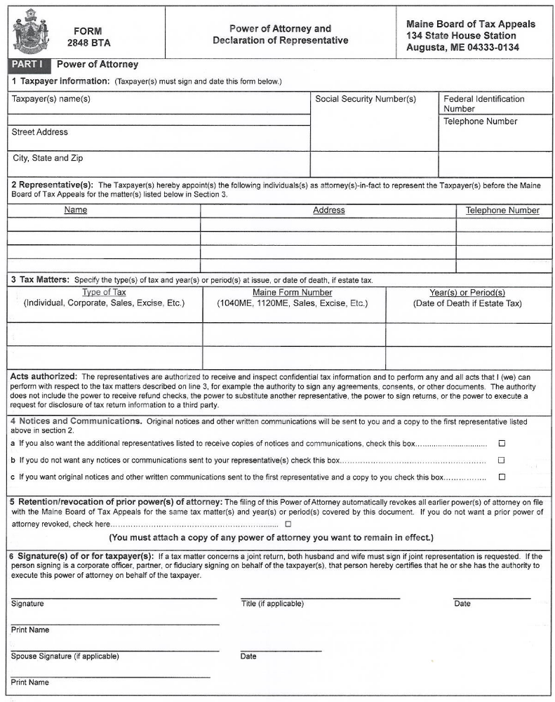

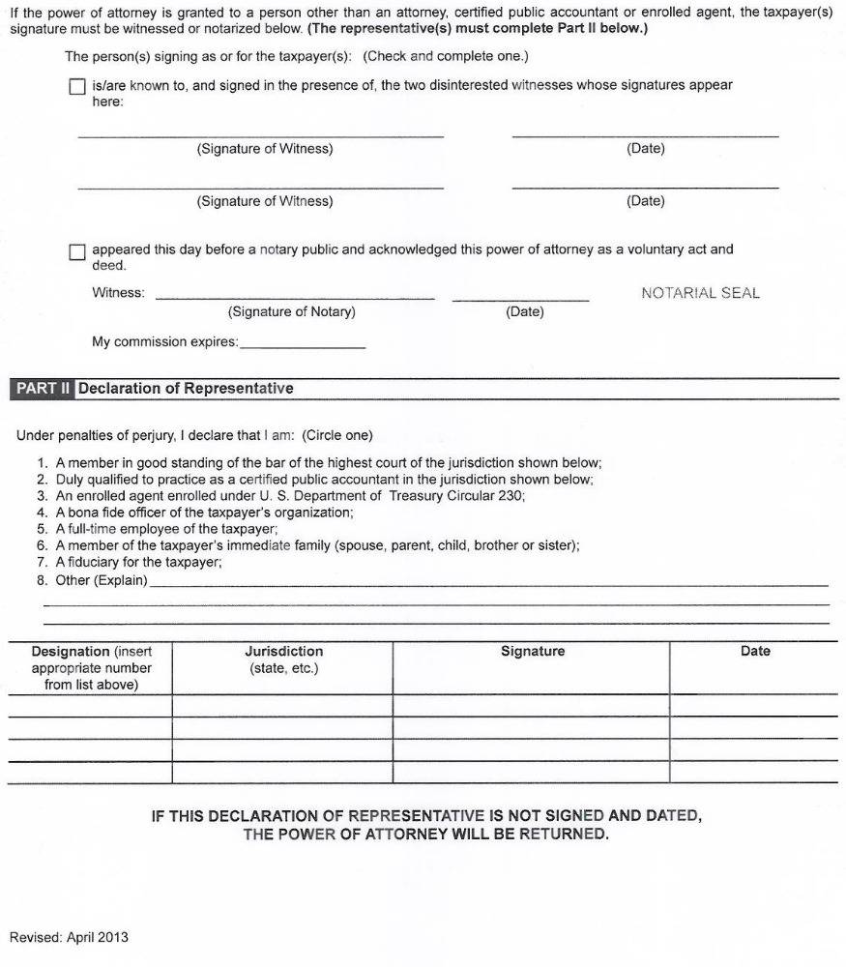

SAMPLE STATEMENT OF APPEAL
REQUESTING A CONFERENCE

Maine Board of Tax Appeals
134 State House Station
Augusta, ME 04333-0134

Dear Maine Board of Tax Appeals:

I hereby appeal the attached assessment [or denial of refund] that was issued by Maine Revenue Services, dated _________.

As part of my appeal, I also request that the Board hold an appeals conference at which I may present my argument for why the assessment [or refund denial] is incorrect. Enclosed is my check in the amount of $100.00 for the conference processing fee.

Sincerely,

_____________________
Taxpayer

Mailing address

Telephone number

SAMPLE STATEMENT OF APPEAL
NOT REQUESTING A CONFERENCE

Maine Board of Tax Appeals
134 State House Station
Augusta, ME 04333-0134

Dear Maine Board of Tax Appeals:

I hereby appeal the attached assessment [or denial of refund] that was issued by Maine Revenue Services, dated _________.

Sincerely,

_____________________
Taxpayer

Mailing address

Telephone number

