STATE OF MAINE
MAINE BOARD OF TAX APPEALS
APPEALS OFFICE



Taxpayer’s Guide to Appearing before the Maine Board of Tax Appeals

May 2014

The procedures described in this Guide apply to all cases filed with the Maine Board of Tax Appeals on or after May 1, 2014.
GENERAL INFORMATION

What is the Maine Board of Tax Appeals? The Maine Board of Tax Appeals (the “Board”) is an independent board within the Department of Administrative and Financial Services that provides taxpayers with a fair system to resolve disagreements with Maine Revenue Services (“MRS”). The Board is neither part of MRS nor subject to its control in any way. It consists of three Board members appointed by the Governor and confirmed by the Legislature, who are supported by an Appeals Office that conducts the initial review of appeals.

When can you appeal to the Board? If you have received an assessment, a denial of a refund request, or some other determination from MRS that you believe is incorrect, you must first ask MRS to reconsider that assessment, denial, or determination. MRS will then re-examine its assessment, denial, or determination and send you a Decision on Reconsideration. If you disagree with MRS’s Decision on Reconsideration, you can appeal to the Board if the amount of tax (including interest and penalties) in controversy when you asked MRS for reconsideration was $1,000 or more.

What is the deadline for appealing to the Board? You must file your appeal within 60 days of receiving MRS’s Decision on Reconsideration.

Do you need an attorney or any other type of representative? No. The Board provides a fair and easy to understand system to resolve a disagreement between you and MRS without the need for a representative such as an attorney.

If you wish, however, you may have someone represent you before the Board. This can be an attorney, a certified public accountant, a public accountant, an enrolled agent, an enrolled actuary, or any other person you choose, such as a family member or friend. If you decide to have someone represent you, you must submit a Power of Attorney form (“POA”) to the Board designating that person as your representative. Without the POA, the Board will not be able to communicate with the representative you have chosen. The POA form is included in the appendix to this Guide and can also be obtained from the Board’s Appeals Office (call 207-287-2864), or downloaded from the Board’s website at http://www.maine.gov/boardoftaxappeals.

The Board cannot give you legal advice and no one at the Board can be your representative.

Burden of Proof. The law makes it your responsibility to show that it is more likely than not that MRS has made a mistake in its decision. This responsibility is often referred to as having the “burden of proof.”

You must try to prove to the Board that it is more likely than not that MRS has made a mathematical mistake, a factual mistake, or a mistake in interpreting Maine’s tax laws (which can be found at http://www.mainelegislature.org/legis/statutes/36/title36ch0sec0.html).

Simply stating that MRS’s decision is unfair or that you do not owe the tax assessed is not enough to show that the decision is incorrect. Instead, you need to present supporting legal authority (such as court cases or MRS rules and decisions) and/or factual evidence showing that it is more likely than not that the decision is incorrect. If you cannot show that it is more likely than not that MRS has made a mistake, the Board will uphold the agency’s decision.

For example, suppose you received an income tax assessment based on MRS’s belief that you are a Maine resident, but you think that the assessment is incorrect because, although you own property in Maine, you believe that you are a resident of New Hampshire. In order to show that it is more likely than not that MRS has made a mistake, you would need to present evidence of your links to New Hampshire, such as information about your home there, your driver’s license, voter registration, social involvement, where your children go to school, where you keep your pets, etc. If you could not present this kind of evidence, the Board would likely uphold the assessment.

No Ex Parte Communications. The law forbids ex parte communications between you and the Board or its staff, and between MRS and the Board or its staff. An ex parte communication would occur if you or an MRS employee spoke to the Board or its staff without the other party being present, or if you or an MRS employee wrote a letter to the Board or its staff without sending a copy to the other party.

To avoid any ex parte communications, you must always send MRS copies of anything you send to the Board, and you must not speak with the Board or any member of its staff without an MRS employee present. Likewise, MRS must send you a copy of everything it sends to the Board, and MRS employees may not speak with the Board or its staff unless you are present.

The only exception to this rule is for communications limited to administrative or informational matters that are unrelated to the facts or issues involved in your appeal. Examples of permitted communications are: (1) calling the Board to discuss how you were not able to attend a conference on the scheduled date; and (2) requesting a clarification of the Board’s rules or procedures.

HOW TO BRING AN APPEAL BEFORE THE BOARD

Filing Your Appeal. Filing an appeal with the Board is easy. Just send a letter to the Board saying that you are appealing a Decision on Reconsideration that you have received from MRS (but also see the next section on requesting a conference). This letter is called a “Statement of Appeal.” The Statement of Appeal must notify the Board that you are appealing MRS’s decision. Be sure to include your phone number and email address, if you have one, in your Statement of Appeal, and attach a copy of the Decision on Reconsideration.

A sample Statement of Appeal letter is included in the Appendix to this Guide. You should make a copy of your Statement of Appeal and then send the original to the Board at:

Maine Board of Tax Appeals
134 State House Station
Augusta, ME 04333-0134

Keep the copy for your records. It is a good idea to keep all documents relating to your appeal together in a file folder or box.

Requesting an Appeals Conference. An important decision you must make when appealing to the Board is whether to request an appeals conference. The appeals conference is an opportunity for you to appear in person before the Appeals Officer who will review your case. This allows you to further explain your arguments, address any evidence submitted by you or MRS, and answer any questions the Appeals Officer may have. You may also have witnesses speak on your behalf at the appeals conference. The appeals conference may be conducted by telephone if it is inconvenient or impossible for you to appear in person.

If you wish to have an appeals conference, you must request one in your Statement of Appeal or in a separate written request submitted within 20 days of filing your Statement of Appeal. There is a $100.00 fee for an appeals conference, which must be paid within 21 days of filing your Statement of Appeal.

If you do not request an appeals conference, no fee will be due and the Board will decide your appeal based only on the written materials submitted by you and MRS.

De Novo Review. The Board’s review of MRS’s tax assessment or refund denial is a de novo review. This means that the Board is not bound by what MRS has decided about the facts or law involved in your case. You may raise facts and legal issues before the Board even if MRS has already made a decision concerning those facts or issues. In addition, you (as well as MRS) may raise new facts or legal issues that were not part of your reconsideration request to MRS.

For example, if: (1) MRS decides that you owe Maine use tax on your boat because the agency determined that the boat was present in Maine for more than 30 days in the first year after it was purchased; then (2) you may still argue before the Board that your boat was here for less than 30 days that year; and (3) you may present any evidence you have to support that argument, even if you had not previously submitted that evidence to MRS.

Process after filing. After you file your Statement of Appeal, the Board’s Appeals Office will notify you in writing that it has received your statement and will notify MRS that you have filed an appeal. It will also assign an Appeals Officer to your case.

Case Management Conference. The Appeals Officer will schedule a case management conference with you and MRS. At the case management conference, the Appeals Officer will work with you and MRS to identify: (1) the primary issues in the case; (2) the areas of agreement and disagreement between you and MRS; and (3) the witnesses and evidence that each party expects to bring to the appeals conference, if you requested one, in order to avoid either party being surprised and unprepared. Case management conferences will usually be conducted by telephone.

Submitting Information to the Board. Your submission of arguments and evidence to the Board is primarily voluntary, and you are not required to submit any written statement to the Board if you choose not to. (But, keep in mind that if you did not request an appeals conference, submitting a written statement is the only way you will be able to present your argument to the Appeals Officer.) If you do wish to submit written statements to the Board, you will be required to do so according to the following procedure:
- At the case management conference, the Appeals Officer will set a schedule for both you and MRS to submit all written arguments, evidence, and any other information for the Board to consider in deciding the appeal.
- First, you will be asked to submit a written statement that: (1) identifies the issue(s) in your appeal; (2) specifies what you are requesting the Board to do (cancel the assessment, abate penalties, grant your refund request, etc.); and (3) presents your argument for why the Board should grant your request. This written statement may be no longer than 10 pages, although the Appeals Officer may allow you to submit additional pages if you present a good reason for doing so. You may attach to your written statement any documentary evidence or affidavits you wish the Appeals Officer to consider. Normally, the Appeals Officer will give you 21 days in which to submit your written statement. Remember to send MRS a copy of everything you submit to the Board.
- Once you have submitted your written statement, MRS will have 21 days in which to file a response. Like you, MRS is limited to a statement of no longer than 10 pages, to which the agency may attach any documentary evidence it wishes the Appeals Officer to consider. MRS is required to send you a copy of this response.
- Finally, once you receive MRS’s response, you will have 7 days in which to submit a short (5 pages or less) reply that must be limited to addressing any of the arguments or issues MRS has raised.

None of your submissions needs to be a formal legal brief. A simple letter to the Appeals Officer that explains your argument is perfectly acceptable.

The Appeals Conference. If you requested one, the Appeals Officer will schedule an appeals conference for you to present and explain your arguments and evidence to the Appeals Officer in person, and to have any witnesses you may have speak on your behalf. MRS will also present the arguments it has to support its position, along with any evidence and witnesses the agency wishes to produce. The Appeals Officer will conduct the appeals conference to ensure that both you and MRS have a chance to make your arguments and respond to the presentation made by the other party.

As mentioned previously, if you cannot attend your appeals conference in person, it can be conducted as a telephone conference.

Recommended Decision. Once the appeals conference has been completed—or, if you did not request a conference, after all information and responses have been submitted—the Appeals Officer will examine the evidence that has been presented and prepare a recommended decision for the Board to consider. The Appeals Officer will send copies of that decision to both you and MRS so that you may comment on it before it is sent to the Board members. You and MRS must submit all comments regarding the recommended decision by a deadline that will be set by the Appeals Officer. Just as with all other materials submitted during the appeals process, you must send a copy of your comments to MRS at the same time you send the original to the Appeals Officer, and MRS will send a copy of its comments to you.

The Appeals Officer will consider the comments submitted by both you and MRS and he or she may modify the recommended decision based on those comments. If the Appeals Officer decides not to modify the recommended decision, he or she will still send you a written response to any comments that were submitted.

Consideration by the Board and the Final Determination of your Appeal. After the comment period, the Appeals Officer will provide the Board with the recommended decision, copies of all comments received, and copies of any written responses that the Appeals Officer has made to those comments. The Board will then schedule a meeting to consider your appeal, and you will be notified of the date.

You and MRS may submit written statements to the Board explaining why you think the Appeals Officer’s recommended decision reaches the right or wrong result in your appeal. The statements may be no more than five pages in length, and must be submitted to the Board at least 10 days before the meeting.

You and MRS may also request that the Board allow you each to speak at the meeting in support of your positions. Each party’s speaking time is limited to 20 minutes in length, during which time the Board may ask questions. Requests to speak to the Board must be in writing and must also be submitted to the Board at least 10 days before the meeting. Please note that the Board will not automatically grant a request to speak. Instead, the Board will only grant such a request if the Board members believe they need to hear more from you and MRS in order to make a fair decision on your appeal. If one party submits a request to speak to the Board and the Board grants the request, both parties will be allowed to speak to the Board.

You must send a copy of your written statement and request to speak to the Board to MRS at the same time you send them to the Board.

At the meeting, the Board will consider the recommended decision, the comments submitted concerning that decision, the parties’ written statements, and, if allowed, the parties’ oral statements. The Board will then decide your case and copies of that decision will be mailed to you and MRS.

What can you do if you disagree with the Board’s decision? If you believe that the Board’s decision on your appeal was incorrect, you have two options.

First, you may ask the Board to reconsider its decision because you believe that: (1) there is new evidence that you did not know about or that you did know about but could not get before the Board issued its decision; or (2) the Board’s decision contains a mistake concerning the facts or law involved and this affected the outcome of your appeal. You must submit your request for reconsideration in writing (with a copy to MRS) within 20 days of your receipt of the Board’s decision. If the Board grants a request for reconsideration, then it may directly address the issues raised or it may send the appeal back to an Appeals Officer for review. If the Board does not grant a request for reconsideration within 20 days from the date it is filed, then the request is considered to have been denied.

Second, you may file an appeal with the Maine Superior Court for the county in which you live, or in the Superior Court for Kennebec County. If you take this option, you must file your appeal within 60 days of your receipt of either a decision of the Board or its denial of a reconsideration request. You must also send a copy of your appeal to MRS. If you file in Kennebec County, you should send your appeal, together with the filing fee, to: Michele Lumbert, Clerk, Kennebec County Superior Court, 95 State Street, Augusta, ME 04330. As of January 1, 2014, the filing fee was $150.00.

EXPECTATIONS

- The Board realizes that tax issues can be extremely difficult and emotional, and that many Taxpayers feel angry and overwhelmed. We still expect, however, that everyone involved in an appeal to the Board will act in a civil manner and be courteous, honest, and cooperative.
- Remember that the Appeals Officer is not your opponent. He or she is a neutral party who is there to evaluate the arguments and evidence presented by you and MRS.
- Be prepared for all conferences and hearings. Make sure you have all necessary documents with you and that you are ready to participate in an in-depth discussion of the issues in your appeal.
- Read all documents that you receive from the Board very carefully; these will often contain schedules and deadlines.
- If you do not understand something, including the process your appeal will follow, ask the Appeals Officer or another staff person at the Board about it. Although the Board’s staff cannot give you legal advice, and cannot speak about the specific issues in your case without a representative from MRS present, we can discuss technical issues with you, such as how the Board’s procedures work.

You can find links to forms, statutes, rules, and a copy of this guide at the Maine Board of Tax Appeals website:
http://www.maine.gov/boardoftaxappeals

APPENDIX

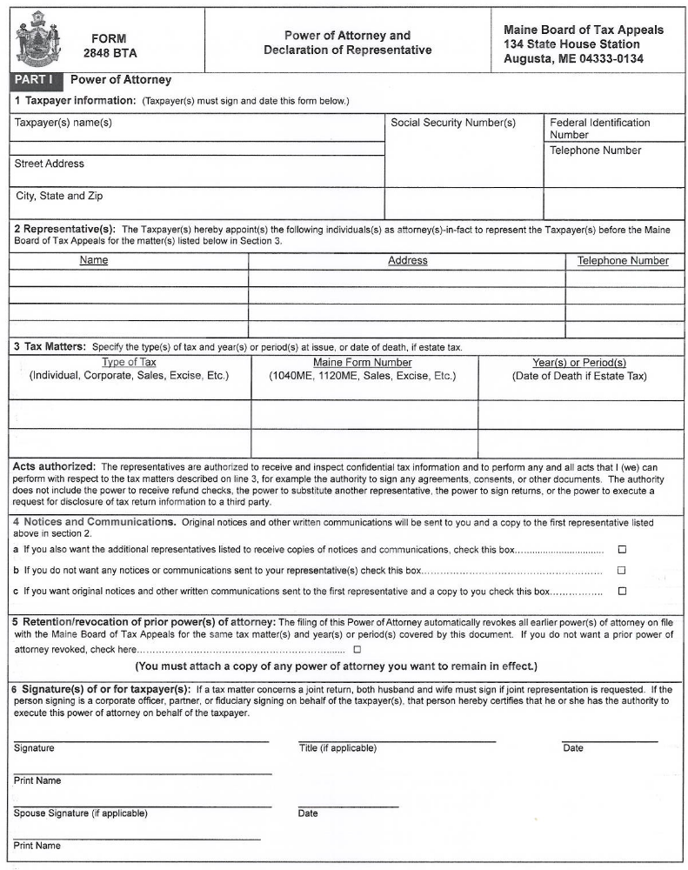

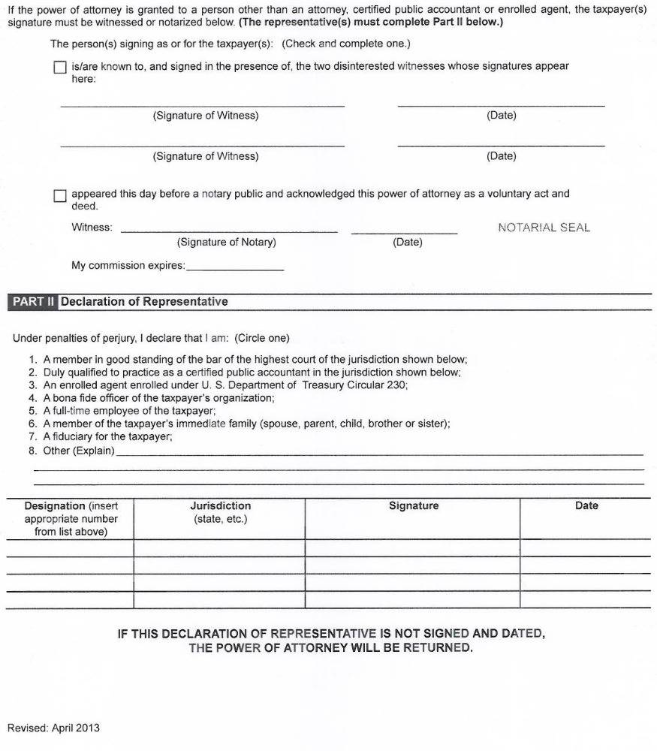

[SAMPLE STATEMENT OF APPEAL
REQUESTING A CONFERENCE]

Maine Board of Tax Appeals
134 State House Station
Augusta, ME 04333-0134

Dear Maine Board of Tax Appeals:

I hereby appeal the attached assessment [or denial of refund] that was issued by Maine Revenue Services, dated _________.

As part of my appeal, I also request that the Board hold an appeals conference at which I may present my argument for why the assessment [or refund denial] is incorrect. Enclosed is my check in the amount of $100.00 for the conference processing fee.

Sincerely,

_____________________
Printed Name
Mailing address
Telephone number
Email address

SAMPLE STATEMENT OF APPEAL
NOT REQUESTING A CONFERENCE

Maine Board of Tax Appeals
134 State House Station
Augusta, ME 04333-0134

Dear Maine Board of Tax Appeals:

I hereby appeal the attached assessment [or denial of refund] that was issued by Maine Revenue Services, dated _________.

Sincerely,

_____________________
[Printed Name]
Mailing address
Telephone number
Email address

