Social Service Hubs!
- Food Pantries
- Department of Health and Human Services (DHHS) – for local offices go to:
  - https://www.maine.gov/dhhs/
- Women, Infants, and Children (WIC) Clinics – for local offices go to:
  - https://www.maine.gov/dhhs/mecdc/population-health/wic/
- Community Action Program (CAP) Agencies – for local office go to:
  - https://www.mainehousing.org/charts/maine-community-action-agency-contacts
- General Assistance Administrators/Town Offices
- Local Housing Authorities
- Rotary & Kiwanis clubs
- Recreation departments

In the Community!
Flyer as many places as you can, including businesses, public buildings,
libraries, grocery stores (flyer on bulletin board, stack on counters, flyers in
bags), convenience stores, laundromats, churches, public safety buildings,
food pantries (in all bags/boxes that go out), doctor’s offices, and clinics
- Church bulletins
- Movie theater advertisement
- Boys and Girls Clubs and YMCAs
Media!
Media can be getting the word out in the newspaper or on social media; explore all outlets!
- Town marquees or signs that are located at school district central offices, public safety and municipal buildings, or schools. This is something people will see again and again.
- Community calendars - just call the Town Office to get your program listed
- School, recreation department, and municipal websites
- Public Access Channel- Contact the person at the Town Office for more information
- If you have a creative volunteer who wants to use their social media skills, have them set-up accounts and regularly update. Consider a Facebook page for your sites.
- Public Service Announcement (PSA)
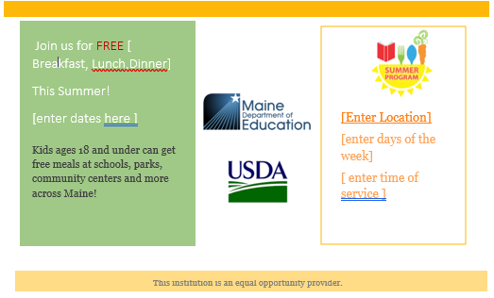
- Local publications- newspapers, newsletters
This institution is an equal opportunity provider.
Sample TV Slide:
Made in PowerPoint, this simple slide includes the same information as the flyer

