NEO Daily Attendance Details Report Instructions
In order to access the Attendance Reports, you will need an active NEO login with Student Data access for your school district.
If you do not yet have a NEO account or Student Data access, you must contact your Superintendent/Director to submit an access request form on your behalf.
Note: If your SAU does not operate any schools, you will not have any reports to view.

- Login to NEO

- Choose ‘Student Data’ module from up top:
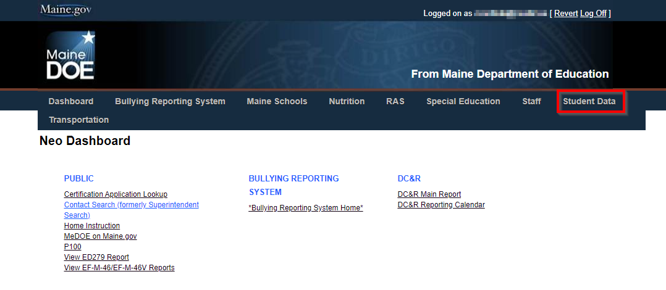
- Choose ‘Student Reports’: 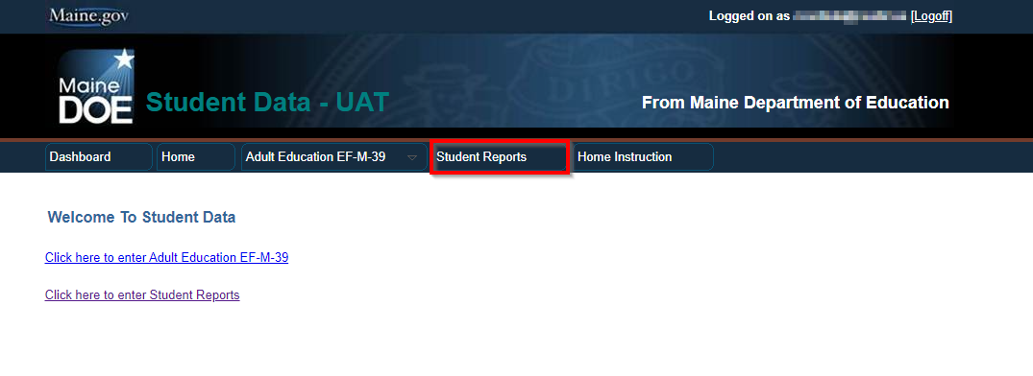

- Scroll down in the report listing to locate the Daily Attendance Details Report, and click ‘View Report’ on the right side:
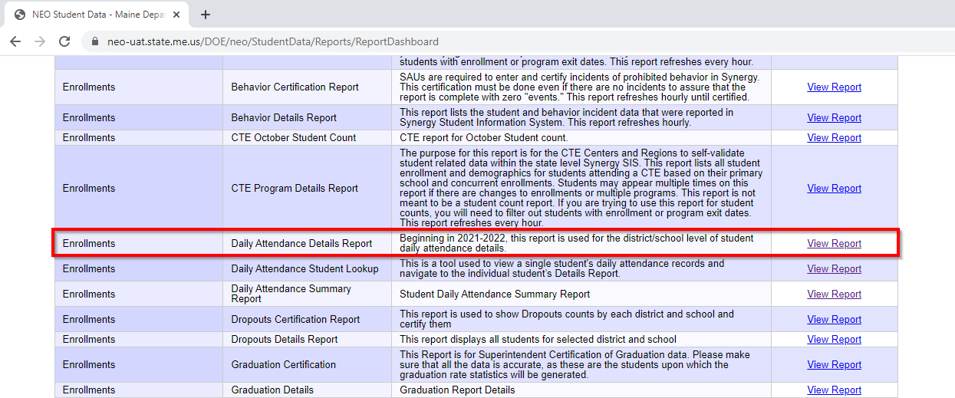

- The report is very large and will take a few moments to generate, and opens in a new tab. It displays all the current year data for the SAU:
(See below)
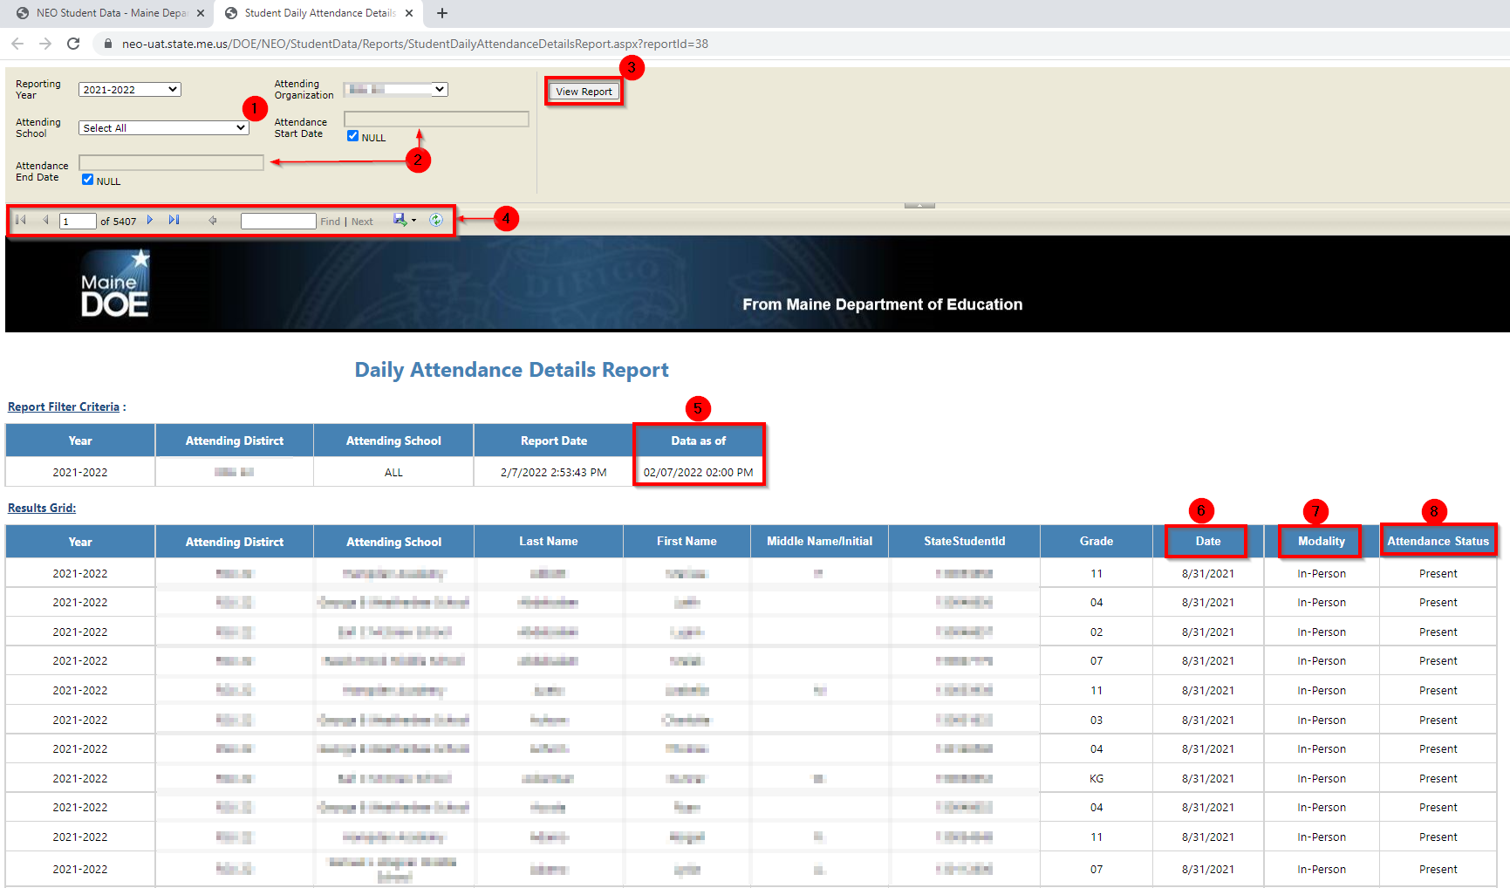

1 – Attending Schools filter allows you to view only a single school’s data.
2 – Allows you to specify a date range to view only.
3 – Once any filters are changed, you must hit ‘View Report’ to re-generate the report.
4 – Navigation buttons and search box allow you move through the report. You also can choose the floppy disc to download the report in various formats.
5 – Displays the timestamp for when data was last updated from Synergy.
6 – Lists the date of attendance.
7 – Lists the Modality of the student for that date.
8 – Lists the student’s attendance status for that date.

FAQs:
- This data is loaded directly from Synergy each hour. Check Synergy if data in the report is incorrect, as a first check. Then check #5 to see if the report has updated since changes were made. Synergy is correct and the report is recently updated, contact the Helpdesk.
- These reports are very large and take much longer to generate than other NEO reports.

If you have any questions, comments, or concerns regarding this document please do not hesitate to contact the Maine Education Data Management Systems Helpdesk directly.

Contact Us
(207)-624-6896
Medms.helpdesk@maine.gov
Hours: Mon-Fri – 8:00 am to 4:00 pm

