We are offering Free Meals to kids this summer!  Your Sponsor Name Here______  Kids age 18 and under can get free meals in [your town] this summer.  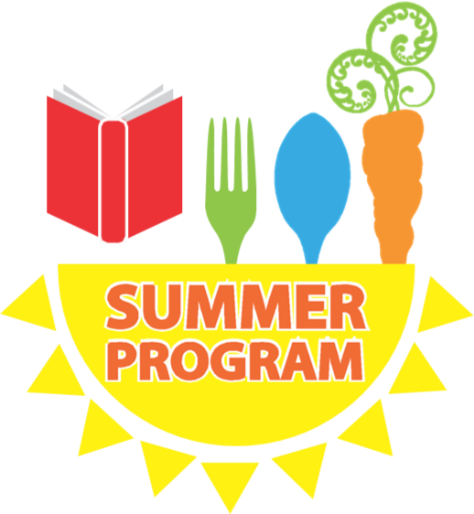  This institution is an equal opportunity provider | Meals will be offered at the following locations:  ────  Enter location here:  Enter days of the week here:  Enter time here:  ────  Enter location here:  Enter days of the week here:  Enter time here:  ────  Enter location here:  Enter days of the week here:  Enter time here:  ────  You Have Room for Another One Here!  Sponsor Name  Telephone  Web Address

