DEP Environmental Education Curricula
Lesson Plan
GRADE/LEVEL: Middle School
LESSON TITLE: Solid Waste
Next Generation Science Standards
MS-ESS3-4 | MS-ESS3-4 | Construct an argument supported by evidence for how increases in human population and per-capita consumption of natural resources impact Earth’s systems.
 | Science and Engineering Practices | Engaging in Argument from Evidence  Engaging in argument from evidence in 6–8 builds on K–5 experiences and progresses to constructing a convincing argument that supports or refutes claims for either explanations or solutions about the natural and designed world(s).  - Construct an oral and written argument supported by empirical evidence and scientific reasoning to support or refute an explanation or a model for a phenomenon or a solution to a problem.
 | Disciplinary Core Ideas | ESS3.C: Human Impacts on Earth Systems  - Typically as human populations and per-capita consumption of natural resources increase, so do the negative impacts on Earth unless the activities and technologies involved are engineered otherwise.
 | Crosscutting Concepts | Cause and Effect  - Cause and effect relationships may be used to predict phenomena in natural or designed systems.
Objectives
Objective 1: Generate an understanding of solid waste issues in Maine.
Objective 2: Determine how public and private sectors can influence the generation and treatment of municipal solid waste.
Objective 3: Discuss the waste hierarchy and each individual level.
Vocabulary
 | Agronomic | Application of the various soil and plant sciences to soil management and crop production; scientific agriculture.
 | Boiler | A fuel-burning unit for heating water. It is also a unit that can be used to provide a hot-water supply or serve a central heating system.
 | British Thermal Unit (Btu) | The British thermal unit (Btu or BTU) is a traditional unit of heat; it is defined as the amount of heat required to raise the temperature of one pound of water by one degree Fahrenheit.
 | Hazardous Waste | Hazardous wastes are waste substances or materials with properties that make them dangerous or potentially harmful to human health or the environment. Hazardous wastes can be liquids, solids, contained gases, or sludges.
 | Latent Heat of Vaporization | A physical property of a substance. When a material in liquid state is given energy, it changes its phase from liquid to vapor; the energy absorbed in this process is called heat of vaporization.
 | Leachate | Water that has percolated through a solid and leached out some of the constituents.
 | Scrubber | A diverse group of air pollution control devices that can be used to remove some particulates and/or gases from industrial exhaust streams.
 | Solid Waste | Any garbage or refuse, sludge from a wastewater treatment plant, water supply treatment plant, or air pollution control facility and other discarded material, resulting from industrial, commercial, mining, and agricultural operations, and from community activities.
 | Turbine | A rotary mechanical device that extracts energy from a fluid flow and converts it into useful work.
Background
Teacher Version  Selected Materials from … |  | Source: http://web.colby.edu/stateofmaine2014/the-state-of-municipal-waste-in-maine/
Introduction
The disposal of municipal solid waste (MSW) is currently a growing challenge in Maine due to declining landfill space, high disposal costs, and risks to public and environmental health.

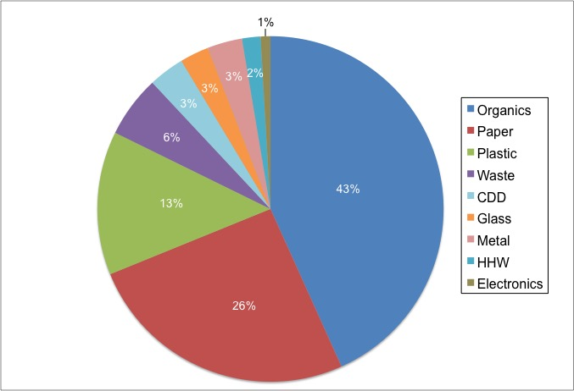
MSW Composition of MSW in Maine (Criner & Blackmer, 2012)

The Maine Department of Environmental Protection (DEP) is responsible for licensing and monitoring Maine’s solid waste facilities; these facilities include landfills, incinerators, waste transfer stations, special waste sites, and recycling and composting operations. The general provisions of the Solid Waste Management Rules of the DEP requires the design of these facilities to prevent the contamination of any water in the state, ambient air, and also prevent health hazards.

Stakeholders
Three types of stakeholders comprise Maine’s waste management: governmental agencies, the public, and the private sector. Important governmental stakeholders include the federal Environmental Protection Agency (EPA) and the Maine DEP. Other public stakeholders include residents, and municipalities. The Private sector includes industry, private companies, non-profits, and non-governmental organizations (NGOs).

Federal Agencies
Federal agencies set regulations and guidelines on solid waste disposal, recycling, and hazardous waste disposal. Agencies such as the EPA are responsible for the state level implementation of federal laws, environmental standards, and state-level contributions to overall national environmental degradation.

State Agencies
Specific state agencies provide guidance and implementation plans for waste management. These agencies specifically set state goals and delegate waste disposal services to municipalities. Agencies such as the Maine DEP and the EPA are responsible for the licensing and monitoring of Maine’s solid waste facilities and transfer stations, as well as regulating various management programs.

Municipalities
Municipalities are entirely responsible for the management of waste disposal. They are required to provide waste disposal and recycling services to households and businesses, and provide waste reduction and safe waste disposal education to all their residents.

The Public
Maine residents are responsible for the generation of waste, are affected by implemented municipal policies, and invest in the future success of waste management. Residents bear the costs of waste disposal and recycling through direct payments or through taxes. Their actions are also very important to the waste management systems, as their household behavior affects waste generation and disposal.

The Private Sector
Privately-owned companies within the waste management system adhere to Maine regulations and provide waste collection services to residents. By providing these services, these companies are able to determine costs of waste disposal and recycling to either residents or municipalities.

Non-Governmental Organization (NGOs)
NGOs partner with municipalities or residents to help manage and facilitate waste management system and its programs as determined by the State. Specific in household hazardous waste (HHW) management, NGOs voluntarily facilitate the product-specific stewardship management programs.

Industry
Manufacturers of HHW products are primarily important as a stakeholder in the waste management system because of the responsibility some attain through the product stewardship program. The program requires these manufacturers to establish a balance with the government on selling and distributing their products, managing their products’ end-of-life (when a product can no longer be used), and providing the necessary funds for recycling programs.

Incineration facilities are also an important stakeholder in the waste management system because of the economic and environmental impact they have on other stakeholders in Maine Waste Management (Criner, 2013; Duchesne, 2013; Gabe, 2011, 2013; Williams, 2011). These disposal facilities provide jobs to Maine residents, as well as keep waste from ending up in landfills. However, incineration facilities are contributors to the creation of renewable energy in Maine, while also affecting public and environmental health impacts.
2nd topic source |  | Source Material taken from http://www.maine.gov/dep/sustainability/sw-hierarchy.html
What Can We Do With All This Waste?

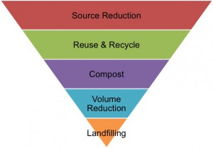
Waste Hierarchy

Reduce / Waste Minimization
- The best way to deal with trash is to not have any!
- Reducing the amount of trash you have to throw out actually prevents waste from piling up in the first place.
- To reduce your waste, avoid unnecessary packaging and items designed to be used only once.
  - Reduce the need for ’single use’ plastic bags by bringing your own bags when you shop, and use a travel mug when you buy coffee.
  - Choose durable, reusable products to make less trash.

Reuse
- Reusing items can save energy and money, and prolong the item’s useful life.
- Extend the life of items you buy by reusing them.
  - For example, reuse containers and jars, and donate still usable household goods and clothing to charity.

Recycle
- Every day we use products made from recycled materials.
- Take your glass, cans, newspapers, milk jugs and other acceptable recyclable items to your local transfer station, drop off location or place out for curbside collection so that they can be turned into new products like fleece jackets,
- Frisbees, paper products, and soda cans. Recycling saves money, energy, and the environment.
- 36.76% of Maine's municipal solid waste was recycled in 2015.

Compost
- Composting is nature's way of recycling organics.
- When you compost, you convert vegetable scraps, leaves, grass clippings and other materials into a nutrient rich soil material.
- You can use finished compost in your garden and around shrubs or other plants to help them grow.
- Composting also reduces the amount of materials that need to be disposed of, reducing those related costs.

Processing and Beneficial Use
- Processing reduces the volume of materials to be landfilled and can create products such as fuel oils and steam for electricity generation.
- Beneficial use means the reuse of solid waste as a substitute for raw material in manufacturing, as construction material or fill, as a fuel, or as an agronomic soil amendment.

Waste-To-Energy
- Waste-to-Energy facilities accept our solid waste and combust it at very high temperatures, producing heat that is used to convert water into steam. The steam is used to run turbines that generate electricity.
- Scrubbers, filters, and other pollution control equipment reduce pollutants released during the incineration process. Ash and other residues from this process are landfilled.
- Over 27% of Maine's municipal solid waste was combusted in 2015.

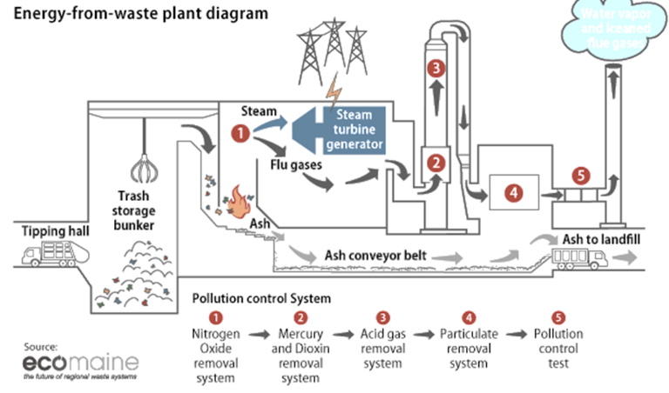

https://www.americanprogress.org/issues/green/reports/2013/04/17/60712/energy-from-waste-can-help-curb-greenhouse-gas-emissions/

Landfill
- Today’s landfills are very different from the old ones where people just dumped their garbage in an open area.
- Landfills are constructed and operated to strict environmental standards, including liners to protect groundwater.

Within this hierarchy, landfilling waste is the lowest priority of the solid waste management options.

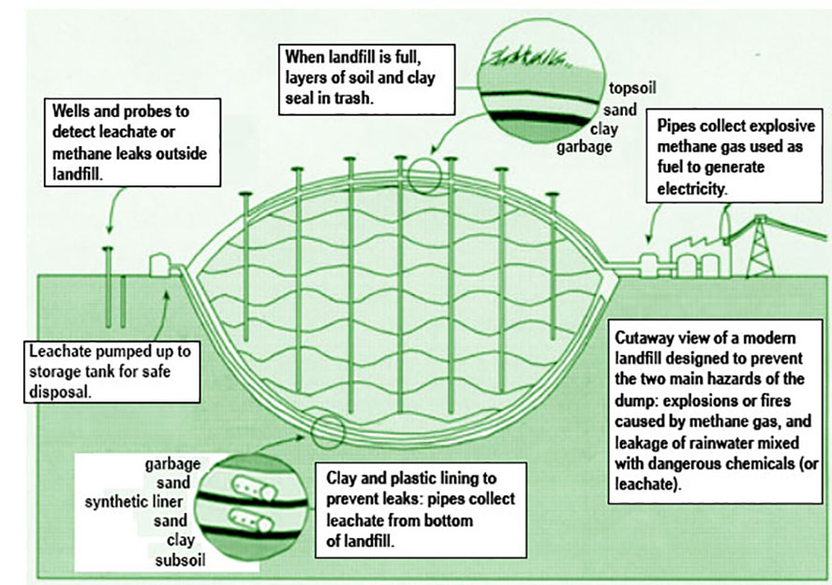
Cross Cutting Concepts Cause and effect relationships may be used to predict phenomena in natural or designed systems.

Designed systems can be made to utilize waste. We can predict the energy recovery they will generate.

How would using trash to create energy affect the volume of trash being put in landfills in the US?
The volume of trash put in a landfill is drastically reduced by this process. Predicting the amount of trash to be landfilled can be done fairly accurately, as can the change of volume produced by sending waste to a trash to energy plant.

How much energy can be produced by wastes?
The amount of energy (BTUs) in a given waste can be closely estimated. Energy for a mix of wastes can be calculated as well.

Demonstration Project  Calculating Waste to Energy |  | Materials taken from Source: http://www.balboa-pacific.com/WasteToEnergy/BTU_Values.pdf, http://www.waste360.com/mag/waste_profiles_garbage_yard

Introduction

Wastes contain energy, energy that can be used to our advantage rather than being buried in a landfill. Energy content can be listed in British Thermal Units, or Btus.

The British thermal unit (Btu or BTU) is a traditional unit of heat; it is defined as the amount of heat required to raise the temperature of one pound of water by one degree Fahrenheit. It is part of the United States customary units. Its counterpart in the metric system is the calorie, which is defined as the amount of heat required to raise the temperature of one gram of water by one degree Celsius. Heat is now known to be equivalent to energy, for which the SI unit is the joule; one BTU is about 1055 joules. Source: https://en.wikipedia.org/wiki/British_thermal_unit
WASTE | BTU/LB  (approximate value)
Yard Waste | 2,876
Newspaper | 7,975
Magazines | 5,250
Corn Cobs | 8,000
Coffee Grounds | 10,000
Citrus Rinds | 1,700
Coated Milk Cartons | 11,330
Animal Fats | 17,000
Rags | 7,200

Using the table above, determine the following:
- Which waste has the highest energy (Btu) content per pound?
  - Animal fats, 17,000 Btu/lb
- Which waste has the lowest energy (Btu) content per pound?
  - Citrus Rinds, 1,700 Btu/lb
- How many Btus are available for 20 pounds of Coffee Grounds? 20 pounds of Citrus Rinds?
  - Coffee grounds: 20 lbs of coffee grounds x 10,000 Btu/lb = 200,000 Btu
  - Citrus Rinds: 20 lbs of citrus rinds x 1,700 Btu/lb = 34,000 Btu

Boilers used for heating systems often operate at a pressure of 15 pounds per square inch (psi). Latent heat of evaporation for water at 15 psi is 945 Btu/lb. How many pounds of steam could be generated for a heating system by burning the following waste comprised of a mix of the following wastes in the amounts listed below? There is a total of 860 pounds of waste.

- 100 pounds of coffee grounds
- 200 pounds of yard waste
- 500 pounds of magazines
- 10 pounds of rags
- 50 pounds of animal fat

Steps to solving this problem.
- Determine the heat value (Btu) for each individual waste for the given weight.
- Total the Btus for the total (860 pounds) weight of the wastes.
- For each pound of steam you want to generate for a 15 psi boiler you need to supply 945 Btu. Therefore, to calculate the pounds of steam you can generate you must divide the total Btus provided by the waste by 945 Btu. This will allow you to calculate the pounds of steam you are able to generate.

Calculations for each individual waste

Coffee Grounds have 10,000 Btu/lb. 100 lb of coffee beans x 10,000 Btu/lb = 1,000,000 Btu

Yard Waste has 2,876 Btu/lb. 200 lb of yard waste x 2,876 Btu/lb = 575,200 Btu

Magazines have 5,250 Btu/lb. 500 lb of magazines x 5,250 Btu/lb = 2,625,000 Btu

Rags have 7,200 Btu/lb. 10 lb of rags x 7,200 Btu/lb = 72,000 Btu

Animal fat has 17,000 Btu/lb. 50 lbs of animal fat x 17,000 Btu/lb = 850,000 Btu

Total Btus for all wastes

= 1,000,000 Btu + 575,200 Btu + 2,625,000 Btu + 72,000 Btu + 850,000 Btu = 5,122,200 Btu

Reminder

For each pound of steam you want to generate for the 15 psi boiler you must supply 945 Btu.

Solution

5,122,000 Btu/(945 Btu/pound of steam generated) = 4,273,099 pounds of steam can be generated

(Below) coal -http://www.engineeringtoolbox.com/coal-heating-values-d_1675.html

All others - file:///C:/Users/CE%20User/Downloads/Lower_and_Higher_Heating_Values_of_Gas_Liquid_and_Solid_Fuels.pdf
Non-Renewable Fuels | Btu/lb  (approximate value)
Low-volatile bituminous | 14,340
Crude Oil | 18,352
Diesel Fuel | 18,397
Liquified Natural Gas (LNG) | 20,908
Low Sulfur Gasoline | 18,211

Questions for Discussion

Look at the second table of fuels and their heating values. Lead a discussion with the students using the following questions.
- Which has higher energy (Btu) contents per pound, the waste fuels or the fuels in the second table, non-renewable fuels?
The non-renewable fossil based fuels typically contain higher Btu/lb values.
- If the fossil fuels have a higher energy value why don’t we just use those and landfill the waste energy sources instead of burning them?
Fossil fuels are non-renewable, and do not provide the benefit of reducing the volume of waste going to the landfill. There are also considerations for each fuel regarding the amount and type of pollution each fuel will emit.
- How are the fossil fuels obtained, versus using waste materials for fuel?
Fossil fuels can be obtained by drilling for oil, digging for coal, collecting gases from wells, etc. Energy must be expended to collect the energy available in the fossil fuels.

Teacher Prep
 | Advanced Preparation Steps &  Duration | - Read and consider associated background material, demonstration procedures, and questions for discussion. (1 hour)  - Review video clip (7 minutes)  - Review Solid Waste & Recycling PowerPoint (15 minutes)  - Assemble Demonstration Materials & Practice (2 hours)
Needed Materials
- Video Clip - Pearson Landfills and Recycling Video Field Trip - https://vimeo.com/28170420 (Embedded in PowerPoint).
- PowerPoint
- Internet Connection
 | Duration of activities | 60 minutes
 | Safety notes | Not applicable to this exercise.
Procedures for instruction
 |  | Introduce the class to the idea of solid waste and recycling. | ~2 minutes
 |  | Introduce the Solid Waste and Recycling PowerPoint with Video embedded. | ~20 minutes  (PowerPoint)
 |  | Calculating Waste To Energy | ~25minutes  (In-Class)
 |  | Discussion | ~10 minutes
Student Materials
 | Background Informational Sheet | Reading assignment prior to the demonstration day.
 | Vocabulary List | Available for clarification of terminology as students read their Background Informational Sheet and Demonstration Procedure

Student Background Information Sheet – Solid Waste and Recycling
Introduction
The disposal of municipal solid waste (MSW) is currently a growing challenge in Maine due to declining landfill space, high disposal costs, and risks to public and environmental health.

MSW Composition of MSW in Maine (Criner & Blackmer, 2012)

The Maine DEP is responsible for licensing and monitoring Maine’s solid waste facilities; these facilities include landfills, incinerators, waste transfer stations, special waste sites, and recycling and composting operations. The general provisions of the Solid Waste Management Rules of the DEP requires the design of these facilities to prevent the contamination of any water in the state, ambient air, and also prevent health hazards.

Stakeholders
Three types of stakeholders comprise Maine’s waste management: governmental agencies, the public, and the private sector. Important governmental stakeholders include the federal Environmental Protection Agency (EPA) and the Maine DEP. Other public stakeholders include residents, and municipalities. The Private sector includes industry, private companies, non-profits, and non-governmental organizations (NGOs).

Federal Agencies
Federal agencies set regulations and guidelines on solid waste disposal, recycling, and hazardous waste disposal. Agencies such as the EPA are responsible for the state level implementation of federal laws, environmental standards, and state-level contributions to overall national environmental degradation.

State Agencies
Specific state agencies provide guidance and implementation plans for waste management. These agencies specifically set state goals and delegate waste disposal services to municipalities. Agencies such as the Maine DEP and the EPA are responsible for the licensing and monitoring of Maine’s solid waste facilities and transfer stations, as well as regulating various management programs.

Municipalities
Municipalities are entirely responsible for the management of waste disposal. They are required to provide waste disposal and recycling services to households and businesses, and provide waste reduction and safe waste disposal education to all their residents.

The Public
Maine residents are responsible for the generation of waste, are affected by implemented municipal policies, and invest in the future success of waste management. Residents bear the costs of waste disposal and recycling through direct payments or through taxes. Their actions are also very important to the waste management systems, as their household behavior affects waste generation and disposal.

The Private Sector
Privately-owned companies within the waste management system adhere to Maine regulations and provide waste collection services to residents. By providing these services, these companies are able to determine costs of waste disposal and recycling to either residents or municipalities.

NGOs (Non-Governmental Organization)
NGOs partner with municipalities or residents to help manage and facilitate waste management system and its programs as determined by the State. Specific in HHW management, NGOs voluntarily facilitate the product-specific stewardship management programs.

Industry
Manufacturers of household hazardous waste (HHW) products are primarily important as a stakeholder in the waste management system because of the responsibility some attain through the product stewardship program. The program requires these manufacturers to establish a balance with the government on selling and distributing their products, managing their products’ end-of-life (when a product can no longer be used), and providing the necessary funds for recycling programs.

Incineration facilities are also an important stakeholder in the waste management system because of the economic and environmental impact they have on other stakeholders in Maine Waste Management (Criner, 2013; Duchesne, 2013; Gabe, 2011, 2013; Williams, 2011). These disposal facilities provide jobs to Maine residents, as well as keep waste from ending up in landfills. However, incineration facilities are contributors to the creation of renewable energy in Maine, while also affecting public and environmental health impacts.
2nd topic source |  | Source Material taken from http://www.maine.gov/dep/sustainability/sw-hierarchy.html
What Can We Do With All This Waste?

Waste Hierarchy

Reduce / Waste Minimization
- The best way to deal with trash is to not have any!
- Reducing the amount of trash you have to throw out actually prevents waste from piling up in the first place.
- To reduce your waste, avoid unnecessary packaging and items designed to be used only once.
  - Reduce the need for ’single use’ plastic bags by bringing your own bags when you shop, and use a travel mug when you buy coffee.
  - Choose durable, reusable products to make less trash.

Reuse
- Reusing items can save energy and money, and prolong the item’s useful life.
- Extend the life of items you buy by reusing them.
  - For example, reuse containers and jars, and donate still usable household goods and clothing to charity.

Recycle
- Every day we use products made from recycled materials.
- Take your glass, cans, newspapers, milk jugs and other acceptable recyclable items to your local transfer station, drop off location or place out for curbside collection so that they can be turned into new products like fleece jackets,
- Frisbees, paper products, and soda cans. Recycling saves money, energy, and the environment.
- 36.76% of Maine's municipal solid waste was recycled in 2015.

Compost
- Composting is nature's way of recycling organics.
- When you compost, you convert vegetable scraps, leaves, grass clippings and other materials into a nutrient rich soil material.
- You can use finished compost in your garden and around shrubs or other plants to help them grow.
- Composting also reduces the amount of materials that need to be disposed of, reducing those related costs.

Processing and Beneficial Use
- Processing reduces the volume of materials to be landfilled and can create products such as fuel oils and steam for electricity generation.
- Beneficial use means the reuse of solid waste as a substitute for raw material in manufacturing, as construction material or fill, as a fuel, or as an agronomic soil amendment.

Waste-To-Energy
- Waste-to-Energy facilities accept our solid waste and combust it at very high temperatures, producing heat that is used to convert water into steam. The steam is used to run turbines that generate electricity.
- Scrubbers, filters, and other pollution control equipment reduce pollutants released during the incineration process. Ash and other residues from this process are landfilled.
- Over 27% of Maine's municipal solid waste was combusted in 2015.

https://www.americanprogress.org/issues/green/reports/2013/04/17/60712/energy-from-waste-can-help-curb-greenhouse-gas-emissions/

Landfill
- Today’s landfills are very different from the old ones where people just dumped their garbage in an open area.
- Landfills are constructed and operated to strict environmental standards, including liners to protect groundwater.

Within this hierarchy, landfilling waste is the lowest priority of the solid waste management options

Student Vocabulary List– Solid Waste
 | Argonomic | Application of the various soil and plant sciences to soil management and crop production; scientific agriculture.
 | Boiler | A fuel-burning unit for heating water. It is also a unit that can be used to provide a hot-water supply or serve a central heating system.
 | British Thermal Unit (Btu) | The British thermal unit (Btu or BTU) is a traditional unit of heat; it is defined as the amount of heat required to raise the temperature of one pound of water by one degree Fahrenheit.
 | Hazardous Waste | Hazardous wastes are wastes with properties that make them dangerous or potentially harmful to human health or the environment. Hazardous wastes can be liquids, solids, contained gases, or sludges.
 | Latent Heat of Vaporization | A physical property of a substance. ... When a material in liquid state is given energy, it changes its phase from liquid to vapor; the energy absorbed in this process is called heat of vaporization.
 | Leachate | Water that has percolated through a solid and leached out some of the constituents.
 | Scrubber | A diverse group of air pollution control devices that can be used to remove some particulates and/or gases from industrial exhaust streams.
 | Solid Waste | Any garbage or refuse, sludge from a wastewater treatment plant, water supply treatment plant, or air pollution control facility and other discarded material, resulting from industrial, commercial, mining, and agricultural operations, and from community activities.
 | Turbine | A rotary mechanical device that extracts energy from a fluid flow and converts it into useful work.

Student Worksheet – Solid Waste
WASTE | BTU/LB  (approximate value)
Yard Waste | 2,876
Newspaper | 7,975
Magazines | 5,250
Corn Cobs | 8,000
Coffee Grounds | 10,000
Citrus Rinds | 1,700
Coated Milk Cartons | 11,330
Animal Fats | 17,000
Rags | 7,200

Using the table above, determine the following:
- Which waste has the highest energy (Btu) content per pound? ______________________________
- Which waste has the lowest energy (Btu) content per pound? ______________________________

- How many Btus are available for 20 pounds of Coffee Grounds? 20 pounds of Citrus Rinds?
  - Coffee grounds: ____________________________________________________________

  - Citrus Rinds: _______________________________________________________________

Boilers used for heating systems often operate at a pressure of 15 pounds per square inch (psi). Latent heat of evaporation for water at 15 psi is 945 Btu/lb. How many pounds of steam could be generated for a heating system by burning the following waste comprised of a mix of the following wastes in the amounts listed below? There is a total of 860 pounds of waste.
- 100 pounds of coffee grounds
- 200 pounds of yard waste
- 500 pounds of magazines
- 10 pounds of rags
- 50 pounds of animal fat

With the assistance of your teacher, use the space below to calculate how many pounds of steam that could be generated for a 15 psi heating system.
Project Assessment
Project Title: ___________________________________________________________________________
Instructor/School/Grade: _______________________/______________________/________
Instructor Contact Information: __________________________________________________
Date you assigned this project to your class: _______ Number of Students Participating ______
The following questions are intended to help us understand your feelings regarding the presentation and materials. Your sincerity in answering these questions is appreciated. Please feel free to use the space at the end of the form for any additional comments that you may have. This form has been left in Microsoft Word format so that you may fill it in electronically. Please fill out the form completely and email your assessment to david.madore@maine.gov.
Ranking System
1 ~ Excellent / Strongly agree
2 ~ Good – Above average / Moderately agree
3 ~ Average – ok / Neutral in agree or disagree
4 ~ Poor – below average / Moderately disagree
4 ~ Very poor – not acceptable / Strongly disagree
NA / not applicable
Please continue on the second page…
1 | 2 | 3 | 4 | 5 | NA | Questions
 |  |  |  |  |  | Course Content
 |  |  |  |  |  | - Value of course content to you.
 |  |  |  |  |  | - Importance of course content given your teaching topic.
 |  |  |  |  |  | - Overall rating of course content.
 |  |  |  |  |  | - Ease of implementing materials into daily lessons.
 |  |  |  |  |  | Materials/Project
 |  |  |  |  |  | - Movie (if applicable) was easy to present.
 |  |  |  |  |  | - Student worksheet was useful and easy to follow.
 |  |  |  |  |  | - Student project stimulated thinking & conversation.
 |  |  |  |  |  | - The project put ideas across effectively.
 |  |  |  |  |  | - Teacher materials were useful and easy to follow.
 |  |  |  |  |  | - The method of material presentation encouraged students feel free to ask questions, disagree, express ideas, etc.
 |  |  |  |  |  | Self-Evaluation (Instructor)
 |  |  |  |  |  | - What was your level of knowledge concerning this topic prior to this presentation?
Please share any recommendations you feel would be helpful.

Thank you for providing your feedback!

Please email your assessment to david.madore@maine.gov.

