DEP Environmental Education Curricula
Lesson Plan
GRAD/LEVEL: Highschool
LESSON TITLE: Environmental Careers
Next Generation Science Standards
HS-ESS3-4 | HS-ESS3-4 | Evaluate or refine a technological solution that reduces impacts of human activities on natural systems.
 | Science and Engineering Practices | Design or refine a solution to a complex real-world problem, based on scientific knowledge, student-generated sources of evidence, prioritized criteria, and tradeoff considerations.
 | Disciplinary Core Ideas | Scientists and engineers can make major contributions by developing technologies that produce less pollution and waste and that preclude ecosystem degradation.
 | Crosscutting Concepts | Feedback (negative or positive) can stabilize or destabilize a system.
Objectives
Objective 1: Students will learn about the different levels of post high school educational opportunities.
Objective 2: Students will discuss seven popular environmental careers, considering topic areas such as – what do they do? where do they work? Level of education needed?
Objective 3: Students will research career opportunities by utilizing the United States Department of Labor Bureau of Labor Statistics web site.
Vocabulary
 | Asbestos | Fibrous mineral formerlyused for making incombustible or fireproof articles.
 | OSHA | Occupational Health and Safety Administration
Background
Teacher Version  Selected Materials from … |  | Source: https://www.bls.gov or as noted.
Environmental Careers
This presentation will focus on the following environmental career paths. It is by no means an exhaustive list of opportunities, but will give students an idea of some of the paths they may choose if they are interested in pursuing this area of study/work:
- Zoologist/Wildlife Biologists
- Environmental Engineers
- Environmental Scientists
- Hazardous Waste Removal/Spill response
- Environmental Science and Protection Technicians
- Environmental Education
- Conservation/Non-Profit
- Chemist
- Hydrologist
- Geologist
- Environmental Lawyer

Education Levels to Consider
This area gives a quick introduction to some of the common education levels found in the United States. Many students are typically unfamiliar with the wide array of levels of educational/training opportunities and what may be required for a career track. This brief introduction will give the students a framework for their future discussions.

High School or General Equivalency Diploma are the minimum needed educational level to work in the environmental careers, for most cases.

Technical Training teaches the skills needed to design, develop, implement, maintain, support or operate a particular technology or related application, product or service.
(Source: https://www.trainingindustry.com/glossary/technical-training/)

An associate degree (or associate's degree) is an undergraduate academic degree awarded by colleges and universities upon completion of a course of study intended to usually last two years. It is considered to be greater level of education than a high school diploma or General Equivalency Diploma (GED).
(Source: https://en.wikipedia.org/wiki/Associate_degree)

A bachelor's degree (from Middle Latin baccalaureus) or baccalaureate (from Modern Latin baccalaureatus) is an undergraduate academic degree awarded by colleges and universities upon completion of a course of study lasting three to seven years – often four years in the U.S. - (depending on institution and academic discipline).
(Source: https://en.wikipedia.org/wiki/Bachelor%27s_degree)

A master's degree (from Latin magister) is usually a second-cycle academic degree awarded by universities or colleges upon completion of a course of study demonstrating mastery or a high-order overview of a specific field of study or area of professional practice.
(Source: https://en.wikipedia.org/wiki/Master%27s_degree) It typically takes several years to complete a Master’s degree, although programs may vary.

A doctorate (from Latin docere, "to teach") or doctor's degree (from Latin doctor, "teacher") or doctoral degree (from the ancient formalism licentia docendi) is awarded by universities that is, in most countries, a research degree that qualifies the holder to teach at the university level in the degree's field, or to work in a specific profession.
(Source: https://en.wikipedia.org/wiki/Doctorate)

Review of Several Environmental Careers
Zoologists/Wildlife Biologists: What do they do?
- Zoologists and wildlife biologists study animals and other wildlife and how they interact with their ecosystems.
- They study
  - the physical characteristics of animals
  - animal behaviors
  - the impacts humans have on wildlife and natural habitats.
(source: https://www.bls.gov/ooh/life-physical-and-social-science/zoologists-and-wildlife-biologists.htm#tab-2)
Example: Wildlife Biologist Randy Cross and “Dozer”

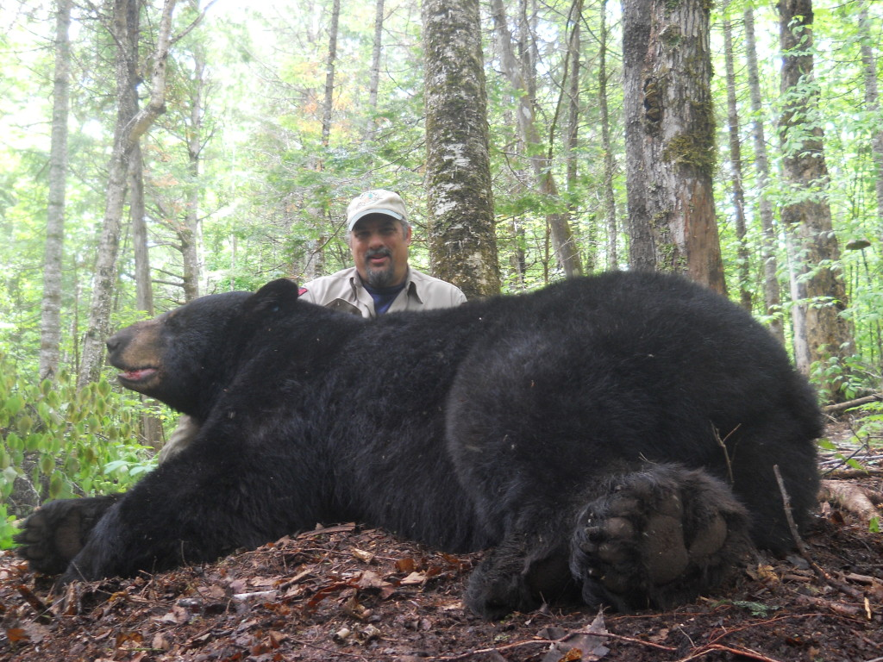

Sometimes Cross receives a welcome surprise, when bears he “met” before return and temporarily are captured with a cable foot-restraint trap. Cross, who works for the Maine Department of Inland Fisheries and Wildlife, sent a photo of a bear he thinks is one researchers call “Dozer.” Dozer is now a doozie and weighed in at 442 pounds. Cross said the bear was caught in the state’s Bradford study area.
(Source: http://outthere.bangordailynews.com/2015/06/19/outdoor-recreation/bear-crew-recaptures-442-pound-male/)
Zoologists/Wildlife Biologists: Where do they work?
- Zoologists and wildlife biologists work in offices, laboratories, and outdoors.
  - Depending on their job and interests, they may spend considerable time in the field gathering data and studying animals in their natural habitats.
  - Other zoologists and wildlife biologists may spend very little time in the field.
- Fieldwork can require zoologists and wildlife biologists to travel to remote locations anywhere in the world.
(source: https://www.bls.gov/ooh/life-physical-and-social-science/zoologists-and-wildlife-biologists.htm#tab-2)
Education Needed for Zoologist/Wildlife Biologist

- Zoologists and wildlife biologists typically need at least a bachelor’s degree.
  - An undergraduate degree in biology with coursework in zoology and wildlife biology typically is good preparation for a career as a zoologist or wildlife biologist.
- Zoologists and wildlife biologists typically need at least a master’s degree for higher level investigative or scientific work.
  - A Ph.D. is necessary for the majority of independent research positions and for university research positions.
Zoologists generally specialize first in either vertebrates or invertebrates and then in specific species.

(Source: https://www.bls.gov/ooh/life-physical-and-social-science/zoologists-and-wildlife-biologists.htm#tab-2)
Environmental Engineers: What do they do?
- Environmental engineers use the principles of engineering, science, biology, and chemistry to develop solutions to environmental problems.
  - They work to improve recycling, waste disposal, public health, and water and air pollution control.
  - They also address global issues, such as unsafe drinking water, climate change, and environmental sustainability.
https://www.bls.gov/ooh/architecture-and-engineering/environmental-engineers.htm
Environmental Engineers: Where do they work?
- Environmental engineers work in a variety of settings because of the nature of the tasks they do:
  - When they are working with other engineers and with urban and regional planners, environmental engineers are likely to be in offices.
  - When they are working with businesspeople and lawyers, environmental engineers are likely to be at seminars, presenting information and answering questions.
  - When they are working with hazardous materials removal workers and environmental scientists, environmental engineers work at specific sites outdoors.
https://www.bls.gov/ooh/architecture-and-engineering/environmental-engineers.htm
Education Needed for Environmental Engineers
Environmental engineers must have a bachelor’s degree in environmental engineering or a related field, such as civil, chemical, or general engineering.
Employers also value practical experience. Therefore, cooperative engineering programs, in which college credit is awarded for structured job experience, are valuable as well.

Environmental Scientists: What do they do?
Environmental scientists and specialists use their knowledge of the natural sciences to protect the environment and human health.
They may clean up polluted areas, advise policymakers, or work with industry to reduce waste.
Environmental Scientists: Where do they work?
Environmental scientists and specialists work in offices and laboratories.
Some may spend time in the field gathering data and monitoring environmental conditions firsthand, but this work is much more likely to be done by environmental science and protection technicians.
Environmental scientists and specialists may have to travel to meet with clients or present research at conferences.
Education Needed for Environmental Scientists
For most entry-level jobs, environmental scientists and specialists must have a bachelor’s degree in environmental science or a science-related field, such as biology, chemistry, physics, geosciences, or engineering. However, a master’s degree may be needed for advancement.
Environmental scientists and specialists who have a doctoral degree make up a small percentage of the occupation, and this level of training typically is needed only for the relatively few postsecondary teaching and basic research positions.

Hazardous Materials Removal Worker/Spill Response: What do they do?
Hazardous materials (hazmat) removal workers identify and dispose of asbestos, lead, radioactive waste, and other hazardous materials. They also neutralize and clean up materials that are flammable, corrosive, or toxic.
Spill response workers understand: what a spill is, characteristics of a spill response, and how to identify and control hazards pertaining to the response and cleanup activities associated with a spill.
Maine Department of Environmental Protection (DEP) - Spill Response
Education Needed for Hazardous Waste Removal/Spill Response Workers
Hazmat removal workers typically need a high school diploma. Technical training is required and often very specialized…
Hazmat removal workers receive training on the job. Training generally includes a combination of classroom instruction and fieldwork.
In the classroom, they learn safety procedures and the proper use of personal protective equipment. Onsite, they learn about equipment and chemicals, and are supervised by an experienced worker.
Workers must often complete training in accordance with OSHA standards. The length of training depends on the type of material that the workers handle.
Hazardous Waste and Spill Response Workers: Where do they work?
Working conditions vary with the hazardous material being removed.
For example, workers removing lead or asbestos often work in confined spaces or at great heights and bend or stoop to remove the material.
Workers responding to emergency and disaster scenarios may work outside in all weather conditions.
Many other workers are employed at facilities such as landfills, incinerators, and industrial furnaces. Others may work at nuclear facilities and electric power plants.

Environmental Science and Protection Technicians: What do they Do?
Environmental science and protection technicians use laboratory equipment, such as microscopes, to analyze samples collected in the field.
Environmental science and protection technicians monitor the environment and investigate sources of pollution and contamination, including those affecting public health.
Education Needed for Environmental Science and Protection Technicians
Environmental science and protection technicians typically need an associate’s degree in environmental science, environmental health, or public health, or a related degree.
Because of the wide range of tasks, environments, and industries in which these technicians work, there are jobs that do not require postsecondary education and others that require a bachelor’s degree.
Environmental Science and Protection Technicians: Where do they work?
Environmental science and protection technicians work in laboratories, offices, and in the field.

Environmental Education: What do Teachers Do?
Kindergarten and elementary school teachers instruct young students in basic subjects, such as math and reading, to prepare them for future schooling.
High school teachers help prepare students for life after graduation. They teach academic lessons and various skills that students will need to attend college and to enter the job market.
Postsecondary teachers instruct students in a wide variety of academic and technical subjects beyond the high school level. They may also conduct research and publish scholarly papers and books.
Education Needed to become a Teacher
Kindergarten, elementary, and high school teachers must have at least a bachelor’s degree. In addition, public school teachers must have a state-issued certification or license.
Post-secondary (college) Educational requirements vary by subject and the type of educational institution. Typically, postsecondary teachers must have a Ph.D. However, a master's degree may be enough for some postsecondary teachers at community colleges, and others may need work experience in their field of expertise.
Environmental Conservation and/or Non-Profit Work
Conservationists manage environmental protection efforts in order to balance the needs of human users with environmental health. They manage projects that maintain ecosystem health and protect natural resources from a variety of threats. They are involved in land-use negotiations to meet the needs of users like farmers and other landowners. Some conservationists specialize in a particular area of the field, such as range management, land management or soil and water conservation.
Environmental Conservation and/or Non-Profit Work
Work in this area can vary widely depending on your area of interest and your level of education.

Chemists: What do they do?
Chemists and materials scientists study substances at the atomic and molecular levels and analyze the ways in which the substances interact with one another.
Chemists: Where do they work?
Chemists and materials scientists work in laboratories, the field, and offices. They typically work full time and keep regular hours.
Education Needed for A Chemist
Chemists and materials scientists need at least a bachelor’s degree in chemistry or a related field. However, a master’s degree or Ph.D. is needed for many research jobs.

Hydrologists: What do they do?
Hydrologists study how water moves across and through the Earth’s crust. They use their expertise to solve problems in the areas of water quality or availability.
Hydrologists: Where do they work?
Hydrologists work in offices and in the field. In offices, hydrologists spend much of their time using computers to analyze data and model their findings. In the field, hydrologists may have to wade into lakes and streams to collect samples or to read and inspect monitoring equipment.
Educational Needs for a Hydrologist
Hydrologists need at least a bachelor’s degree for entry-level positions; however, some workers begin their careers with a master’s degree.

Geologists: What do they do?
Study the composition, structure, and history of the earth's crust. Examine rocks, minerals, and fossil remains to identify and determine sequence of processes affecting development of the earth. Apply knowledge of chemistry, physics, biology, and mathematics to explain these phenomena and to help locate mineral and petroleum deposits and underground water resources. Prepare geologic reports and maps, interpret data and recommend further study or action.
Geologists: Where do they work?
Most split their time between working indoors in offices and laboratories and working outdoors.
Educational Needs for a Geologist
Geologists typically need at least a bachelor’s degree for most entry-level positions.

Environmental Lawyers: What do they do?
Lawyers advise and represent individuals, businesses, and government agencies on legal issues and disputes.
Environmental Lawyers: Where do they work?
Many lawyers work in private and corporate legal offices. Some work for federal, local, and state governments. Most work full time, and many work more than 40 hours a week.

Educational Needs for an Environmental Lawyer
Lawyers must have a law degree and must also typically pass a state’s written bar examination.
Demonstration Project  Exploring Career Options |  |  | Materials taken from Source:  https://www.bls.gov/ooh/
Name: _______________________ Date: ___________________
Exploring Career Options
With your teacher’s permission go to the United States Department of Labor Bureau of Labor Statistics https://www.bls.gov/ooh/ to complete the following assignment.
Choose one of the following career options (discussed in class) that interests you the most.
- Zoologist/Wildlife Biologists
- Environmental Engineers
- Environmental Scientists
- Hazardous Waste Removal/Spill response
- Environmental Science and Protection Technicians
- Environmental Education
- Conservation/Non-Profit (see Social and Community Service Managers)

The area of environmental careers that interests me the most is _____________________________.

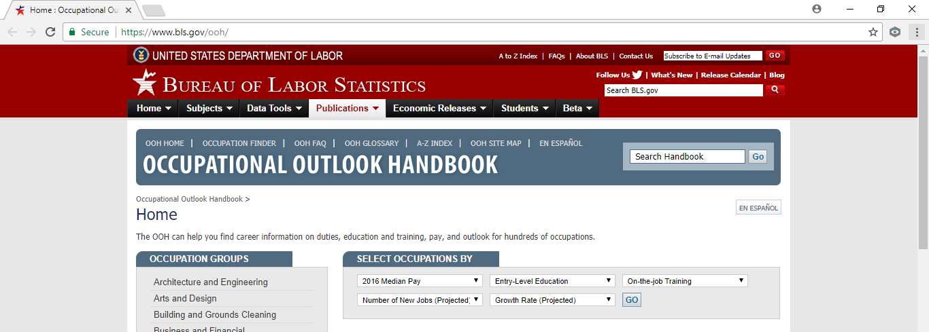
Type this into the “Search Handbook” window (location highlighted by the arrow in the above photo) and click on the associated “go” button. This will bring you to a second page listing options that you may choose from to learn details about your selection. Select the option closest to your choice. An example search follows….

Using Zoologist as an example: Type “zoologist’ into the “Search Handbook” window as shown below.
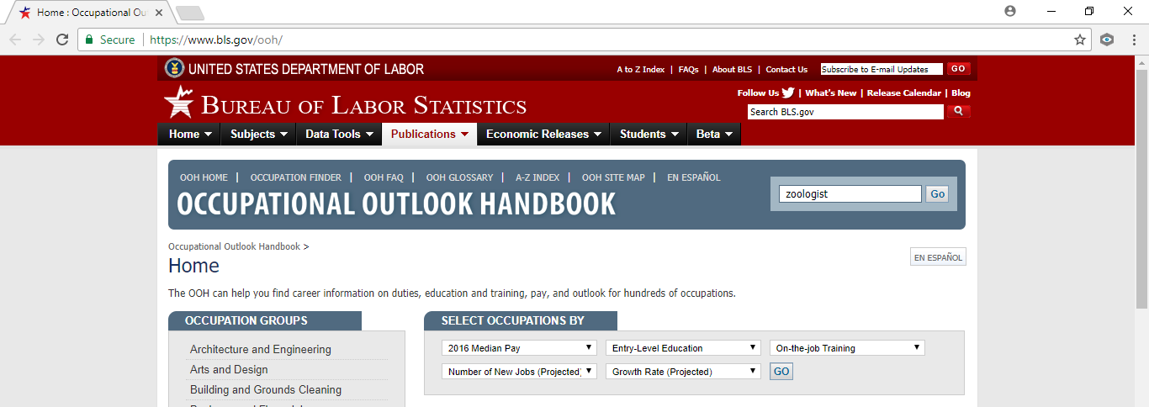
Press “go” near your entry to be brought to the following window:
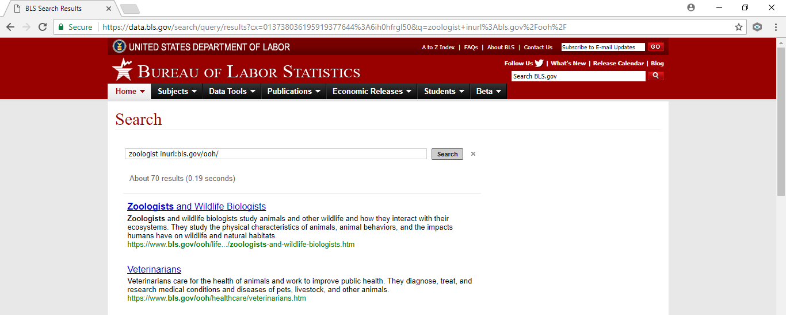
Select the “Zoologists and Wildlife Biologists” link to be brought to the following window:
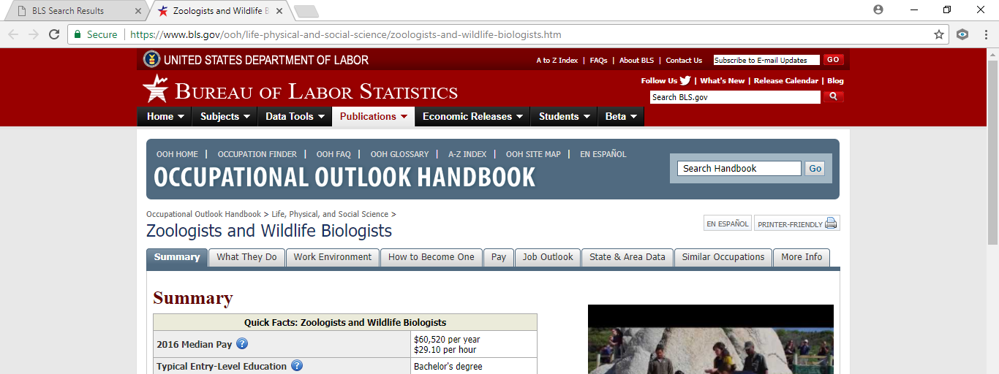
On this page your information can be found by reading through the summary table and/or selecting the tabs above the summary table for more details.

Answer the following questions concerning your area of interest:
• How does the occupation fit your skills and interests?
____________________________________________________________________________________________________________________________________________________________________________________________________________________________________________________________________________________________________________________________________________
• What will you be doing in the occupation? (List a few examples below) _________________________________________________________________________________________________________________________________________________________________________________________________________________________________________________________
• What is the necessary education and/or training? _________________________________________________________________________________________________________________________________________________________________________________________________________________________________________________________
• How many jobs are there in the occupation currently? ______________________________________________________________________________________________________________________________________________________________________
• Is the occupation projected to grow, decline, or remain unchanged? Why? _________________________________________________________________________________________________________________________________________________________________________________________________________________________________________________________
• How much does this occupation pay? ___________________________________________________________________________________
Choose one other occupation of your choosing (environmentally related or not), perhaps a path you are considering for a career. Repeat the exercise above.
Answer the following questions concerning your 2nd area of interest _________________________
• How does the occupation fit your skills and interests?
____________________________________________________________________________________________________________________________________________________________________________________________________________________________________________________________________________________________________________________________________________
• What will you be doing in the occupation? (List a few examples below) _________________________________________________________________________________________________________________________________________________________________________________________________________________________________________________________
• What is the necessary education and/or training? _________________________________________________________________________________________________________________________________________________________________________________________________________________________________________________________
• How many jobs are there in the occupation currently? ______________________________________________________________________________________________________________________________________________________________________
• Is the occupation projected to grow, decline, or remain unchanged? Why? ___________________________________________________________________________________
• How much does this occupation pay? ___________________________________________________________________________________

Be prepared to share your information with your teacher and classmates in future discussions.
Note: This website is a good resource for you to explore any of your career interests!

Questions for Discussion
Discuss in class the career options that students have chosen, both in the environmental field and outside of this area. Ask why the students chose the career they did and why.

Teacher Prep
 | Advanced Preparation Steps &  Duration | - Read and consider associated background material, visit the United States Department of Labor Bureau of Labor Statistics https://www.bls.gov/ooh/ for familiarity, and questions for discussion. (1 hour)  - Review Environmental Career PowerPoint (20 minutes)  - Practice Student Assignment with a career of your choosing (30 minutes hours)
Needed Materials
- Environmental Careers Power Point
- Environmental Careers Lesson Plant
- Internet Access for student work
 | Duration of activities | 60 minutes
 | Safety notes | Always follow your school rules when going online for computer work.
Procedures for instruction
 |  | Introduce the class to the idea of environmental careers. |  | ~2 minutes
 |  | Introduce the education levels and discuss the selected environmental careers in more detail. |  | ~30 minutes  (PowerPoint)
 |  | Environmental Careers Worksheet |  | ~15 minutes
 |  | Discussion |  | ~15 minutes
Student workbook
 | Background Informational Sheet | Reading assignment prior to the demonstration day.
 | Vocabulary List | Available for clarification of terminology as students read their Background Informational Sheet and Demonstration Procedure

Student Background Information Sheet – Environmental Careers
Environmental Careers
This presentation will focus on the following environmental career paths. It is by no means an exhaustive list of opportunities, but will give you an idea of some of the paths you may choose if you are interested in pursuing this area of study/work:
- Zoologist/Wildlife Biologists
- Environmental Engineers
- Environmental Scientists
- Hazardous Waste Removal/Spill response
- Environmental Science and Protection Technicians
- Environmental Education
- Conservation/Non-Profit

Education Levels to Consider
This area gives a quick introduction to some of the common education levels found in the United States. Many students are typically unfamiliar with the wide array of levels of educational/training opportunities and what may be required for a career track. This brief introduction will give you a framework for their future discussions.

High School or General Equivalency Diploma are the minimum needed educational level to work in the environmental careers, for most cases.

Technical Training teaches the skills needed to design, develop, implement, maintain, support or operate a particular technology or related application, product or service.
(Source: https://www.trainingindustry.com/glossary/technical-training/)

An associate degree (or associate's degree) is an undergraduate academic degree awarded by colleges and universities upon completion of a course of study intended to usually last two years. It is considered to be greater level of education than a high school diploma or General Equivalency Diploma (GED).
(Source: https://en.wikipedia.org/wiki/Associate_degree)

A bachelor's degree (from Middle Latin baccalaureus) or baccalaureate (from Modern Latin baccalaureatus) is an undergraduate academic degree awarded by colleges and universities upon completion of a course of study lasting three to seven years – often four years in the U.S. - (depending on institution and academic discipline).
(Source: https://en.wikipedia.org/wiki/Bachelor%27s_degree)

A master's degree (from Latin magister) is usually a second-cycle academic degree awarded by universities or colleges upon completion of a course of study demonstrating mastery or a high-order overview of a specific field of study or area of professional practice.
(Source: https://en.wikipedia.org/wiki/Master%27s_degree) It typically takes several years to complete a Master’s degree, although programs may vary.

A doctorate (from Latin docere, "to teach") or doctor's degree (from Latin doctor, "teacher") or doctoral degree (from the ancient formalism licentia docendi) is awarded by universities that is, in most countries, a research degree that qualifies the holder to teach at the university level in the degree's field, or to work in a specific profession.
(Source: https://en.wikipedia.org/wiki/Doctorate)

Review of Several Environmental Careers
Zoologists/Wildlife Biologists: What do they do?
- Zoologists and wildlife biologists study animals and other wildlife and how they interact with their ecosystems.
(source: https://www.bls.gov/ooh/life-physical-and-social-science/zoologists-and-wildlife-biologists.htm#tab-2)
Zoologists/Wildlife Biologists: Where do they work?
- Zoologists and wildlife biologists work in offices, laboratories, and outdoors.
(source: https://www.bls.gov/ooh/life-physical-and-social-science/zoologists-and-wildlife-biologists.htm#tab-2)
Education Needed for Zoologist/Wildlife Biologist
- Zoologists and wildlife biologists typically need at least a bachelor’s degree.
- Zoologists and wildlife biologists typically need at least a master’s degree for higher level investigative or scientific work.
Zoologists generally specialize first in either vertebrates or invertebrates and then in specific species.
(Source: https://www.bls.gov/ooh/life-physical-and-social-science/zoologists-and-wildlife-biologists.htm#tab-2)

Environmental Engineers: What do they do?
- Environmental engineers use the principles of engineering, science, biology, and chemistry to develop solutions to environmental problems.
https://www.bls.gov/ooh/architecture-and-engineering/environmental-engineers.htm
Environmental Engineers: Where do they work?
- Environmental engineers work in a variety of settings because of the nature of the tasks they do.
https://www.bls.gov/ooh/architecture-and-engineering/environmental-engineers.htm
Education Needed for Environmental Engineers
Environmental engineers must have a bachelor’s degree in environmental engineering or a related field, such as civil, chemical, or general engineering.
Employers also value practical experience. Therefore, cooperative engineering programs, in which college credit is awarded for structured job experience, are valuable as well.

Environmental Scientists: What do they do?
Environmental scientists and specialists use their knowledge of the natural sciences to protect the environment and human health.
Environmental Scientists: Where do they work?
Environmental scientists and specialists work in offices and laboratories.
Education Needed for Environmental Scientists
For most entry-level jobs, environmental scientists and specialists must have a bachelor’s degree in environmental science or a science-related field, such as biology, chemistry, physics, geosciences, or engineering. However, a master’s degree may be needed for advancement.

Hazardous Materials Removal Worker/Spill Response: What do they do?
Hazardous materials (hazmat) removal workers identify and dispose of asbestos, lead, radioactive waste, and other hazardous materials. They also neutralize and clean up materials that are flammable, corrosive, or toxic.
Spill response workers understand: what a spill is, characteristics of a spill response, and how to identify and control hazards pertaining to the response and cleanup activities associated with a spill.
Education Needed for Hazardous Waste Removal/Spill Response Workers
Hazmat removal workers typically need a high school diploma. Technical training is required and often very specialized…
Hazmat removal workers receive training on the job. Training generally includes a combination of classroom instruction and fieldwork.
Hazardous Waste and Spill Response Workers: Where do they work?
Working conditions vary with the hazardous material being removed.

Environmental Science and Protection Technicians: What do they Do?
Environmental science and protection technicians use laboratory equipment, such as microscopes, to analyze samples collected in the field.
Environmental science and protection technicians monitor the environment and investigate sources of pollution and contamination, including those affecting public health.
Education Needed for Environmental Science and Protection Technicians
Environmental science and protection technicians typically need an associate’s degree in environmental science, environmental health, or public health, or a related degree.
Because of the wide range of tasks, environments, and industries in which these technicians work, there are jobs that do not require postsecondary education and others that require a bachelor’s degree.
Environmental Science and Protection Technicians: Where do they work?
Environmental science and protection technicians work in laboratories, offices, and in the field.

Environmental Education: What do Teachers Do?
Kindergarten and elementary school teachers instruct young students in basic subjects, such as math and reading, to prepare them for future schooling.
High school teachers help prepare students for life after graduation. They teach academic lessons and various skills that students will need to attend college and to enter the job market.
Postsecondary teachers instruct students in a wide variety of academic and technical subjects beyond the high school level. They may also conduct research and publish scholarly papers and books.
Education Needed to become a Teacher
Kindergarten, elementary, and high school teachers must have at least a bachelor’s degree. In addition, public school teachers must have a state-issued certification or license.
Post-secondary (college) Educational requirements vary by subject and the type of educational institution. Typically, postsecondary teachers must have a Ph.D. However, a master's degree may be enough for some postsecondary teachers at community colleges, and others may need work experience in their field of expertise.

Environmental Conservation and/or Non-Profit Work
Conservationists manage environmental protection efforts in order to balance the needs of human users with environmental health.
Environmental Conservation and/or Non-Profit Work
Work in this area can vary widely depending on your area of interest and your level of education.

Chemists: What do they do?
Chemists and materials scientists study substances at the atomic and molecular levels and analyze the ways in which the substances interact with one another.
Chemists: Where do they work?
Chemists and materials scientists work in laboratories, the field, and offices. They typically work full time and keep regular hours.
Education Needed for A Chemist
Chemists and materials scientists need at least a bachelor’s degree in chemistry or a related field. However, a master’s degree or Ph.D. is needed for many research jobs.

Hydrologists: What do they do?
Hydrologists study how water moves across and through the Earth’s crust. They use their expertise to solve problems in the areas of water quality or availability.
Hydrologists: Where do they work?
Hydrologists work in offices and in the field. In offices, hydrologists spend much of their time using computers to analyze data and model their findings. In the field, hydrologists may have to wade into lakes and streams to collect samples or to read and inspect monitoring equipment.
Educational Needs for a Hydrologist
Hydrologists need at least a bachelor’s degree for entry-level positions; however, some workers begin their careers with a master’s degree.

Geologists: What do they do?
Study the composition, structure, and history of the earth's crust. Examine rocks, minerals, and fossil remains to identify and determine sequence of processes affecting development of the earth. Apply knowledge of chemistry, physics, biology, and mathematics to explain these phenomena and to help locate mineral and petroleum deposits and underground water resources. Prepare geologic reports and maps, interpret data and recommend further study or action.
Geologists: Where do they work?
Most split their time between working indoors in offices and laboratories and working outdoors.
Educational Needs for a Geologist
Geologists typically need at least a bachelor’s degree for most entry-level positions.

Environmental Lawyers: What do they do?
Lawyers advise and represent individuals, businesses, and government agencies on legal issues and disputes.
Environmental Lawyers: Where do they work?
Many lawyers work in private and corporate legal offices. Some work for federal, local, and state governments. Most work full time, and many work more than 40 hours a week.
Educational Needs for an Environmental Lawyer
Lawyers must have a law degree and must also typically pass a state’s written bar examination.

Student Vocabulary List– Environmental Careers
 | Asbestos | Fibrous mineral formerlyused for making incombustible or fireproof articles.
 | OSHA | Occupational Health and Safety Administration

Project Assessment
Project Title: ___________________________________________________________________________
Instructor/School/Grade: _______________________/______________________/_________________
Instructor Contact Information: ________________________________________________________________
Date assigned: _____________ Number of Students Participating ____________
The following questions are intended to help us understand your feelings regarding the presentation and materials. Your sincerity in answering these questions is appreciated. Please feel free to use the space at the end of the form for any additional comments that you may have. This form has been left in Microsoft Word format so that you may fill it in electronically. Please fill out the form completely and email your assessment to david.madore@maine.gov.
Ranking System
1 ~ Excellent / Strongly agree
2 ~ Good – Above average / Moderately agree
3 ~ Average – ok / Neutral in agree or disagree
4 ~ Poor – below average / Moderately disagree
4 ~ Very poor – not acceptable / Strongly disagree
NA / not applicable
Please continue on the second page…
1 | 2 | 3 | 4 | 5 | NA | Questions
 |  |  |  |  |  | Course Content
 |  |  |  |  |  | - Value of course content to you.
 |  |  |  |  |  | - Importance of course content given your teaching topic.
 |  |  |  |  |  | - Overall rating of course content.
 |  |  |  |  |  | - Ease of implementing materials into daily lessons.
 |  |  |  |  |  | Materials/Project
 |  |  |  |  |  | - Movie (if applicable) was easy to present.
 |  |  |  |  |  | - Student worksheet was useful and easy to follow.
 |  |  |  |  |  | - Student project stimulated thinking & conversation.
 |  |  |  |  |  | - The project put ideas across effectively.
 |  |  |  |  |  | - Teacher materials were useful and easy to follow.
 |  |  |  |  |  | - The method of material presentation encouraged students feel free to ask questions, disagree, express ideas, etc.
 |  |  |  |  |  | Self-Evaluation (Instructor)
 |  |  |  |  |  | - What was your level of knowledge concerning this topic prior to this presentation?
Please share any recommendations you feel would be helpful.

Thank you for providing your feedback!
Please email your assessment to david.madore@maine.gov.

