STATE OF MAINE REQUEST FOR PROPOSALS

RFP AMENDMENT #1 AND

RFP SUBMITTED QUESTIONS & ANSWERS SUMMARY

RFP NUMBER AND TITLE: | 202402044 – Transit Asset Management Software as a Service
RFP ISSUED BY: | Department of Transportation
SUBMITTED QUESTIONS DUE DATE: | April 29, 2024, no later than 11:59 p.m., local time
AMENDMENT AND QUESTION & ANSWER SUMMARY ISSUED: | May 14, 2024
PROPOSAL DUE DATE: | June 10, 2024, no later than 11:59 p.m., local time (As Amended)
PROPOSALS DUE TO: | proposals@maine.gov
Unless specifically addressed below, all other provisions and clauses of the RFP remain unchanged.

DESCRIPTION OF CHANGES IN RFP (if any):
All references to the RFP Proposal Submission Deadline of May 20, 2024, no later than 11:59 p.m., local time are amended to June 10, 2024, no later than 11:59 p.m., local time.
REVISED LANGUAGE IN RFP (if any):

Proposal Submission Deadline | Proposals must be received by the Division of Procurement Services by:  Submission Deadline: June 10th, 2024, no later than 11:59 p.m., local time.  Proposals must be submitted electronically to: Proposals@maine.gov

Provided below are submitted written questions received and the Department’s answer.

1 | RFP Section & Page Number | Question
 | RFP Part I, p. 5 | - Can you explain the overlap with the centralized Public/Citizen Portal initiative scope of work?  - Part II, A. Scope of Services to be Provided, 2. Implementation Services, page 5 states “No systems integration is required.” However, Part I, A. Purpose and Background discusses a public/citizen portal. Additionally, on page 25 of Appendix D under 2. External User Management, the RFP states “it is not likely to be available for the initial implementation. DOT anticipates handling it as a later task order. Can the Department please confirm there are no system integrations required for this RFP? If there are required integrations, please indicate the following for each:  - What is the System name and version?  - Is this one way or two way data exchange?  - What is the sync frequency?  - What data points are exchanged?  - What is the goal of the integration?  - Does the integration require real-time data transfer or batch imports?  - Is there a Rest API available for the integration?
 | Answer
 | This effort is independent from that effort. Some day in the future an integration might be added.

2 | RFP Section & Page Number | Question
 | RFP Part II, p.7 | What integrations are in scope for this project?
 | Answer
 | None as is stated in the RFP Part II A-2, p.7 Implementation Services.

3 | RFP Section & Page Number | Question
 | RFP Part II, p. 7 | Can the data load be completed by having the current data copied to templated Excel spreadsheets provided by the vendor versus using existing Excel documents mentioned in this section of the RFP?
 | Answer
 | As stated in Part II, data transformations are the responsibility of the vendor; however, that does not mean that data transformations are not expected. This is a vendor responsibility.

4 | RFP Section & Page Number | Question
 | RFP Part II, A, p. 7 | Part II, A. Scope of Services to be Provided, 2. Implementation Services, c. on page 5 states “The Department expects to load the system with the current transit provider and asset data stored in its Excel and MS Access databases.” Regarding data conversion from the current systems used by the Department:  - What is the quality of the data? How many years of data will need to be migrated to the new EAM system?  - What data will be converted, i.e. work, cost history, inspection history, request history, etc.?  - What assets would need to be in this project?
 | Answer
- We are looking to load the data from the current Access Database and the current PTMS report to the new system. The inventory data in the Vehicle Database contains information on 282 vehicles. The overall data quality in the database is good with the exception of the Contract and Grant Percentages fields, and some vendor names. The Contract field in the database is limited to a certain number of characters and therefore may have been shorthanded to fit. Additionally, there are multiple contracts in a single contract line that must be put into separate fields. The grant percentages have been rounded to whole numbers and must be corrected. Some vendor names are missing from the database and can be filled in during the conversion process.
Along with the inventory data, the 2023-2024 PTMS report must be loaded to the new system (ideally, will be ready during the conversion) which is an Excel spreadsheet. Apart from the locally purchased vehicles, most of the vehicles in the spreadsheet overlap with the ones in the database. Hence the Department estimates that about 70 additional vehicle inventory records must be loaded from the spreadsheet. Some static vehicle information such as the VIN number will exist in both the database and the spreadsheet; however, the condition assessment information for vehicles does not exist in the database. The Department must have access to that information for all the vehicles in the new system. Additionally, while vehicle type field exists in both places, it is represented differently. This must be corrected and made consistent going forward. Please see RFP Appendix J for sample PTMS vehicle data. Below is a sample of the Vehicle database:

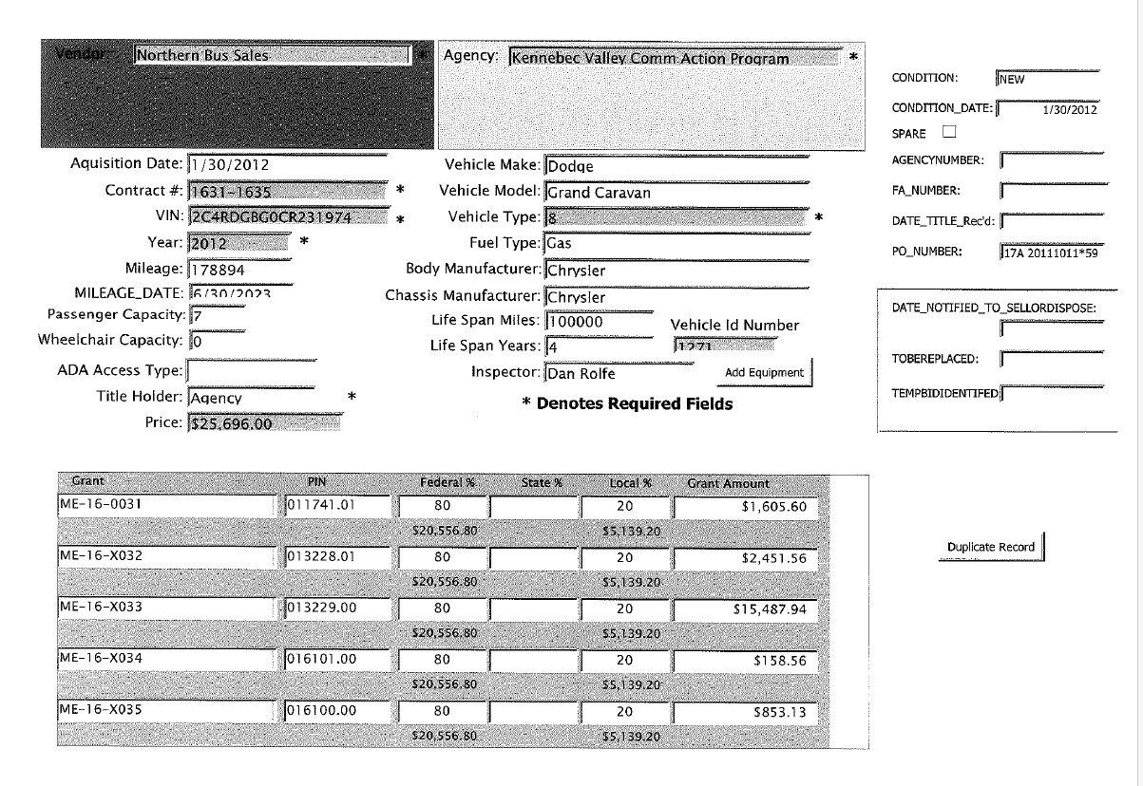

- See RFP Appendix J- Sample PTMS Vehicle Evaluation Summary Form and K- List of Departmental Asset Data Fields
- See RFP Appendix F, 3, p.26- Asset Management.

5 | RFP Section & Page Number | Question
 | RFP Part III, p.9 | Does the Department wish for the responses to the RFP to be in a Word or PDF format?
 | Answer
 | PDF as stated in RFP Part III C, p. 9.- Submitting the Proposal

6 | RFP Section & Page Number | Question
 | RFP Part IV, pp.10-11 | Is there a preferred format for the Service Level Agreement and Uptime and Unplanned Outage Report requirements as part of Section III - Proposed Services?
 | Answer
 | The Department prefers a PDF - See Part III, C, p. 9- Submitting the Proposal.

7 | RFP Section & Page Number | Question
 | RFP Part V, p.13 | How would we be notified of your decision on the RFP?
 | Answer
 | See RFP Part V, C, p. 13

8 | RFP Section & Page Number | Question
 | RFP Appendix F, p. 24 | - How many users would you anticipate needing access to platform?  - Please provide a count of internal users by role who will be interacting with the Enterprise Asset Management (EAM) system.  - Please provide a count of external users by role who will be interacting with the Enterprise Asset Management (EAM) system.  - Who are the end users?
 | Answer
 | As stated in RFP Appendix F, p. 24, 1, The Transit Asset Management SaaS software and licenses must fully cover at least 3 Departmental users. In terms of the number of external users, the Department assumes that each Transit Provider agency would need a primary and a backup.

9 | RFP Section & Page Number | Question
 | RFP Appendix F, p. 26 | Are email notifications of changes to asset data required as part of system configuration?
 | Answer
 | We are agnostic on the notification solution as long as it meets business requirements.

10 | RFP Section & Page Number | Question
 | RFP Appendix F, p.28 | Our off-the-shelf solution doesn’t currently offer NTD reporting. Is NTD reporting a requirement?
 | Answer
 | No.

11 | RFP Section & Page Number | Question
 | RFP Appendix F, p. 29. | In Appendix F of the RFP, 9. IT Hosting Provision starting on page 29 mentions FedRAMP and other security accreditations/attestations. Is the successful bidder required to be FedRAMP certified or is this a preference?
 | Answer
 | FedRAMP certification is not required based on anticipated data classification of TPL: white or TLP:Green. (For more, see System and Services Acquisition Policy and Procedures (SA-1) and Data Classification Policy.)

12 | RFP Section & Page Number | Question
 | Appendix F- 10.1, p. 30 | Is the Department open to a phased implementation?
 | Answer
 | Yes.

13 | RFP Section & Page Number | Question
 | RFP Appendix G, p.35 | In regards to PTMS, would this require an integration? If this is not an integration, please provide an example of the requirement.
 | Answer
 | See RFP Appendix F, p.27, 4- Public Transportation Management System (PTMS) Form. Also, see Appendix J- Sample PTMS Vehicle Evaluation Summary Form

14 | RFP Section & Page Number | Question
 | RFP Appendix H, p. 37 | Do you require that the awarded vendor be headquartered in the United States?
 | Answer
 | No, however the Remote Hosting Policy does require that all Hosting Environment Components be physically located in the United States.

15 | RFP Section & Page Number | Question
 | Part VI, p. 14 and Appendix I, p. 7 | - Sections 41-43 of BP54-IT Rider B contain ownership and licensing terms that are dependent on the type of software or other materials provided.  - For custom software, it may not be possible to transfer full ownership rights in such custom software to the Department. Will the Department consider alternative proposals to these terms, and consider allowing the Provider a right to re-use custom software for other purposes as well?  - Will the Department consider adding a clause to cover the use of open source software and applicable open source licensing terms that govern such software?  - Section 2 of BP54-IT Rider B allows the Department to withhold 10% retainage until end of the warranty period. Will the Department consider paying such retainage upon acceptance of final deliverable rather than end of warranty period (which would leave the Provider unable to be paid it’s full amount for a full year after deliverable acceptance), or alternatively, reduce the amount of retainage to be withheld?  - Section 44 of BP54-IT Rider B requires the Provider to enter into an escrow agreement with a software escrow agent. Will the Department consider an alternative option for the contractor to make all software source code available at any time via GitHub or a similar cloud-based repository in place of escrow? We have found this option to be more efficient  - As an alternative to the letter of credit or financial institution commitment letter in Section 46 of BP54-IT Rider B, will the Department accept CPA-audited financial statements from the Provider to satisfy the Department that the Provider has sufficient capital?  - Page 7 of Appendix I of the RFP mentions performance bond sureties and payment bond sureties. We offer a commercial off-the-shelf (COTS) solution similar to a Microsoft Office product you would typically utilize at the Department of Transportation. This means that the day you purchase the software, you have access to it and will be utilizing the same version of the software as our 1,800 customers (it would be configured to the Department’s process, not customized software). A proposal bond is not applicable to COTS. As such, would the Department please consider removing the bond requirement, as we will be unable to submit a proposal if the requirement remains in place?
 | Answer
 | The contract template covers a wide range of projects with varied risks, so it is typical to negotiate contract modifications as appropriate to the case at hand. Contract negotiation occurs with the selected bidder after bidder selection.

16 | RFP Section & Page Number | Question
 | N/A | What platforms are currently in use in the Department? (e.g., Salesforce, ServiceNow, others etc.)?
 | Answer
 | We use the Microsoft 365 Office platform. We have explored the Microsoft PowerApps/Azure tools.

17 | RFP Section & Page Number | Question
 | N/A | Do you have a preference for a platform; commercial-off-the-shelf or custom?
 | Answer
 | For State Policy, the Department always prefers a COTS solution.

18 | RFP Section & Page Number | Question
 | N/A | Will telematics be a part of this RFP?
 | Answer
 | No.

19 | RFP Section & Page Number | Question
 | N/A | Does the Department want to integrate with your current fuel provider? Who is your current fuel provider? Are there any Fuel Islands? Does the Department utilize Fuel Cards?
 | Answer
 | No.

20 | RFP Section & Page Number | Question
 | N/A | Would the department consider extending the response submission deadline by two weeks?  By the time we receive the answers to our questions, we would not have enough time to prepare our response. Would you please extend the deadline by 30 days after we receive answers to the questions?
 | Answer
 | The due date has been extended to June 10, 2024.

21 | RFP Section & Page Number | Question
 | N/A | Any requirement of a native Android or iOS app? Or any requirement of a native web app?
 | Answer
 | We have no mobile app requirements.

22 | RFP Section & Page Number | Question
 | N/A | What electronics (mobile devices, tablets, Windows devices such as Surface Pro’s) are/would be available in the field? Is/would there be a standard for electronics in the field to employees or do they use personal devices?
 | Answer
 | There is no expectation of field use.

23 | RFP Section & Page Number | Question
 | N/A | What is your GIS environment like? (What GIS system(s) do you use? And do you anticipate staying with that, or upgrading in the near future?)
 | Answer
 | We have no GIS requirements.

24 | RFP Section & Page Number | Question
 | N/A | If a feature you request is under construction, would you consider it meets the requirement if it is completed after the award but before the finish of the project?
 | Answer
 | No.

25 | RFP Section & Page Number | Question
 | N/A | Was a Request for Information (RFI) released for this same project? If so, please list respondents?
 | Answer
 | No.

