Model Open Space Subdivision Ordinance
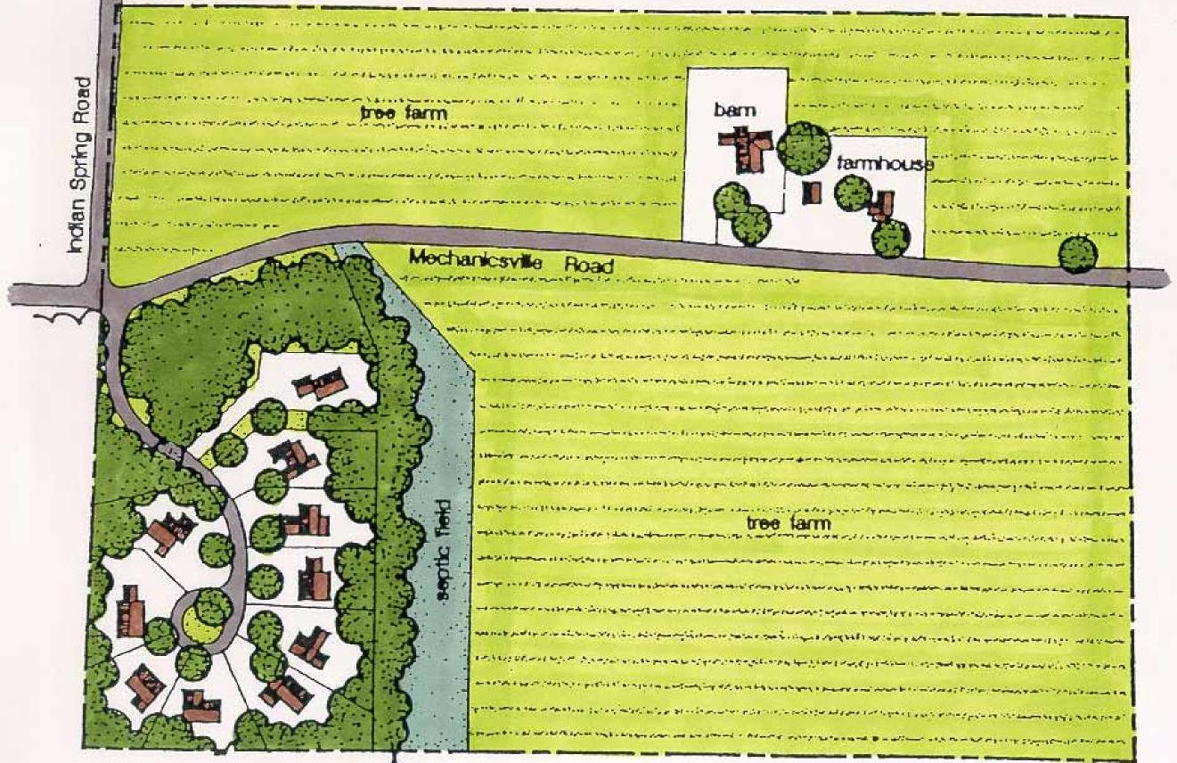
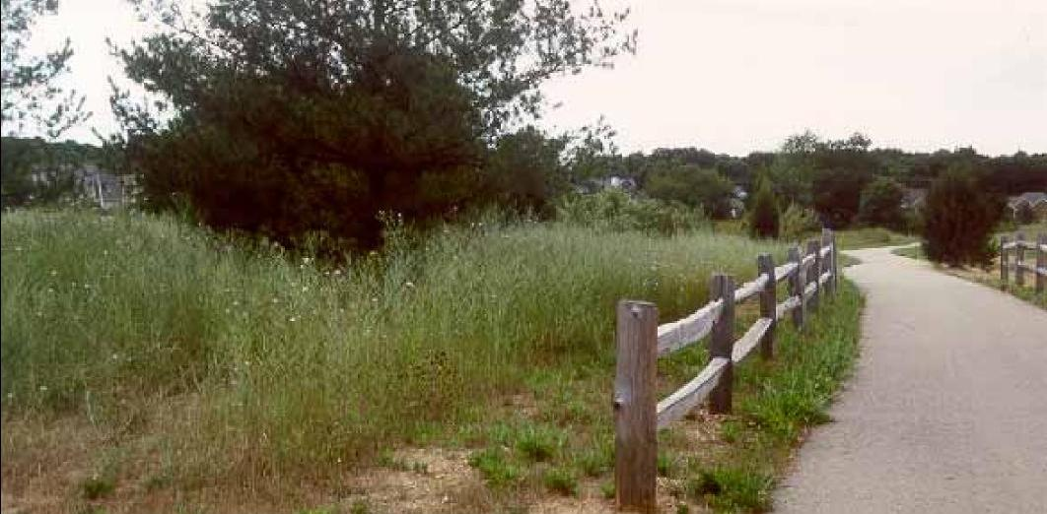

Kennebec Valley Council of Governments
July 2009

Introduction

Low-density development is altering the rural landscape of Maine. The State converted over 869,000 acres of rural land to suburban uses from 1980 to 2000 second only to Virginia in proportional change according to the 2006 Brookings Institute report “Charting Maine’s Future: An Action Plan for Promoting Sustainable Prosperity and Quality of Places”. This represents a loss of 1300 square miles of rural land, a territory roughly the size of Rhode Island. As the report lists the costs of sprawl it asserts that the greatest concern is that this low-density development is undermining Maine’s brand, its rural character and special quality of life that remains the heart of the State’s current and future economy. Put another way becoming more like “Anywhere USA” is bad for Maine’s economy and environment.

Most Maine communities with Comprehensive Plans (and many towns without such plans) evidence a strong concern about loss of open space, farmland, and rural character. Local attitude surveys that often accompany these plans invariably show high levels of support for protecting open space, farmland, and rural character. Protecting rural character is a primary goal in practically every local Comprehensive Plan. Not surprisingly many municipalities have adopted cluster development ordinances with purposes that reflect this and other related goals. Typical purposes of these ordinances include: “to provide for the efficient use of land and the preservation of open space, farmland and rural character; to provide for development in harmony with natural features of the land; to encourage the efficient use of infrastructure; to protect environmentally sensitive areas; to encourage affordable housing; … “.

Open space subdivisions can provide economic, environmental and social benefits to a community as well as advantages for developers. Site development costs are decreased by designing with the terrain. Infrastructure and the service costs to maintain it are reduced because roads and water and sewer lines are almost always shorter. School buses, snow plows, rubbish trucks and other service vehicles will have shorter routes. Reduced costs to develop lots can incentivize including some affordable housing as part of the project. The protected open space provides residents with recreational opportunities and scenic views. Added amenities from adjacent protected open space increase home resale value and enhance marketing. Homes in open space subdivisions appreciate faster than those in conventional subdivisions. Such developments can protect unique, fragile and significant wildlife and plant habitats. Open space subdivisions reduce the pollution impacts from storm water runoff and promote aquifer recharge. Clustered housing with neighborhood trails encourages more frequent interactions with one’s neighbors, fostering a sense of community. A larger open space network (green infrastructure) can be created if open space is connected across several developments and potentially support recreational trail networks and wildlife habitat links. Although open space subdivisions offer many benefits these developments are a partial essential prescription to protecting community rural character, etc.. Creation and implementation of a local open space plan that has identified high value natural areas including farmland for protection is also essential.

Open space subdivisions intentionally (or should intentionally) include important features in protected open space. Cluster subdivisions typically do not. Unfortunately most cluster subdivision ordinances fail to accomplish their purposes. Many of these ordinances lack site design criteria for locating lots and open space. Some of these design criteria direct new construction to locations on the site where buildings can be absorbed by natural landscape features. Many cluster subdivision ordinances set aside too little open space in rural districts. Several studies show that rural character breaks down when open space percentage falls below 60 – 70 percent. Cluster subdivisions are often optional and not mandated. Developers typically do not choose a development option that they’re unfamiliar with. When open space subdivisions are optional most if not all subdivisions in that municipality will continue to be conventional. A preliminary review that maps site constraints and opportunities and designs the subdivision around these features is also often absent.

This model open space subdivision ordinance strives to address these and other typical deficiencies so that the typical purposes (listed earlier in this introduction) of cluster subdivision ordinances can be achieved. This model mandates open space subdivisions in rural districts while assuring that the same number of lots allowed for a conventional subdivision is allowed for an open space subdivision. A preliminary review is required that includes a site inventory map and a conceptual (sketch) plan for the proposed development. Site design standards for lot and open space location are part of the ordinance. Open space ownership, use and maintenance standards are also included.

This model ordinance is designed to fit into an existing local land use ordinance, which has a review structure. It is not a stand-alone ordinance. Application of this ordinance should be reviewed by a municipal attorney prior to adoption.

This model ordinance is a product of reviewing numerous ordinances and reports related to open space subdivisions. Feedback from Planning Board members at open space subdivision workshops was appreciated and useful. Appreciation also extends to Chris Huck and Jen Boothroyd respectively Planning Director and Community Planner at KVCOG for review comments. This model ordinance was prepared by Fred Snow Community Planner at KVCOG.

Model Open Space Subdivision Ordinance
Kennebec Valley Council of Governments

- Purposes

The purposes of these provisions are:
- To provide for efficient use of the land and the preservation of open space, farmland, and rural character;
- To provide for development in harmony with the natural features of the land that is consistent with historic land use patterns of village-like areas where residences are grouped, surrounded by areas of open space used for agriculture, forestry, recreation and similar purposes;
- To protect high value natural areas;
- To reduce the impacts on water resources by minimizing land disturbance and creation of impervious surfaces and stormwater runoff;
- To encourage efficient use of infrastructure.

- Applicability

- The provisions of this ordinance apply to all major subdivisions.
- The provisions of this ordinance shall be mandatory for all major subdivisions in rural district(s) or rural area(s) except as otherwise noted.
- The provisions of this ordinance shall be [mandatory] for all major subdivisions in village district(s) or village area(s)

3.0 Definitions

Buildable Area. Land area of a parcel excluding Unbuildable Area.

Building Envelope. The area formed by front, side, and rear building restrictions or setback lines of a lot within which development including clearing, excavation, and grading and structures shall be contained.

Open Space, Designated. Reserved land that is permanently protected from further development and remains in a natural condition or is managed according to an approved management plan for natural resource functions, e.g. habitat protection, passive recreation, agriculture, forestry or some combination of these.

Open Space Percentage. The percentage of Buildable Area that’s required to be part of designated open space.

Primary Conservation Area. Those Unbuildable Areas that include steep slopes (20% or more), hydric soils, wetlands, and surface waters including intermittent streams.

Secondary Conservation Areas. Those areas with significant features that include open fields, high value natural areas, prime USDA agricultural soils, mature woodlands, stone walls, treelines, existing historic structures, scenic views into and out of the property, trails and hilltops.

Subdivision, Future. A proposed or potential subdivision subsequent to an initial subdivision on the same parent parcel. Note: the number of future lots, a delineated area that will contain all future lots, and a delineated area for future designated open space must be established according to requirements of this Ordinance prior to and shall not be altered subsequent to an initial approved Minor or Major Subdivision.

Subdivision, Minor. A subdivision with up to 4 lots. Note: minor subdivisions are not required to be Open Space Subdivisions.

Subdivision, Major. A subdivision with five or more lots. Note: major subdivisions shall be Open Space Subdivisions.

Subdivision, Open Space. An alternative form of residential development where, instead of subdividing an entire tract into lots of conventional size, the same or a similar, number of housing units are arranged on lots of reduced dimensions, with the remaining area of the parcel permanently protected as Designated Open Space.

Unbuildable Area. Land area that cannot be counted toward the minimum lot size under a conventional subdivision and includes steep slopes (20% or more), hydric soils, wetlands, surface water, rights of ways and easements, Resource Protection District, flood ways and coastal high hazard zones and portions used for storm water management facilities.

- Pre-application Review

All applicants for review of major subdivisions are required to participate in a pre-application review process with the Planning Board. The purpose of this process is to discuss the characteristics of the site and proposed plan for development in conceptual terms. The preliminary review shall be conducted following notification to abutters and the general public. Public input will be accepted.

- Pre-application Discussion. A pre-application discussion is strongly encouraged between the applicant, site designer(s), and the Planning Board. The purpose of this informal meeting is to introduce the applicant and site designer(s) to the municipality’s zoning and subdivision regulations and discuss the applicant’s objectives in relation to those requirements. The applicant may choose to bring a Site Context Map and an Existing Features Plan to this meeting.

- Site Context Map. The site context map shall be drawn to a size adequate to show the relationship of the proposed subdivision to adjacent properties and to locate the subdivision within the municipality, e.g., 1 inch = 400 feet. The site context map shall include the following:

- An outline of subject parcel along with abutting properties perhaps from a tax map.
- Existing subdivisions in proximity of the subject parcel.
- An outline of the subject parcel on a USGS topographic map.
- Zoning district.
- Tax map and lot number of subject parcel.
- Watershed description.
- Location and names of existing streets.
- Location of a circle showing features within half mile of subject parcel on Beginning with Habitat High Value map.

- Existing Features (Site Inventory) Map. The site inventory map(s) shall be at a scale of one inch equals 100 feet (unless another scale is mutually agreed upon) and shall involve an individual or team with the necessary training in natural resources, preferably a landscape architect, and who shall certify the information submitted. The inventory and map(s) shall include, at a minimum, the following:

- The proposed name of the subdivision, north arrow, date and scale.
- The boundaries of the parcel based upon a standard boundary survey prepared by a registered land surveyor and giving the bearings and distances of all property lines.
- A contour map based at least upon topographic maps published by the U.S. Geological Survey.
- The location and delineation of Primary Conservation Areas. (Note a high intensity soils map based on test pits may be advantageous in determining less area with hydric soils.) The total acreage of Primary Conservation areas shall be included.
- The location and delineation of existing buildings and unbuildable areas that are not Primary Conservation Areas including rights-of-ways and easements, portions in Resource Protection district, and portions utilized for storm water management facilities.
- The location and delineation of any Essential Habitat Areas onsite or within 250 feet of the subdivision and any other important habitat areas onsite indicated on State Beginning with Habitat maps
- Identification of scenic views into and out from the property with accompanying photos and location and delineation of other Secondary Conservation Areas. The total acreage of Secondary Conservation Areas when applicable shall be included.
- The identification and location of vegetative cover on the property

- Calculations. Applicants shall:

- Minimum Lot Size. Provide applicable minimum lot size in the zone project is located in.
- Unbuildable Land. Provide total acreage of Unbuildable Land. Include and total applicable elements from list in section 10.1.
- Number of Allowable Lots. Provide number of allowable lots according to formula in section 5.3
- Open Space Set Aside. Provide total acreage of designated open space that shall be set aside using formula in section 5.4.

- On-Site Visit. After the Existing Features Plan has been prepared, the Planning Board shall schedule an on-site visit to walk the property with the applicant and the site designer. The applicant shall bring a copy of the Existing Features Plan to the on-site visit. The purpose of this visit is to familiarize Town officials with the property's special features, and to provide them an informal opportunity to offer guidance (or at least a response) to the applicant regarding the location of the Secondary Conservation Areas and potential house locations and street alignments. How the "four step process" to designing subdivisions in section 4.6 could be applied to the subject property should also be discussed.

- Conceptual Plan of Proposed Development. Applicants shall submit a conceptual plan for the development of the subject parcel that reflects the characteristics of the site as detailed in the site inventory and map(s) and its location within the community as indicated in the site context map. The conceptual plan shall be prepared at the same scale as the site inventory map and be provided as both a translucent sheet, which can be overlaid onto the site inventory map(s), and solid plan. A conceptual plan shall be a draft plan, which does not include engineering details, but is drawn to scale and indicates the following:
- Proposed location of any new road(s) or common driveway(s).
- Proposed residential lots, building envelopes, and potential house sites for each lot.
- Existing and proposed features and amenities, including common areas, trails, or community buildings, etc.
- Proposed boundaries of the designated open space.
- A narrative description of the proposed approach for providing for drinking water supply, waste water treatment, stormwater management, and landscaping.
Applicants shall demonstrate that their conceptual plan is consistent with the following approach for designing a subdivision:
a. Step One: Identify Conservation Areas. All Primary and Secondary Conservation Areas and unbuildable areas shall be identified and when applicable shall be delineated.
b. Step Two: Locate House Sites. To the maximum extent feasible, house sites shall be located outside of those areas delineated in Step One. The location of the house sites shall also reflect the design objectives identified in section 8.0.
c. Step Three: Align Streets, Common Driveways and Trails. The minimum length and network of road(s) necessary to access each house lot shall be identified. Common driveways shall also be identified. Roads and common driveways shall be located in such a way that avoids or at least minimizes adverse impacts on both Primary and Secondary Conservation Areas e.g. when possible these access ways shall not be located in open fields unless along part of field perimeter or along a tree line. Proposed trails shall be identified where access to the designated open space is appropriate and/or to provide for pedestrian circulation within the development as well as pedestrian access to areas outside the development.
d. Step Four: Identify Lot Lines and Building Envelopes. Lot lines and building envelopes for each house site, or group of homes on a common lot, shall be identified. The placement of lot lines and building envelopes shall give consideration to those areas identified in Step One as well as conform to the natural features of the landscape to the greatest extent possible, e.g., follow stone walls, lines of boundary trees, streams. The delineation of lots shall also consider the privacy provided for individual homeowners.

7. Conceptual Long Range Development Plan. When a subdivision will not utilize the entire parcel and there is potential for future subdivision or development of the parcel or any of the lots being created, the application shall include a conceptual long-range development plan showing the potential utilization of the lots and the balance of the parcel not being subdivided. The conceptual long range development plan is a sketch plan with no engineering details, intended to be conceptual in nature, to rely on published data about natural resources relevant to the parcel, and to demonstrate that the current subdivision proposal will not compromise important conservation values or the long term development of the parcel as a conservation design subdivision. This plan shall show the relationship of the proposed subdivision area to the balance of the parcel and to adjacent land. This plan shall analyze the conservation and development potential of the remaining area of the parcel and shall identify and delineate future designated open space area(s), and development area(s) in a manner that demonstrates that both the proposed development and the future development can occur so that it conforms to the requirements for conservation design subdivisions and preserves the significant natural resource and conservation values of the entire parcel. The number of future lots allowed and number of future lots proposed must be shown on the plan. After an initial subdivision has been approved the number of lots for the entire parcel and the boundaries of future area(s) to be developed and future area(s) to be protected as designated open space cannot be changed. The size of future lots can be altered.

5.0 Formal Application Procedure

[A community should evaluate its existing formal application procedure for consistency. Much of the information from the preliminary application process could be applied to the formal application process, which typically concerns a preliminary subdivision plan and a final plan. Because of opportunity for public input during preliminary review the Planning Board may opt not to hold a public hearing to expedite review.]

6.0 Maximum Density and Open Space

- Growth (and/or Village) Open Space Percentage. Growth (and/or Village) district(s) shall have an Open Space Percentage of [30] percent for open space subdivisions.

- Rural Open Space Percentage. Rural district(s) shall have an Open Space Percentage of 60 percent for open space subdivisions.

- Number of Allowable Lots. The total number of residential units allowable within an open space subdivision shall equal but not exceed the number of units that would otherwise be allowed in a conventional subdivision in an existing zoning district unless a density bonus is granted per Section 7.0. The total number of dwelling units allowed shall be determined by the following formula:

Total Dwelling Units Allowed = Total Parcel minus Unbuildable Area divided by Minimum Lot Size

TU = (TP – UA) / MLS

TU = Total Units Allowed (dwelling units)
TP = Total Parcel (acres)
UA = Unbuildable Area (acres)
MLS = Minimum Lot Size (acres)

Note: If minimum lot size is in square feet round to nearest fraction of an acre e.g. a 20,000 square foot minimum lot size would be rounded up to half an acre.

- Open Space Set Aside. The amount of Designated Open Space that shall be set aside shall be determined by the following formula:

Total Open Space Set Aside = Total Parcel minus Primary Conservation Areas multiplied by Open Space Percentage then added to Primary Conservation Areas

TO = ((TP – PC) OSP) + PC

TO = Total Open Space Set Aside (acres)
TP = Total Parcel (acres)
PC = Primary Conservation Areas (acres)
OSP = Open Space Percentage (% of Buildable Area)

Note: See Appendix 1 for an example of how these formulas are applied.

7.0 Density Bonuses

The Planning Board may grant a density bonus to an applicant who proposes affordable housing and/or a Low Impact Development approach as a component of the open space subdivision, in accordance with the following criteria:

- Affordable Housing Bonus.

- A 10% increase in the number of dwelling units allowed may be granted by the Planning Board if an applicant provides a minimum of 25% of units affordable for families meeting criteria of 80% to 120% of the County’s median income. Such units may be either for sale or rent.
- The Planning Board must approve a plan for long-term retention of the affordable units within that category.

- Low Impact Development (LID) Bonus. A 10% increase in the number of dwelling units allowed may be granted by the Planning Board if LID practices according to Maine State Planning Office’s “LID Guidance Manual for Maine Communities” are incorporated into the subdivision.

8.0 Design Standards

- The following objectives for location of lots and designated open space shall be achieved to the greatest extent feasible in prioritized order:

1. Within Rural District(s):
- Primary Conservation Areas in protected open space
- Lots on or with access to suitable soils for subsurface wastewater disposal if no public sewer system
- Lots within woodlands or if that’s not possible along far edges of open fields preferably adjacent to woodlands (to enable new construction to be absorbed by natural landscape features)
- Lots where scenic views from public roadways are least likely to be blocked or interrupted
- Essential habitats of rare, threatened or endangered wildlife and rare or exemplary plants and natural communities identified on State Beginning with Habitat maps in protected open space
- Stream corridors and wildlife travel corridors with respective undisturbed vegetative buffers of 100 feet and 300 feet width in protected open space
- Preservation of cultural features of the rural landscape, including significant trees, stonewalls, tree lines, and when feasible historic farmhouses and outbuildings. Significant trees, tree lines, and stone walls and other important natural features not included within designated open space should be incorporated along the edges of individual lots or along a path or road, rather than transected by lot lines or a roadway.
- High Value Plant and Animal Habitat areas identified on State Beginning with Habitat map and high value natural areas identified in an adopted local or regional open space plan in protected open space
- Contiguous, usable area for agriculture or sustainable wood lot production in protected open space
- Lots where linkage with nearby open space on other properties is not blocked, and when possible, where continuous corridors of natural vegetation are protected in alignment with any adopted local or regional open space plan
- Lots avoid slopes exceeding 20% and tops of ridgelines
- Lots avoid natural drainage ways
- Class 1, 2, 3 agricultural soils as defined by USDA in protected open space
- Lots where greatest number of units could take maximum advantage of solar heating opportunities provided there is no or minimal conflict with other objectives

- Within Village District(s):
- Primary conservation areas in protected open space
- Preservation of cultural features of the village landscape, including stone walls, tree lines, and when feasible historic homes and outbuildings
- Lots where linkage with nearby open space on other properties is not blocked, and when possible, where continuous corridors of natural vegetation are protected in alignment with any adopted local or regional open space plan
- Lots where buildings will not interfere with solar access of other properties
- Lots where greatest number of units could be designed to take maximum advantage of solar heating opportunities
- Lots within woodlands contained in the parcel or if that’s not possible along far edges of open fields preferably adjacent to woodlands (to enable new construction to be absorbed by natural landscape features)
- Lots where scenic views from public roads are least likely to be blocked or interrupted

2. Architectural compatibility of new construction with historic buildings in the community or region is [strongly recommended].

9.0 Open Space Ownership, Use, and Maintenance

The Designated Open Space created by the subdivision shall be:

- Shown on the plat plan with the following notation: “Designated Open Space shall not be further subdivided or used for future building lots.”

- Shown on the plat plan including boundaries of Designated Open Space areas, active recreation area if any, agricultural area, and naturally, undisturbed vegetated areas and marked in the field with signage approved by the Planning Board to distinguish these areas from private property.

- Accessible to the owners or residents of the development, subject to any necessary limitations in connection with the uses of the land (e.g., farming), which may be permitted.

- Uses. Limited to uses for passive recreation, or other passive outdoor activities, agriculture, forest management or individual or group septic systems, and for preserving the natural features of the site except as noted in section 10.18. Potential uses (e.g., farming) may be by the subdivider, owners or residents, or a lessee. The use of any open space may be further limited or controlled at the time of final subdivision approval as necessary to protect adjacent properties.

- Management Plan. Managed according to a management plan for the designated open space and facilities that’s approved by the Planning Board, which includes the following:

1. Identifies the entity assuming responsibility for stewardship and management of the designated open space, including regular inspections to confirm continued compliance with the terms of the subdivision approval and conservation easement or deed restrictions.
2. Includes detailed standards and schedules for maintenance of the designated open space, including maintenance of vegetation.
3. Allows for municipal maintenance in the event that the maintenance specified under the agreement is not completed and recovery of costs incurred from the designated management entity or the owners of the designated open space within the subdivision.
4. Provides that any amendments to the plan shall be reviewed and approved by the Municipal Reviewing Authority.
5. Prior to the commencement of any timber harvesting a forest management plan defined by Title 36 MRSA section 573.3-A shall be submitted to the Municipal Reviewing Authority. The plan must be prepared by a licensed professional forester or a landowner and be reviewed and certified by a professional forester.

- Ownership. Owned, preserved, and maintained as required by this section by any of the following mechanisms or combinations thereof:

- Dedication of open space to the Town or a suitable land trust, if either is willing to accept the dedication.
- Dedication of development rights of open space to a suitable land trust with ownership by a private individual or homeowners association.
- Ownership of the open space by a homeowners' association which assumes full responsibility for its maintenance with open space protection deed restrictions enforceable by any landowner in the subdivision, any owner of separate land parcels abutting the open space, or the municipality
- Ownership by a private individual with open space protection deed restrictions enforceable by any land owner within the subdivision, any owner of separate land parcels abutting the open space, or the municipality. This option may apply only if open space is part of an existing farm, working or not, if there is a future intent to farm by the owner and no land trust is willing to accept dedication of development rights of the open space.

- Homeowner’s Association. Controlled by a homeowners association in the event ownership options per sections 6.1, 2 and 4 are not exercised. If a homeowners’ association (association) is to be formed it shall be incorporated by the developer prior to final subdivision approval. Covenants for mandatory membership in the association shall be approved by the Planning Board and included in the deed for each lot or unit. Draft by-laws of the proposed lot owners' association specifying the responsibilities and authority of the association, the operating procedures of the association and providing for proper capitalization of the association to cover the costs of major repairs, maintenance and replacement of common facilities shall also be subject to Planning Board approval. The association’s documents shall specify that:

- The association shall have the responsibility of maintaining the designated open space and other private facilities dedicated to the use in common by the development’s resident.
- The association shall levy annual charges against all property owners to defray the expenses, if any, connected with maintenance of the common open spaces and facilities.
- The association shall have the power to place a lien on the property of members who fail to pay dues or assessments.
- The developer shall maintain control of designated open spaces and facilities and be responsible for their maintenance until at least 51% of the development lots or units have been conveyed, with evidence of such completion and sales submitted to and approved by the Planning Board.

10.0 Other Standards

- Professional Services. The Municipal Reviewing Authority may retain professional services, third-party technical review of information provided concerning the existing features map and conceptual plan of proposed development submitted for pre-application review and for formal application review including but not limited to an attorney or consultant. The attorney or consultant shall first estimate the reasonable cost of such review and the applicant shall deposit, with the municipality, the full estimated cost, which the municipality shall place in an escrow account. The municipality shall pay the attorney or consultant from the escrow account and reimburse the applicant if funds remain after payment.

- Legal Review. Prior to final approval by the Municipal Reviewing Authority the applicant shall submit for review by the municipal attorney any restrictive covenants, conservation easement, deed restrictions or other legal agreements proposed for use in the open space subdivision. The municipal attorney shall advise the Municipal Reviewing Authority of the adequacy of such legal provisions. The applicant shall pay all associated costs of the legal review.

- Unbuildable Area. Unbuildable area includes those portions of the lot:
- With hydric soils.
- Subject to rights-of-way or easements.
- Located in Resource Protection District.
- Covered by surface waters.
- Utilized for storm water management facilities.
- With slopes exceeding 20%.
- Ten (10) percent of the area of the lot to account for roads and parking.
- In a floodway or a coastal high hazard zone as designated in the Flood Boundary and Floodway Map prepared by the Federal Insurance Administration

- Flexible Lot Dimensions. Reductions below the minimum otherwise required by this Ordinance for lot area, street frontage, and lot width are allowed for open space subdivision lots except that minimum lot size for subsurface disposal remains 20,000 square feet. Irregular lot shapes are allowed.

- Minimum Setback. The minimum setback of lot lines from edge of road pavement shall be 20 feet.

- Parcel Boundary Setback and Buffer. Lots shall not be less than 50 feet from parcel boundary. A minimum 50 foot undisturbed buffer shall be established between lots and the parcel perimeter.

- Privacy. To the extent practical, building sites shall be delineated to maximize the privacy afforded to each dwelling unit, by, for example, positioning homes to eliminate direct sight lines to neighboring homes. Single-loaded streets (houses on just one side of the street) are encouraged.

- Green Lot Perimeter Strip. A green perimeter strip, not less than 25 feet wide shall be maintained with shrubs and trees along all lot lines except outside of wooded areas in designated growth districts or areas the front yard buffer strip may be vegetated with grass or flowers. Such a green strip shall not be built on or paved or used for parking or storage. There shall be no removal of trees over 4 inches in diameter within this buffer. Vegetation shall be retained in its natural state, although tree planting shall be permitted as a matter of right.

- Roadside Buffer. Outside of designated growth areas, a subdivision in which the land cover type at the time of application is forested, shall maintain an undisturbed wooded buffer strip no less than fifty feet in width along all existing public roads. The buffer may be broken only for driveways and streets.

- Ridgelines. When a proposed subdivision contains a ridge line identified in the comprehensive plan as a visual resource to be protected, the plan shall restrict tree removal and prohibit building placement within 50 feet vertical distance of the ridge top. These restrictions shall appear as notes on the plan and as covenants in the deed.

- Historic Resources. If any portion of the subdivision is designated a site of historic or prehistoric importance by the comprehensive plan, National Register of Historic Places, or the Maine Historic Preservation Commission, appropriate measures for the protection of the historic or prehistoric resources shall be included in the plan. When the historic features to be protected include buildings, the placement and the architectural design of new structures in the subdivision shall be similar to the historic structures. The Board shall seek the advice of the Maine Historic Preservation Commission in reviewing such plans.

- Essential Habitat Buffer. At least a minimum 300 foot undisturbed natural buffer shall be established between development and any Essential Habitat Areas as mapped by Maine Department of Inland Fisheries and Wildlife (MDIFW) Beginning with Habitat program. The applicant shall provide review comments from MDIFW or Maine Natural Areas Program as applicable when essential habitat Areas have been identified.

- Access Limit. Points of subdivision access to a single existing road shall not exceed two.

- Roads.
- Roads serving open space subdivisions with up to 20 dwelling units shall have a minmum pavement width of 18 feet with a minimum shoulder width of 3 feet. Roads for all subdivisions shall have a maximum pavement width of twenty feet. Shoulders shall be topped with 2 -3 inches of loam and seeded with grass suited for the purpose.
- Where feasible, horizontal road alignments shall work with the topography and existing site conditions to follow the natural contours and avoid physical features that give the land its character.
- Open fields, agricultural lands and sensitive habitats should be crossed at the edges, preferably along hedgerows and treelines when possible. Roadways shall avoid bisecting fields.
- Where feasible, proposed roads should follow any existing gravel/dirt road that has value as a local historic resource.
- When roads cross significant viewsheds in open fields, consideration shall be given to design approaches that will minimize their visual impact. These may include earth berms (designed with gently tapered side slopes), landscape screening using native shrubs, and ‘ha-ha’s’ ( an old English tradition which puts the roadway in a slight depression and out of view).
- Where existing roads must be widened to accommodate increased traffic volumes, care shall be taken to preserve mature roadside trees and other features which contribute to the road’s character.
- Where drainage culverts are visible, the ends shall be cut off to follow the contour of the surrounding grade and/or covered with stone.
- Guardrails shall be constructed of wood or self-oxidized steel to avoid a harsh industrialized appearance.

- Common Driveways. Common driveways are allowed and encouraged where appropriate to access individual lots. The following design and construction standards shall apply:
- The maximum length shall not exceed 1000 feet.
- Al l common driveways in excess of 500 feet shall contain at least one 10 foot by 30 foot turnout. The exact location shall be determined by the Planning Board with the review of the Fire Department.
- The common driveway shall have a minimum 25 foot right of way (ROW) for up to 2 lots or dwelling units, and a minimum 50 foot ROW for over 2 lots or dwelling units.
- The travel way shall be 12 feet wide with 2 foot graded and grassed shoulders, and shall be located as close as possible to ROW centerline.
- The travel way shall be constructed of a minimum of 12 inches of gravel.
- Drainage ditches and culverts shall be provided as necessary.

- Trails.
- Trail improvements shall demonstrate adherence to principles of quality trail design.
- Trails shall have a vetical clearance of not less than 10 feet.
- The width of the trail surface may vary depending upon type of use to be accomodated , but in no case shall it be less than 3 feet or greater than 6 feet.
- No trail shall be designed with the intent to accommodate motorized vehicles.
- Trails except for points of access shall be no less than 50 feet from parcel boundary.

- Mowing. Any portion of the designated open space not under cultivation which is comprised of open field or pasture shall be mowed at least once annually.

- Open Space Contiguity. Reasonable efforts shall be made to locate designated open space adjacent to existing undeveloped land to form a continuous integrated open space system according to local or regional open space plan if any. At least 75% of designated open space shall be contiguous.

- Shared Subsurface Disposal Systems. Shared subsurface disposal systems may be permitted in designated open space provided that requirements of the Maine State Plumbing Code are met, including appropriate provisions for legal obligations related to maintenance and replacement.

- Underground Utilities. All utilities shall be installed underground unless specifically waived by the Planning Board. Transformer boxes, pumping stations and meters shall be located so as not to be unsightly or hazardous to the public.

- Phosphorous Export. When a proposed subdivision is within the direct watershed of a Great Pond , the applicant shall make provisions to limit the export of phosphorus from the site following completion of the development, consistent with the maximum allowable phosphorus standard from Maine Department of Environmental Protection’s “Phosphorus Control in Lake Watersheds: A Technical Guide to Evaluating New Development”.

- Active Recreation. Active recreation requires equipment and takes place at prescribed sites and includes tennis and other court games, swimming, baseball and other field sports and playground activities. Active recreation shall be limited to one site, can encompass no more than one acre of the designated open space and must be screened from view in rural districts or areas except as noted further in this subsection. Any building associated with the active recreation site is limited to 400 square feet. When open space subdivisions are located in a growth area with zoning district density equal to or greater than 3 dwelling units per acre 25% of the designated open space up to a maximum of 3 acres can be used for active recreation including ball fields and total building footprint is limited to 1000 square feet.

- Future Subdivision. When a subdivision will not utilize the entire parcel and there is a potential for future subdivision the total number of initial lots and future lots shall be provided and an area where future lots will be located and remaining area where protected open space will be designated shall be delineated according to the requirements for open space subdivisions. Once an initial subdivision has been approved the number of future lots and delineated areas of future development and future protected open space cannot be altered. Lot sizes can be changed within the future development area.

Appendix 1

Example of Applying Formulas That Determine Number of Allowable Lots and Amount of Open Space To Set Aside

Assume That a 100 acre parcel is being developed. Assume that the unbuildable area of the parcel is 10 acres. Assume that the minimum lot size in the zone is 2 acres. Assume that there are 8 acres of Primary Conservation areas. Assume that the open space percentage for the zone is 60% (or as a decimal .6).

The following formula would be used to determine the number of allowable lots:

Total Dwelling Units Allowed = Total Parcel minus Unbuildable Area divided by Minimum Lot Size

TU = (TP – UA) / MLS

TU = Total Units Allowed (dwelling units)
TP = Total Parcel (acres)
UA = Unbuildable Area (acres)
MLS = Minimum Lot Size (acres)

Note: If minimum lot size is in square feet round to nearest fraction of an acre e.g. a 20,000 square foot minimum lot size would be rounded up to half an acre.

TU = Total Units or Lots Allowed
TP = 100 acres Total Parcel
UA = 10 acres Unbuildable Area
MLS = 2 acres Minimum Lot Size

TU = (100 – 10)/ 2
TU = 90/ 2
TU = 45 Total Lots or Dwelling Units Allowed

The following formula would be used to determine the amount of open space to set aside:

Total Open Space Set Aside = Total Parcel minus Primary Conservation Areas multiplied by Open Space Percentage then added to Primary Conservation Areas

TO = ((TP – PC) OSP) + PC

TO = Total Open Space Set Aside (acres)
TP = Total Parcel (acres)
PC = Primary Conservation Areas (acres)
OSP = Open Space Percentage (% of Buildable Area)

TO = Total Open Space Set Aside
TP = 100 acres Total Parcel
PC = 8 acres Primary Conservation Areas
OSP = 60% (or .6) Open Space Percentage

TO = ((100 – 8) .6 ) + 8
TO = ( (92) .6 ) + 8
TO = ( 55 ) + 8
TO = 63 acres of Total Open Space Set Aside

So a maximum of 45 lots could be developed on 37 acres (100 – 63 = 37).

