Synergy - Student Daily Attendance Upload Guide

- This upload will enter student daily attendance data into Synergy.
- Complete the Student Daily Attendance upload after the Student Enrollment upload has been successfully uploaded.

Contents
File Preparation: 1
File Upload: 2
Results: 5

File Preparation:

Option 1: use your local Student Information System such as Infinite Campus, Power School or Web2School to export a file. You will need to work with your local SIS for assistance in downloading the file from their system.

Option 2: Fill out the Student Daily Attendance sample file which can be downloaded from here:
https://www.maine.gov/doe/data-reporting/collection/helpdesk/resources/synergy_instructions
(Note: the sample file has example students that you will need to delete.)

The upload file needs to be in either CSV or TXT format. You cannot upload an XLSX (excel) file. The sample file can be edited in excel but must be saved as a CSV.

The Student Daily Attendance upload file must have the 07 required columns. The Student Daily Attendance requirements document lists the columns and the order they must be in. The Student Daily Attendance Upload requirements document can be downloaded from here:
https://www.maine.gov/doe/data-reporting/collection/helpdesk/resources/synergy_instructions

File Upload:

- In the top right, click the school year or school/district name and the Change Focus box appears.
- Select the following in the Change Focus box and click Save:
Year: Select the current school year (the example picture shows 2021-2022)
Organization: Choose your district (the example picture shows Acton Elementary)
NOTE: In order to enter attendance, you must be focused at the school level
Show Students: Show Active and Inactive
- Click on the PAD Tree icon.
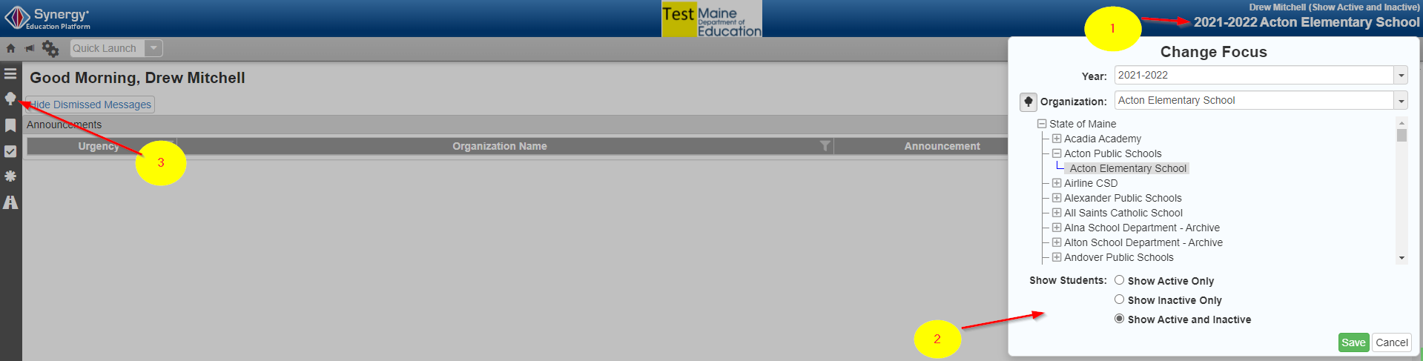

- Click the arrow next to Synergy SIS to expand the section.
  - Click the arrow next to ME to expand the section.
  - Click State Reporting Status.
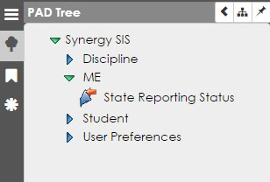

4

- In the State Reporting Status page, hover over the Menu drop down. Click Upload File:
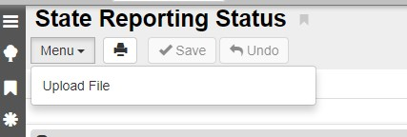

5

- In the Upload File box, click the File Type drop down. Select Student Daily Attendance.
- Click the Attach File button.

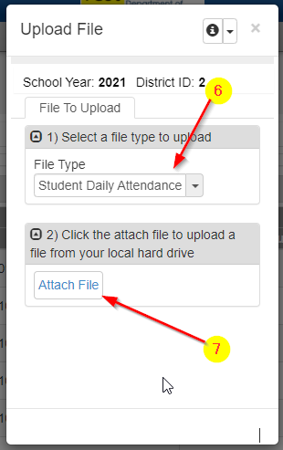

- In the File Upload box, click Choose File.
- Locate your file and then click the Upload button.
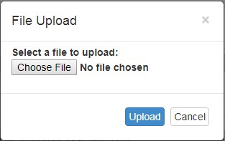

8

9

- You will get a job result screen where you can download the file you uploaded or the error report.
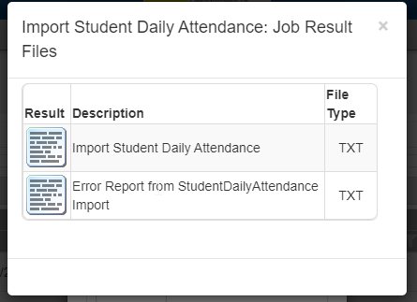

- On the State Reporting Status page, click the refresh button in the top right.
- The upload is complete when numbers appear in the Row Count, Success Count and Error columns. (You may need to click the refresh button multiple times but once it refreshes you will see the date and time of upload).
- Click on the Result Log to the right and download the file.
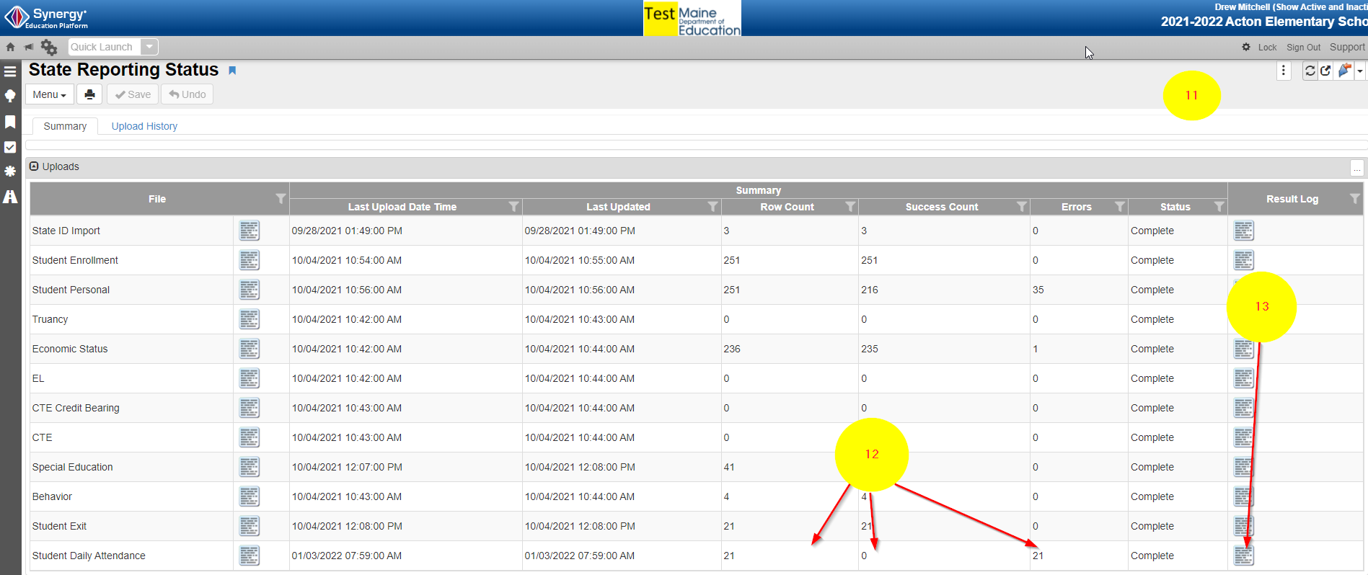

Results:

If all Student Daily Attendance data was successfully upload you will receive this message in the result log:
StudentDailyAttendance Import Error Log
All Records completed successfully

If not all Student Daily Attendance data was uploaded, the result log will have 6 columns:
Row Number: corresponds to the row in the upload file that had the error.
SAU ID: is the SAU ID found in the upload file
School ID: the ID used in your local SIS
Year Code: the current year code
State Student Number: The student’s State ID
Error: a message about why the data was not uploaded

The following Error messages indicate there was an issue processing the uploaded data:

ERROR | RESOLUTION
Student has no enrollment in the current year. | The Student Enrollment upload must be completed prior to the Student Daily Attendance.
The SAU ID 28 does not match the user current focus SAU ID 860 | The SAU ID in the file is incorrect. The SAU ID in the upload file should be of the SAU they are attending.  SAU Codes can be found here: https://www.maine.gov/doe/data-reporting/collection/helpdesk/resources/infrastructureupload.html
Attendance Status code of ‘XXXXX' is not a valid value. | You uploaded the old attendance format – use correct upload file
File is invalid. Errors: Expected field count in line 0 (15) does not match definition expected field count of 07 for map. | The upload file is missing a column.  OR  The upload file is in the wrong file format. Upload files must be in either CSV or TXT format only (not  XLSX)  OR  The incorrect File Type was selected on the upload screen.
Unable to find student "13008819" | State ID in the upload file is incorrect. State IDs are 9 digits.
Year code is not valid | Format for year is ‘XXXX-XXXX’

