Instructions for Verifying and Certifying the Special Education Exit Report

Reporting Period: June 1st through July 30^{th,}:
Students who have exited special education services during the reporting period (July 1, through June 30) must have special education exit information (a special ed exit date and exit reason) added to their enrollments in Synergy State Edition. Student information must be entered or uploaded into the Synergy State Edition by the school where the student is attending. School Administrative Units (SAUs) are required to certify the exit data using the Special Education Exit Report found in NEO. Changes to student information in Synergy will be reflected on the NEO report after the data have been refreshed (NEO refreshes automatically every hour on the half hour).
*Reporting period contains all extensions. No additional extensions will be given.

Synergy Uploading

Synergy Manual Entry

Responsible and Attending SAUs
The Special Education Exit Report and Certification are available within NEO. Personnel with the role of “District User” who are designated as “Special Education Director” or “Local Special Education Administrator” may access the report, but only the Special Education Director can certify.
- Each SAU is responsible for verifying and certifying the accuracy of the information of students for whom the SAU is responsible.
- The RESPONSIBLE SAU is the SAU responsible for the student’s IEP, but the student exit data is entered and updated in Synergy by the ATTENDING SAU.
- Students publicly tuitioned to private schools should be enrolled and updated in Synergy by the private school.
- Students attending special purpose private schools or regional programs retain their primary special ed enrollment with the sending school/district and the student's exit information in Synergy should be updated by the sending school/district.
- For students attending charter schools, the charter school is responsible for uploading exit data to Synergy and verifying and certifying the exit data in NEO.

Verifying and Certifying the Reports
Follow the steps below to access, verify, and certify the reports: • Login to NEO: https://neo.maine.gov/
- Go into Student Data up top.
- Go to Student Reports.
- Set the Reporting Area at the top to Special Services.

• Find the Special Education Exit Certification Report, and click View Report
- Select the current year and SAU you want to look at.
- You will see a table for the attending student counts at your SAU and a separate table for the student for whom you are responsible. To see the individual records of the students that make up the counts in these tables, click on “View Details” (see screenshot below).
- The Special Education Director should verify the counts in these tables and ensure that all required updates to student records are made. If the student count or exit information is not correct, make the necessary changes in your local student information system, re-upload the student data to Synergy State Edition, and ensure the changes are reflected in NEO. When the counts are correct, certify the report.
- To certify the report, click back to the certification report containing the tables of the student counts. At the bottom of the page, click “Certify and Submit to DOE” (see screenshot below) (SPECIAL ED DIRECTOR ONLY).

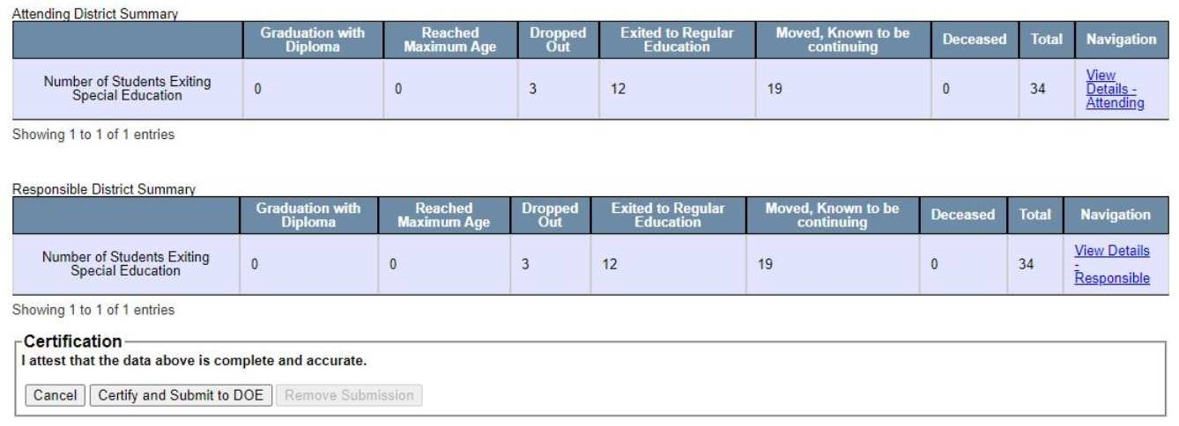

Special Education Exit Reasons
For each student who has exited special education services or exited the SAU, choose one option listed below. If there is a special circumstance, use your best judgment to fit the student into one of the categories. For cases in which the student stops attending an SAU but no other information is known about the student, the exit reason should be
‘Dropped Out’. In this case, the student will be federally reported as a dropout by Maine
DOE only if the student was not picked up by another Maine SAU by the following October. Newly added students and students who are expected to continue special education services in your SAU do not require exit data. The exit reason options are as follows:

Graduation with Diploma - exited an educational program through receipt of a high school diploma identical to that for which non-disabled students are eligible (met the same standards for graduation as students without disabilities).

Reached Maximum Age - exited special education as a consequence of reaching the maximum age for receipt of special education services and did not receive a diploma.
** NEW ** Students are eligible for special education services through the age of 21 (through the day prior to the student turning 22). Students aged 22 and older are not eligible for special education services.

Dropped Out - exited special education as a consequence of dropping out of school without completing the individual education program or were enrolled at some point in the reporting year but not enrolled at the end of the reporting year and did not exit by other means listed.

Exited to Regular Education - exited to regular education as a result of completion of an IEP and termination of special education services.

Moved Out-of-District, Known to be Continuing - moved out of the school administrative unit and known to be continuing in another educational program (the educational program doesn't necessarily need to be a special education program).

Deceased

Exited to School Age Special Education Services - should be used only by Child Development Services (CDS) – moved out of the school administrative unit and not known to be continuing in another educational program.

Parents Refuse Services - should be used ONLY by CDS, otherwise use Exited to Regular Education.

Confidentiality
Confidentiality of personally identifiable data will continue to be maintained by the Maine
Department of Education in accordance with the provisions of the Family Educational
Rights and Privacy Act, Individuals with Disabilities Education Act, and Section 504 of the
Rehabilitation Act. No names will be released to the United States Department of Education, Office of Special Education Programs (OSEP) in completing our data requirements under P.L.108-446.

Questions
For questions regarding the Special Education Exit Report, contact Brandi Giguere at brandi.a.giguere@maine.gov or 446-6526. For Synergy or NEO questions and issues, contact the Help Desk at MEDMS.Helpdesk@maine.gov or 624-6896.

